APPLICATION OF COMPUTER VISION WITH COLOR IMAGE SEGMENTATION TECHNIQUE IN AGRICULTURAL PRODUCTIVITY



*Major project submitted in the partial fulfilment of the requirements for*

*the award of the degree of*

**BACHELOR OF TECHNOLOGY**

**in**

# CSE(Data Science)

*By*

**K. DEEPAK (22K95A6706)**

**B. SAI PRIYA (21K91A6714)**

**K. KOUSHIK (21K91A6755)**

**D. SAI REDDY (21K91A6728)**

**Under the guidance of**

**MR. RAJESH BANALA**

**ASSOCIATE PROFESSOR.**

DEPARTMENTMENT OF CSE (DATA SCIENCE)

**TKR COLLEGE OF ENGINEERING AND TECHNOLOGY**

**(AUTONOMOUS)**

(ACCREDITED BY NAAC WITH ’A+’ GRADE)

**Medbowli, Meerpet, Saroornagar, Hyderabad-500097**

### **TKR COLLEGE OF ENGINEERING AND TECHNOLOGY**

**Autonomous,**

(Accredited by NBA & NAAC with ‘A+’ Grade)

## _________________________________________________________________

## Department if CSE (CSD)

## DECLARATION BY THE CANDIDATES

We, **Mr. Katakam Deepak** bearing Hall Ticket Number: **22K95A6706**, **Mrs. Banoth Sai Priya** bearing Hall Ticket Number: **21K91A6714**, **Mr. K****ammpati Koushik Goud** bearing Hall Ticket Number: **22K95A6755** and **Mr. Devarapalli Sai Reddy** bearing Hall Ticket Number: **21K91A6728**, hereby declare that the major project report titled **APPLICATION OF COMPUTER VISION WITH COLOR IMAGE SEGMENTATION TECHNIQUE IN AGRICULTURAL PRODUCTIVITY** under the guidance of **MR. RAJESH BANALA**, ***ASSOCIATE PROFESSOR*** in Department of Computer Science and Engineering (Data Science), is submitted in partial fulfillment of the requirements for the award of the degree of ***Bachelor of Technology in CSE(Data Science)****.*

**SIGNATURES OF THE CANDIDATES:**

**K. DEEPAK (22K95A6706):**

**B. SAI PRIYA (21K91A6714):**

**K. KOUSHIK (21K91A6755):**

**D. SAI REDDY (21K91A6728):**

### **TKR COLLEGE OF ENGINEERING AND TECHNOLOGY**

**Autonomous,**

(Accredited by NBA & NAAC with ‘A+’ Grade)

## _________________________________________________________________

## Department if CSE (CSD)

## CERTIFICATE

This is to certify that the major project report entitled “**APPLICATION OF COMPUTER VISION WITH COLOR IMAGE SEGMENTATION TECHNIQUE IN AGRICULTURAL PRODUCTIVITY”**, being submitted by **Mr. Katakam Deepak** bearing Roll.No: **22K95A6706**, **Mrs. Banoth Sai Priya** bearing Roll.No: **21K91A6714**, **Mr. Kammpati Koushik Goud** bearing Roll.No: **21K91A6755**, **Mr. Devarapalli Sai Reddy** bearing Roll.No: **21K91A6728**, in partial fulfillment of requirements for the award of the degree of ***Bachelor of Technology in CSE (Data Science),***  to the TKR College of Engineering and Technology is a record of Bonafide work carried out by them under my guidance and supervision.

**Signature of the Guide** **Signature of the HOD**

Mr. Rajesh Banala Dr. V. Krishna

Associate professor Professor

**ACKNOWLEDGEMENT**

The satisfaction and euphoria that accompanies the successful completion of any task would be incomplete without the mention of the people who made it possible and whose encouragement and guidance have crowned our efforts with success.

We express our sincere gratitude to **Management of TKRCET** for granting permission and giving inspiration for the completion of the project work.

Our faithful thanks to our **Principal Dr. D. V. Ravi Shankar, M.Tech., Ph.D.,** TKR College of Engineering & Technology for his Motivation in studies and completion of the project work.

With our heart full pleasure we thank our **Head of the Department Dr. V. Krishna, M.Tech., Ph.D.,** Professor, Department of CSE (Data Science),TKR College of Engineering & Technology for his suggestions regarding the project.

Thanks to our Project Coordinator **Mr.M.Arokia Muthu, M.E.,( Ph.D).,** Assistant Professor, Department of CSE (Data Science), TKR College of Engineering & Technology for his constant encouragement.

We are indebted to the **Internal Guide,** **Rajesh Banala,** Associate Professor, Department of CSE (Data Science), TKR College of Engineering & Technology for his support in completion of the project successfully.

Finally, we express our thanks to one and all that have helped us in successfully completing this project. Furthermore, we would like to thank our family and friends for their moral support and encouragement.

By

**K. DEEPAK (22K95A6706)**

**B. SAI PRIYA (21K91A6714)**

**K. KOUSHIK (21K91A6755)**

**D. SAI REDDY (21K91A6728)**

## TABLE OF CONTENTS

**ABSTRACT**i

LIST OF FIGURES iii

1 INTRODUCTION 1

* 1. Motivation 1
  2. Problem definition 1
  3. Limitations of existing system 1
  4. Proposed system 1

2 LITERATURE REVIEW 2

* 1. Review of Literature 2

3 REQUIREMENTS ANALYSIS 23

* 1. Functional Requirements 23
  2. Non-Functional Requirements 23

4 DESIGN 24

* 1. System Architecture 24
  2. DFDs and UML diagrams 24
  3. Use Case Diagram 25
  4. Relational Table for Database Design diagram 26

**5** **CODING**  **27**

* 1. Pseudo Code 27

6 IMPLEMENTATION and RESULTS

* 1. Explanation of Key functions 29
  2. Implementation 30
  3. Technologies Used 30

**7 SCREENSHOTS 31**

**8** **CONCLUSION** 32

REFERENCES 33

## ABSTRACT

Agricultural productivity is a cornerstone for sustaining the food demands of an ever-increasing global population. However, traditional farming practices often rely on manual observation and estimation, which can be labor-intensive, time-consuming, and prone to human error. These limitations pose significant challenges in optimizing resource utilization, monitoring crop health, and achieving sustainable yields. In recent years, technological advancements have paved the way for integrating computer vision and image processing into agriculture, providing innovative solutions to address these challenges. This study highlights the role of computer vision, with a focus on color image segmentation techniques, as a transformative approach to enhance agricultural efficiency. By leveraging these technologies, farmers can gain real-time insights into crop conditions and make data-driven decisions to improve productivity.

Color image segmentation, a technique that partitions images into distinct regions based on color properties, allows for the precise identification and classification of agricultural features, such as fruits, leaves, stems, and weeds. This capability has vast applications, including automated monitoring of crop health, early detection of diseases, yield estimation, and effective resource allocation. For instance, detecting diseased leaves based on their color variations can help mitigate the spread of infections, while segmenting ripe fruits can facilitate efficient harvesting. By reducing the dependency on manual labor and minimizing errors, color image segmentation not only streamlines farming operations but also contributes to sustainable agricultural practices.

## Key words: Computer Vision, Color Image Segmentation, Agricultural Productivity, Crop Health Monitoring, Disease Detection, Yield Estimation, Image Processing

## i

## LIST OF FIGURES

4.1 SYSTEM ARCHITECTURE

4.2 DFD FLOW DIAGRAM

4.3 USE CASE DIAGRAM

4.4 RELATION TABLE

## 7.1 HOME PAGE

## ii

**Chapter 1**

# INTRODUCTION

## Motivation

## The global agricultural sector faces the challenge of increasing food production to meet the demands of a rapidly growing population while ensuring sustainable use of resources. Traditional agricultural practices, which heavily rely on manual labor and human expertise, are often limited in their ability to scale and adapt to changing conditions. As a result, there is a pressing need for innovative technologies that can enhance the efficiency and productivity of agricultural processes. In agriculture, computer vision can be applied to various tasks such as crop monitoring, disease detection, yield estimation, and resource management.

## Limitations of existing system

AI-based crop monitoring systems face several challenges that can impact their effectiveness and widespread adoption. One significant issue is limited real-time processing, as analyzing large volumes of data from drones or sensors may introduce delays, hindering prompt decision-making. Additionally, these systems depend heavily on high-quality, extensive datasets to deliver accurate predictions and insights; poor or incomplete data can lead to erroneous conclusions. Manual intervention also remains necessary for verifying AI-detected crop diseases or infestations, which can slow down response times. Moreover, the high cost of advanced drones, sensors, and AI software poses a financial barrier for small-scale farmers, limiting accessibility and adoption.

**Proposed System**

Applying computer vision techniques with color image segmentation can significantly enhance precision in crop health detection. By analyzing different color ranges, the system can accurately identify specific conditions such as diseases, pest infestations, or nutrient deficiencies at an early stage. Enhanced real-time processing through edge computing or cloud-based AI solutions allows for immediate analysis of large datasets collected from drones and sensors, improving response times and reducing data transfer bottlenecks. Furthermore, integrating advanced machine learning algorithms with image segmentation enables the system to adapt to various crops and geographical regions, enhancing accuracy and effectiveness across diverse agricultural settings.

**Chapter 2**

# LITERATURE REVIEW

## 2.1 Review of Literature

The literature review reveals the ability to input their assignments, track progress, and receive timely feedback, fostering a sense of ownership and responsibility. Staff, on the other hand, can utilize the system to efficiently manage and evaluate assignments, providing timely guidance and support. These systems, equipped with features that allow both students and staff to add, delete, update, and monitor the progress of assignments, signify a shift towards inclusive and interactive educational technologies.

The second area of exploration centers on the design of information systems tailored to delves into the role of collaborative homework management systems in promoting peer-to-peer interaction and collaborative learning. Platforms that facilitate students sharing resources, discussing assignments, or even co-working on projects contribute to a more communal approach to education. Such collaborative features have the potential to break down traditional hierarchies, encouraging a more egalitarian learning atmosphere. Research underscores the significance of user-friendly interfaces and comprehensive training programs to ensure that both students and staff can leverage the full potential of these systems. The collaborative nature of these platforms fosters a sense of shared responsibility for academic success and promotes effective communication between students and educators. Moreover, the literature emphasizes the need for secure and privacy-conscious designs to protect sensitive academic information.

Lastly, the literature review reflects a growing interest in leveraging technology to enhance educational practices. These systems, equipped with features like task organization, reminders, and calendar integration, aim to address the perennial challenge of effective homework management. Studies investigating the impact of these systems on student outcomes reveal a positive relationship between their use and academic success. the literature suggests that student homework management systems with collaborative features hold great promise in enhancing communication, transparency, and efficiency in the assignment management process, benefiting both students and staff in the educational ecosystem.

**LITERATURE SURVEY**

**LITERATURE SURVEY-1**

**Title :** A Comprehensive Review on Deep Learning Assisted Computer Vision Techniques for Smart Greenhouse Agriculture (2024)

**Authors** : Jalal Uddin Md Akbar, Syafiq Fauzi Kamarulzaman, Abu Jafar Md Muzahid, Md. Arafatur Rahman, Mueen Uddin.

**Description:**

The application of deep learning (DL) and computer vision (CV) technologies in automating and optimizing smart greenhouse environments. It focuses on plant health monitoring, environmental parameter control, and yield prediction using various DL architectures like CNNs, RNNs, and hybrid models. The review also emphasizes the role of these technologies in real-time decision-making for greenhouse management.**Merits:**

1. **Real-time Decision-Making and Automation:** This technology facilitates real-time decision-making through automation, significantly reducing the need for manual intervention. By automating the analysis of crop data, farmers can quickly detect issues and take corrective actions, improving overall efficiency and productivity.

2. **Adaptable Deep Learning Models for Greenhouse Scenarios**: A diverse range of deep learning models can be tailored specifically for greenhouse environments. These adaptable solutions address the unique challenges of controlled settings, enabling precise monitoring and management of crops in various greenhouse scenarios.

3. **Enhanced Plant Health Monitoring and Prediction:** The system enhances the ability to monitor and predict plant health by analyzing color variations and other visual indicators. This predictive capability optimizes growth conditions, allowing for early detection of diseases, pests, and nutrient deficiencies, ultimately leading to healthier crops and higher yields.

**Demerits:**

1. **Limited Applicability to Open-Field Agriculture:** The technology is primarily focused on controlled greenhouse environments, which restricts its effectiveness in open-field settings. Factors such as varying weather conditions and large field sizes pose challenges for accurate implementation and monitoring outside greenhouses.

2. **High Computational Costs**: The high computational demands of these systems can be prohibitive, particularly for smaller farms. Accessing and maintaining the necessary hardware and software infrastructure requires significant investment, which may limit widespread adoption among small-scale farmers.

3. **Complex Integration with Existing Systems**: Integrating computer vision solutions with existing greenhouse systems is complex and often requires specialized expertise. This complexity can pose a barrier to implementation, as it demands technical knowledge and resources that may not be readily available in all agricultural settings.

**LITERATURE SURVEY-2**

**Title :** Plant Leaf Disease Detection, Classification, and Diagnosis Using Computer Vision and Artificial Intelligence**Authors** : Anuja Bhargava , Aasheesh Shukla, Om Prakash Goswami, Mohammed H. Alsharif, Peerapong Uthansakul And Monthippa Uthansakul.

**Description:**

The use of AI and computer vision for identifying, classifying, and diagnosing plant leaf diseases has gained significant attention due to its potential to transform agricultural practices. By leveraging advanced image processing techniques and deep learning models, these systems can detect and analyze subtle changes in leaf characteristics, such as color, texture, and shape, to identify diseases at early stages. This early detection is crucial for preventing the spread of infections and reducing crop losses, thereby improving overall yield and quality.

**Merits:**

1. **Early Disease Detection:** These systems are capable of identifying diseases at early stages, allowing farmers to take preventive measures before infections spread. This significantly reduces the risk of large-scale crop losses and improves overall yield.

2. **High Accuracy in Disease Classification**: Advanced deep learning models offer high accuracy in classifying various plant diseases. By analyzing intricate features such as leaf color, texture, and shape, these models can differentiate between similar diseases with precision, enhancing diagnostic reliability.

3. **Scalability for Large Agricultural Operations:** AI-driven solutions provide a scalable approach to monitoring and managing plant health across extensive agricultural fields. These systems can process large volumes of data efficiently, making them suitable for both small farms and large-scale commercial operations.

**Demerits:**

1. **Dependence on High-Quality Image Data**: The effectiveness of these models relies heavily on high-quality image data. Variations in lighting conditions, shadows, or poor image resolution can impact the system's performance and lead to inaccurate diagnoses.

2**. Vulnerability to Errors with Overlapping**: Deep learning models can struggle when presented with overlapping or partially damaged leaves, which may obscure important features. This can result in misclassification or missed detections, reducing the system's overall accuracy.

3. **Difficulty in Generalizing Across Different Plant Species:** Models often require retraining to adapt to different plant species and disease types. This lack of generalization can make implementation more complex and time-consuming, particularly in diverse agricultural environments.

**LITERATURE SURVEY-3**

**Title :** Deep Learning and Computer Vision Techniques for Enhanced Quality Control in Manufacturing Processes

**Authors :** Md Raisul Islam, Md Zakir Hossain Zamil, Md Eshmam Rayed, Md Mohsin Kabir, M. F. Mridha, Satoshi Nishimura, And Jungpil Shin.

**Description:**

Although primarily focused on manufacturing, this paper explores the application of deep learning (DL) and computer vision (CV) techniques for quality control, with promising implications for agricultural products. In manufacturing, these technologies are widely used for real-time defect detection, image segmentation, and feature extraction, ensuring that products meet stringent quality standards. The methodologies discussed include identifying surface imperfections, structural inconsistencies, and color deviations, all of which can be adapted to monitor and assess the quality of agricultural produce.

In an agricultural context, these techniques can be leveraged to detect defects in fruits, vegetables, and grains, such as bruising, discoloration, and size irregularities. Real-time monitoring systems equipped with CV algorithms can analyze produce as it moves through processing lines, automatically flagging substandard items for removal.

**Merits:**

1**. High Accuracy in Defect Identification**: Deep learning and computer vision technologies offer high accuracy in identifying defects, ensuring that only high-quality agricultural produce reaches consumers. This precision improves overall quality control and reduces the risk of substandard products entering the market.

2**. Real-Time Monitoring Capabilities**: These systems can be adapted for real-time monitoring of agricultural produce, enabling early detection of defects or spoilage. This helps reduce post-harvest losses by identifying issues promptly and allowing for timely interventions.

3**.** **Automation of Quality Inspection Processes**: By automating quality inspection processes, these technologies minimize the need for human intervention. This not only increases efficiency but also reduces the potential for human error, making quality control more consistent and reliable.

**Demerits:**

1. **Need for Modifications in Agricultural Applications:** The models are primarily designed for industrial settings and require significant modifications to be effective in agricultural applications. Adapting these systems to handle the variability and complexity of agricultural produce can be challenging.

2. **High Computational Power Requirements**: Real-time image processing demands substantial computational power, which can be costly and difficult to implement, particularly for smaller agricultural operations. Access to high-performance hardware is often a limiting factor.3. **Limited Handling of Natural Variations**: Agricultural products exhibit natural variations in shape, size, and color, which can pose challenges for defect detection models. These systems may struggle to differentiate between normal variations and actual defects, reducing their accuracy and reliability in diverse environments.

**LITERATURE SURVEY-4**

**Title** : A Review of Leaf Diseases Detection and Classification by Deep Learning

**Authors** : Assad Souleyman Doutoum, Bulent Tugrul.

**Description**:

This paper presents a comprehensive review of deep learning (DL) approaches for detecting and classifying leaf diseases, emphasizing their potential to revolutionize precision agriculture. The review primarily focuses on convolutional neural networks (CNNs), widely regarded as the backbone of DL for image analysis due to their ability to automatically learn spatial hierarchies of features from images. CNNs have demonstrated remarkable accuracy in identifying complex patterns associated with various plant diseases, surpassing traditional machine learning methods in performance.

Additionally, the paper explores the use of transfer learning models, which leverage pre-trained networks on large datasets and adapt them to specific agricultural tasks. This technique reduces the need for extensive labeled data, making it particularly beneficial in agricultural scenarios where data collection can be challenging. By fine-tuning these models, researchers can achieve high classification accuracy across different crops and disease types, even with limited datasets. Transfer learning also accelerates model training and enhances generalization, enabling rapid deployment in real-world settings.

**Merits**:

1. **Comprehensive Coverage of Various Deep Learning Models**: The paper offers a thorough overview of various deep learning models, such as CNNs, transfer learning models, and hybrid architectures, tailored specifically for leaf disease detection. This broad coverage provides insights into the most effective models for different types of leaf diseases, enhancing understanding and applicability.

2**. Potential of Hybrid Models for High Accuracy**: The study highlights the potential of hybrid models that combine the strengths of multiple deep learning architectures. These models are shown to achieve higher classification accuracy by leveraging diverse techniques, improving the robustness and reliability of disease detection.

3. **Broad Spectrum of Classification Approaches**: By presenting a range of classification approaches, the paper provides solutions that can be adapted to detect various leaf diseases. This flexibility ensures that the models can be used in diverse agricultural contexts, making them suitable for a wide array of crops and disease types.

**Demerits**:

1. **Focus on Leaves, Excluding Other Plant Organs**: While the study provides an in-depth analysis of leaf disease detection, it primarily focuses on the leaves and overlooks other vital plant organs such as stems and roots. This limited scope restricts the overall applicability of the models in comprehensive plant health monitoring.

2. **Real-Time Implementation Challenges**: The paper does not address the challenges associated with real-time implementation of these models in dynamic, uncontrolled environments. Factors such as lighting changes, movement, and environmental noise can affect model accuracy and reliability when deployed in real-world settings.

3. **Limited Evaluation on Large-Scale Datasets**: The models discussed in the paper have been primarily evaluated on small, controlled datasets, which impacts their ability to generalize to larger, more diverse datasets. This limitation may hinder their scalability and performance when applied to large-scale agricultural operations.

**LITERATURE SURVEY-5**

**Title** : Multi-step Preprocessing with UNet Segmentation and Transfer Learning Model for Pepper Bell Leaf Disease Detection**Authors** : Aisha Ahmed Alarfaj, Abdulaziz Altamimi, Turki Aljrees, Shakila Basheer, Muhammad Umer, Md. Abdus Samad, Shtwai Alsubai, And Imran Ashraf..

**Description**:

A novel multi-step preprocessing approach that integrates the UNet architecture for image segmentation with transfer learning models for disease detection in pepper bell leaves. The primary aim of this approach is to enhance both the accuracy and speed of segmentation, enabling the simultaneous detection of multiple disease symptoms on the leaves. UNet, a well-established deep learning architecture known for its high performance in image segmentation tasks, is employed to first segment the images of pepper bell leaves into distinct regions, isolating diseased areas from healthy tissue. This step is crucial for ensuring that subsequent detection models focus on the relevant portions of the image, reducing the chances of misclassification and improving model efficiency.

**Merits**:

1. **Multi-step Preprocessing Improves Segmentation Accuracy**: The multi-step preprocessing approach enhances the accuracy of segmentation, effectively reducing false positives. By carefully segmenting the images into distinct regions, the model can focus on the relevant areas of the leaves, leading to more precise detection of disease symptoms.

2**. UNet Architecture Captures Fine-grained Features**: The UNet architecture excels in capturing fine-grained features of diseased leaves, which is essential for accurately identifying and classifying subtle disease symptoms. Its ability to work with high-resolution images and preserve spatial details significantly improves detection performance.

3. **Transfer Learning Reduces Training Time and Data Requirements**: Transfer learning models leverage pre-trained weights from large-scale datasets, reducing the time and amount of data required for training. This approach accelerates the adaptation of the model to specific disease detection tasks, making it a practical solution for real-world applications with limited labeled data.

**Demerits**:

1. **Limited to Pepper Bell Crops**: The proposed approach is primarily designed for pepper bell crops, which limits its broader applicability. Expanding the model to other crops may require additional retraining and fine-tuning on different datasets, reducing its generalizability.

2. **High Computational Resources Required**: The multi-step preprocessing pipeline, which includes complex image segmentation and deep learning models, demands significant computational resources. This could pose a challenge for smaller farms or regions with limited access to advanced computing infrastructure.

3. **Complex Pipeline for Real-time Deployment**: The complexity of the multi-step pipeline makes real-time deployment challenging. Processing time, especially for segmentation and disease detection using deep learning models, may hinder the system's ability to function effectively in dynamic agricultural environments where quick decision-making is crucial.

**LITERATURE SURVEY-6**

**Title** : Machine Learning and Deep Learning for Plant Disease Classification and Detection**Author** : Vasileios Balafas, Emmanouil Karantoumanis, Malamati Louta, And Nikolaos Ploskas.

**Description**:

This paper provides a comprehensive evaluation of the effectiveness of both machine learning (ML) and deep learning (DL) models in the context of plant disease detection. It delves into a comparative analysis between traditional ML algorithms, such as Support Vector Machines (SVM) and K-Nearest Neighbors (KNN), and advanced DL architectures like Convolutional Neural Networks (CNNs) and transfer learning models. The study examines key performance metrics including accuracy, scalability, and adaptability, offering valuable insights into the strengths and limitations of each approach

**Merits**:

1. **Comparative Analysis for Best-Suited Techniques**: The paper provides a detailed comparative analysis of machine learning (ML) and deep learning (DL) models, helping researchers and practitioners identify the most suitable techniques for specific scenarios. This comparison facilitates informed decision-making based on factors like dataset size, computational resources, and desired accuracy.

2**. Synergy Between ML and DL Methods**: By highlighting the potential synergy between traditional ML and DL methods, the study demonstrates how combining these approaches can lead to improved performance. This hybrid approach leverages the strengths of both techniques, enhancing the robustness and accuracy of plant disease detection systems.

3. **Optimization Insights Based on Resources**: The paper offers valuable insights into optimizing models according to available resources, such as computing power and data availability. This helps tailor solutions that are both cost-effective and efficient, particularly for small-scale farmers or regions with limited technological infrastructure.

**Demerits**:

1. **Real-World Deployment Challenges Not Addressed**: The study does not thoroughly address real-world deployment challenges, such as data scarcity and variability in field conditions. These factors can impact the performance of ML and DL models in practical applications.

2. **Dependency on Large Labeled Datasets**: Both ML and DL models often require large, labeled datasets for training, which are not readily available for all plant diseases. This dependency limits the applicability of the models, particularly for rare or less-documented diseases.

3. **Limited Testing on Different Crop Varieties**: The models' generalization capacity is reduced due to limited testing on different crop varieties. This restriction means that additional retraining and fine-tuning may be necessary to adapt the models for use in diverse agricultural settings, increasing the overall complexity and cost.

**LITERATURE SURVEY-7**

**Title** : Role of Artificial Intelligence in Agriculture: An Analysis and Advancements with Focus on Plant Diseases

**Authors**  : Ruchi Rani, Jayakrushna Sahoo, Sivaiah Bellamkonda, Sumit Kumar, And Sanjeev Kumar Pippal.

**Description**:

This paper delves into the transformative role of artificial intelligence (AI) in modern agriculture, particularly focusing on the automation of plant disease detection, yield estimation, and pest management. It highlights how AI technologies, including machine learning (ML), deep learning (DL), and computer vision (CV), are reshaping traditional agricultural practices by introducing innovative solutions that enhance productivity, sustainability, and decision-making processes in farming.

In the domain of plant disease detection, AI-driven systems use advanced image processing techniques to automatically identify early signs of disease in crops, enabling farmers to take timely action and reduce the risk of large-scale crop loss. These systems, powered by AI models like convolutional neural networks (CNNs), can analyze plant images captured by drones or sensors to classify diseases with remarkable accuracy. This shift towards automation significantly reduces the reliance on manual inspection, increasing efficiency and reducing human error.

**Merits**:

1. **Broad Coverage of AI Applications**: The paper offers a comprehensive exploration of various AI applications in agriculture, providing a holistic view of how AI is impacting multiple facets of the industry, including disease detection, yield estimation, and pest management. This wide-ranging perspective helps stakeholders understand the full potential of AI in reshaping agriculture.

2**. Highlights Advancements in Disease Detection and Pest Management**: The paper emphasizes the transformative advancements that AI has brought to plant disease detection and pest management. These innovations have greatly improved accuracy and efficiency, allowing for early detection and precise intervention, which reduces crop losses and enhances productivity.

3. **Labor Cost Reduction and Increased Productivity**: By automating routine tasks, AI technologies can significantly reduce labor costs and enhance productivity on farms. Automation helps streamline operations, allowing farmers to focus on more strategic aspects of their work while ensuring more efficient resource use and faster decision-making.

**Demerits**:

1. **Lack of Focus on Practical Implementation Challenges**: Although the paper highlights the benefits of AI, it does not address in sufficient detail the practical challenges involved in implementing AI systems in real-world agricultural settings. These challenges may include the integration of AI into existing farm operations, the need for technical expertise, and infrastructure limitations.

2. **Limited Depth on Region-Specific Agricultural Practices**: The study provides a broad overview of AI applications but does not delve deeply into region-specific agricultural practices. Different regions may have unique crops, climates, and farming conditions that require tailored AI solutions, and this aspect is underexplored in the paper.

3. **Economic Feasibility for Small-Scale Farmers**: The paper does not provide a thorough analysis of the economic feasibility of AI adoption, especially for small-scale farmers. High initial costs, the need for specialized equipment, and access to data may limit the ability of small-scale operations to implement AI-driven solutions effectively.

**LITERATURE SURVEY-8**

**Title** : Analysis of Fruit Images with Deep Learning: A Systematic Literature Review and Future Directions

**Authors**  : Sebastián Espinoza, Cristhian Aguilera, Luis Rojas, And Pedro G. Campos.

**Description**:

This systematic review delves into the application of deep learning models for fruit image analysis, specifically highlighting the techniques used for quality control and disease detection. The paper offers an in-depth exploration of how deep learning, particularly through convolutional neural networks (CNNs) and other advanced architectures, is transforming the way fruits are analyzed in agricultural settings. These models are crucial in automating the process of assessing fruit quality, detecting diseases, and ensuring that produce meets the required standards.

A significant focus of the review is the use of deep learning models for disease detection, where CNNs and other architectures are trained to recognize early symptoms of diseases such as rot, mold, and blight. By analyzing images of fruit surfaces, these models can identify subtle changes in texture, color, or shape that may indicate the onset of disease, allowing for early intervention and reducing the risk of widespread contamination.

**Merits**:

1. **Detailed Review of Fruit-Specific DL Models**: The paper provides a comprehensive review of deep learning models tailored specifically for fruit image analysis. This focus on fruit-specific models enables targeted research, helping researchers and practitioners to explore and optimize techniques that are most relevant to fruit quality control and disease detection.

2**. Suggestions for Future Research Directions**: The paper identifies promising avenues for future research in the field of fruit image analysis. By suggesting potential areas of improvement and new applications, the paper encourages innovation and exploration of advanced techniques, such as improved segmentation methods or more robust disease detection models.

3. **Adaptability of DL Models for Various Fruit Types**: The review demonstrates the versatility of deep learning models in being applied to different fruit types. Whether for apples, citrus fruits, or berries, these models can be adapted to suit the unique characteristics of each fruit, offering scalability and flexibility in quality control applications.

**Demerits**:

1. **Narrow Focus on Fruits**: While the paper focuses specifically on fruits, it excludes other crop categories, limiting its applicability to broader agricultural settings. The findings may not be directly transferable to other types of produce or agricultural products, reducing the overall impact of the review.

2. **Lack of Real-World Implementation Examples**: Despite discussing various models and techniques, the paper lacks practical, real-world examples of implementation. This absence makes it difficult for practitioners to assess how these models would perform in actual agricultural environments, hindering the transfer of knowledge from theory to practice.

3. **High Computational Costs**: The deep learning models discussed in the paper are often computationally expensive, requiring significant hardware and resources for training and deployment. This high computational cost can be a barrier for small-scale farms or operations with limited access to advanced technology, making these solutions less accessible.

**LITERATURE SURVEY-9**

**Title** : Predicting Agriculture Yields Based on Machine Learning Using Regression and Deep Learning

**Authors**  : Priyanka Sharma, Pankaj Dadheech, Nagender Aneja And Sandhya Aneja.

**Description**:

This paper provides an in-depth evaluation of both regression-based and deep learning (DL) models for predicting agricultural yields, a critical component of modern agricultural management. The primary objective of the study is to compare various predictive techniques such as linear regression, neural networks, and long short-term memory (LSTM) models to forecast crop output based on historical data, climate variables, and other influencing factors.

The paper begins by exploring regression-based models, starting with linear regression, which has long been used for yield prediction due to its simplicity and interpretability. The linear regression model works by establishing a linear relationship between input variables, such as weather patterns, soil moisture, and temperature, and the resulting crop yield. However, the study notes that linear regression models may struggle with the complexity of agricultural data, particularly when non-linear relationships or multiple variables need to be accounted for.

**Merits**:

1. **Combines traditional and modern regression methods**: By integrating both regression-based models and deep learning techniques, the approach offers a more versatile and reliable prediction framework that can handle different types of data and relationships.

2**. Capable of handling complex datasets with multiple features**: The models, especially neural networks and LSTMs, excel in dealing with high-dimensional datasets, where numerous features such as weather conditions, soil quality, and farming practices are taken into account simultaneously.

3. **Shows significant accuracy improvements over conventional forecasting methods**: Compared to traditional linear regression, deep learning models like LSTMs provide more accurate predictions, particularly when non-linear relationships between variables are involved, enhancing forecasting precision in agricultural yield prediction.

**Demerits**:

1. **Data-intensive**: These models, particularly deep learning methods, perform better when trained on large volumes of data. The lack of historical data can limit their accuracy and effectiveness, particularly in regions with limited data availability.

2. **Not suitable for predicting non-yield-related agricultural factors**: While these models are effective in forecasting crop yields, they are not designed to predict other agricultural factors such as pest outbreaks or soil health, which may require different types of models.

3. **High dependency on quality of input data**: The performance of these models is highly dependent on the quality of the input data. Inaccurate, incomplete, or noisy data can lead to poor predictions, highlighting the importance of good data collection and preprocessing.

**LITERATURE SURVEY-10**

**Title** : IoT-driven Machine Learning for Precision Viticulture Optimization

**Authors**  : Chiara Pero, Sambit Bakshi, Senior Member, Michele Nappi and Genoveffa Tortora

**Description**:

This paper explores the integration of Internet of Things (IoT) sensors with machine learning (ML) models to optimize vineyard management. The study delves into how IoT devices, such as soil moisture sensors, temperature monitors, and weather stations, collect real-time data that can be used for various critical tasks in vineyard management. One of the primary focuses is disease prediction, where machine learning algorithms analyze sensor data and historical trends to detect early signs of plant diseases, enabling prompt intervention before significant damage occurs. This proactive approach reduces the need for manual inspection and minimizes pesticide use, leading to healthier crops and more sustainable farming practices.

Another key area of exploration is irrigation control. The paper highlights how real-time soil moisture and weather data can be leveraged to develop optimized irrigation schedules that conserve water and ensure that the plants receive the right amount of moisture. This precision irrigation not only saves resources but also improves plant health by preventing over-irrigation or drought stress.

**Merits**:

1. **Real-time monitoring**: The integration of IoT sensors provides continuous, real-time data on critical factors such as soil moisture, temperature, and plant health. This allows for precise control over irrigation, fertilization, and pest management, leading to more efficient and sustainable agricultural practices.

2**. IoT integration reduces manual labor**: By automating data collection and integrating it with machine learning models, the need for manual inspections and interventions is reduced. This streamlines operations and allows farmers to make data-driven decisions, improving the overall management of the vineyard.

3. **High potential for optimizing water usage**: IoT-enabled systems can closely monitor soil moisture levels, weather conditions, and irrigation systems to ensure that water usage is optimized. This reduces water waste, conserves resources, and helps to maintain environmentally sustainable practices.

**Demerits**:

1. **High costs associated with IoT infrastructure setup:** The initial investment in IoT infrastructure, including sensors, communication networks, and data management systems, can be expensive. For small-scale farmers, this might pose a barrier to adoption, despite the long-term benefits.

2. **Requires stable internet connectivity, which is challenging in remote areas:** In regions where reliable internet access is unavailable, real-time data transmission and remote monitoring can be disrupted, limiting the effectiveness of IoT-based systems.

3. **Limited to viticulture, restricting its applicability to other crops:** The current focus of these IoT-based systems is primarily on vineyards, and while the technology can be adapted to other crops, it is not yet widely implemented in other agricultural sectors. This limits its broader application across diverse farming environments.

**Chapter 3**

# REQUIREMENTS ANALYSIS

## 

## Functional Requirements

The system must provide the following functionality-

1. Keeping records of user.

2. User Login and Password.

3. Admin Login.

4. User registration or Signup.

5. Manage requirements.

## Non Functional Requirements

Non-Functional Requirement is a quality attribute of a software system. They evaluate the

software system’s responsiveness, usability, security, portability, and other non-functional

characteristics that are critical to its success. Non-functional requirements must be speci-

fied with the same attention as

1. Usability requirement
2. Serviceability requirement
3. Security requirement
4. Data Integrity requirement
5. Capacity requirement
6. Availability requirement
7. Scalability requirement
8. Interoperability requirement
9. Reliability requirement
10. Maintainability requirement

**Chapter 4**

# DESIGN

# SYSTEM ARCHITECTURE

## Fig. 4.1 SYSTEM ARCHITECTURE

## DATA FLOW DIAGRAMS

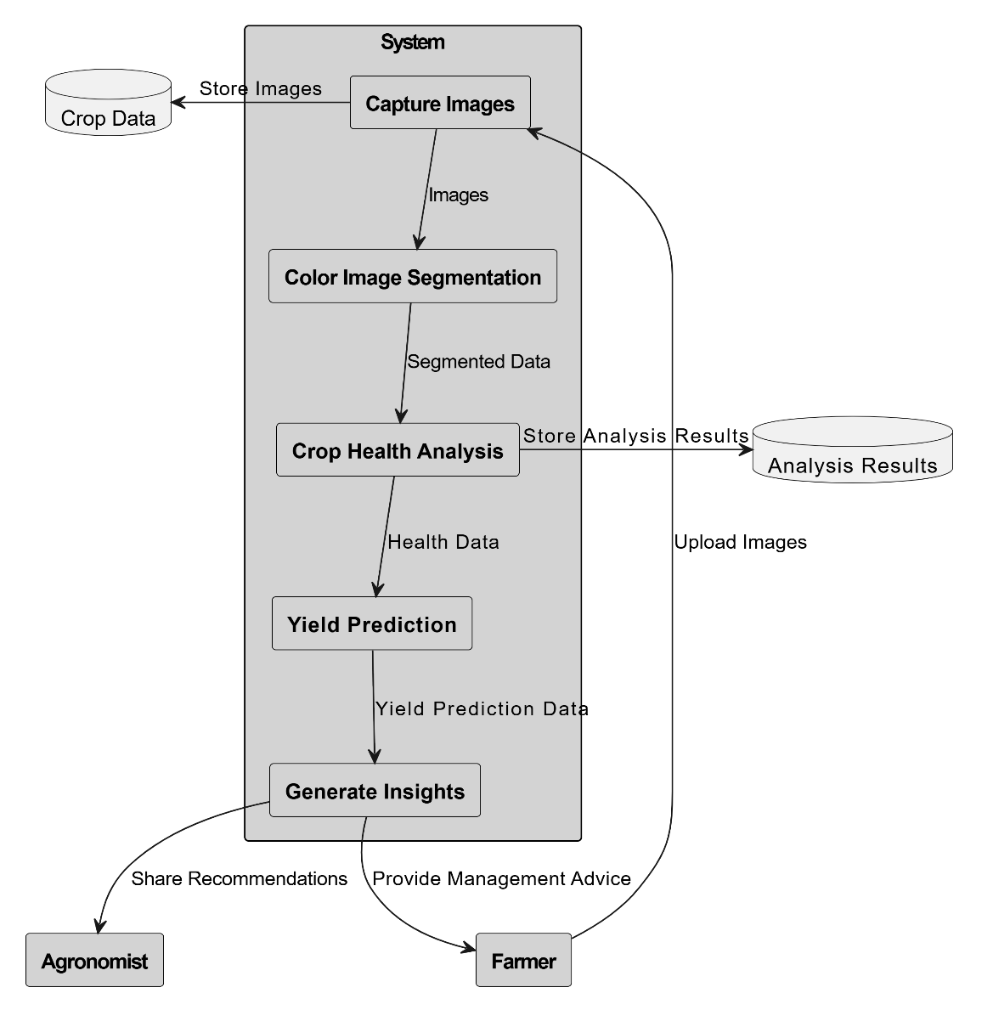

## Fig. 4.2 DFD FLOW DIAGRAM

## DFD shows the entities that interact with a system and defines the border between the system and its environment. The illustration presents the main process in a single node to introduce the project context. This context explains how the project works in just one look. The user feeds data into the system and then receives the output from it.

## Use Case Diagram

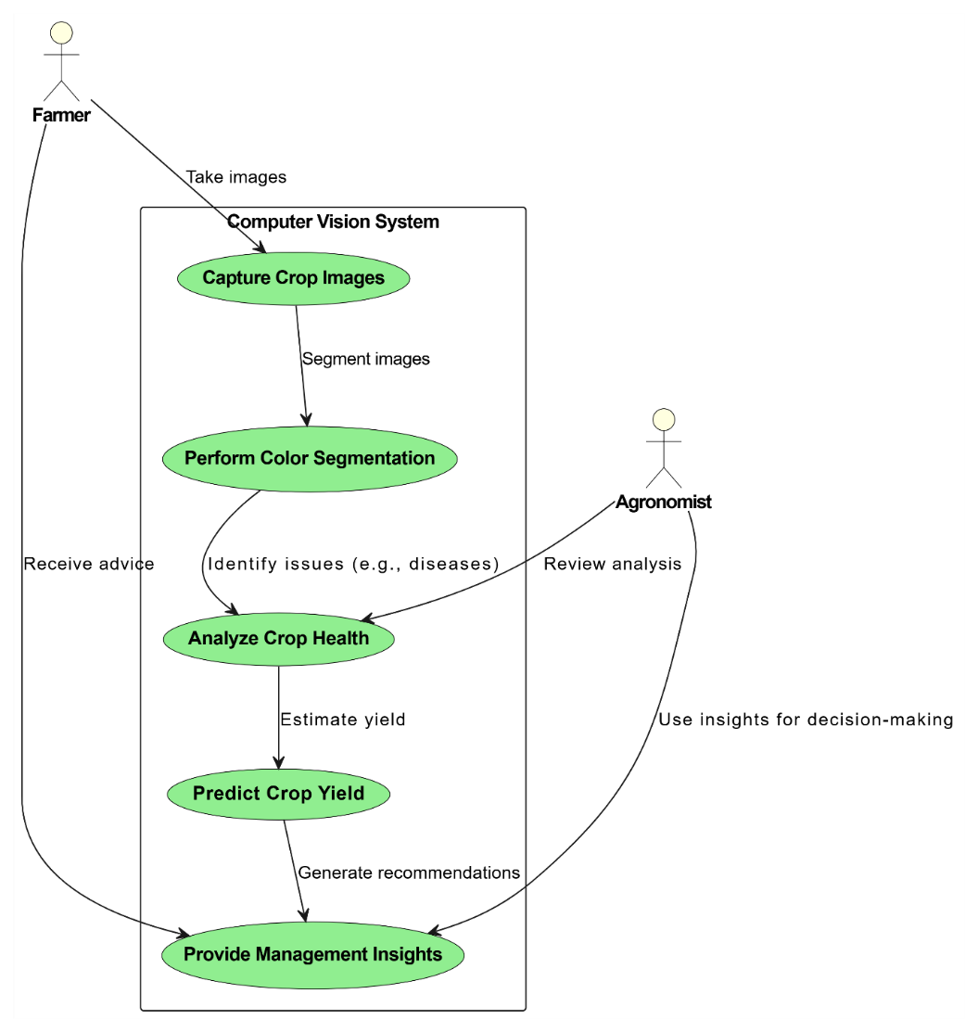

**Fig. 4.3** Use Case Diagram

A UML Use Case Diagram is a visual representation of a system's actors and the system's use cases. A use case represents a function or group of functions, from the point of view of an actor. Actors are external entities that interact with the system being modeled using the provided functionality. They can be human users, other hardware devices, or software systems. Use cases are represented as ellipses. They can be linked with dashed lines to show the actor using them (and which actor initiated the use case).

## Relational Table for Database Design diagram

A database design is a collection of stored data organized in such a way that the data requirements are satisfied by the database. The general objective is to make information access easy, quick, inexpensive and flexible for the user. There are also some specific objectives like controlled redundancy from failure, privacy, security and performance. A collection of relative records make up a table. To design and store data to the needed forms database tables are prepared. Two essential settings for a database are:

1. Primary key: - The field that is unique for all the record occurrences.

2. Foreign key: -The field used to set relation between tables. Normalization is a technique to

avoid redundancy in the tables.

**Relational Table:**

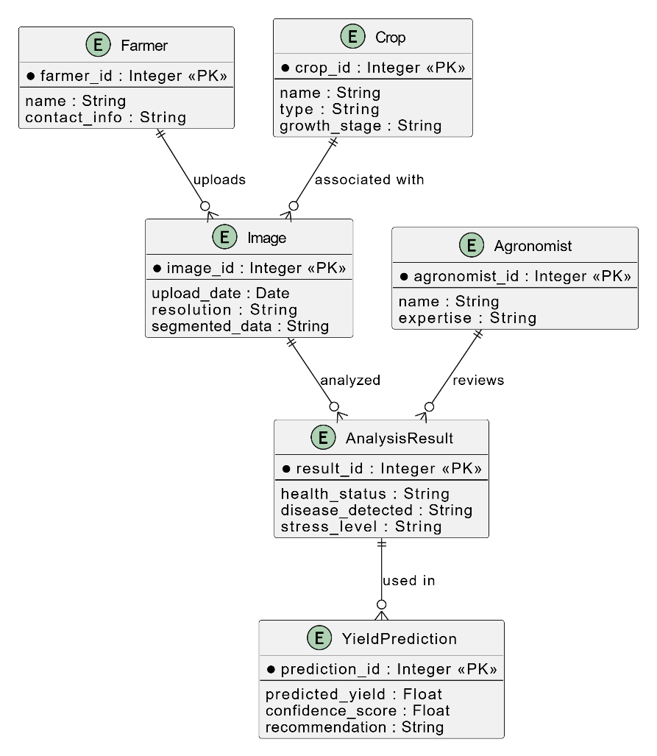

**Fig. 4.4** Relation Table

**Chapter 5**

# CODING

## Pseudocode:

**index.html:**

<!DOCTYPE html>

<html lang="en">

<head>

<meta charset="UTF-8">

<meta name="viewport" content="width=device-width, initial-scale=1.0">

<title>Farma Vision</title>

<link rel="stylesheet" href="https://cdn.jsdelivr.net/npm/bootstrap@5.3.1/dist/css/bootstrap.min.css">

<style>

body {

background: url('bg.jpg') no-repeat center center/cover;

height: 100vh;

margin: 0;

}

.navbar {

background-color: rgba(0, 128, 0, 0.9); /* Slightly opaque green */

position: fixed; /* Keeps navbar at the top */

width: 100%; /* Full width */

z-index: 1000; /* Ensures navbar stays on top */

}

.content {

padding-top: 70px; /* Prevents content from being hidden under the navbar */

}

.navbar-brand img {

width: 40px; /* Adjust logo size */

height: auto;

margin-right: 10px; /* Space between logo and text */

}

</style>

</head>

<body>

<!-- Navbar -->

<nav class="navbar navbar-expand-lg navbar-dark">

<div class="container-fluid">

<a class="navbar-brand" href="#">

<img src="farmalogo.jpg" alt="Farma Vision">Farma Vision

</a>

<button class="navbar-toggler" type="button" data-bs-toggle="collapse" data-bs-target="#navbarNav" aria-controls="navbarNav" aria-expanded="false" aria-label="Toggle navigation">

<span class="navbar-toggler-icon"></span>

</button>

<div class="collapse navbar-collapse" id="navbarNav">

<ul class="navbar-nav ms-auto">

<li class="nav-item dropdown">

<a class="nav-link dropdown-toggle" href="#" id="navbarDropdown" role="button" data-bs-toggle="dropdown" aria-expanded="false">

Crop Health Monitoring

</a>

<ul class="dropdown-menu" aria-labelledby="navbarDropdown">

<li><a class="dropdown-item" href="pest_detection.html">Pest Detection</a></li>

<li><a class="dropdown-item" href="disease_identification.html">Disease Identification</a></li>

</ul>

</li>

<li class="nav-item dropdown">

<a class="nav-link dropdown-toggle" href="#" id="navbarDropdown2" role="button" data-bs-toggle="dropdown" aria-expanded="false">

Yield Prediction

</a>

<ul class="dropdown-menu" aria-labelledby="navbarDropdown2">

<li><a class="dropdown-item" href="growth_monitoring.html">Growth Monitoring</a></li>

<li><a class="dropdown-item" href="environmental_analysis.html">Environmental Impact Analysis</a></li>

</ul>

</li>

<li class="nav-item">

<a class="nav-link" href="aboutus.html">About Us</a>

</li>

<!-- Added Signup and Login links -->

<li class="nav-item">

<a class="nav-link fw-bold" href="signup.html">Signup</a>

</li>

<li class="nav-item">

<a class="nav-link fw-bold" href="login.html">Login</a>

</li>

</ul>

</div>

</div>

</nav>

<!-- Content placeholder -->

<div class="content">

<!-- Add any page-specific content here -->

</div>

<!-- Add Bootstrap JavaScript -->

<script src="https://cdn.jsdelivr.net/npm/bootstrap@5.3.1/dist/js/bootstrap.bundle.min.js"></script>

</body>

</html>

**Chapter 6**

# IMPLEMENTATION and RESULTS

## Explanation of Key functions

**index.html:**

The index.html file serves as the main landing page for the Farma Vision website, designed to provide a clean, organized, and visually appealing interface for users. The page is built using Bootstrap for responsive design, ensuring it adapts well across different devices. It includes a fixed navigation bar at the top with a green color scheme, which remains visible as users scroll through the page. The navbar provides easy access to different sections of the site, such as Crop Health Monitoring (with options for Pest Detection and Disease Identification), Yield Prediction (with options for Growth Monitoring and Environmental Impact Analysis), and About Us.

**Implementation**

System Implementation:

Implementation is the realization of an application, or execution of a plan, idea, model, design, specification, standard, algorithm, or policy. We worked so hard to implement this project. We used system implementation and website implementation.

For implementation of a website:

1. The website can be installed on a servers

2. The owners of the website are to be properly trained to use all the features of the website.

3. To show the accuracy of the website and conformance of the owners or users.

**Technologies Used:**

**Server:** Apache (XAMPP)

**Database:** Farma

**System Tools:**

A project development and an implementation technology can be mapped out using a project timeline. It is a process for defining designing, testing, and implementation of a software application or program. Acquisition of their party tools like dependency manager, database system all can be included for customizing the total system.

• **HTML**

• **CSS**

• **PHP**

• **JavaScript**

• **MySQL**

• **Python**

**Chapter 7**

# Screenshots

**FIG:7.1 Home page:**

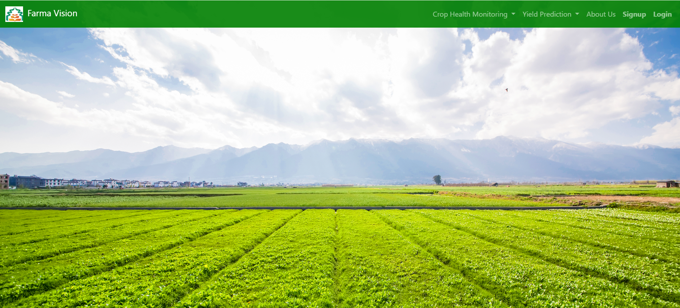

**Chapter 8**

# CONCLUSION

# The integration of computer vision with color image segmentation techniques in agriculture presents a transformative approach to enhancing agricultural productivity. As the global demand for food increases and the challenges of sustainable farming intensify, these technologies offer a powerful solution for modern agriculture. Through the use of high-resolution imaging, advanced segmentation algorithms, and machine learning models, computer vision enables precise monitoring and analysis of crops. This approach allows for real-time detection of diseases, accurate yield estimation, and optimized resource management, including irrigation, fertilization, and pesticide application. The automation and scalability provided by these technologies reduce the reliance on manual labor and improve the overall efficiency of agricultural operations. Through the use of high-resolution imaging, advanced segmentation algorithms, and machine learning models, computer vision enables precise monitoring and analysis of crops. This approach allows for real-time detection of diseases, accurate yield estimation, and optimized resource management, including irrigation, fertilization, and pesticide application. The automation and scalability provided by these technologies reduce the reliance on manual labor and improve the overall efficiency of agricultural operations.

# REFERENCES

[1] W. K. Mok, Y. X. Tan, and W. N. Chen, ‘‘Technology innovations for food security in Singapore: A case study of future food systems for an increasingly natural resource-scarce world,’’ Trends Food Sci. Technol., vol. 102, pp. 155–168, Aug. 2020, doi: 10.1016/J.TIFS.2020.06.013.

[2] Y. Liu, X. Ma, L. Shu, G. P. Hancke, and A. M. Abu-Mahfouz, ‘‘From industry 4.0 to agriculture 4.0: Current status, enabling technologies, and research challenges,’’ IEEE Trans. Ind. Informat., vol. 17, no. 6, pp. 4322–4334, Jun. 2021, doi: 10.1109/TII.2020.3003910.

[3] FAO, IFAD, UNICEF, WFP, and WHO, The State of Food Security and Nutrition in the World 2022, FAO, Rome, Italy, 2022, doi: 10.4060/cc0639en.

[4] The State of Food Security and Nutrition in the World 2023, FAO, Rome, Italy, Jul. 2023, doi: 10.4060/cc3017en.

[5] M. O. Ojo and A. Zahid, ‘‘Deep learning in controlled environment agriculture: A review of recent advancements, challenges and prospects,’’ Sensors, vol. 22, no. 20, p. 7965, Oct. 2022, doi: 10.3390/S22207965.

[6] T. Karanisa, Y. Achour, A. Ouammi, and S. Sayadi, ‘‘Smart greenhouses as the path towards precision agriculture in the food-energy and water nexus: Case study of Qatar,’’ Environ. Syst. Decis., vol. 42, no. 4, pp. 521–546, Dec. 2022, doi: 10.1007/S10669-022-09862-2.

[7] R. Rayhana, G. Xiao, and Z. Liu, ‘‘Internet of Things empowered smart greenhouse farming,’’ IEEE J. Radio Freq. Identificat., vol. 4, no. 3, pp. 195–211, Sep. 2020, doi:10.1109/JRFID.2020.2984391.

[8]A. J. Castro, M. D. López-Rodríguez, C. Giagnocavo, M. Gimenez, L. Céspedes, A. La Calle, M. Gallardo, P. Pumares, J. Cabello, E. Rodríguez, D. Uclés, S. Parra, J. Casas, F. Rodríguez, J. S. Fernandez-Prados, D. Alba-Patiño, M. Expósito-Granados, B. E. Murillo-López, L. M. Vasquez, and D. L. Valera, ‘‘Six collective challenges for sustainability of Almería greenhouse horticulture,’’ Int. J. Environ. Res. Public Health, vol. 16, no. 21, p. 4097, Oct. 2019, doi: 10.3390/IJERPH16214097.

[9] B. Yang and Y. Xu, ‘‘Applications of deep-learning approaches in horticultural research: A review,’’ Horticulture Res., vol. 8, no. 1, p. 123, Dec. 2021, doi: 10.1038/S41438-021-00560-

[10] V. G. Dhanya, A. Subeesh, N. L. Kushwaha, D. K. Vishwakarma, T. N. Kumar, G. Ritika, and A. N. Singh, ‘‘Deep learning based computer vision approaches for smart agricultural applications,’’ Artif. Intell. Agricult., vol. 6, pp. 211–229, Jan. 2022, doi: 10.1016/J.AIIA.2022.09.007.