The design problem:
I am to design a three-input, two-output sequential digital circuit which functions as a digital locking mechanism.

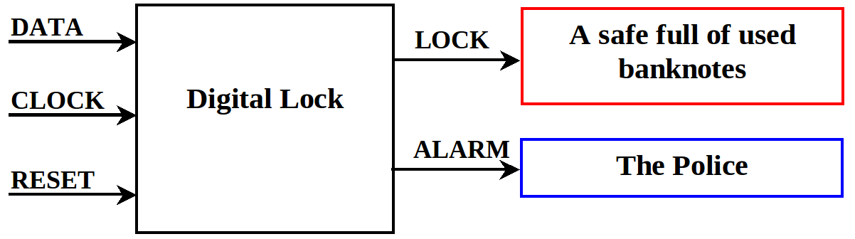

Logic level 0 on the LOCK output unlocks the safe and logic level 1 on the ALARM output calls the police. When logic level 1 appears on the RESET line then the mechanism is put into a know reset state. For logic 0 to appear on the LOCK line a correct sequence of digits must be entered, if an incorrect sequence is entered the logic 1 appears in the ALARM line after which, to reset, the RESET input becomes 1.

For the purposes of this problem, my unique number is 15 hence, by;

Binary Sequence = Binary Equivalent (1 + (15 mod 30))

my binary sequence is 10000, this binary sequence is the correct input sequence for my safe design.

From this I can create the following Moore state diagram:
Reset Input
(from any state)
S1
S2
Reset
S3
Open
S4
Alarm
0
1

1
0

1

0,1
0
0

1

1
1

0
0

1 on the RESET input takes the the finite state machine to the reset state from any state.

From this state diagram I can create a State Transition Table:

the three Karnaugh maps can now be generated, they are as follows:

using the minterms in the Karnaugh map we can get the minimisations of:

D2 = (DATA' · Q1' · Q0') + ( Q2 · Q1') + (DATA · Q0) + (Q1 · Q0) + (DATA · Q1)

D1 = (DATA' · Q1') + ( DATA · Q2) + (Q2 · Q0) + (DATA · Q0) + (Q2' · Q1 · Q0')

D3 = (Q2' · Q0') + (DATA · Q1') + (DATA · Q2') + (Q2 · Q0)

These minimisations can, however, be factorised to both reduce the number of logic gates and area of silicon used. These factorisations are:

D2 = Q1' · ((DATA' · Q0') + Q2) + DATA · (Q0 + Q1) + (Q1· Q0)

D1 = DATA · (Q2 +Q0) + (DATA' · Q1') + (Q2 · Q0) + (Q2' · Q1 · Q0')

D0 = Q2' · (Q0' + DATA) + (DATA · Q1') + (Q2 · Q0)

these give me the inputs to my 3 D-Q flip-flops. With this information I can now generate my circuit. The NAND gate, of Q1, Q2 and Q3', to the LOCK and AND gate, of Q1, Q2 and Q3, to the ALARM outputs have been acquired by by observing that my open state is 110 and my alarm state is 111. Also, my three D-Q flip-flops have been set clear as my reset state is 000.

The wiring design below displays my solution, its total area of silicon used is:

Below is, also, a zoomed in version of the waveform, depicting the only time at which the lock opens, as well as the entire waveform throughout the whole simulation.

However this size could be reduced using De Morgan's theorem, this would produce another circuit also shown below.

