Architecture Coursework

1i) By adding IR₆₋₁₅ to the inputs to M₂ and adding another control signal C₅, also to M₂, the two control signals C₂ and C₅ to select which inputs to use for the Register File. This would look like the following:

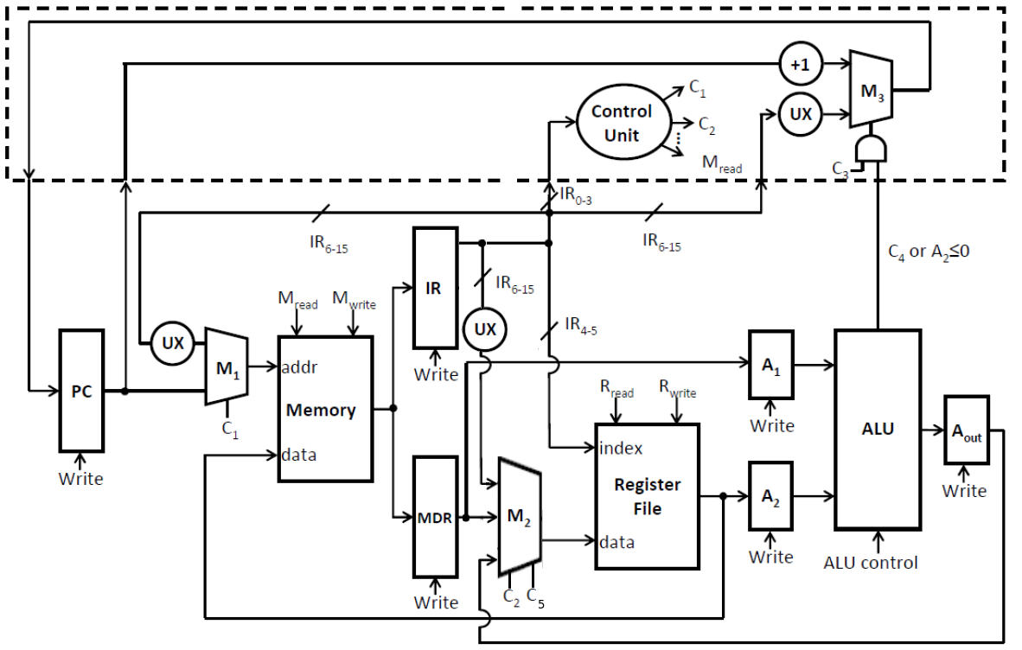
therefore the outputs from M₂ would be based on the C₂ and C₅ would be the following:

C₂ | C₅ | M₂ Output
0 | 0 | MDR output
0 | 1 | IR₆₋₁₅
1 | 0 | A_{out} output
1 | 1 | unused

- The registers and control signals that would be used in the LOADI instruction are:
Step 1:
PCwrite:
C₁:
M_{read}:
IR_{write}:
IR:

Step 2:
C₂:
C₅:
IR_{write}:

iii) the new state diagram, after these alterations, would look as such:
Mread
IR Write
PC Write
C1=1, C3 = 0
0

1
4
2
5
Mread
MDR
C1=0
PCwrite
C3 = 1
C4 = 1
Rwrite
C2 = 0
C5 = 1
Mread
MDR write

3
6
Rwrite
C2 = 0
Rread
A1 write
A2 write

7
Aout Write
ALU control = 0

8
Rwrite
C2 = 1

2i) The “+1” unit can be remove by adding 2 new multiplexers, say M₄ and M₅, which lead into the ALU, into M₄ would lead the PC output and the output of the A₁ register and into M₅ would be an input which was fixed as one, this is hard coded, and the output from the A₂ register. Both of these new multiplexers would use a single control signal C₆ which would determine whether to use the PC output and the 1 input or A₁ and A₂ outputs. The output from the ALU would then go into the A_{out} register and then the output from this register into M₃. If we wish to then increment the PC, we do this by setting C₆ to 0, so the ALU inputs are 1 and the current PC value, and using the ALU control signal so it adds the values together, STUFF GOES HERE ABOUT C4 AND C3 AND PC WRITE, so the output from M₃ into the PC is the original PC value +1. The following set-up would look as such:

CHANGE THE IMAGE
