Architecture Coursework

1i) To access and use a constant stored in bit 6 to 15 of the instruction, assuming that the constant is unsigned, this can be done by adding IR₆₋₁₅, after having being increased to 16 bits using a UX unit, to the inputs to M₂ and adding another control signal C₅, also to M₂, using the two control signals C₂ and C₅ to select which inputs to use for the Register File data input. These changes are displayed in figure 1. Therefore to use the LOADI instruction we would first read the instruction into Memory and we would set C₂ = 0 and C₅ = 1 and R_{write}, to read the 16 constant into the Register File.

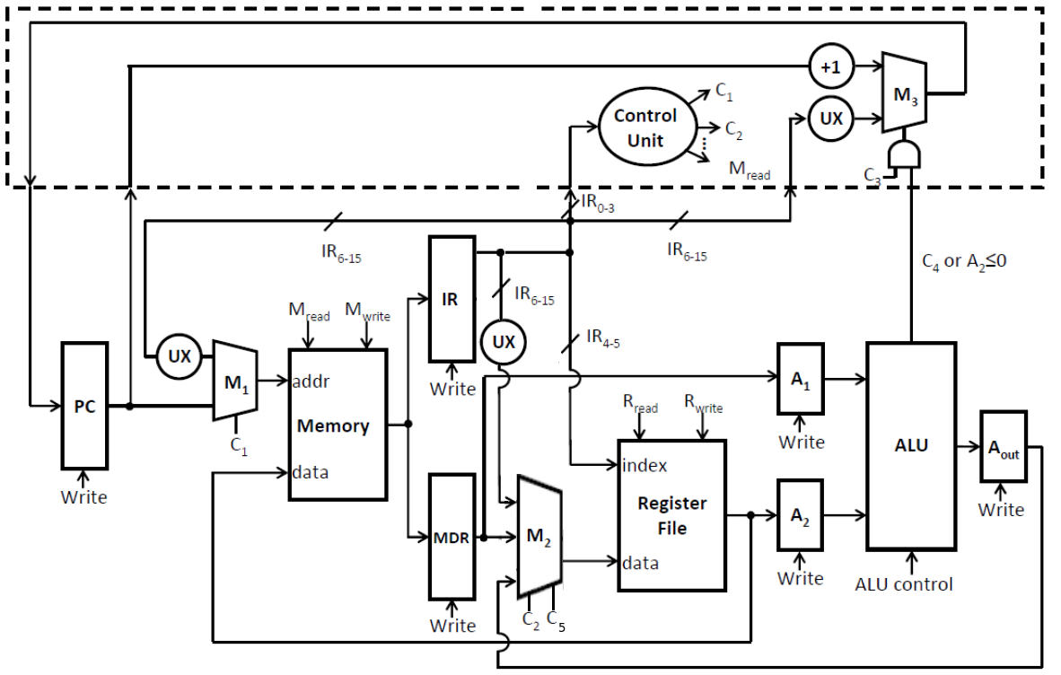
figure 1

The outputs from M₂ would be based on the C₂ and C₅ would be the following:
C₂ | C₅ | M₂ Output
0 | 0 | MDR output
0 | 1 | IR₆₋₁₅
1 | 0 | A_{out} output
1 | 1 | unused

- The registers and control signals that would be used in the LOADI instruction are:
PCwrite: set PCwrite so that the instruction can be written into the PC
C₁: set to 1 so that the address stored in the PC is used as the Memory address input
C₃: set to 0 so that the PC value is incremented
M_{read}: set M_{read} so that an instruction can be read from memory a loaded into the IR
IR_{write}: set IR_{write}, so that the instruction can be written into the IR
IR_{write}: set IR_{write} so that a value can be written into the IR
IR: the instruction from memory, that is to be used containing the constant, is loaded into the IR so that it may be used
C₂: set to 0 so that the constant from the instruction is selected using the multiplexer and used as the data input in the Register File.
C₅: set to 1 , and used in the same way as C₂
iii) the new state diagram, after these alterations, would involve adding a new branch to incorporate the LOADI instruction opcode as well as altering any branches which involve M₂. This is shown in figure 2.
Mread
IR Write
PC Write
C1=1, C3 = 0
0

Opcode
= add
Opcode = goto
Opcode
= loadi
1
2
Opcode
= load
4
5
Mread
MDR write
C1=0
PCwrite
C3 = 1
C4 = 1
Rwrite
C2 = 0
C5 = 1
Mread
MDR write

3
6
Rwrite
C2 = 0
C5 =0
Rread
A1 write
A2 write

7
Aout Write
ALU control = 0

8
Rwrite
C2 = 1
C5 = 0

figure 2

2i) The “+1” unit can be remove by adding 2 new multiplexers, say M₄ and M₅, M₄ would have inputs of an input of 1, which has been put converted to a 16 representation of 1 using a UX unit, and the MDR output. M₄ would then lead into the A₁ register. M₅ would have the inputs of the current value stored in the PC and, also, the output from the register file, it's output wire will lead into A₂. The two multiplexers will share a control signal, say C₆, which will select whether you want to use the PC value and 1 or the MDR and register file outputs, we can the set the ALU to add the PC and 1, by setting the ALU control to 0, and output this to A_{out}. The output from A_{out} will then lead into M₃, and M₂ as it originally did, and we can use C₃ and PC write to write a the new, incremented value, into the PC. The following changes to the original TOY1 architecture are displayed in figure 3.
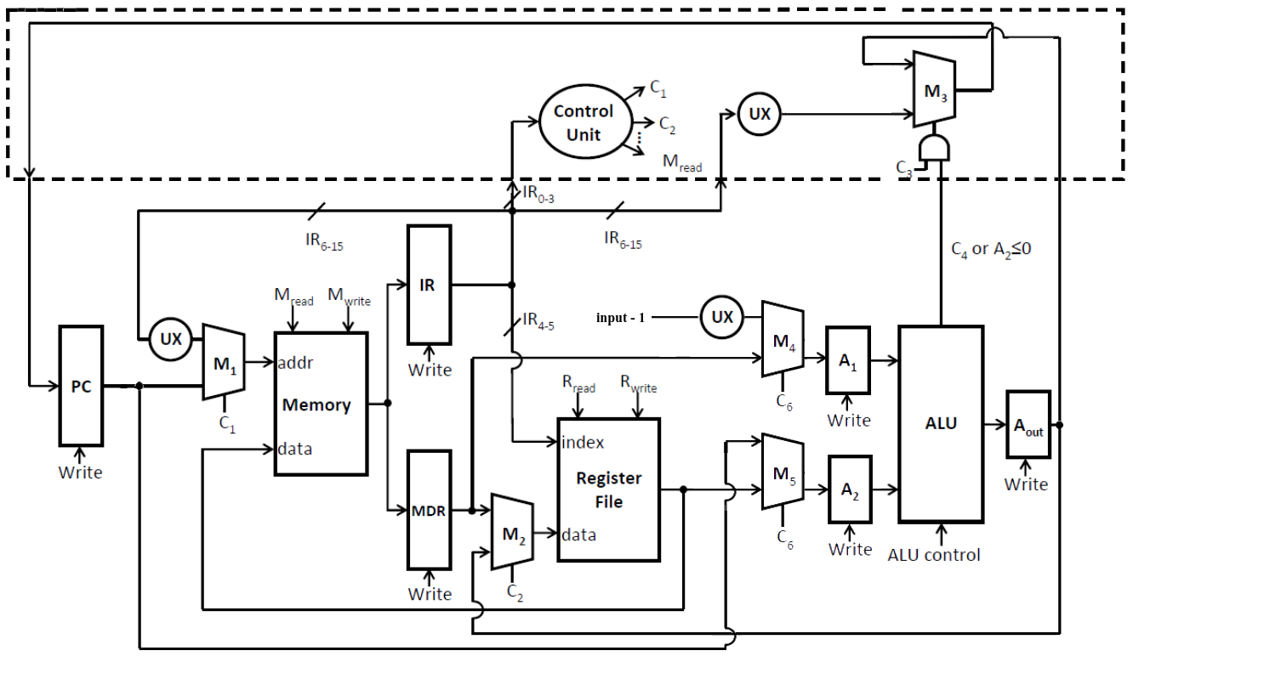
figure 3

2ii) The registers and control signals, now, used in the load instruction are:

PC: used to store the address of the next instruction
C₁: set to 1 so that the address from the PC is used as the input address in the memory unit to load the instruction from a specified location in memory
Mread: Allow and instruction to be read from memory and loaded into the IR
IRwrite: Allow the instruction to be written to the IR
IR: Store the current instruction which has been loaded from Memory

Mread: set so that the data can be read from the specified address in memory to load the data needed
MDRwrite: set so that data may be written to the MDR
MDR: store the data that is loaded, and needed, by the instruction
C₁: set to 0 so that the address is read from current instruction that contains the address of the data needed for the instruction

Rwrite: set so that data, and index, may be written to the Register File
C₂: set to 0 so that the data is loaded from the MDR

A₁write: set so that 1 may be loaded into the A₁ register
A₁: contains the value of 1
A₂write: set so that current PC address may be loaded into A₂
A₂: contains the current address in the PC
A_{out}write: Set so that a value may be written to A_{out}
A_{out}: Holds the incremented value of the PC, i.e. the next address
ALU control: set to 0 so that it adds the current PC address and 1
C₆: set to 0 so that 1 is loaded into A₁ and the current PC address into A₂

Pcwrite: set so that the new address may be written to the PC
C₃: set to 0 so that the incremented PC value is written to the PC

CHECK THIS!!!!

