|  |
| --- |
|  |
| User Documentation |
|  |
|  |
|  |
|  |

|  |
| --- |
|  |

This document is available by clicking Help hyperlink on the Topic Selection Screen:

# – Installation

# – Instructions

## – Starting the game

## – Playing the Game

The objective of the game is to answer as many questions correctly as possibly, once you select a topic you will be asked 5 questions based on that topic, after you have answered each question you will be told whether you have answer right or wrong. Once you have answered 5 questions you will then be told your scored, based upon how many answers you got right, the more correct answers you get, the higher the score. After this you are free to select the same or another topic.

### 2.2.1 – Welcome Screen

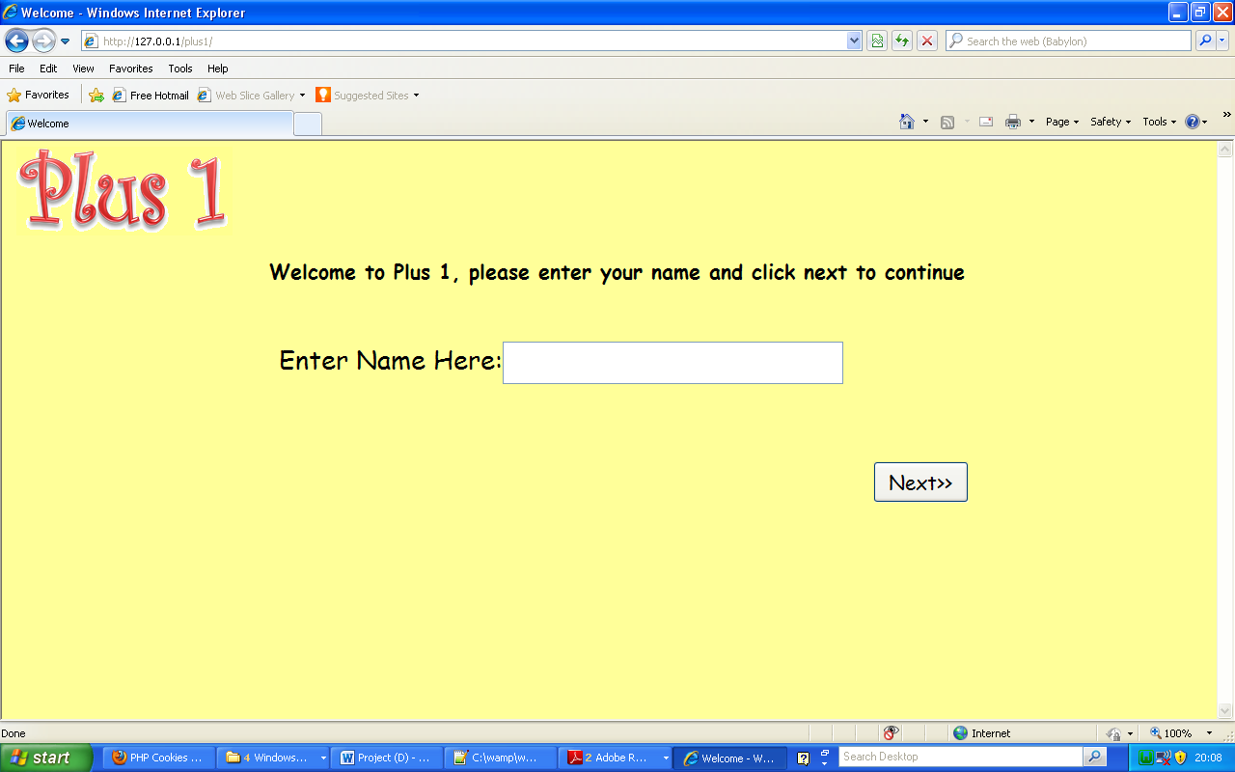When you begin the Plus 1 game, the initial screen that you are presented with should look as such:

The marked areas on the page can be interacted with

1. This is the input box where you can enter your name
2. Once you have entered your name, you can click next to start the game and select a topic

### 2.2.2 – Topic Selection Screen

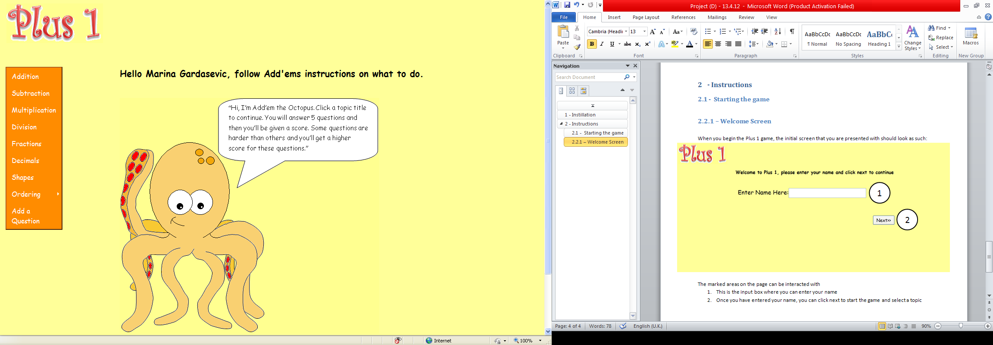Once you have entered your name and clicked next, you will be presented with the topic selection screen where you can select which topic you wish to play through in the game.

1. This menu allows you to select which topic to play through, click on any of the topic titles to begin the game, i.e. start the questions
2. This is Add’em the Octopus, he will be used to guide you through the game and give you help
3. The ‘Add a question’ button allows teachers to add a question to the database of stored questions

### 2.2.3 – Question Screen

Once you have selected a topic you will be presented with a screen that will look similar to this:

1. 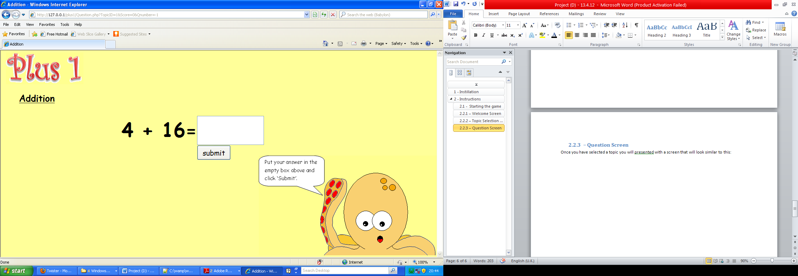Here, the title of the topic that you are currently playing through will be presented, this is mostly to confirm you’re choice of topic
2. The question that you are currently trying to answer will be displayed here and it will be relevant to your chosen topic
3. In this text box is where you should place your answer to the question, you can type the answer using the keyboard
4. Once you have given an answer, click the ‘submit’ button to submit your answer and move on to the Answer Screen
5. Again, Add’em will provide additional aid if you are unsure of what to do

### 2.2.4 – Answer Screen

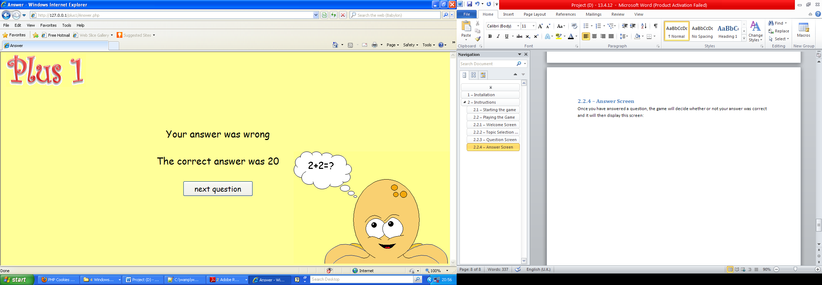Once you have answered a question, the game will decide whether or not your answer was correct and it will then display this screen:

1. You will be told whether your answer to the question was right or wrong, in this case the answer was wrong
2. You will also be told the correct answer to the question also
3. To move on to the next question click ‘next question

### 2.2.5 – Score Screen

Once you have answered 5 questions and have clicked ‘next question’ instead of being asked another question, you will be presented with the score that you have achieved for the past 5 questions.

1. 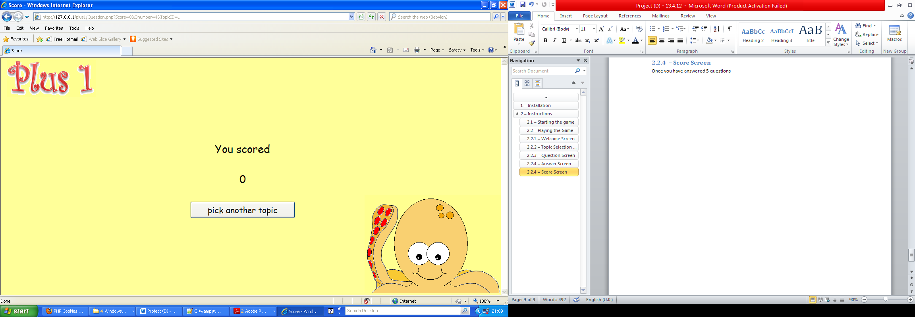The value here will be your score from the 5 questions you have answered
2. Clicking ‘pick another topic’ will return you to the topic selection screen where you can play the game again but with another, or the same, topic

## – Adding Questions

This sections is to aid teachers in adding questions to the database of questions, it is intended solely for the use of teachers. It will explain the login and Add questions sections.

### 2.3.1 – Topic Selection Screen

On the Topic Selection Screen, on the topic menu, there is a link to the Add Question page called ‘Add a Question’

1. By clicking on this link you will be taken to the add question login page

### 2.3.2 – Login Screen

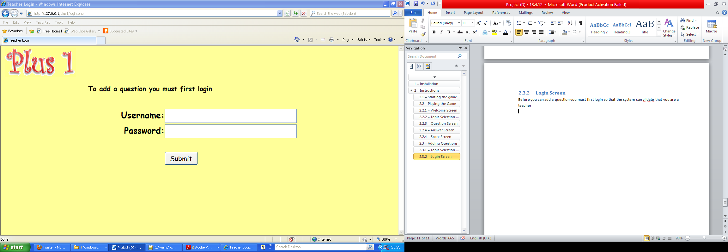Before you can add a question you must first login so that the system can validate that you are allowed to add a question

1. Here you may enter the username, the username is ‘teacher1’
2. You may also enter the password below the username, the password is ‘password’ this is case sensitive so ensure that it is entered correctly
3. Once you have entered both username and password click ‘Submit’ to progress

### 2.3.3 – Add Question Screen

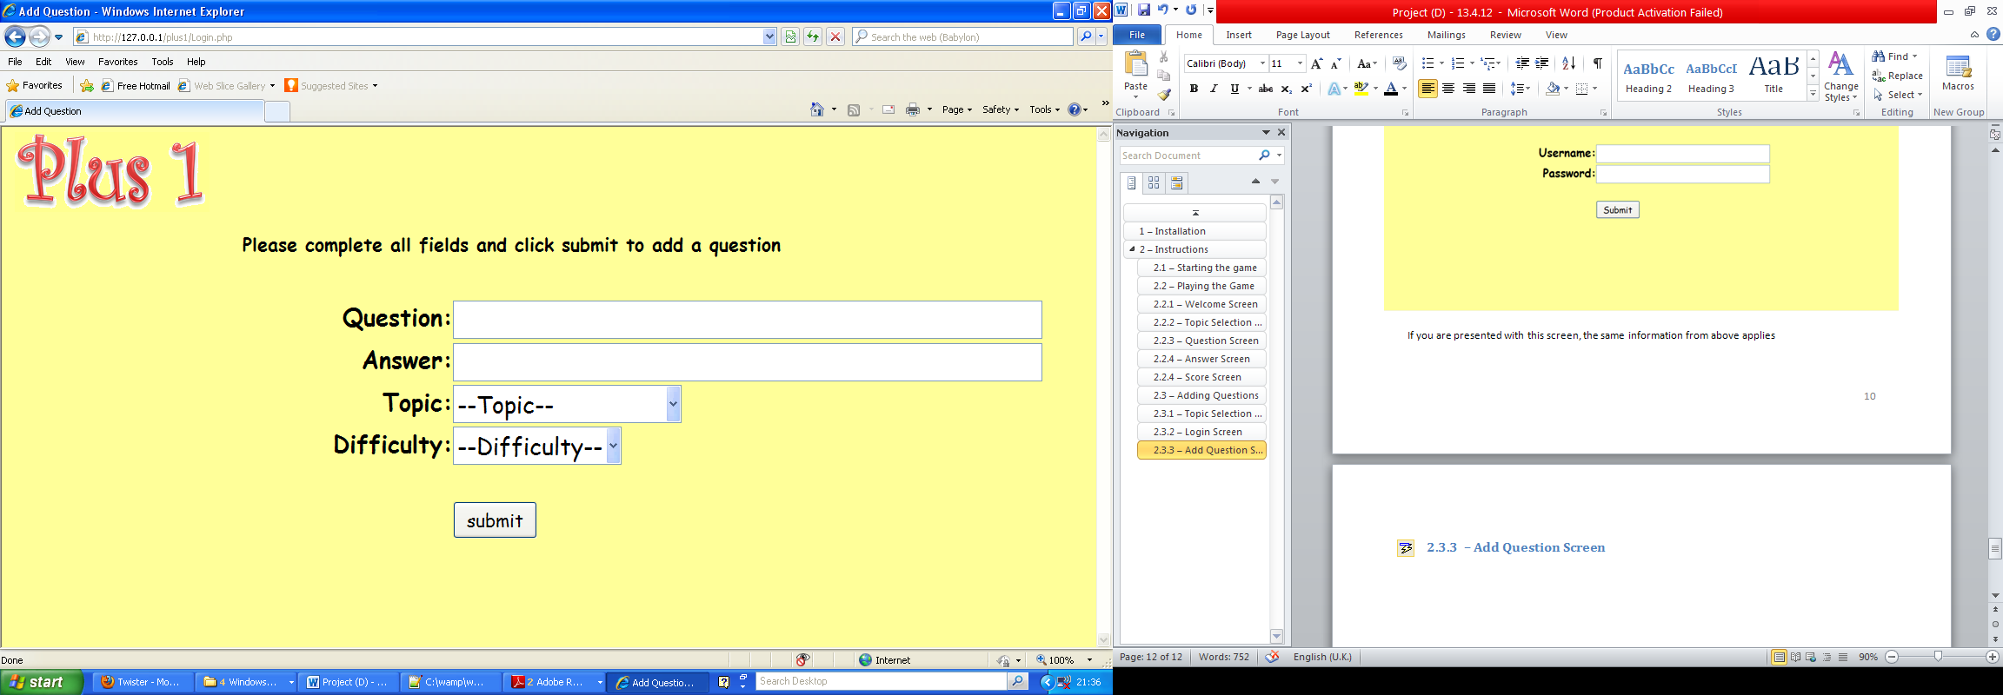Once you have logged in you will be presented with this screen:

1. You can enter you question into the question field using the keyboard
2. You can enter the answer to the question into the answer field using the keyboard, check these two fields carefully as they will not be check for correctness
3. You can select the relevant topic for the question from the drop down list
4. You can select a difficulty for the question, where 1 is the easiest and 5 the hardest, which will be associated with the question
5. Once all the fields are complete you may click ‘submit’ to add the question to the database

### 2.3.4 – Confirmation Screen

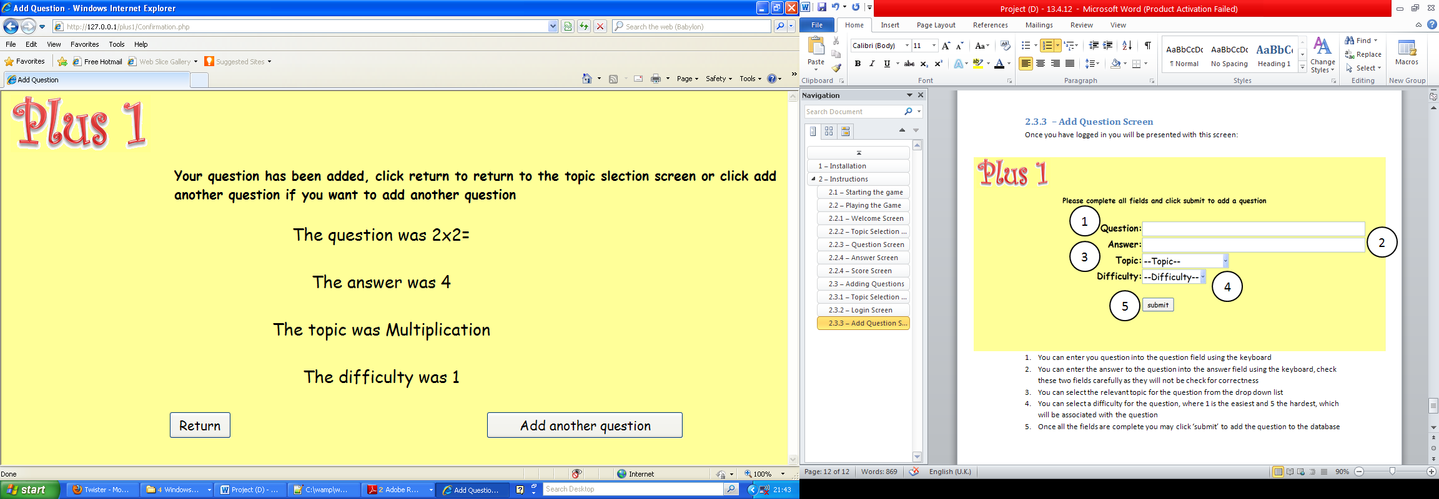Once you have submitted your question you will be presented with a confirmation screen which will display all of the data that you have entered, it will then allow you to either return to the topic selection screen or add another question.

1. The data about the question that you have just entered will be shown back to you on the confirmation page to ensure that it is correct and that it is the same data tat you have entered
2. The ‘Return’ button will return you to the Topic Selection Screen and the ‘Add another question’ button will allow you to add another question in the same manner as before

# – Troubleshooting

## – Error Messages

There are multiple pages in the game where error messages will appear, here they will explained.

### – Welcome Screen

On the Welcome Screen the following error message may occur

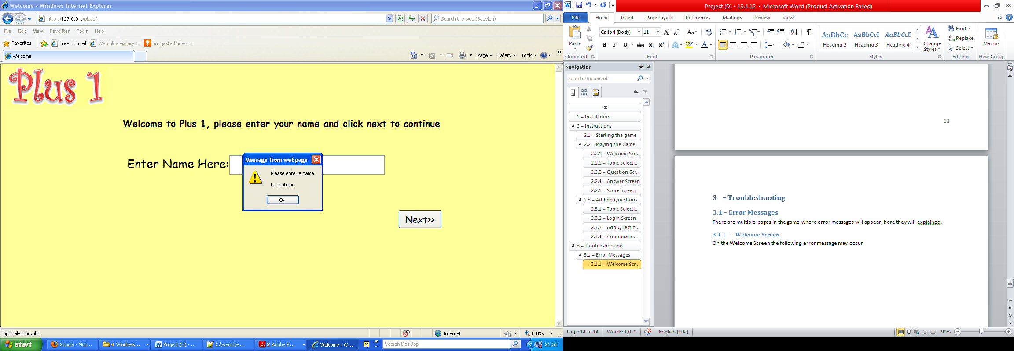

This has occurred due the fact that a name has name has not been entered into the name field before clicking next, to resolve the issue simply click ok and then enter a name and click submit

### – Login Screen

On the login screen the following error message may occur:

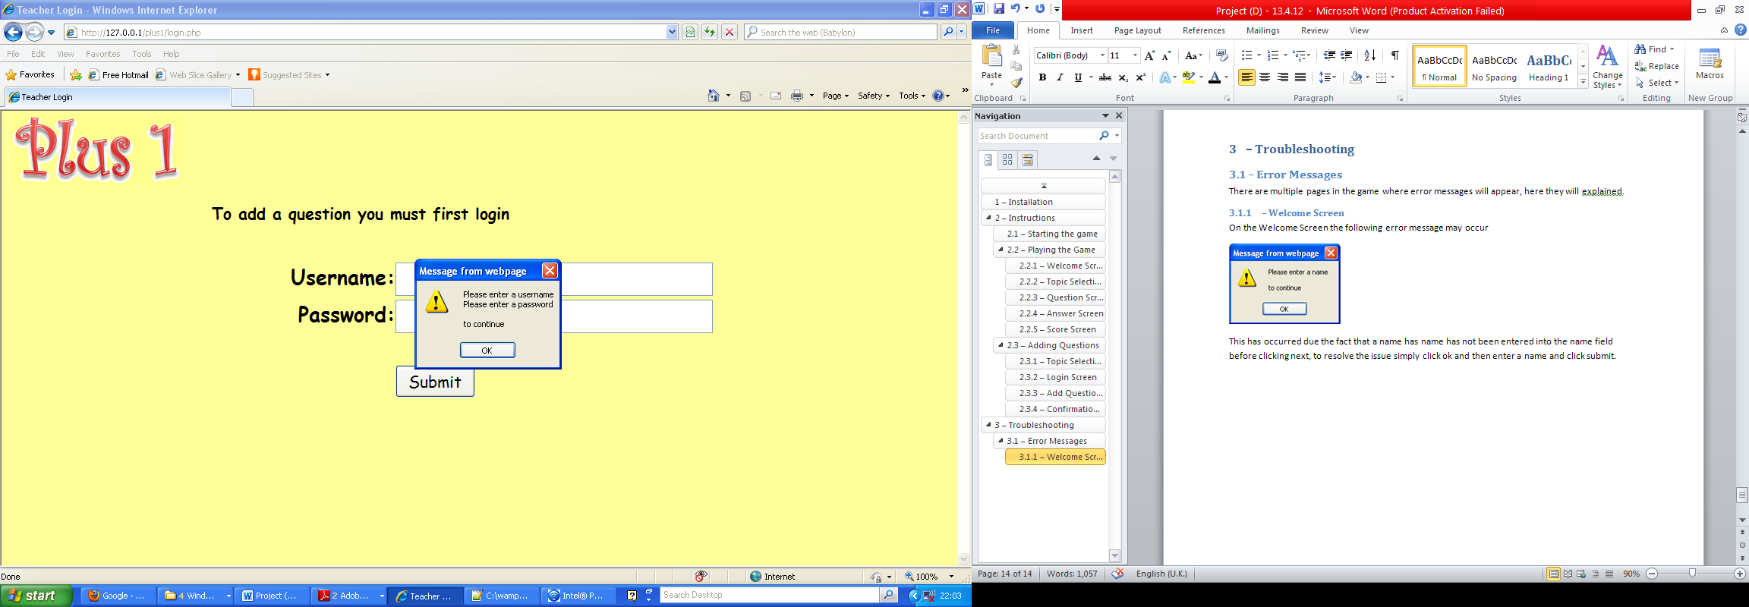

This occurs if both the username and password fields have been left blank before clicking submit, if only one field has been left blank then this will be indicated by the error message will inform you that only one field needs to be filled in. The error can be solved by entering data into the Username and Password fields before clicking submit

If you entered an invalid username and password you will be presented with this screen:

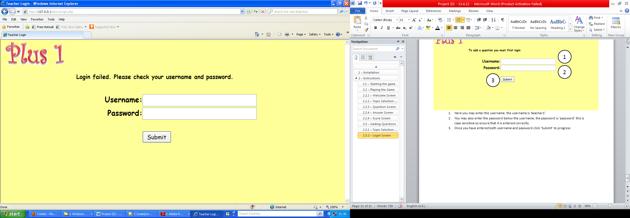

### – Add Question Screen

On the Add Question screen, variations on the below error message may occur:

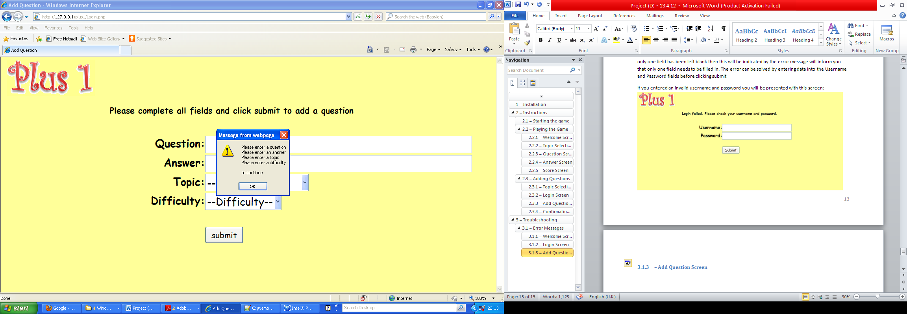

This is caused by a lack of data in the relevant field, to resolve this simply input data into the relevant field(s)

The below error message may also appear, again with variation:

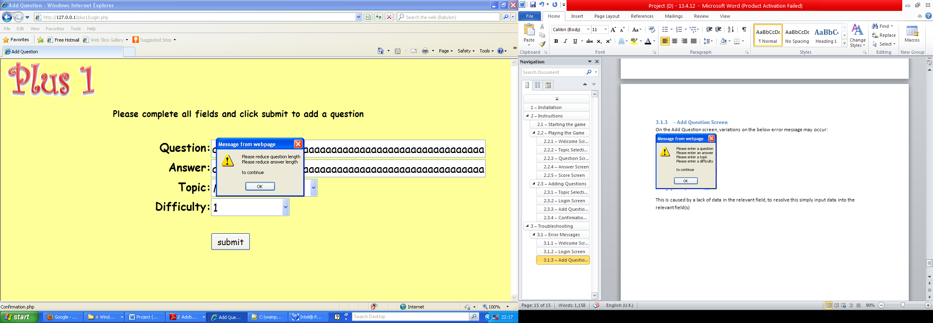

This is due to a question and/or answer being too long to be entered, to resolve the issue try to shorten data in the relevant field

# – Glossary