ELEN 100L (Electric Circuits II): Project 2 Tutorial
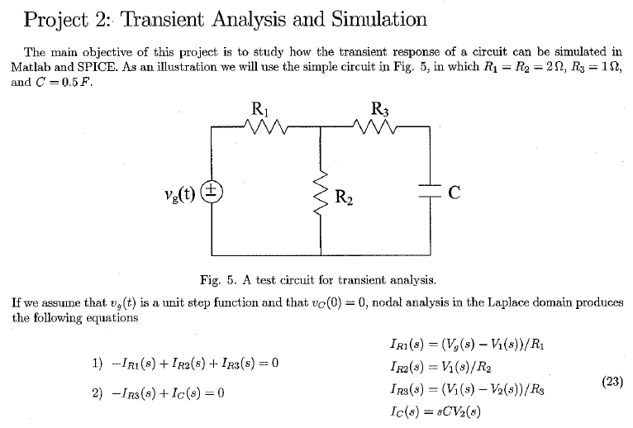
Hard Copy Deliverables:
- Hard copy for hand calculations.
- A MATLAB script and publish the solution using MATLAB's publish feature.
- Turn in MATLAB scripts and a document of the run-time results.
- Turn in oscilloscope images of the measured results.
Soft Copy Deliverables:
- Turn in all MATLAB files.
- Turn in all LTSpice files.
- Turn in all oscilloscope images of the measured results.
Initialize MATLAB Environment 2
Setup global variables 2
Problem 2 3
Problem 3 5
Program execution complete 10
MATLAB code listing 10

Initialize MATLAB Environment
clear; clc; clf; cla; close all;
format long; format compact;

Setup global variables
% These Ideal Design element values are fixed in the circuit.
VG = 1; % Generator voltage
R1_ideal = 2.0; % Ohms
R2_ideal = 2.0; % Ohms
R3_ideal = 1.0; % Ohms
C1_ideal = 0.5; % Farads
% Build an array for the R elements.
R_ideal = [R1_ideal, R2_ideal, R3_ideal];
% Build an array for the C elements.
C_ideal = [(0), (0), (0) ; ...
(0), (0), (0) ; ...
(0), (0), -(C1_ideal)];
% Build an array for the source elements.
B = [VG; 0; 0];
% Build an array for the the time vector.
time = [0, 5];
% Build an array for the the initial conditions.
x0 = [0; 0; 0]; % Assume everything is zero to start
% These values are used for plotting purposes.
fignum = 1;
plot_left = 0; plot_right = time(2); % x-axis range (seconds)
plot_bottom = 0; plot_top = VG+0.1; % y-axis range (volts)

Problem 2
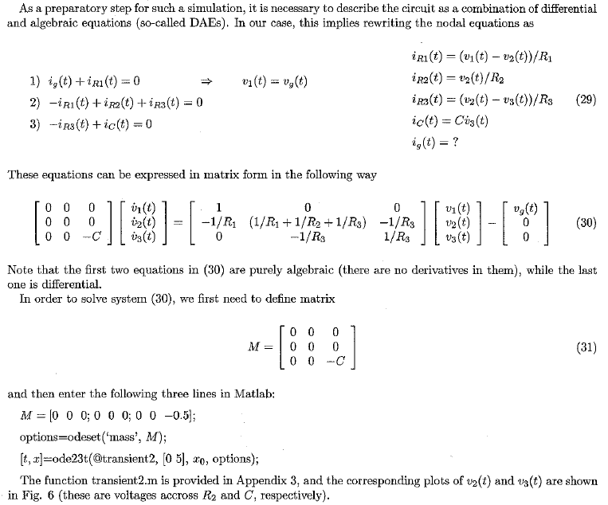
fignum = fignum+1;
Display the component values for the Ideal design.
display(' ');
display('The Ideal Design component values are:');
fprintf(' R1 = %+11.4f Ohms.\n', R1_ideal);
fprintf(' R2 = %+11.4f Ohms.\n', R2_ideal);
fprintf(' R3 = %+11.4f Ohms.\n', R3_ideal);
fprintf(' C1 = %+11.4e Farads.\n', C1_ideal);
The Ideal Design component values are:
R1 = +2.0000 Ohms.
R2 = +2.0000 Ohms.
R3 = +1.0000 Ohms.
C1 = +5.0000e-01 Farads.
Calculate the transient response for the Ideal design.
% Update the resistor variables used in the proj2E100_transient function
% before calling the ode23t solver.
R1_circuit = R1_ideal;
R2_circuit = R2_ideal;
R3_circuit = R3_ideal;
options = odeset('mass', C_ideal, 'RelTol', 0.1e-9);
[t, x] = ode23t(@proj2E100_transient, time, x0, options);
% Capture a voltage point with index.
v3_point_of_interest = 400e-3; % This particular value is chosen only for
% plot annotation illustration purposes.
v3_shifted_mag = abs( x(:,3) - v3_point_of_interest );
v3_point_of_interest_index = ...
find( min( v3_shifted_mag ) == v3_shifted_mag );
v3_point_of_interest = x(v3_point_of_interest_index, 3);
% Capture the time stamp at voltage point of interest.
t_point_of_interest = t(v3_point_of_interest_index);
Generate the plot for the transient response.
fignum = 5; % Bump the figure number to match tutorial documentation.
fignum = fignum+1; figObj = figure(fignum); % Establish a figure number
set(fignum, 'Name', ...
['Transient Response Ideal Design']); % Name the figure
Tr_ideal_Plot = plot(t, x); % Generate plot
grid on; % Turn grid on
xlabel('Time (seconds)'); % Label the x-axis
ylabel('Amplitude (volts)'); % Label the y-axis
axis([plot_left, plot_right, ...
plot_bottom, plot_top]); % Bound plot
title(['Figure ',num2str(fignum,'%-2.u'),...
': Transient Response']);
legend('v_1(t)', 'v_2(t)', 'v_3(t)', 'Location', 'NorthEast');
% Add annotation to the plot.
str_curs = ['\leftarrow ', num2str(t_point_of_interest), 's, ', ...
num2str(v3_point_of_interest),'V'];
text(t_point_of_interest, ...
v3_point_of_interest, ...
str_curs, 'HorizontalAlignment', 'left', 'FontWeight', 'bold');
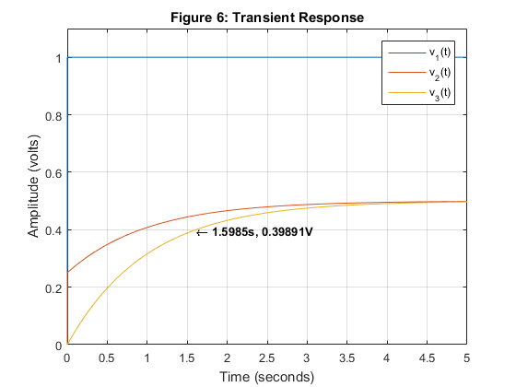
Display the MATLAB point of interest values for the Ideal design.
display(' ');
display('The MATLAB point of interest values are:');
fprintf(' V3 p.o.i. = %+11.4f Volts.\n', v3_point_of_interest);
fprintf(' t p.o.i. = %+11.4f seconds.\n', t_point_of_interest);
The MATLAB point of interest values are:
V3 p.o.i. = +0.3989 Volts.
t p.o.i. = +1.5985 seconds.

Problem 3
fignum = fignum+1;
The LTSpice model for the circuit is shown below.
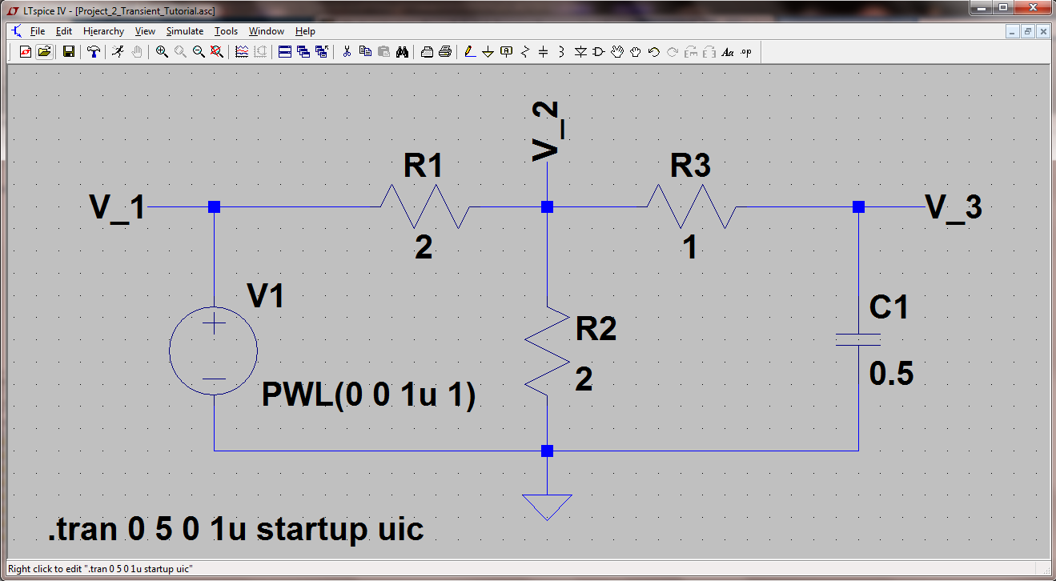
fignum = fignum+1;
The LTSpice model voltage source setup, to correlate with the MATLAB unit step function definition in Appendix #3, is shown below.
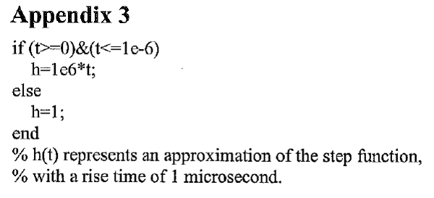
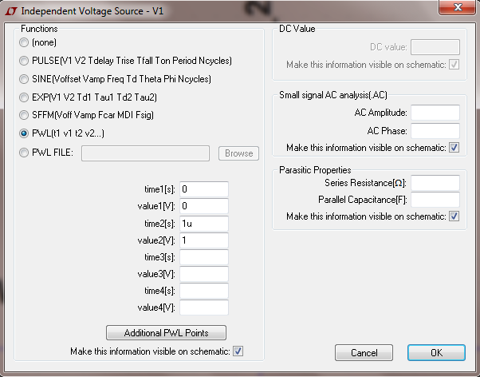
fignum = fignum+2;
The LTSpice model transient analysis simulation setup is shown below.
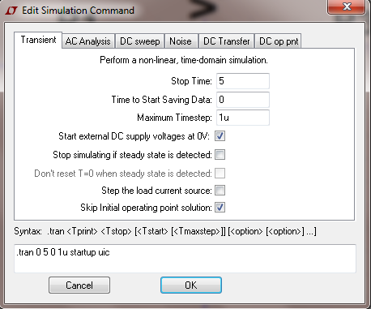
fignum = fignum+1;
The LTSpice model for the simulation result is shown below.
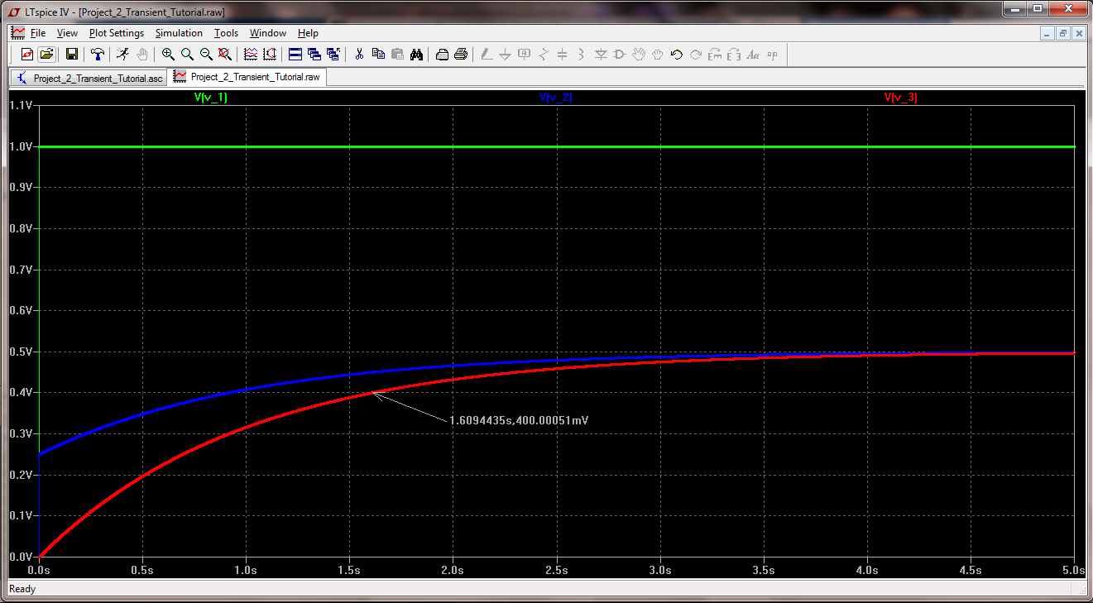
fignum = fignum+1;
% Capture point of interest voltage from the plot.
ltspice_v3_point_of_interest = 400.00051e-3;
% Capture point of interest time stamp from the plot.
ltspice_t_point_of_interest = 1.6094435;
Display the LTSpice voltage point of interest values for the Ideal design.
display(' ');
display('The LTSpice point of interest values are:');
fprintf(' V3 p.o.i. = %+11.4f Volts.\n', ...
ltspice_v3_point_of_interest);
fprintf(' t p.o.i. = %+11.4f seconds.\n', ...
ltspice_t_point_of_interest);
The LTSpice point of interest values are:
V3 p.o.i. = +0.4000 Volts.
t p.o.i. = +1.6094 seconds.
Calculate the percent difference at the point of interest values between MATLAB and LTSpice Ideal Designs.
diff_ideal_v3_point_of_interest = ...
(ltspice_v3_point_of_interest - v3_point_of_interest) ...
/abs(v3_point_of_interest)*100;
diff_ideal_t_point_of_interest = ...
(ltspice_t_point_of_interest - t_point_of_interest) ...
/abs(t_point_of_interest)*100;
display(' ');
display('The % difference between MATLAB and LTSpice at');
display('the point of interest:');
fprintf(' MATLAB V3 p.o.i. = %+11.4f Volts.\n', ...
v3_point_of_interest);
fprintf(' LTSpice V3 p.o.i. = %+11.4f Volts.\n', ...
ltspice_v3_point_of_interest);
fprintf(' %% diff = %+8.4f (%%).\n', ...
diff_ideal_v3_point_of_interest);
fprintf(' MATLAB t p.o.i. = %+11.4f seconds.\n', ...
t_point_of_interest);
fprintf(' LTSpice t p.o.i. = %+11.4f seconds.\n', ...
ltspice_t_point_of_interest);
fprintf(' %% diff = %+8.4f (%%).\n', ...
diff_ideal_t_point_of_interest);
The % difference between MATLAB and LTSpice at
the point of interest:
MATLAB V3 p.o.i. = +0.3989 Volts.
LTSpice V3 p.o.i. = +0.4000 Volts.
% diff = +0.2746 (%).
MATLAB t p.o.i. = +1.5985 seconds.
LTSpice t p.o.i. = +1.6094 seconds.
% diff = +0.6864 (%).

Program execution complete
display(' ');
disp('Program execution complete....');
Program execution complete....

MATLAB code listing
Published with MATLAB® R2015b

