Analysis of the Social and Political Factors for Success/Failure in Tackling the Covid-19 Pandemic

## Introduction

## Justification:

## The Results:

## Table

|  |  |  |  |  |
| --- | --- | --- | --- | --- |
| Variable | Name of the Relevant MCT | Value of the MCT | Name of the Relevant MD | Value of the MD |
| Total Deaths Per Million | Continuous | 140.40 | variance and/or standard deviation | 209.88 |
| GDP Per Capita | Continuous | 14910.69 | variance and/or standard deviation | 16071.77 |
| Female Head of Government | Nominal | 0 (Male) = 107 1 (Female) = 9 | proportion in each category | 0 (Male) = 0.92 1 (Female) = 0.08 |
| V-Dem Polyarchy | Continuous | 0.56 | variance and/or standard deviation | 0.22 |

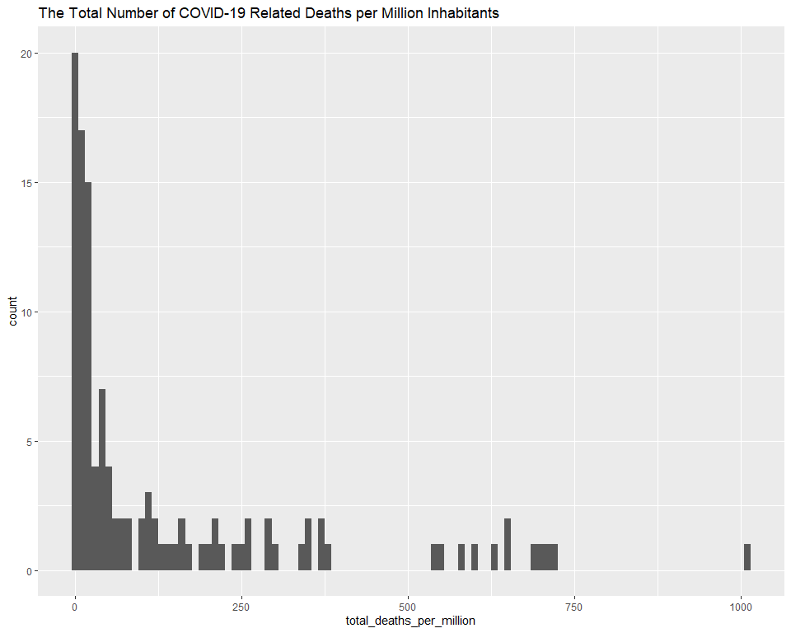

## `stat_bin()` using `bins = 30`. Pick better value with `binwidth`.

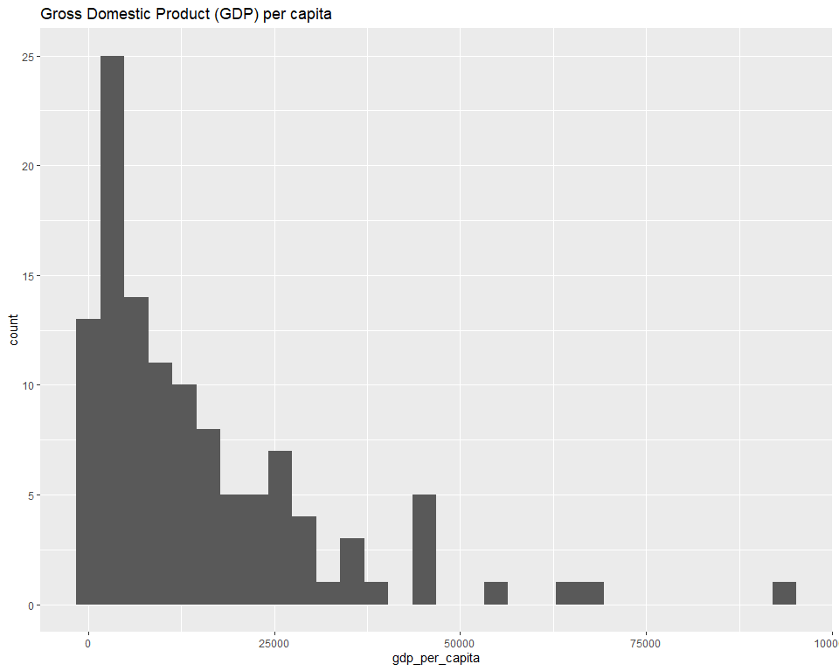

## mapping: label = ~location   
## geom_text: parse = FALSE, check_overlap = FALSE, na.rm = FALSE  
## stat_identity: na.rm = FALSE  
## position_identity

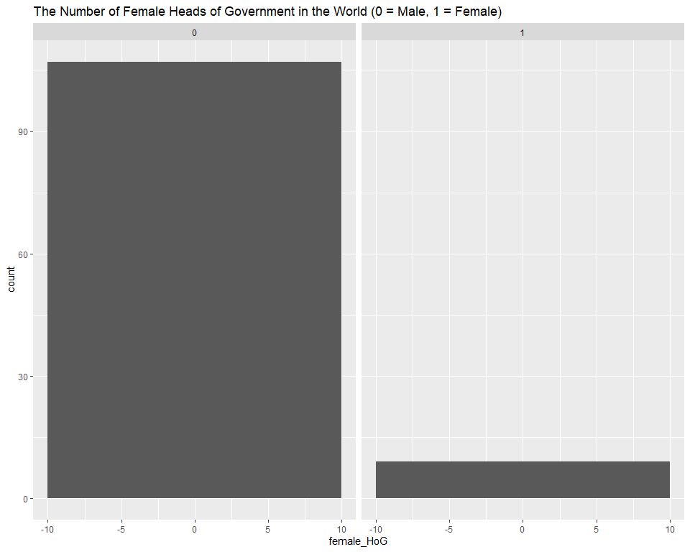

## `stat_bin()` using `bins = 30`. Pick better value with `binwidth`.

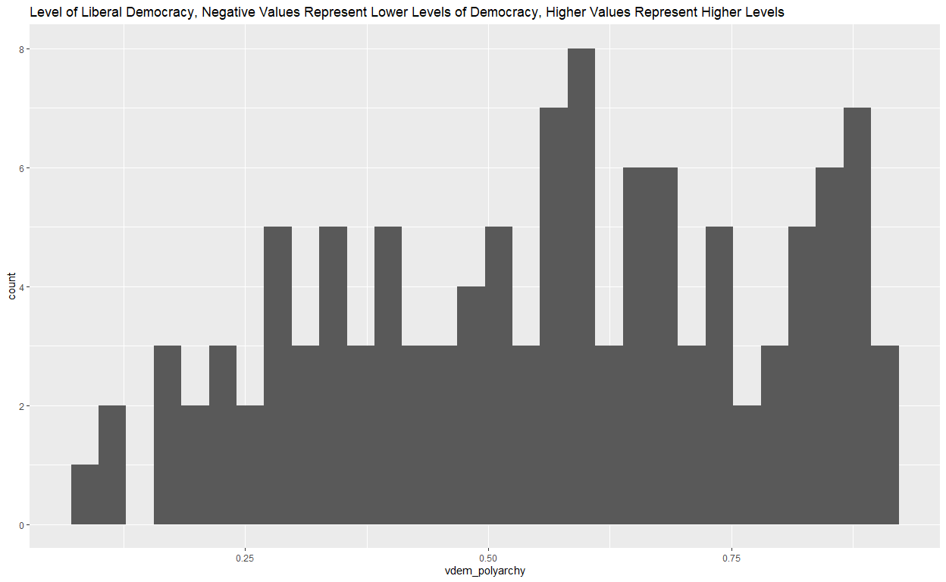

## `stat_bin()` using `bins = 30`. Pick better value with `binwidth`.

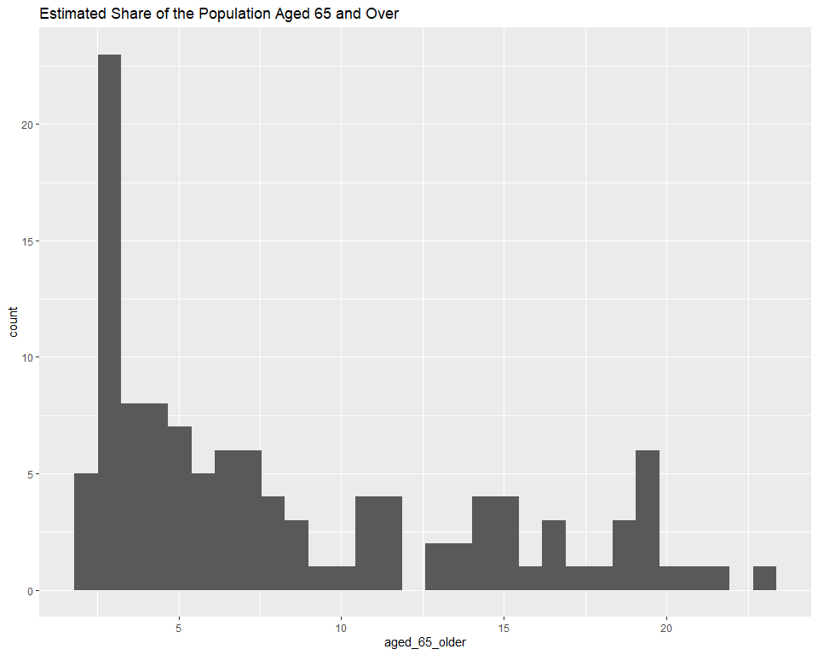

#### Richer Countries do better than Poorer countries.

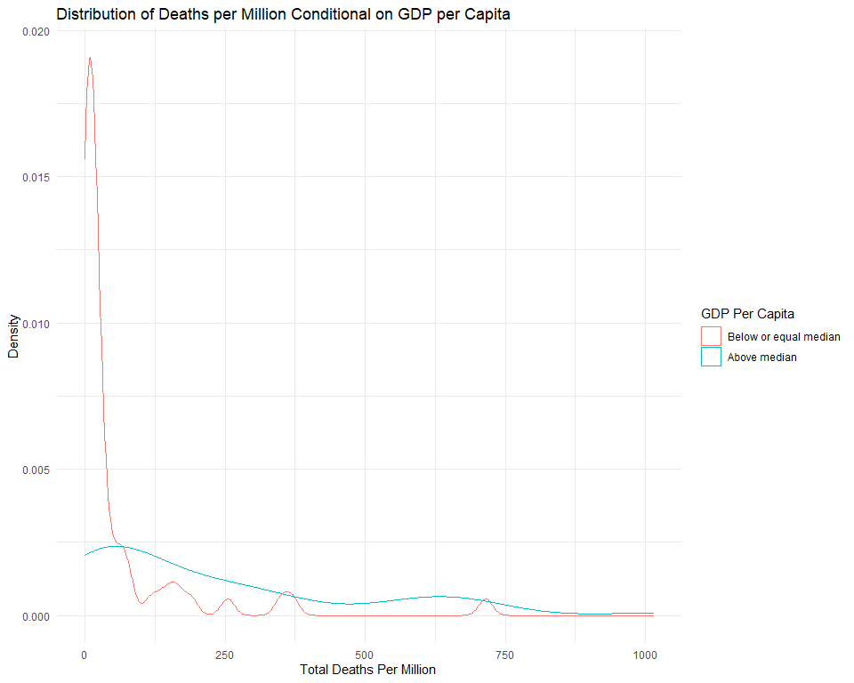

#### Countries led by women are more successful than those led by men.

#### The success in dealing with the pandemic is related to the proportion of older people living in the country.

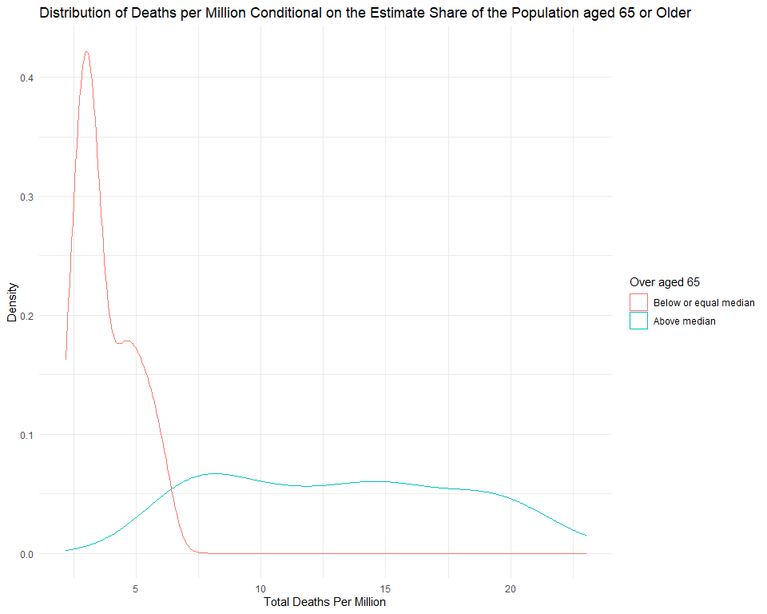

#### Democratic countries are more successful than authoritarian countries.

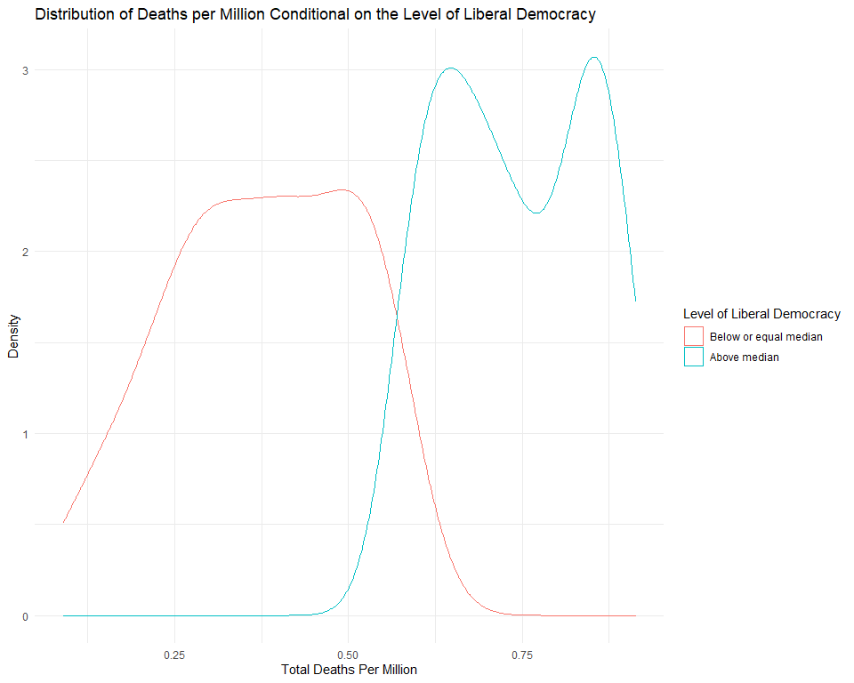

## Conclusion:

## Code:

#### INSTALL LIBRARYS: ####  
library("ggplot2")  
library(tidyverse)  
library(tidyr)  
#### INPUT DATASET: ####  
dataset <- read.csv("https://raw.githubusercontent.com/QMUL-SPIR/Public_files/master/datasets/Covid2020.csv")  
dataset_omit <- read.csv("https://raw.githubusercontent.com/QMUL-SPIR/Public_files/master/datasets/Covid2020.csv")  
dataset_omit <- drop_na(dataset_omit, extreme_poverty)  
head(dataset)  
  
#### EXAMINE THE RELEVENT VARIABLES: ####  
  
# Total Deaths Per Million:  
  
# MCT:  
   
tdm_mean <- mean(dataset_omit$total_deaths_per_million)  
tdm_mean  
  
# MD:  
  
sd(dataset_omit$total_deaths_per_million)  
  
# GDP Per Captia:  
# MCT:  
  
gdp_per_cap <- mean(dataset_omit$gdp_per_capita)  
gdp_per_cap  
  
# MD:  
  
sd(dataset_omit$gdp_per_capita)  
  
# Female Head of Government:   
  
# MCT:  
  
fem_hog <- table(dataset_omit$female_HoG)  
fem_hog  
  
# MD:  
  
fem_hog_dev <- prop.table(table(dataset_omit$female_HoG))  
fem_hog_dev  
  
# Aged 65 of Older:  
  
# MCT:  
  
old_age <- mean(dataset_omit$aged_65_older)  
old_age  
  
# MD:  
  
sd(dataset_omit$aged_65_older)  
  
# VDEM Polyarchy:  
  
# MCT:  
  
vdem <- mean(dataset_omit$vdem_polyarchy)  
vdem  
  
# MD:  
  
sd(dataset_omit$vdem_polyarchy)  
  
#### A TABLE WITH ALL THE VARIBALE AND MEASURE OF CENTRAL TENDENCY: ####  
  
# This will be added in Rmd  
  
#### A RELEVENT PLOT FOR EVERY VARIABLE ####  
  
# Total Deaths Per Million:  
gg_total_deaths_per_mil <- ggplot(dataset_omit, aes(x = total_deaths_per_million))  
gg_total_deaths_per_mil + geom_histogram(binwidth = 10)  
  
# GDP Per Capita:  
gg_gdp_per_cap <- ggplot(dataset_omit, aes(x = gdp_per_capita))  
gg_gdp_per_cap + geom_histogram()  
  
# Female Head of Government:  
gg_female_HoG_deaths <- ggplot(data = dataset_omit, aes(x = female_HoG)) +  
 geom_histogram(binwidth = 20)  
  
geom_text(size = 2,   
 colour = "red",   
 aes(label = location))  
  
gg_female_HoG_deaths + facet_wrap(~ female_HoG)  
  
# Aged 65 or Older:  
gg_aged_65_plus <- ggplot(data = dataset_omit, aes(x = aged_65_older))  
gg_aged_65_plus + geom_histogram()  
  
# VDEM Polyarchy:  
gg_vdem <- ggplot(data = dataset_omit, aes(x = vdem_polyarchy))  
gg_vdem + geom_histogram()  
  
#### RECODES FOR VARIBELS OF INTREST (BINARY)####  
  
# calculate median GDP Per Capita  
med_gdp <- median(dataset_omit$gdp_per_capita)  
  
# create new variable using case_when()  
dataset_omit <- dataset_omit %>% # pipe the dataset  
 mutate( # create new variable  
 gdp_var = # name the new variable  
 factor(case_when(  
 gdp_per_capita > med_gdp ~ 1,  
 gdp_per_capita <= med_gdp ~ 0)))  
  
# calculate median 65 or Older  
med_65_plus <- median(dataset_omit$aged_65_older)  
  
# create new variable using case_when()  
dataset_omit <- dataset_omit %>% # pipe the dataset  
 mutate( # create new variable  
 sixty_five_var = # name the new variable  
 factor(case_when(  
 aged_65_older > med_65_plus ~ 1,  
 aged_65_older <= med_65_plus ~ 0)))  
  
# calculate median vdem Polyarchy  
med_vdem <- median(dataset_omit$vdem_polyarchy)  
  
# create new variable using case_when()  
dataset_omit <- dataset_omit %>% # pipe the dataset  
 mutate( # create new variable  
 vdem_var = # name the new variable  
 factor(case_when(  
 vdem_polyarchy > med_vdem ~ 1,  
 vdem_polyarchy <= med_vdem ~ 0)))  
  
  
  
#### RELATIONSHP BETWEEN TOTAL COVID 19 DEATHS AND THE RELEVENT VARIABLES ####  
  
 #### CONDITIONAL DISTRIBUTION PLOTS ####  
  
# Distribution of Deaths per Million Conditional on GDP per Capita  
  
gdp_dist <- ggplot(data = dataset_omit, aes(total_deaths_per_million, group = gdp_var)) +   
 geom_density(aes(colour = gdp_var)) +  
 labs(x = "Total Deaths Per Million", # clearer x axis label  
 y = "Density", # clearer y axis label  
 title = "Distribution of Deaths per Million Conditional on GDP per Capita") + # title   
 scale_color_discrete(name = "GDP Per Capita", # change legend title  
 labels = c("Below or equal median", # change legend labels  
 "Above median")) +   
 theme_minimal()  
  
gdp_dist  
  
# Distribution of Deaths per Million Conditional on median 65 or Older  
  
sixtyfive_dist <- ggplot(data = dataset_omit, aes(aged_65_older, group = sixty_five_var)) +   
 geom_density(aes(colour = sixty_five_var)) +  
 labs(x = "Total Deaths Per Million", # clearer x axis label  
 y = "Density", # clearer y axis label  
 title = "Distribution of Deaths per Million Conditional on the Estimate Share of the Population aged 65 or Older") + # title   
 scale_color_discrete(name = "Over aged 65", # change legend title  
 labels = c("Below or equal median", # change legend labels  
 "Above median")) +   
 theme_minimal()  
  
sixtyfive_dist  
  
# Distribution of Deaths per Million Conditional on median vdem Polyarchy  
  
vdem_dist <- ggplot(data = dataset_omit, aes(vdem_polyarchy, group = vdem_var)) +   
 geom_density(aes(colour = vdem_var)) +  
 labs(x = "Total Deaths Per Million", # clearer x axis label  
 y = "Density", # clearer y axis label  
 title = "Distribution of Deaths per Million Conditional on the Level of Liberal Democracy") + # title   
 scale_color_discrete(name = "Level of Liberal Democracy", # change legend title  
 labels = c("Below or equal median", # change legend labels  
 "Above median")) +   
 theme_minimal()  
  
vdem_dist  
  
 #### TWO SAMPLE T-TESTS ####  
  
# T-Test: GDP  
  
t.test(vdem_polyarchy ~ vdem_var, # formula y ~ x  
 data = dataset_omit, # dataset where the variables are found  
 mu = 0, # difference under the null hypothesis  
 alt = "two.sided", # two sided test (difference in means could be smaller or larger than 0)  
 conf = 0.95) # confidence interval  
  
# T-Test: Aged 65 Plus  
  
t.test(aged_65_older ~ sixty_five_var, # formula y ~ x  
 data = dataset_omit, # dataset where the variables are found  
 mu = 0, # difference under the null hypothesis  
 alt = "two.sided", # two sided test (difference in means could be smaller or larger than 0)  
 conf = 0.95) # confidence interval  
  
# T-Test: VDEM Polyarchy  
  
t.test(vdem_polyarchy ~ vdem_var, # formula y ~ x  
 data = dataset_omit, # dataset where the variables are found  
 mu = 0, # difference under the null hypothesis  
 alt = "two.sided", # two sided test (difference in means could be smaller or larger than 0)  
 conf = 0.95) # confidence interval