Analysis of the Social and Political Factors for Success/Failure in Tackling the Covid-19 Pandemic

## Introduction

what factors lead to the best or worst responses to the Covid –19 crisis? Is it wealth, who leads the country? Maybe how the country is run? Maybe it’s something out of their control. I have been given four hypotheses to test and using data on an assortment of countries from around the world, I will test them and see how these factors affect their death toll. The theories are as follows:

* Richer Countries do better than Poorer countries.
* Countries led by women are more successful than those led by men.
* The success in dealing with the pandemic is related to the proportion of older people living in the country.
* Democratic countries are more successful than authoritarian countries.

To test these theories, I collected and analyzed data from various countries around the world and used a series of measurements and characteristics to determine what effects the a country’s success at tackling the COVID-19 pandemic.

## Justification:

First, I must justify my initial hypothesis, what I believe the data will show me using prior research from sources, like the news, academic papers etc. (to prove that I didn’t pull these statements out of thin air!).

1. Richer Countries do better than Poorer countries.

A country with a higher GDP per capita and lower extreme poverty levels would be more likely to have a robust healthcare system and greater investment into pandemic preparation.

1. Countries led by women are more successful than those led by men.

In the early days of the pandemic, the media highlighted the success of New Zealand Prime Minister Jacinda Ardern and other female led nations around the world at having lower death rates compared to their male counterparts.

* <https://www.theguardian.com/world/2020/aug/18/female-led-countries-handled-coronavirus-better-study-jacinda-ardern-angela-merkel>
* <https://www.ft.com/content/6b597385-ba51-413a-96bd-cb75d3446718>
* <https://www.forbes.com/sites/avivahwittenbergcox/2020/04/13/what-do-countries-with-the-best-coronavirus-reponses-have-in-common-women-leaders/>

1. The success in dealing with the pandemic is related to the proportion of older people living in the country.

The death rate of COVID-19 infected individuals is much higher in those aged above 60. In nations with a higher older population such as Japan, the government would be prepared to take stronger measures to protect the most vulnerable as they could expect more deaths in their population.

4.Democratic countries are more successful than authoritarian countries.

## The Results:

#### Richer Countries do better than Poorer countries.

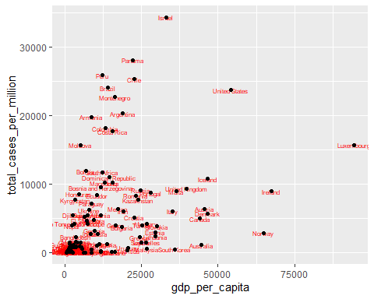

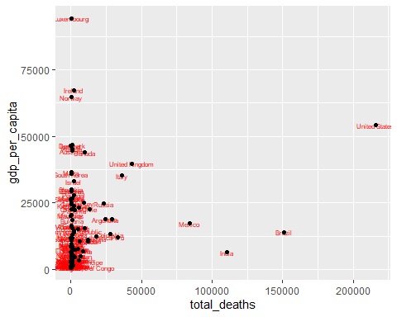 (Distribution Plot)

#### Countries led by women are more successful than those led by men.

## mapping: label = ~location   
## geom_text: parse = FALSE, check_overlap = FALSE, na.rm = FALSE  
## stat_identity: na.rm = FALSE  
## position_identity

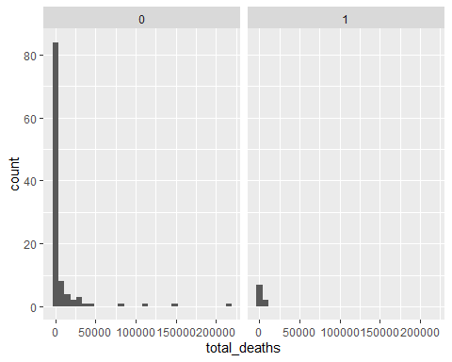

## mapping: label = ~location   
## geom_text: parse = FALSE, check_overlap = FALSE, na.rm = FALSE  
## stat_identity: na.rm = FALSE  
## position_identity

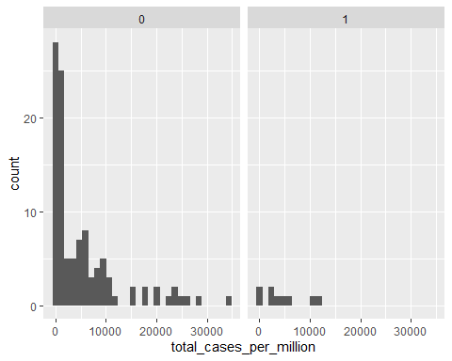

#### The success in dealing with the pandemic is related to the proportion of older people living in the country.

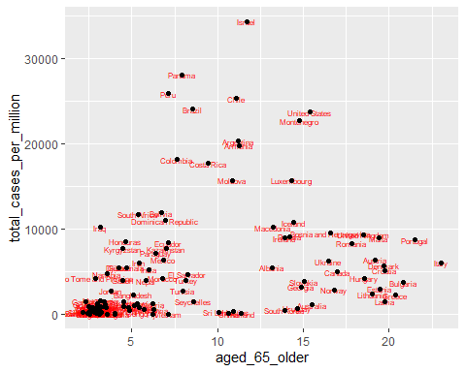

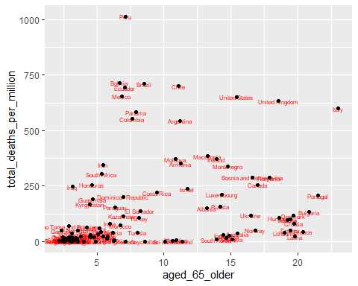

(Distribution Plot)

##   
## Welch Two Sample t-test  
##   
## data: total_deaths_per_million by SixtyFive_Median_Median  
## t = -5.6498, df = 67.436, p-value = 3.509e-07  
## alternative hypothesis: true difference in means between group 0 and group 1 is not equal to 0  
## 95 percent confidence interval:  
## -264.5275 -126.4257  
## sample estimates:  
## mean in group 0 mean in group 1   
## 42.66288 238.13948

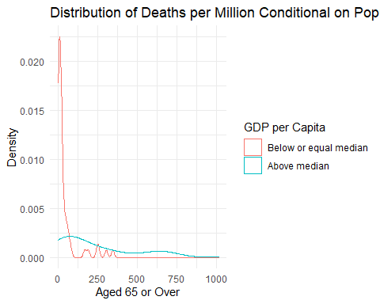 #### Democratic countries are more successful than authoritarian countries.

#VDEM 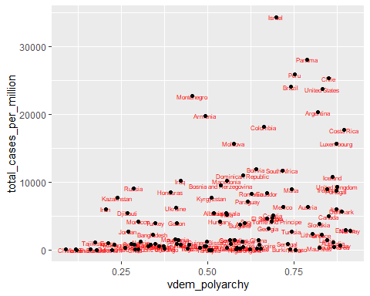

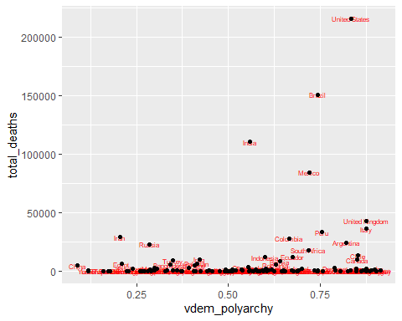

## Conclusion:

## Code:

####LIBRARIES####  
library(tidyverse)  
library(tidyr)  
library(ggplot2)  
####DATASETS####  
dataset1 <- read.csv("https://raw.githubusercontent.com/QMUL-SPIR/Public_files/master/datasets/Covid2020.csv")  
dataset_omit <- read.csv("https://raw.githubusercontent.com/QMUL-SPIR/Public_files/master/datasets/Covid2020.csv")  
dataset_omit <- drop_na(dataset_omit, extreme_poverty)  
  
####MEASURE OF CENTRAL TENDENCY####  
  
#total deaths per million MCT  
tdm_mean <- mean(dataset_omit$total_deaths_per_million)  
tdm_mean  
  
#GDP per capita MCT  
gdp_per_cap <- mean(dataset_omit$gdp_per_capita)  
gdp_per_cap  
  
#Female HOG MCT  
fem_hog <- table(dataset_omit$female_HoG)  
fem_hog  
  
#aged 65 plus MCT  
old_age <- mean(dataset_omit$aged_65_older)  
old_age  
  
#vdem polyarchy MCT  
vdem <- mean(dataset_omit$vdem_polyarchy)  
vdem  
  
#Human Development Index   
hdm_index <-mean(dataset_omit$human_development_index)  
hdm_index  
  
#Life Expectancy   
life_ex <- mean(dataset_omit$life_expectancy)  
life_ex  
  
#Extreme poverty  
ex_pov <- mean(dataset_omit$extreme_poverty)  
ex_pov  
  
#population density  
pop_dens <- mean(dataset_omit$population_density)  
pop_dens  
  
#Median Age  
mid_age <- mean(dataset_omit$median_age)  
mid_age  
  
#population  
pop <- mean(dataset_omit$population)  
pop  
  
#cases per million  
case_per_mil<- mean(dataset_omit$total_cases_per_million)  
case_per_mil  
  
#total deaths  
all_deaths <- mean(dataset_omit$total_deaths)  
all_deaths  
  
#total cases  
all_case <- mean(dataset_omit$total_cases)  
all_case  
  
####MEASURE OF DISPERSION####  
  
#total deaths per million   
sd(dataset_omit$total_deaths_per_million)  
  
#GDP per capita  
sd(dataset_omit$gdp_per_capita)  
  
#female HOG   
fem_hog_dev <- prop.table(table(dataset_omit$female_HoG))  
fem_hog_dev  
  
#aged 65 plus   
sd(dataset_omit$aged_65_older)  
  
#vdem polyarchy  
sd(dataset_omit$vdem_polyarchy)  
  
#Human Development Index   
sd(dataset_omit$human_development_index)  
  
#Life Expectancy  
sd(dataset_omit$life_expectancy)  
  
#Extreme poverty   
sd(dataset_omit$extreme_poverty)  
  
#Total Deaths  
sd(dataset_omit$total_deaths)  
  
#Median Age  
sd(dataset_omit$median_age)  
  
#Population   
sd(dataset_omit$population)  
  
#Total cases per million   
sd(dataset_omit$total_cases_per_million)  
  
#population density  
sd(dataset_omit$population_density)  
  
#Total cases  
sd(dataset_omit$total_cases)  
  
  
####PLOTS####  
  
#Total cases per million  
  
  
  
  
  
gg_total_cases_per_mil + geom_point()  
  
  
  
  
#GDP per Capita  
  
gg_gdp_per_cap <- ggplot(data = dataset_omit,   
 mapping = aes(x =gdp_per_capita , y = total_cases_per_million)) +  
 geom_text(size = 2,   
 colour = "red",   
 aes(label = location))  
  
gg_gdp_per_cap + geom_point()  
  
  
  
#Female HoG  
gg_female_HoG <- ggplot(data = dataset_omit, aes(x = total_cases_per_million)) +  
 geom_histogram(bins = 30)  
  
geom_text(size = 2,   
 colour = "red",   
 aes(label = location))  
  
gg_female_HoG + facet_wrap(~ female_HoG)  
  
#Population over 65  
  
gg_pop_65_plus <- ggplot(data = dataset_omit,   
 mapping = aes(x = aged_65_older , y = total_cases_per_million)) +   
 geom_text(size = 2,   
 colour = "red",   
 aes(label = location))  
  
gg_pop_65_plus + geom_point()  
  
#Population over 65 Deaths   
  
gg_pop_65_plus_deaths <- ggplot(data = dataset_omit,   
 mapping = aes(x = aged_65_older , y = total_deaths_per_million)) +   
 geom_text(size = 2,   
 colour = "red",   
 aes(label = location))  
  
gg_pop_65_plus_deaths + geom_point()  
  
#VDEM  
  
gg_vdem <- ggplot(data = dataset_omit,   
 mapping = aes(x = vdem_polyarchy , y = total_cases_per_million)) +   
 geom_text(size = 2,   
 colour = "red",   
 aes(label = location))  
  
gg_vdem + geom_point()  
  
  
  
  
#Extreme poverty  
  
gg_extreme_poverty <- ggplot(data = dataset_omit,   
 mapping = aes(x = total_cases_per_million, y = extreme_poverty)) +  
 geom_text(size = 2,  
 colour ="red",  
 aes(label = location))  
  
gg_extreme_poverty + geom_point()  
  
#Total Deaths   
  
gg_total_deaths <- ggplot(data = dataset_omit,   
 mapping = aes(x = total_cases_per_million, y = total_deaths)) +  
 geom_text(size = 2,  
 colour ="red",  
 aes(label = location))  
  
  
gg_total_deaths + geom_point()  
  
#median Age   
  
gg_median_age <- ggplot(data = dataset_omit,   
 mapping = aes(x = total_cases_per_million, y = median_age)) +  
 geom_text(size = 2,  
 colour ="red",  
 aes(label = location))  
  
gg_median_age + geom_point()  
  
  
  
  
  
  
####AREAS OF INTREST####  
  
##TEST##  
  
#GDP per capita binary  
median_gdp_p_c <- median(dataset_omit$gdp_per_capita)  
  
gdp_oneOrZero <- dataset_omit %>%  
 mutate(  
 gdp_oneOrZero_Median =  
 factor(case_when(  
 gdp_per_capita > median_gdp_p_c ~ 1,  
 gdp_per_capita<= median_gdp_p_c ~ 0)))  
  
#vdem polyarchy binary   
median_vdemBinary <- median(dataset_omit$vdem_polyarchy)  
  
Vdem_Median <- dataset_omit %>%  
 mutate(  
 Vdem_Median_Median =  
 factor(case_when(  
 vdem_polyarchy > median_vdemBinary ~ 1,  
 vdem_polyarchy<= median_vdemBinary ~ 0)))  
  
#aged 65 plus binary  
median_sixtyFiveBinary <- median(dataset_omit$aged_65_older)  
  
sixtyFive_Median <- dataset_omit %>%  
 mutate(  
 SixtyFive_Median_Median =  
 factor(case_when(  
 aged_65_older > median_sixtyFiveBinary ~ 1,  
 aged_65_older<= median_sixtyFiveBinary ~ 0)))  
  
###CONDITIONAL DISTRBUTION PLOT####  
  
#gdp per capita  
  
  
  
  
gdp_1or0_dist <- ggplot(data = gdp_oneOrZero, aes(total_deaths_per_million, group = gdp_oneOrZero_Median)) +  
geom_density(aes(color = gdp_oneOrZero_Median)) +  
labs(x = "Total Deaths Per Million",  
 y = "Density",  
title = "Distribution of Deaths per Million Conditional on GDP per Capita") + # title  
scale_color_discrete(name = "GDP per Capita",  
labels = c("Below or equal median", "Above median")) + theme_minimal()  
  
gdp_1or0_dist  
  
#vdem polyarchy binary  
  
  
vdem_dist <- ggplot(data = Vdem_Median, aes(total_deaths_per_million, group = Vdem_Median_Median)) +  
 geom_density(aes(color = Vdem_Median_Median)) +  
 labs(x = "Vdem Polyarchy",  
 y = "Density",  
 title = "Distribution of Deaths per Million Conditional on Vdem Polyarchy") + # title  
 scale_color_discrete(name = "GDP per Capita",  
 labels = c("Below or equal median", "Above median")) + theme_minimal()  
  
vdem_dist  
  
#aged 65 plus binary  
  
aged65_dist <- ggplot(data = sixtyFive_Median, aes(total_deaths_per_million, group = SixtyFive_Median_Median)) +  
 geom_density(aes(color = SixtyFive_Median_Median)) +  
 labs(x = "Aged 65 or Over",  
 y = "Density",  
 title = "Distribution of Deaths per Million Conditional on Population aged 65 or Older") + # title  
 scale_color_discrete(name = "GDP per Capita",  
 labels = c("Below or equal median", "Above median")) + theme_minimal()  
  
aged65_dist  
  
###TWO SAMPLE T-tests  
  
#gdp per capita   
  
t.test(total_deaths_per_million ~ gdp_oneOrZero_Median ,  
 data = gdp_oneOrZero ,  
 mu = 0,  
 alt = "two.sided",  
 conf = 0.95)  
  
# vdem polyarchy   
  
t.test(total_deaths_per_million ~ Vdem_Median_Median ,  
 data = Vdem_Median,  
 mu = 0,  
 alt = "two.sided",  
 conf = 0.95)  
  
# aged 65 plus  
  
t.test(total_deaths_per_million ~ SixtyFive_Median_Median ,  
 data = sixtyFive_Median,  
 mu = 0,  
 alt = "two.sided",  
 conf = 0.95)  
  
### Bar Chart ###  
  
#Total cases per million  
  
total_cases_per_mil <- ggplot(data = dataset_omit, aes(x = location, label = location)) +  
 geom_histogram(binwidth = 100) +  
 labs(x = "Countries",  
 y = "location",  
 title = "Countries by Total Cases per Million"  
 ) +  
 theme_minimal()  
   
  
total_cases_per_mil