Analysis of the Social and Political Factors for Success/Failure in Tackling the Covid-19 Pandemic

## Introduction

what factors lead to the best or worst responses to the Covid –19 crisis? Is it wealth, who leads the country? Maybe how the country is run? Maybe it’s something out of their control. I have been given four hypotheses to test and using data on an assortment of countries from around the world, I will test them and see how these factors affect their death toll. The theories are as follows:

* Richer Countries do better than Poorer countries.
* Countries led by women are more successful than those led by men.
* The success in dealing with the pandemic is related to the proportion of older people living in the country.
* Democratic countries are more successful than authoritarian countries.

To test these theories, I collected and analyzed data from various countries around the world and used a series of measurements and characteristics to determine what effects the a country’s success at tackling the COVID-19 pandemic.

## Justification:

First, I must justify my initial hypothesis, what I believe the data will show me using prior research from sources, like the news, academic papers etc. (to prove that I didn’t pull these statements out of thin air!).

1. Richer Countries do better than Poorer countries.

A country with a higher GDP per capita and lower extreme poverty levels would be more likely to have a robust healthcare system and greater investment into pandemic preparation.

1. Countries led by women are more successful than those led by men.

In the early days of the pandemic, the media highlighted the success of New Zealand Prime Minister Jacinda Ardern and other female led nations around the world at having lower death rates compared to their male counterparts.

* <https://www.theguardian.com/world/2020/aug/18/female-led-countries-handled-coronavirus-better-study-jacinda-ardern-angela-merkel>
* <https://www.ft.com/content/6b597385-ba51-413a-96bd-cb75d3446718>
* <https://www.forbes.com/sites/avivahwittenbergcox/2020/04/13/what-do-countries-with-the-best-coronavirus-reponses-have-in-common-women-leaders/>

1. The success in dealing with the pandemic is related to the proportion of older people living in the country.

The death rate of COVID-19 infected individuals is much higher in those aged above 60. In nations with a higher older population such as Japan, the government would be prepared to take stronger measures to protect the most vulnerable as they could expect more deaths in their population.

4.Democratic countries are more successful than authoritarian countries.

## The Results:

|  |  |  |  |  |
| --- | --- | --- | --- | --- |
| Variable | Name of the Relevant MCT | Value of the MCT | Name of the Relevant MD | Value of the MD |
| Total Deaths Per Million | Continuous | 140.40 | variance and/or standard deviation | 209.88 |
| GDP Per Capita | Continuous | 14910.69 | variance and/or standard deviation | 16071.77 |
| Female Head of Government | Nominal | 0 (Male) = 107 1 (Female) = 9 | proportion in each category | 0 (Male) = 0.92 1 (Female) = 0.08 |
| V-Dem Polyarchy | Continuous | 0.56 | variance and/or standard deviation | 0.22 |

#### Richer Countries do better than Poorer countries.

Null Hypothesis = The GDP per capita of a country does not have an effect on the total covid deaths per million.

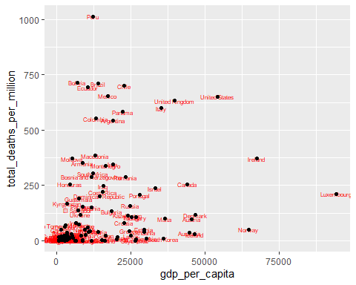

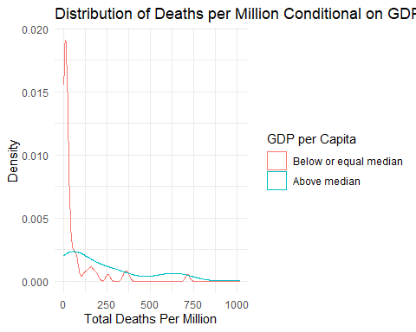

##   
## Welch Two Sample t-test  
##   
## data: total_deaths_per_million by gdp_oneOrZero_Median  
## t = -4.6217, df = 82.055, p-value = 1.398e-05  
## alternative hypothesis: true difference in means between group 0 and group 1 is not equal to 0  
## 95 percent confidence interval:  
## -237.48619 -94.56322  
## sample estimates:  
## mean in group 0 mean in group 1   
## 57.38883 223.41353

#### Countries led by women are more successful than those led by men.

Null Hypothesis = The gender of a nations leader does not have an effect on the total covid deaths per million

## mapping: label = ~location   
## geom_text: parse = FALSE, check_overlap = FALSE, na.rm = FALSE  
## stat_identity: na.rm = FALSE  
## position_identity

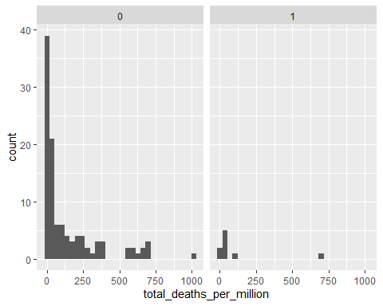

#### The success in dealing with the pandemic is related to the proportion of older people living in the country.

Null Hypothesis = The proportion of people over the age of 65 does not have an effect on the total covid deaths per million

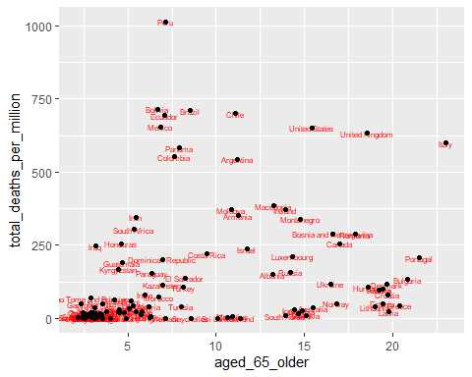

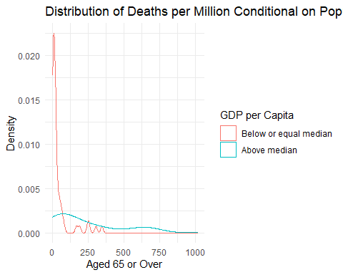

##   
## Welch Two Sample t-test  
##   
## data: total_deaths_per_million by SixtyFive_Median_Median  
## t = -5.6498, df = 67.436, p-value = 3.509e-07  
## alternative hypothesis: true difference in means between group 0 and group 1 is not equal to 0  
## 95 percent confidence interval:  
## -264.5275 -126.4257  
## sample estimates:  
## mean in group 0 mean in group 1   
## 42.66288 238.13948

#### Democratic countries are more successful than authoritarian countries.

Null Hypothesis = The level of democracy in a country does not have an effect on the total coivd deaths per million

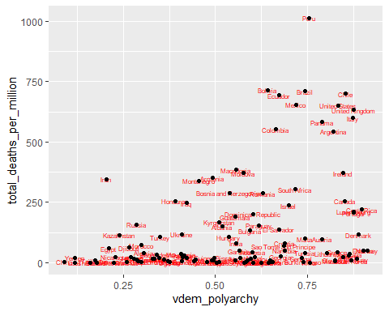 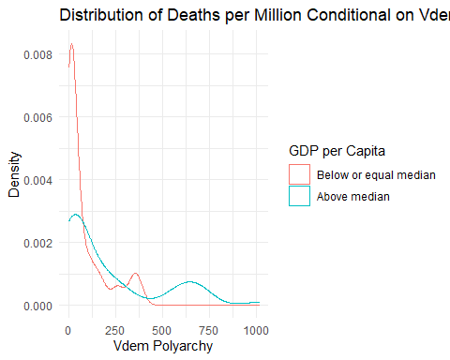

##   
## Welch Two Sample t-test  
##   
## data: total_deaths_per_million by Vdem_Median_Median  
## t = -3.3834, df = 76.758, p-value = 0.00113  
## alternative hypothesis: true difference in means between group 0 and group 1 is not equal to 0  
## 95 percent confidence interval:  
## -200.56063 -51.94485  
## sample estimates:  
## mean in group 0 mean in group 1   
## 77.27481 203.52755

## Conclusion:

## Code:

# This is where the finished code will go.   
# https://www.ncbi.nlm.nih.gov/pmc/articles/PMC8301493/  
# https://www.frontiersin.org/articles/10.3389/fpubh.2021.613484/full