**Lesson 3 Demo 6**

**Working of Distributed Ledger**

|  |
| --- |
| **Objective:** To demonstrate the working of a distributed ledger  **Tools required:** Ubuntu and Web browser  **Pre-requisites:** None |

Steps to be followed:

1. Mining blocks to demonstrate the working of a distributed ledger

**Step 1: Mining blocks to demonstrate the working of a distributed ledger**

1. Visit <https://andersbrownworth.com/blockchain/distributed>
2. In Block 1 of Peer A, enter data in the **Data** field, click **Mine**,and note the **Hash** value

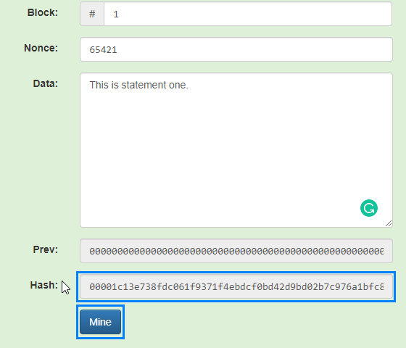

1. Enter data and mine the blocks of Peer A

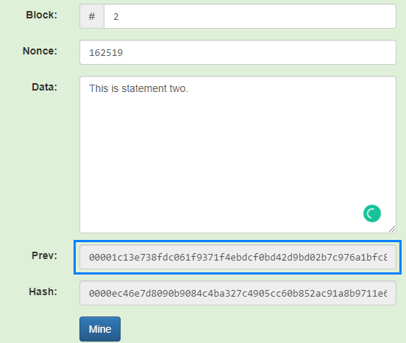

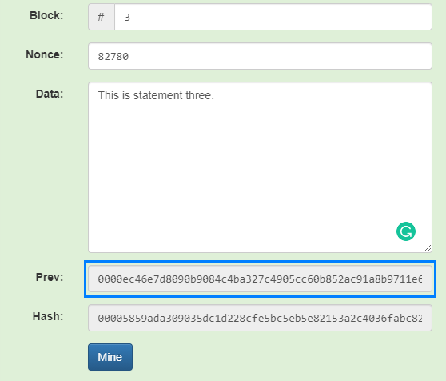

|  |
| --- |
| **Note:** Notice that the hash of the previous block is the same in the next block. |