**Lesson 3 Demo 7**

**Working of Blockchain Transaction**

|  |
| --- |
| **Objective:** Demonstrate the working of blockchain transactions  **Tools required:** Ubuntu and Web browser  **Pre-requisites:** None |

Steps to be followed:

1. Demonstrating the working of blockchain transactions

**Step 1: Demonstrating the working of blockchain transactions**

1. Visit <https://andersbrownworth.com/blockchain/blockchain>
2. Enter any data in the **Data** field and observe the change in the hash value

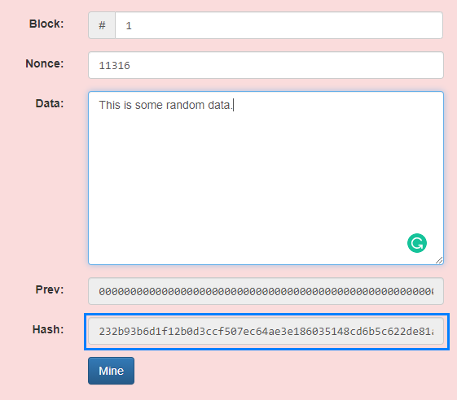

1. Change the information in any block
2. Observe how the hash value changes in the subsequent blocks

