**Lesson 3 Demo 4**

**Generate a Nonce Value**

|  |
| --- |
| **Objective:** To generate a nonce value.  **Tools required:** Ubuntu, Web browser  **Pre-requisites:** None |

Steps to be followed:

1. Generating a nonce value

**Step 1: Generating a nonce value**

1. Visit <https://andersbrownworth.com/blockchain/block>
2. Enter some text in **Data** field and click on **Mine**

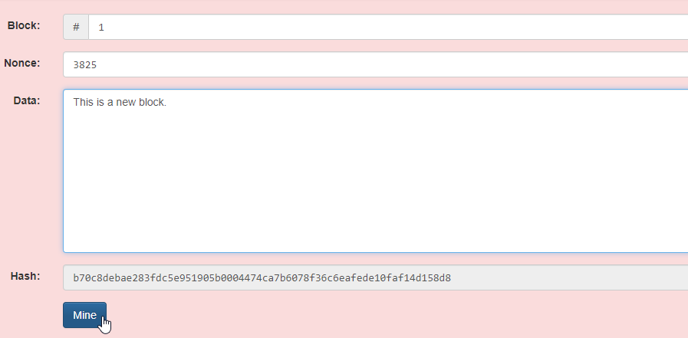

1. The new value is generated for the **Nonce** field

