**Lesson 4 Demo 2**

**Generate a Paper Wallet**

|  |
| --- |
| **Objective:** To generate a Paper wallet  **Tools required:** Ubuntu, web browser  **Prerequisites:** None |

Steps to be followed:

1. Generating a Single Wallet and Paper wallet

**Step 1: Generating a Single Wallet and a Paper wallet**

1. Visit <https://www.bitaddress.org/>

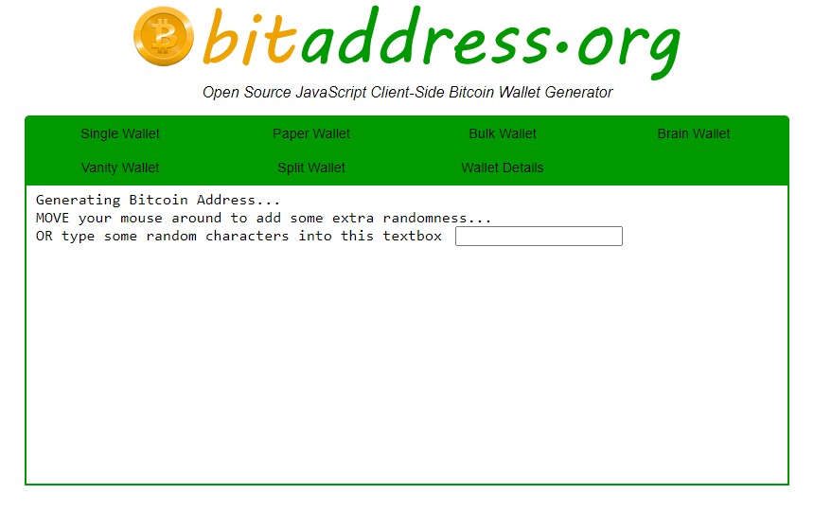

1. Generate a **Bitcoin Address** by moving the mouse around to add some additional randomness

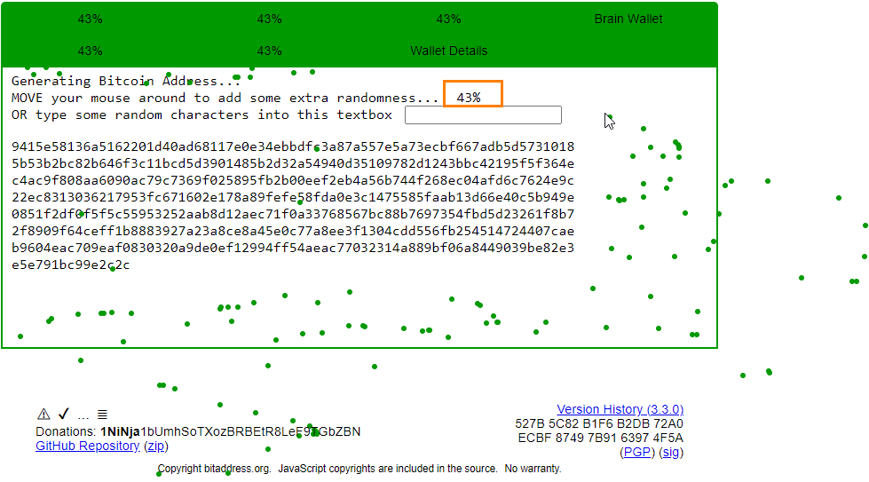

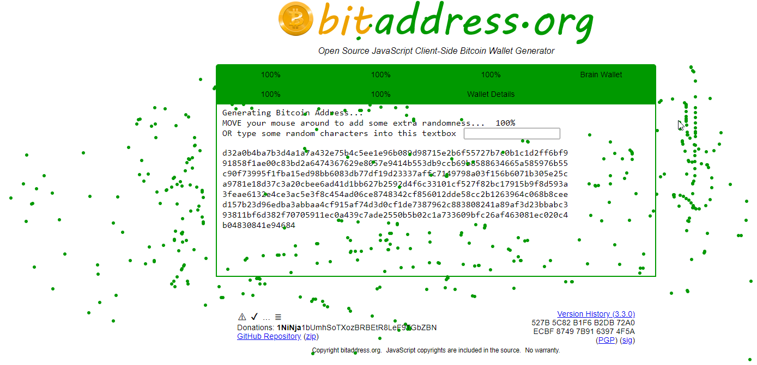

|  |
| --- |
| **Note:** Notice that the randomness percentage keeps on increasing. Keep moving the mouse until the randomness percentage reaches 100%. |

1. Click on **Single Wallet** to generate a Single wallet

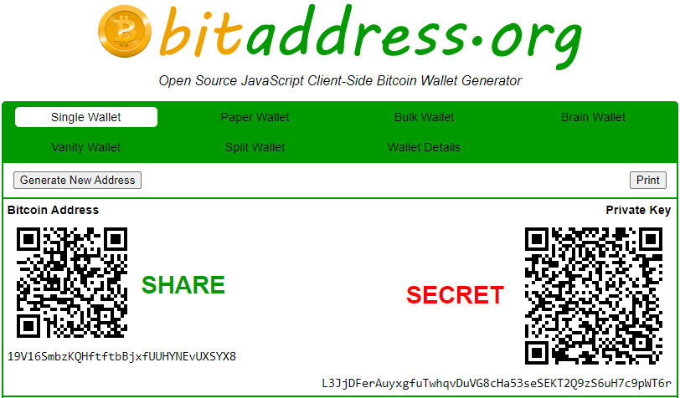

1. Click on **Paper Wallet** to generate a Paper wallet

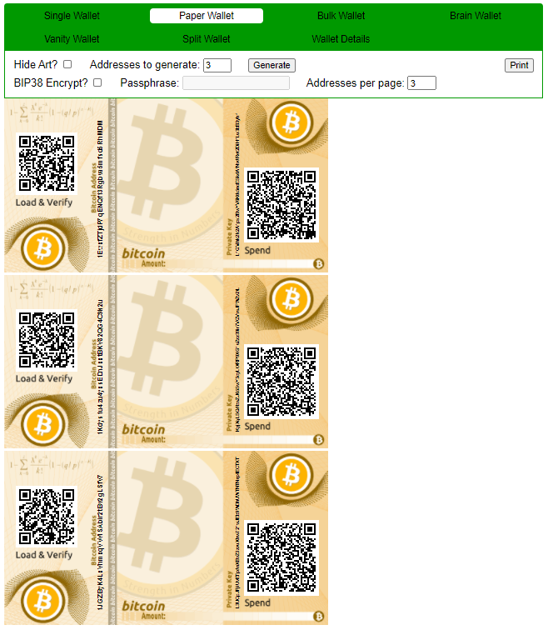

1. Navigate back to **Single Wallet** tab and copy the **Private Key**
2. Click on **Wallet Details** tab, paste the copied Private Key, and click on the **View Details** button

