**Lesson 4 Demo 3**

**Generate a Web Wallet**

|  |
| --- |
| **Objective:** To generate a web wallet  **Tools required:** Ubuntu, Web browser  **Pre-requisites:** None |

Steps to be followed:

1. Generating a Jaxx web wallet

**Step 1: Generating a Jaxx web wallet**

1.1 Visit <https://jaxx.io/> and click on the **Download** button



1.2 Click on the **Chrome Web Store** button to install the Jaxx wallet for the **Chrome** browser



1.3 On Chrome Web Store, click on **Add to Chrome** button and then click the **Add Extension** button to add the **Jaxx Liberty** extension



1.4 Click on the added **Jaxx extension** and click on **I Agree** button for the **Terms of Service** of the Jaxx wallet

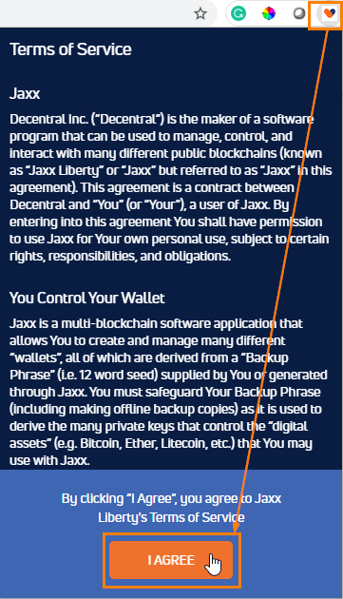

1.5 Select **English** as the languageand click on **Confirm**

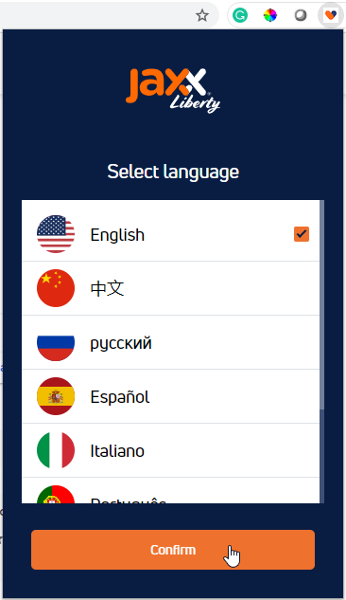

1.6 On the next screen click on the **Get Started** button

1.7 Notice that the wallet is being created



1.8 Click on **Skip** on **Back Up Your Wallet** screen

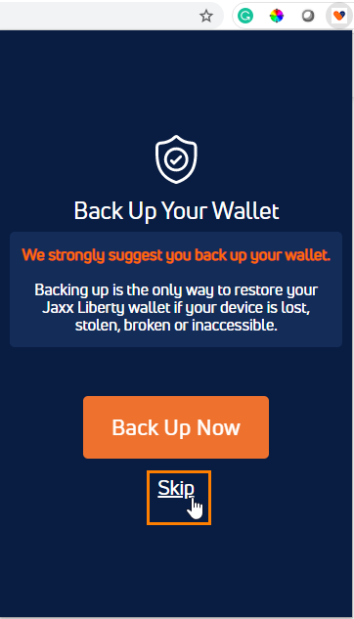

1.9 Different wallets will be displayed that can be used for various transactions



A web wallet is generated.