**Lesson 4 Demo 4**

**Bitcoin Block**

|  |
| --- |
| **Objective:** To review Bitcoin blocks  **Tools required:** Ubuntu, Web browser  **Prerequisites:**  None |

Steps to be followed:

1. Reviewing the latest Bitcoin blocks

**Step 1: Reviewing the latest Bitcoin blocks**

1. Visit <https://www.blockchain.com/explorer>

1. Go to the **Latest Blocks** section

1. Check the block heights to see the different values from the screenshot as a block height keeps on increasing with time

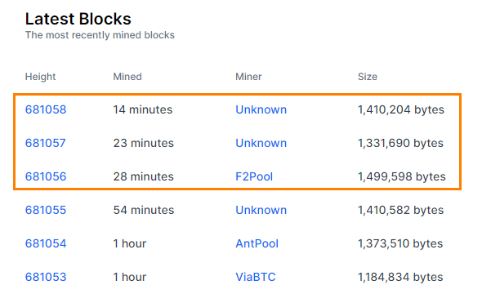

1. Click on the first block to see all the details like block header and transaction details

