**Lesson 5 Demo 8**

**Set up a Private Blockchain Node Using Geth**

|  |
| --- |
| **Objective:** To use Geth to configure a private Blockchain node in our machine  **Tools required:** Ubuntu, Terminal, and Geth  **Prerequisites:** Refer to Lesson 5 Demo 7 for installing the Geth client |

Steps to be followed:

1. Configuring the Geth client to emulate light node functionalities

**Step 1: Configuring the Geth Client to Emulate Light Node Functionalities**

1. Type the following command after installing Geth to add a new Ethereum account:

***geth --datadir ethdata account new***

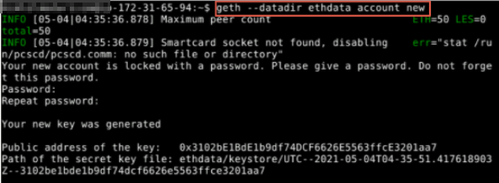

1. After creating the account, configure the new node and Blockchain parameters by creating a **genesis.json** file using the following command:

***nano genesis.json***

1. Add the following code snippet in the **genesis.json** file:

***{***

***"nonce": "0x0000000000000042",***

***"timestamp": "0x00",***

***"parentHash":"0x0000000000000000000000000000000000000000000000000000000000000000",***

***"extraData": "0x00",***

***"gasLimit": "0x8000000",***

***"difficulty": "0x0400",***

***"mixhash":"0x0000000000000000000000000000000000000000000000000000000000000000",***

***"coinbase": "0x3333333333333333333333333333333333333333",***

***"alloc": {***

***},***

***"config": {***

***"chainId": 786,***

***"homesteadBlock": 0,***

***"eip155Block": 0,***

***"eip158Block": 0***

***}***

***}***

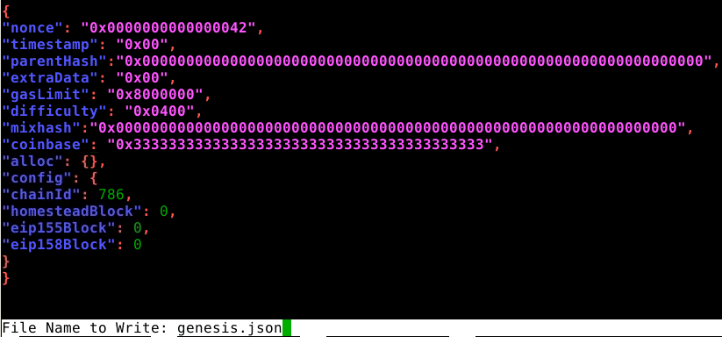

1. We initialize the genesis file by executing the following command:

***geth --datadir=”ethdata” init genesis.json***

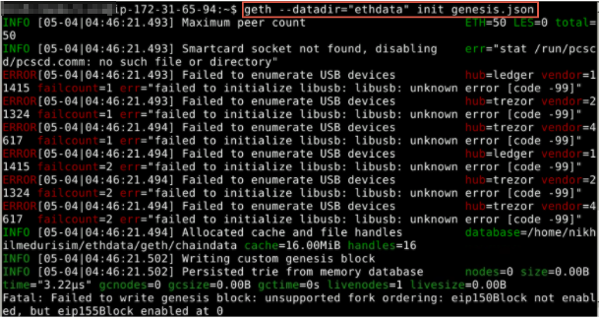

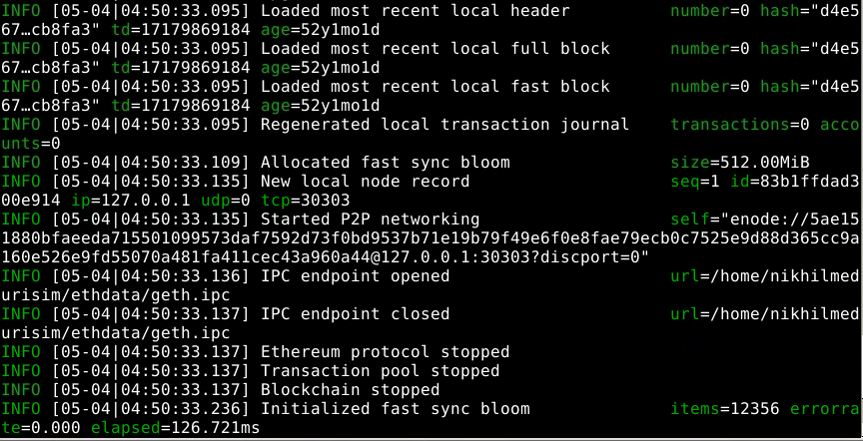

|  |
| --- |
| **Note:** Once the command is successfully executed, the Blockchain node is configured and ready to perform miner functions. |

1. We must execute the following command to initialize the genesis block that we configured:

***geth --datadir=”ethdata” --networkid 15 --nodiscover --rpc --rpcport “8000” --rpccorsdomain “*” --rpcapi “eth,net,web3,miner,debug,personal,rpc” --networkid 1999 console***

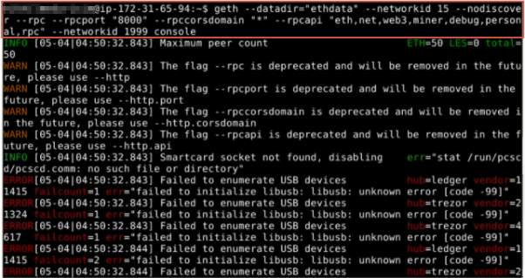

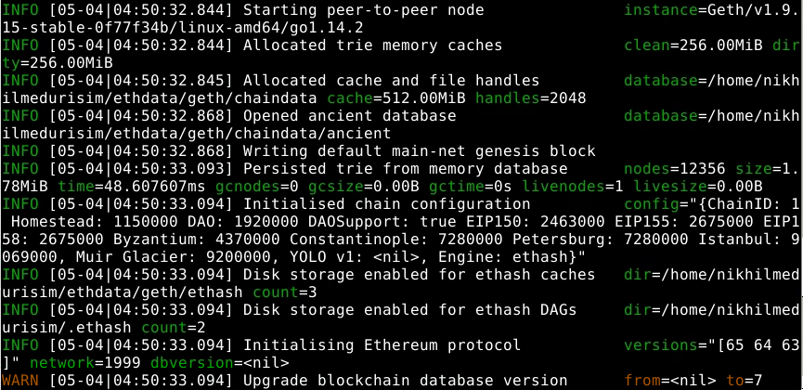

1. Once the node is initialized, we can perform the mining function by executing the following command:

***miner.start()  
 miner.stop()***



Now, we can perform the mining function.