**Lesson 5 Demo 2**

**Connecting Remix IDE to Ganache and Ropsten Test Networks**

|  |
| --- |
| **Objective:** To connect the Remix IDE with the local Ganache network and the Ropsten test network  **Tools required:** Ubuntu, web browser, Ganache, Metamask, and Remix IDE  **Prerequisites:** None |

Steps to be followed:

1. Connecting to the Ganache localhost through Web3 provider
2. Connecting to the Ropsten testnet using Metamask and Injected Web3

**Step 1: Connecting to the Ganache Localhost through Web3 provider**

1. Open the Remix IDE on your browser by accessing the link: <https://remix.ethereum.org/>

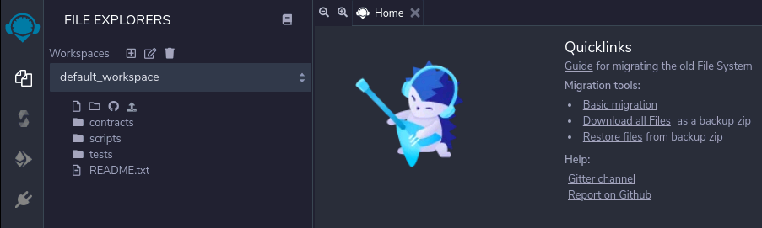

1. Select the **Deploy and run transactions** section to connect to your local network

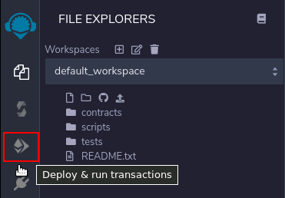

1. We must have an instance of Ganache, and we must copy its RPC URL as shown in the image below to use it in the Remix IDE

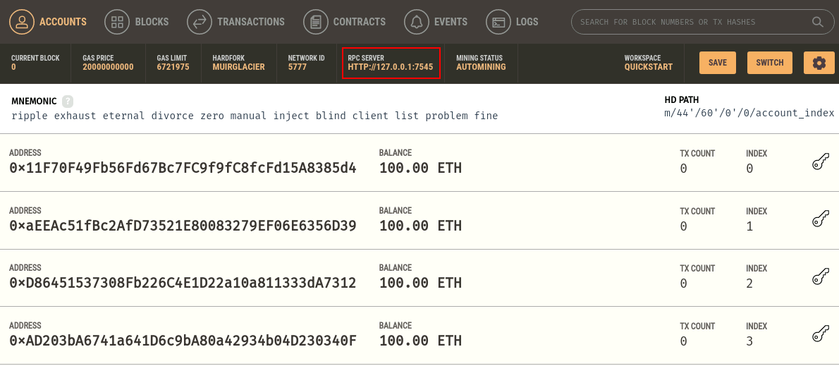

|  |
| --- |
| **Note**: For this demo, we will set the username as **SimpliNetwork** and the URL as **http://127.0.0.1:7545**. |

1. Click on the **Environment** option to see the various execution environment options

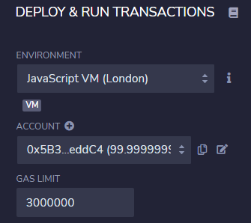

1. Select the **Web3 Provider** option to enable local network connectivity with the Ganache network

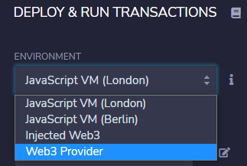

1. Remix IDE prompts you to enter the URL of the local Blockchain server (Ganache in this example). Enter the URL of Ganache: [**http://127.0.0.1:7545**](http://127.0.0.1:7545)

s

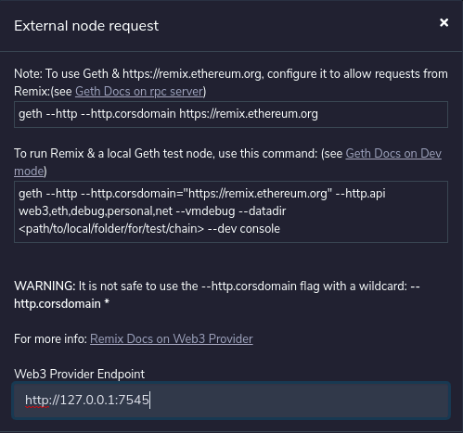

1. Once we enter the URL and press **Enter**, we shall observe that the connection is established with Ganache and a custom ID is generated

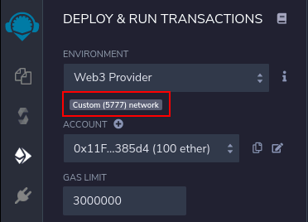

**Step 2: Connecting to the Ropsten testnet using Metamask and Injected Web3**

1. Click the **Deploy and run transactions** section again to change the execution environment to **Injected Web3** (This allows to connect to the testnet or mainnet)

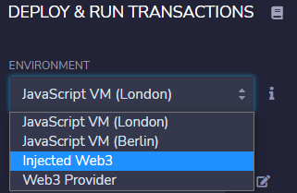

1. Selecting **Injected Web3** will open Metamask and prompt the user to select an account to execute the contracts. Select **Ropsten Test Network** in Metamask, select an account, and click on **Next**

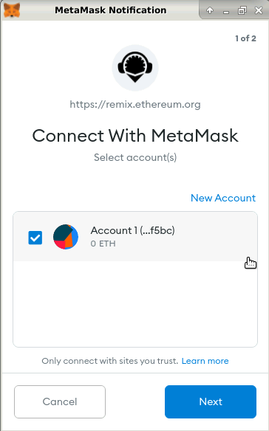

1. After you have verified the right account, click on **Connect** to link this account with Remix IDE and execute contracts

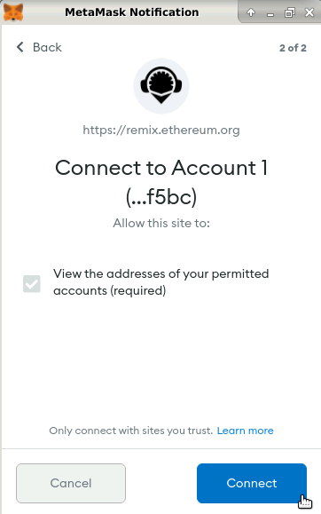

1. Once the account is connected to your IDE, it will display a connection prompt showing the network it is connected to

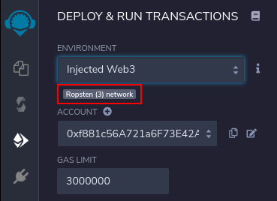

Remix IDE is now connected to Ganache and Ropsten test networks.