**Lesson 5 Demo 4**

**Exploring Ganache Blockchain**

|  |
| --- |
| **Objective:** To explore the features of Ganache and set up a local Blockchain  **Tools required:** Ubuntu, web browser, and Ganache  **Prerequisites:** None |

Steps to be followed:

1. Quickstarting the Ganache instance and exploring the network
2. Creating a private Blockchain in Ganache with custom parameters

**Step 1: Quickstarting the Ganache instance and exploring the network**

1. Open the Ganache application and click the **Quickstart** button

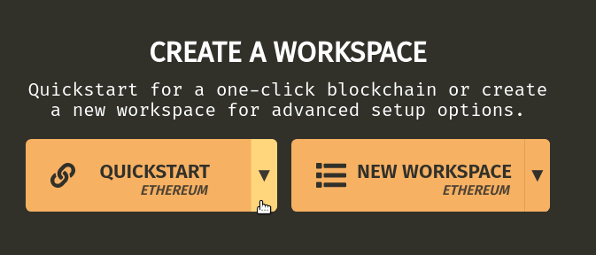

1. The **Quickstart** option creates a private Blockchain with 10 random accounts and uses all the default parameters. The user can connect this test Blockchain to their application and perform transactions

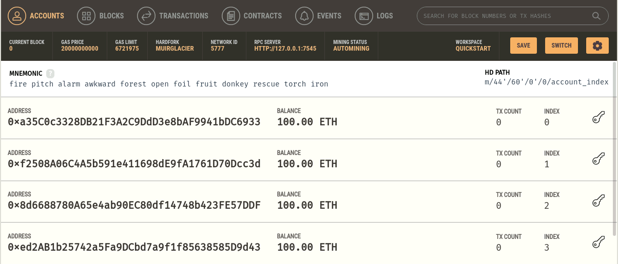

1. Navigate to the **Blocks** section and observe that only the **Genesis** block is created

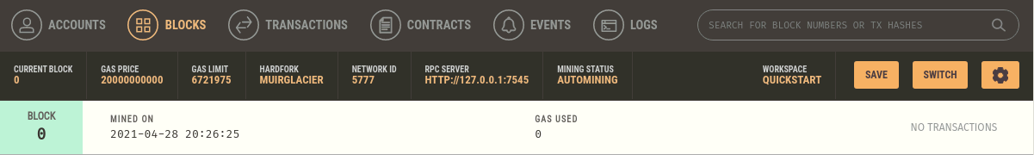

1. Navigate to the **Transactions** section and observe that it is empty as no transactions have taken place

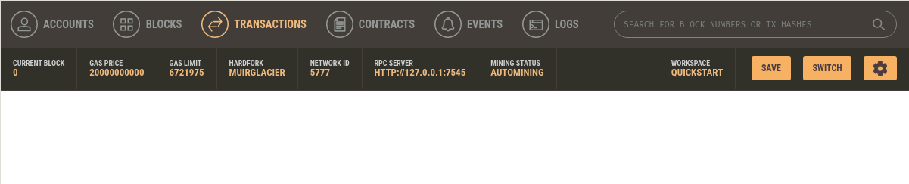

|  |
| --- |
| **Note**: These sections will be populated as more and more transactions take place |

**Step 2: Creating a private Blockchain in Ganache with custom parameters**

1. Open a new Ganache instance and click on the **New Workspace** option to create a custom Blockchain

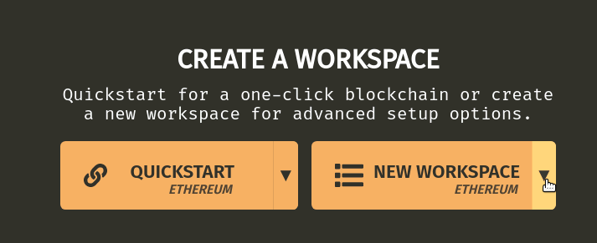

1. Ganache will request the name of the project. It can be named according to the user’s choice

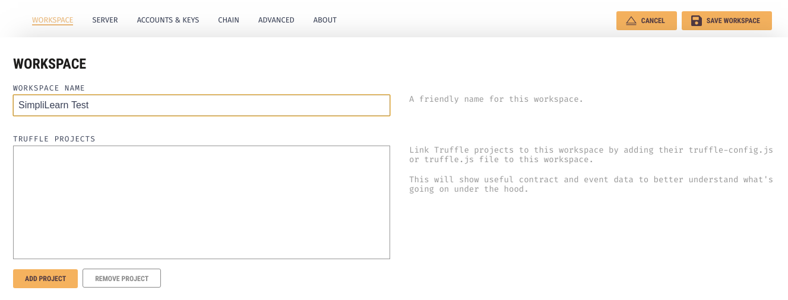

1. The users are now asked to adjust the network parameters by Ganache. The server URL is **127.0.0.1 -lo**, the port number is **7545**, and the Network ID is **5777**. The error logging and auto mine features are enabled

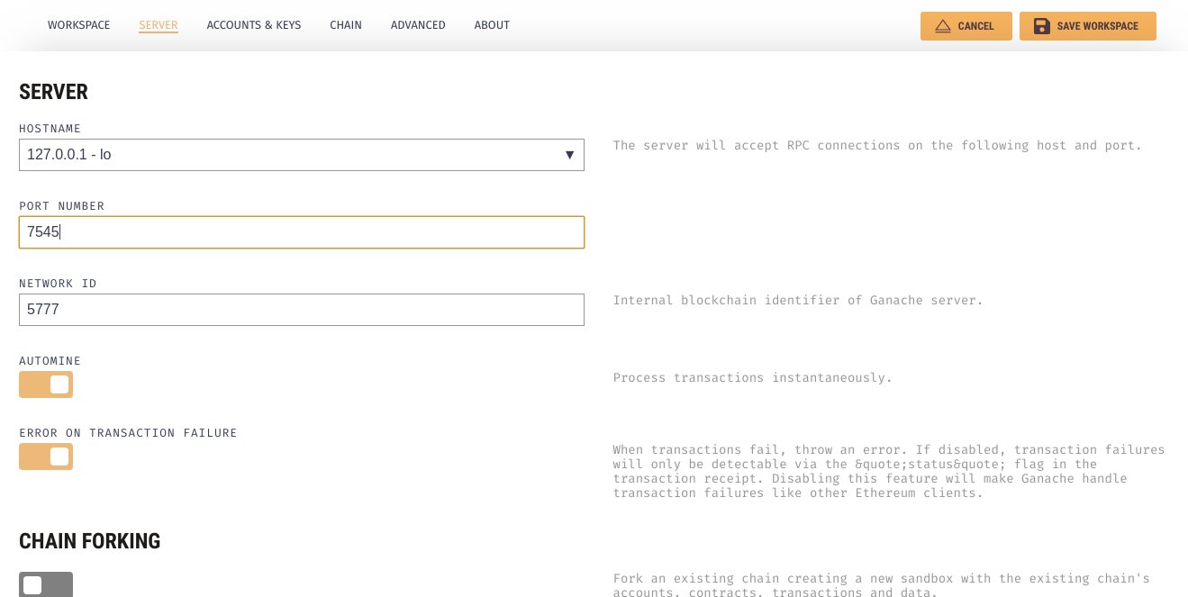

1. In the next section, we set the account parameters. The default balance is **200**, the number of accounts can be of the user’s choice, and the other options may be toggled on or off by the user

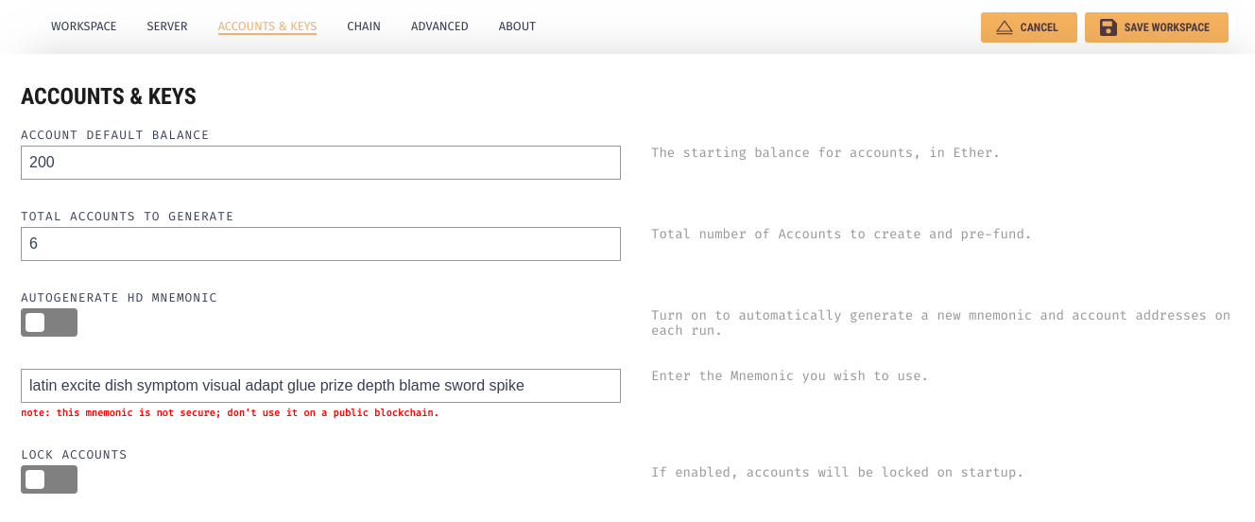

1. The Gas limit is set to an appropriate value, and the Gas price is also decided by the user. The value of Gas is **6721975** Gwei, and the Gas price is **20000000000**

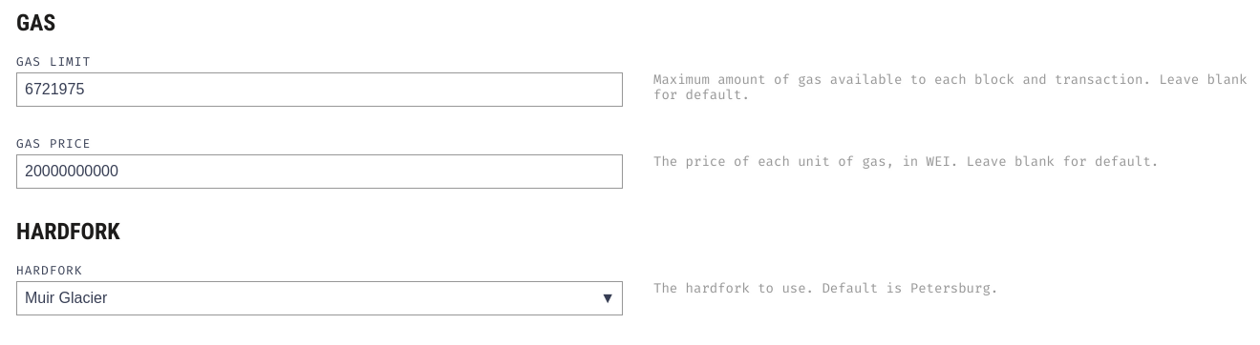

1. The last section is the advanced section, and we will not enable any of these options for representation

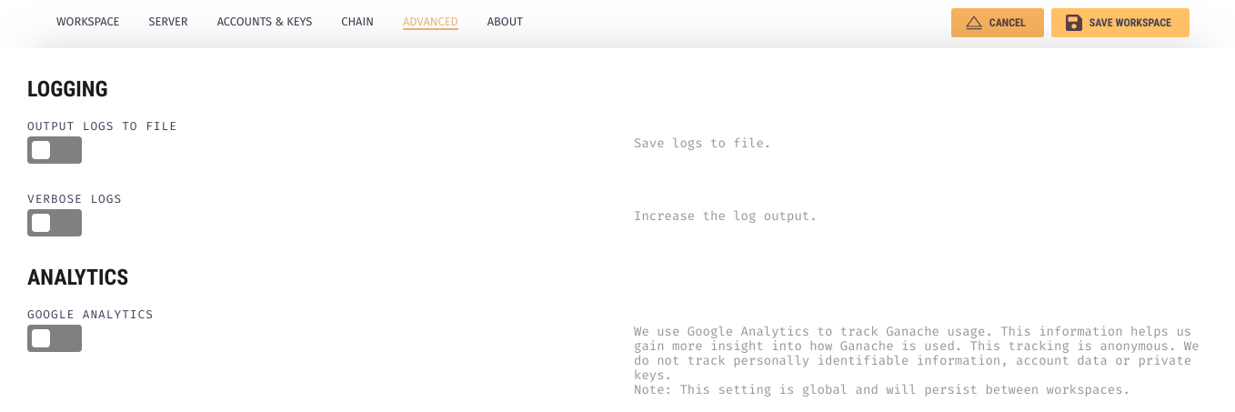

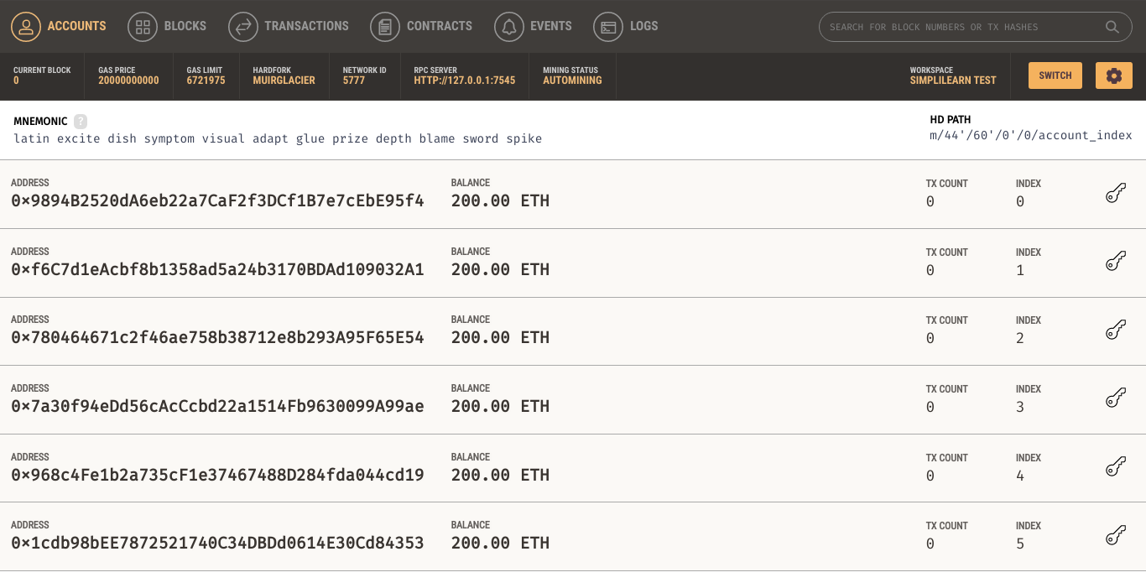

After all the parameters are set by the user according to their requirement, the Ganache Blockchain is ready to be used.