**Lesson 5 Demo 5**

**Install MetaMask and Set up the Wallet**

|  |
| --- |
| **Objective:** To install and set up the MetaMask wallet to perform transactions  **Tools required:** Ubuntu, Web browser, MetaMask  **Prerequisites:** None |

**Steps to be followed:**

1. Adding the Chrome extension to the browser
2. Setting up the account security and initializing a wallet account

**Step 1: Adding the Chrome extension to the browser**

1. Open the web browser and visit the Chrome web store at the provided URL: <https://chrome.google.com/webstore/detail/metamask/nkbihfbeogaeaoehlefnkodbefgpgknn/related>
2. Press the **Add to Chrome** button

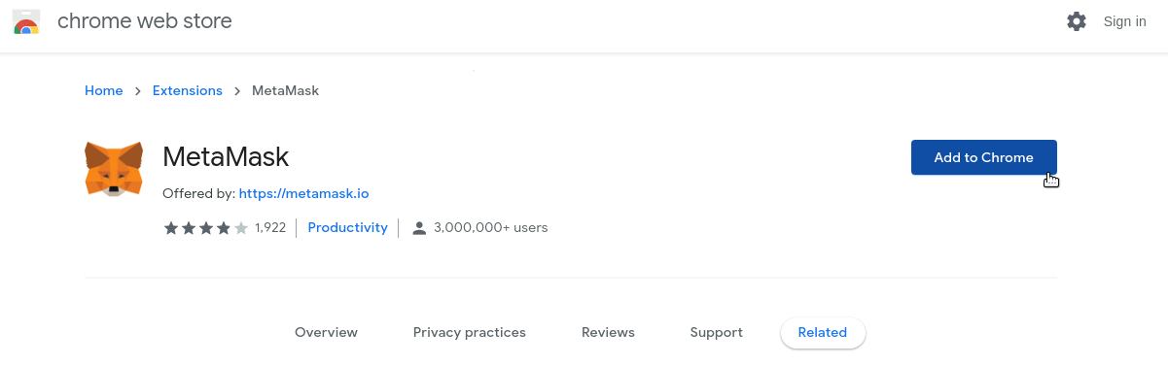

1. A dialog box will pop up asking if you want to add an extension. Click on the **Add extension** button to add MetaMask to Chrome

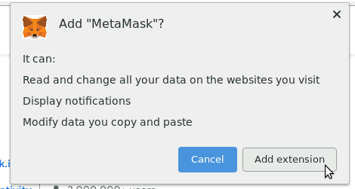

1. After adding the extension to Chrome, the MetaMask wallet is now active. Click on the **Get Started** button to start the wallet

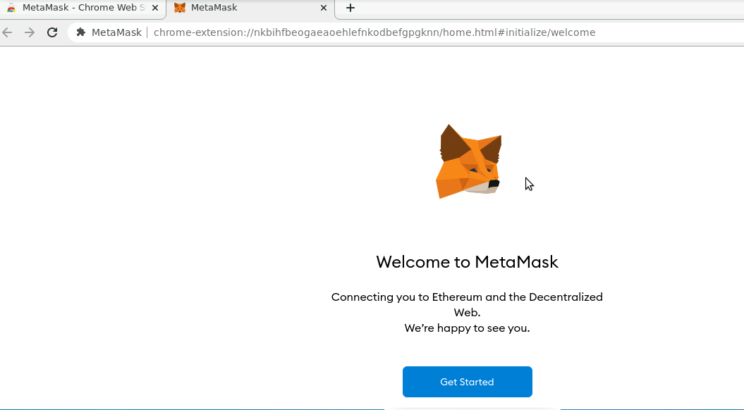

**Step 2: Setting up the account security and initializing a wallet account**

1. If you are creating a wallet for the first time, click on the **Create a Wallet** option.  
   If you already have an account, you can import that account by clicking on **Import Wallet** and entering the secret phrase

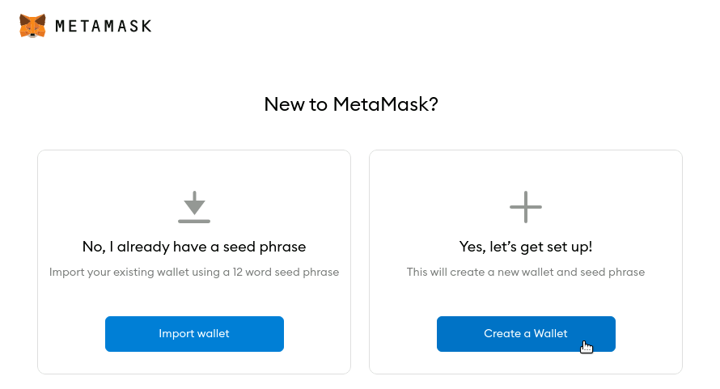

1. MetaMask will ask your permission to track your data usage, and you can enable or disable this tracking based on your preference

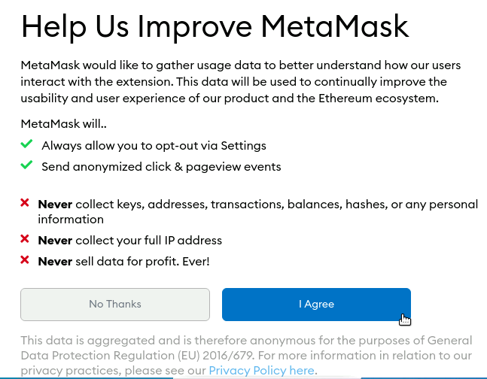

1. MetaMask will prompt you to create a new password. Create your password, read the **Terms of Use**, and then click on **Create** to generate a new Wallet account

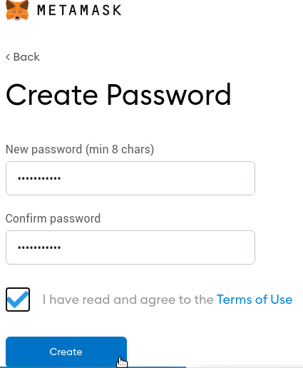

1. MetaMask will provide a secret phrase, store this securely. This will be used to log in to MetaMask from the next time

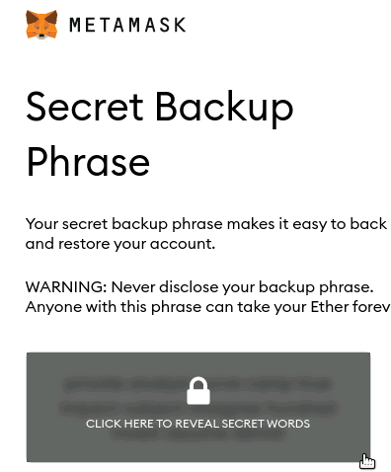

1. Enter the secret phrase in a prompt to securely log in to the wallet  
     
   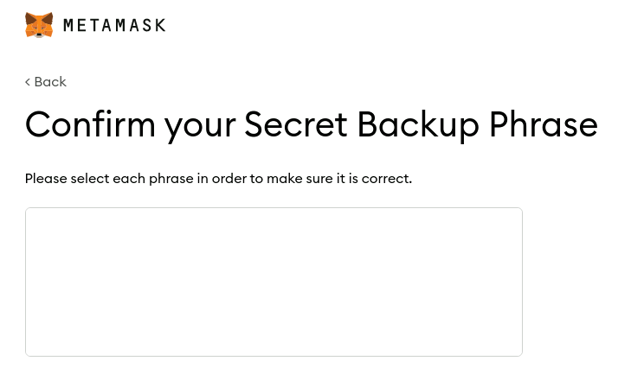
2. After the secret phrase is entered correctly, the MetaMask account is created successfully

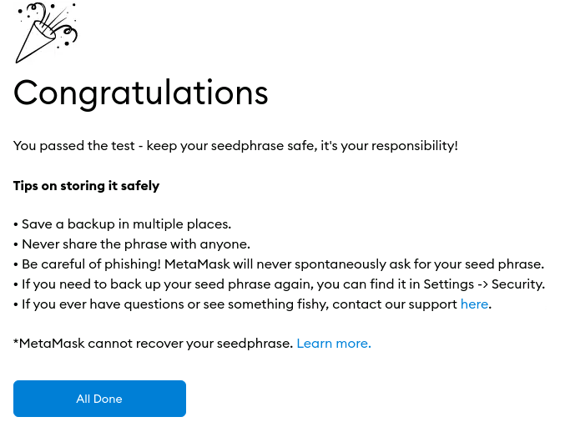

Once all the steps are completed, we will be redirected to our wallet to see our account information.

