**Lesson 5 Demo 6**

**Connecting MetaMask to a Ganache Test Network**

|  |
| --- |
| **Objective:** To connect the MetaMask wallet with the local Ganache network  **Tools required:** Ubuntu, Web browser, Ganache, MetaMask  **Prerequisites:** None |

**Steps to be followed:**

1. Configuring MetaMask to connect to the Ganache localhost
2. Adding an account from the local network to the wallet

**Step 1: Configuring MetaMask to connect to the Ganache localhost**

1. Open your MetaMask wallet and click the **Network** section

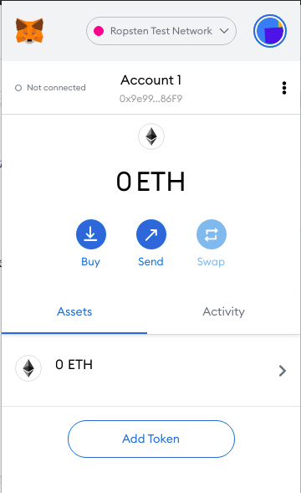

1. Select the **Custom RPC** option to connect to our local network

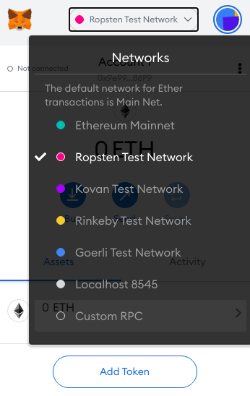

1. MetaMask will prompt you to enter the details of the custom network to be added

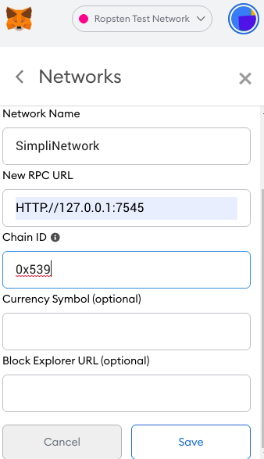

|  |
| --- |
| **Note**: For this demo, we will set the username as **SimpliNetwork**, the URL as **http://127.0.0.1:7545**, and the chain ID. |

1. The easiest method to find the chain ID is by copying the address of an account in the Ganache network and pasting it into the chain ID section



1. In an error prompt, MetaMask will return the corresponding chain ID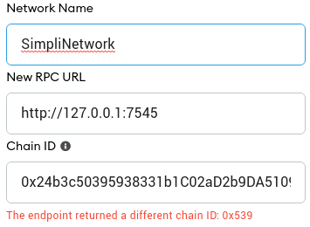

**Step 2: Adding an account from the local network to MetaMask**

1. Click the **My Accounts** section in the top-right corner and then the **Import Account** option

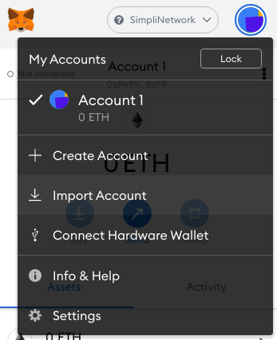

1. It will prompt to enter the private key of the account we intend to add

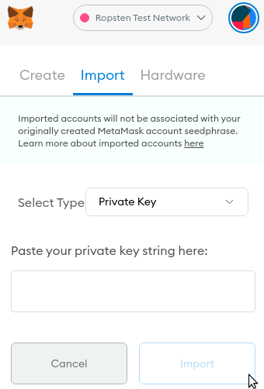

1. Switch to Ganache, select an account you want to add and select its **Show Keys** button



1. The private key of the account is revealed, and we must copy this key and paste it in the MetaMask prompt

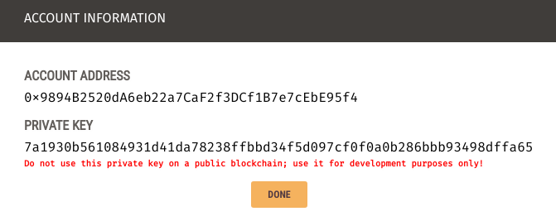

1. Once we have entered the correct private key, the account will be added to the wallet.

Now we can view the balance and perform transactions.

