**Lesson 5 Demo 7**

**Install Geth Client**

|  |
| --- |
| **Objective:** To install the Geth client in the local Linux instance  **Tools required:** Ubuntu, Terminal, and Geth  **Prerequisites:** None |

Steps to be followed:

1. Installing the Geth client using the terminal

**Step 1: Installing the Geth client using the terminal**

1. Open a new terminal and type the following command:

***sudo apt-get install software-properties-common***

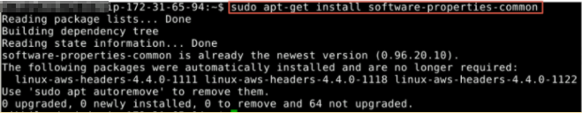

1. Type the following command in the terminal to add the Ethereum repository to your local library:

***sudo add-apt-repository -y ppa:ethereum/ethereum***

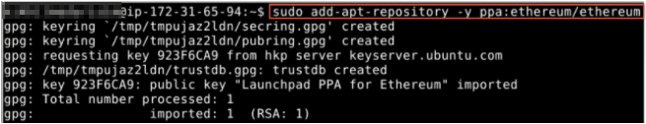

1. Update the existing package repository by typing the following command:

***sudo apt-get update***

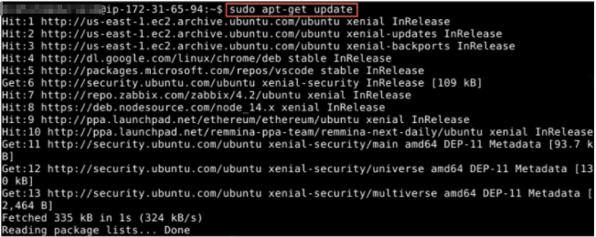

1. Install Ethereum by entering the following command:

***sudo apt-get install ethereum***

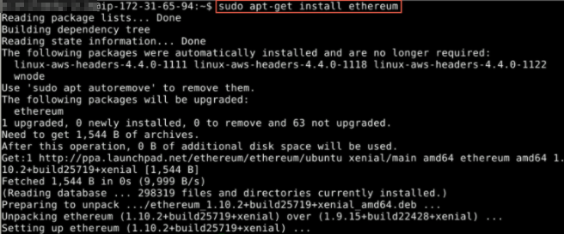

1. Type the following command to confirm the installation of Geth and check its version:

***geth version***

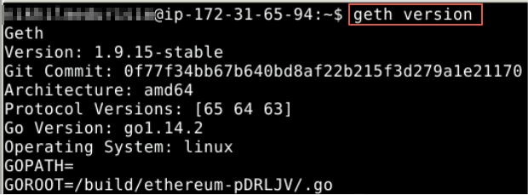

The Geth installation is complete.