**Lesson 6 Demo 3**

**Set up Hyperledger Fabric Prerequisites**

|  |
| --- |
| **Objective:** To install and set up the tools required for Hyperledger Fabric  **Tools required:** Ubuntu, Terminal  **Prerequisites:** None |

Steps to be followed:

1. Installing Curl in the local machine
2. Installing Node.js in the local machine
3. Installing Git in the local machine
4. Installing Python in the local machine
5. Installing Lib tools in the local machine
6. Downloading and installing Docker CE in the local machine
7. Setting up Docker Compose in the local machine

**Step 1: Installing Curl in the local machine**

1. Open a terminal and execute the following command to install Curl:

***sudo apt-get install curl***

1. Confirm the installation by checking the version. Execute the following command to check the version of Curl installed:

***curl --version***

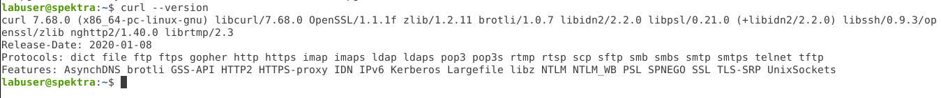

**Step 2: Installing Node.js in the local machine**

2.1 Download the latest version of Node by executing the following command:

***curl -sL https://deb.nodesource.com/setup_14.x | sudo -E bash***

2.2 Once the Node package is downloaded, update the Linux repository by executing the following command:

***sudo apt-get update***

2.3 Install the downloaded Node.js package by using the following command:

***sudo apt-get install nodejs***

2.4 We can confirm the installation by checking the version of Node using the following command:

***node --version***

**Step 3: Installing Git in the local machine**

3.1 Install Git on your machine by executing the following command:

***sudo apt-get install git***

3.2 We can confirm the installation of Git by checking the version using the following command:

***git --version***

**Step 4: Installing Python in the local machine**

4.1 Install Python on your machine by executing the following command:

***sudo apt-get install python***

4.2 After installation, we can check the version of Python using the following command:

***python --version***

**Step 5: Installing Libtools in the local machine**

* 1. Install the GNU Library tools on your machine by executing the following command:

***sudo apt-get install libltdl-dev***

**Step 6: Downloading and installing Docker CE in the local machine**

6.1 Download the stable version of Docker CE on your machine by executing the following command:

***wget https://download.docker.com/linux/ubuntu/dists/xenial/pool/stable/amd64/docker-ce_17.06.2~ce-0~ubuntu_amd64.deb***

6.2 Install the downloaded file using the following command:

***sudo dpkg -i docker-ce_17.06.2~ce-0~ubuntu_amd64.deb***

6.3 We can confirm the installation of Docker by checking its version. We must execute the following command:

***docker --version***

**Step 7: Installing Docker Compose in the local machine**

7.1 We must install pip3 in our system to install Docker Compose. We must execute the following command:

***sudo apt-get install python3-pip***

7.2 We can check the version of the pip by executing the following command:

***pip3 –version***



7.3 We now use pip3 to install Docker Compose by executing the following command:

***sudo pip3 install docker-compose***

7.4 After Docker Compose is installed, we can check its version by executing the following command:

***docker-compose version***

The Docker Compose installation is executed.