**Lesson 6 Demo 7**

**Setting up NodeJS**

|  |
| --- |
| **Objective:** To set up NodeJS  **Tools required:** Ubuntu and web browser  **Pre-requisites:** None |

Steps to be followed:

1. Creating a new directory
2. Opening the newly created directory
3. Creating a new file
4. Adding code in the file
5. Running the newly created file
6. Opening the URL to verify if the server is working

**Step 1: Creating a new directory using the given command**

***mkdir firstServer***

**Step 2: Opening the newly created directory**

***cd firstServer***

**Step 3: Creating a new file using the nano command**

***nano server.js***

**Step 4: Adding code to the file**

***var http = require ('http');***

***var port = 4000;***

***var server = http.createServer(function (request, response) {***

***response.writeHead(200, {'Content-Type': 'text/plain'});***

***response.end('First Server');***

***})***

***server.listen(port, function(){***

***console.log('server running at port 4000');***

***});***

Press **ctrl+X**, then **y** and enter to save the file

**Step 5: Running the newly created file**

***node server.js***

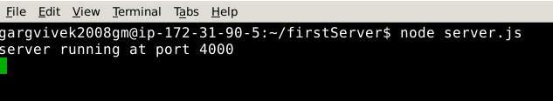

**Step 6: Opening the URL to verify if the server is working**

[***http://localhost:4000***](http://localhost:4000)

The server is working.