**Lesson 6 Demo 10**

**Create Web Application Using ExpressJs File Approach**

**Objective:** Create Web Application Using ExpressJs File Approach

**Tools required:** Ubuntu and web browser

**Prerequisites:** None

**Prerequisites:** None

Steps to be followed:

1. Create a new directory and install the express module

2. Create a new file and add the content

3. Execute the created file

**Step 1: Create a new directory and install the express module**

1.1 Run the given command to create a new directory

***mkdir expressjs***

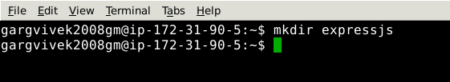

1.2 Open the newly created directory

***cd expressjs***

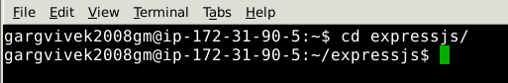

1.3 Install the express module using the given command

***npm install express --save***

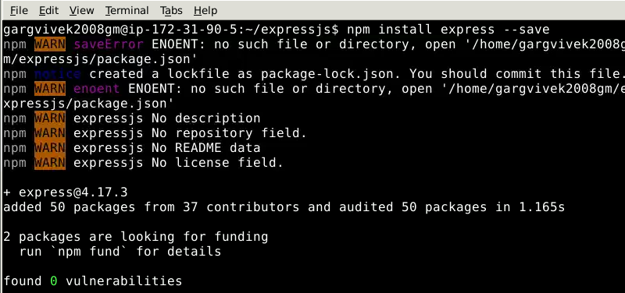

**Step 2: Create a new file and add the content**

2.1 Use the nano command with the name express.js file

***nano express.js***

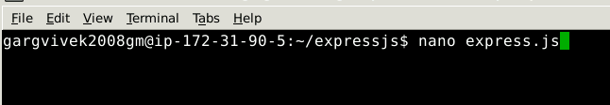

2.2 Paste the given content into the file

***var express = require('express');***

***var app = express();***

***var port = 5000;***

***app.get('/',function (request, response) {***

***response.send(“Hello World");***

***})***

***var server = app.listen(port , function () {***

***var host = server.address().address***

***var port = server.address().port***

***console.log("Sample app ay http://%s:%s", host, port)***

***});***

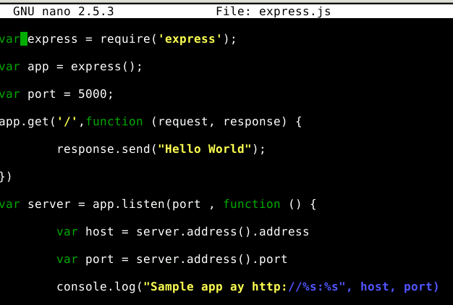

2.3 Press CTRL + X and then click on Y and enter to save the file

**Step 3: Execute the created file**

3.1 Run the newly created file

***node express.js***

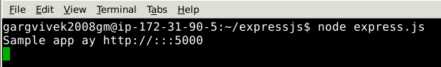

3.2 Click on the URL and verify if the app is working

[***http://localhost:5000***](http://localhost:5000)

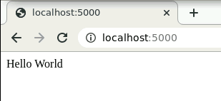

The app is working.