**Lesson 6 Demo 11**

**Create Web Application Using Expressjs Node Project Approach**

**Objective:** Create Web Application Using ExpressJs Node Project Approach

**Tools required:** Ubuntu, Web browser

**Prerequisites:** None

**Prerequisites:** None

**Steps to be followed:**

**1. Create a new directory**

**2. Set up a new node project and download the module**

**3 Create a new file and save that**

**4. Execute the created file**

**Step 1: Create a new directory**

1.1 Run the given command to create a new directory

***mkdir expressExample***

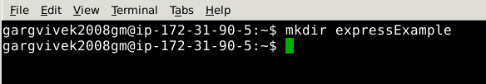

1.2 Go to the newly created directory by running the given command

***cd expressExample***

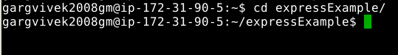

**Step 2: Set up a new node project and download the module**

2.1 Select default options while setting up the node project

***npm init***

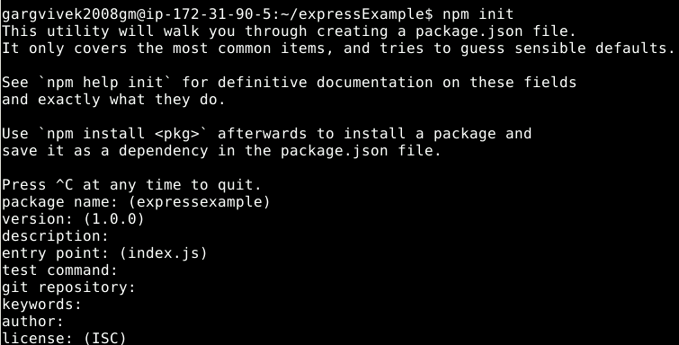

2.2 This creates a package.json file in the backend

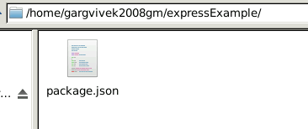

2.3 Open the package.json file and add the below content

***"dependencies": {***

***"express": "^4.17.1"***

}

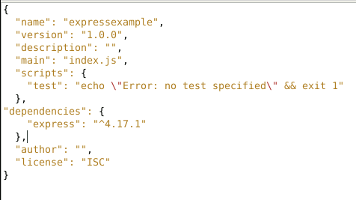

2.4 Use the given command to download the module.

***npm install***

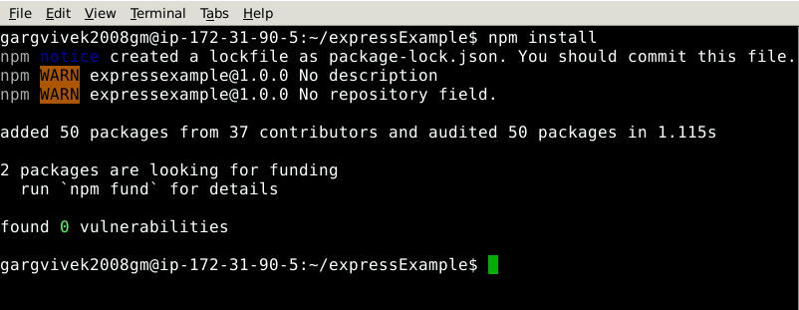

**Step 3: Create a new file and save it**

3.1 Run the below command to create a new file with the name express.js file

***nano express.js***

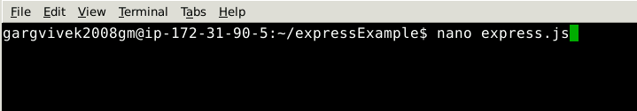

3.2 Paste the below content into the file

***var express = require('express');***

***var app = express();***

***var port = 5000;***

***app.get('/',function (request, response) {***

***response.send(“Hello World");***

***})***

***var server = app.listen(port , function () {***

***var host = server.address().address***

***var port = server.address().port***

***console.log("Sample app ay http://%s:%s", host, port)***

***});***

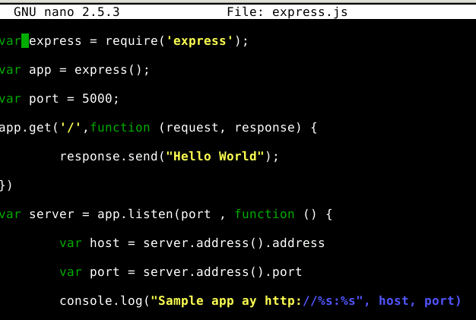

3.3 Press ctrl+X, then click on Y and Enter to save the file.

**Step 4: Execute the created file**

4.1 Run the newly created file.

***node express.js***

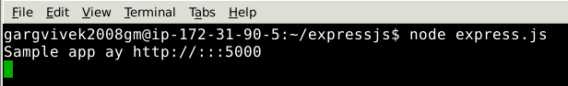

4.2 Go to the given URL to verify if the app is working

***http://localhost:5000***

