Supplementary text: Materials and Methods - Figures expression profiles (A case of insect female neoteny: E93 expression and links to the juvenile hormone in mealybugs)

Isabelle Vea

September 28, 2017

# Summary

You will find here all the analyses related to the statistics of hormonal treatments carried out in Vea et al. (submitted to Journal of Insect Biochemistry and Molecular Biology).

library(ggplot2)  
library(plyr)  
library(tidyr)

# Effect of pyriproxyfen treatment

## Data

#loading file JHM treatment  
#females  
dtf<-read.csv(file="E93-Pyr-N3D0.csv",header = TRUE)  
names(dtf)

## [1] "cDNA." "Compound" "Treatment" "TreatmentStage"  
## [5] "Sex" "DAT" "DayL" "N"   
## [9] "rpL32" "Kr.h1" "E93" "PkE93.1"   
## [13] "PkE93.2" "PkE93.3"

head(dtf)

## cDNA. Compound Treatment TreatmentStage Sex DAT DayL N rpL32  
## 1 203 Methanol Control N3D0 female 1 A 1 0.00281  
## 2 204 Methanol Control N3D0 female 1 A 1 0.00405  
## 3 205 Methanol Control N3D0 female 1 A 1 0.01160  
## 4 206 Methanol Control N3D0 female 1 A 1 0.00519  
## 5 281 Methanol Control N3D0 female 2 B 1 0.01247  
## 6 282 Methanol Control N3D0 female 2 B 1 0.00844  
## Kr.h1 E93 PkE93.1 PkE93.2 PkE93.3  
## 1 4.220e-05 9.750e-06 1.765e-06 3.333e-07 6.944e-08  
## 2 6.700e-05 1.810e-05 1.847e-06 3.363e-07 9.378e-08  
## 3 9.580e-05 3.810e-05 5.162e-06 1.081e-06 1.435e-07  
## 4 7.690e-05 2.780e-05 3.619e-06 5.923e-07 1.668e-07  
## 5 4.730e-05 2.261e-05 1.528e-06 4.653e-07 1.791e-07  
## 6 3.376e-05 1.156e-05 2.448e-07 1.614e-07 1.413e-07

dtf<-gather(dtf,Gene,SDM,10:14)  
#dtf  
head(dtf)

## cDNA. Compound Treatment TreatmentStage Sex DAT DayL N rpL32 Gene  
## 1 203 Methanol Control N3D0 female 1 A 1 0.00281 Kr.h1  
## 2 204 Methanol Control N3D0 female 1 A 1 0.00405 Kr.h1  
## 3 205 Methanol Control N3D0 female 1 A 1 0.01160 Kr.h1  
## 4 206 Methanol Control N3D0 female 1 A 1 0.00519 Kr.h1  
## 5 281 Methanol Control N3D0 female 2 B 1 0.01247 Kr.h1  
## 6 282 Methanol Control N3D0 female 2 B 1 0.00844 Kr.h1  
## SDM  
## 1 4.220e-05  
## 2 6.700e-05  
## 3 9.580e-05  
## 4 7.690e-05  
## 5 4.730e-05  
## 6 3.376e-05

#males  
dtm<-read.csv(file="E93-Pyr-male.csv",header = TRUE)  
names(dtm)

## [1] "Sample.ID" "treatment" "Day" "DayL" "Gene" "SDM.Gene"   
## [7] "SDM.rpL32"

head(dtm)

## Sample.ID treatment Day DayL Gene SDM.Gene SDM.rpL32  
## 1 299 Control 1 A Kr-h1 3.91e-05 0.00116  
## 2 300 Control 2 B Kr-h1 1.05e-05 0.00148  
## 3 301 Control 3 C Kr-h1 2.82e-06 0.00221  
## 4 302 Control 4 D Kr-h1 3.03e-06 0.00206  
## 5 303 Control 4 D Kr-h1 7.78e-06 0.00238  
## 6 304 Mimic 4 D Kr-h1 1.50e-04 0.00197

## Checking for data distribution

#female dataset subsetting to keep Kr-h1 and E93 1 and 2 subset from D4 to D8  
dtf<-subset(dtf, Gene=="Kr.h1" | Gene=="PkE93.1"| Gene=="PkE93.2"| Gene=="PkE93.3")  
dtf$Gene

## [1] "Kr.h1" "Kr.h1" "Kr.h1" "Kr.h1" "Kr.h1" "Kr.h1" "Kr.h1"   
## [8] "Kr.h1" "Kr.h1" "Kr.h1" "Kr.h1" "Kr.h1" "Kr.h1" "Kr.h1"   
## [15] "Kr.h1" "Kr.h1" "Kr.h1" "Kr.h1" "Kr.h1" "Kr.h1" "Kr.h1"   
## [22] "Kr.h1" "Kr.h1" "Kr.h1" "Kr.h1" "Kr.h1" "Kr.h1" "Kr.h1"   
## [29] "Kr.h1" "Kr.h1" "Kr.h1" "Kr.h1" "Kr.h1" "Kr.h1" "Kr.h1"   
## [36] "Kr.h1" "Kr.h1" "Kr.h1" "Kr.h1" "Kr.h1" "Kr.h1" "Kr.h1"   
## [43] "Kr.h1" "Kr.h1" "Kr.h1" "Kr.h1" "Kr.h1" "Kr.h1" "Kr.h1"   
## [50] "Kr.h1" "Kr.h1" "Kr.h1" "Kr.h1" "Kr.h1" "Kr.h1" "Kr.h1"   
## [57] "Kr.h1" "Kr.h1" "Kr.h1" "PkE93.1" "PkE93.1" "PkE93.1" "PkE93.1"  
## [64] "PkE93.1" "PkE93.1" "PkE93.1" "PkE93.1" "PkE93.1" "PkE93.1" "PkE93.1"  
## [71] "PkE93.1" "PkE93.1" "PkE93.1" "PkE93.1" "PkE93.1" "PkE93.1" "PkE93.1"  
## [78] "PkE93.1" "PkE93.1" "PkE93.1" "PkE93.1" "PkE93.1" "PkE93.1" "PkE93.1"  
## [85] "PkE93.1" "PkE93.1" "PkE93.1" "PkE93.1" "PkE93.1" "PkE93.1" "PkE93.1"  
## [92] "PkE93.1" "PkE93.1" "PkE93.1" "PkE93.1" "PkE93.1" "PkE93.1" "PkE93.1"  
## [99] "PkE93.1" "PkE93.1" "PkE93.1" "PkE93.1" "PkE93.1" "PkE93.1" "PkE93.1"  
## [106] "PkE93.1" "PkE93.1" "PkE93.1" "PkE93.1" "PkE93.1" "PkE93.1" "PkE93.1"  
## [113] "PkE93.1" "PkE93.1" "PkE93.1" "PkE93.1" "PkE93.1" "PkE93.1" "PkE93.2"  
## [120] "PkE93.2" "PkE93.2" "PkE93.2" "PkE93.2" "PkE93.2" "PkE93.2" "PkE93.2"  
## [127] "PkE93.2" "PkE93.2" "PkE93.2" "PkE93.2" "PkE93.2" "PkE93.2" "PkE93.2"  
## [134] "PkE93.2" "PkE93.2" "PkE93.2" "PkE93.2" "PkE93.2" "PkE93.2" "PkE93.2"  
## [141] "PkE93.2" "PkE93.2" "PkE93.2" "PkE93.2" "PkE93.2" "PkE93.2" "PkE93.2"  
## [148] "PkE93.2" "PkE93.2" "PkE93.2" "PkE93.2" "PkE93.2" "PkE93.2" "PkE93.2"  
## [155] "PkE93.2" "PkE93.2" "PkE93.2" "PkE93.2" "PkE93.2" "PkE93.2" "PkE93.2"  
## [162] "PkE93.2" "PkE93.2" "PkE93.2" "PkE93.2" "PkE93.2" "PkE93.2" "PkE93.2"  
## [169] "PkE93.2" "PkE93.2" "PkE93.2" "PkE93.2" "PkE93.2" "PkE93.2" "PkE93.2"  
## [176] "PkE93.2" "PkE93.2" "PkE93.3" "PkE93.3" "PkE93.3" "PkE93.3" "PkE93.3"  
## [183] "PkE93.3" "PkE93.3" "PkE93.3" "PkE93.3" "PkE93.3" "PkE93.3" "PkE93.3"  
## [190] "PkE93.3" "PkE93.3" "PkE93.3" "PkE93.3" "PkE93.3" "PkE93.3" "PkE93.3"  
## [197] "PkE93.3" "PkE93.3" "PkE93.3" "PkE93.3" "PkE93.3" "PkE93.3" "PkE93.3"  
## [204] "PkE93.3" "PkE93.3" "PkE93.3" "PkE93.3" "PkE93.3" "PkE93.3" "PkE93.3"  
## [211] "PkE93.3" "PkE93.3" "PkE93.3" "PkE93.3" "PkE93.3" "PkE93.3" "PkE93.3"  
## [218] "PkE93.3" "PkE93.3" "PkE93.3" "PkE93.3" "PkE93.3" "PkE93.3" "PkE93.3"  
## [225] "PkE93.3" "PkE93.3" "PkE93.3" "PkE93.3" "PkE93.3" "PkE93.3" "PkE93.3"  
## [232] "PkE93.3" "PkE93.3" "PkE93.3" "PkE93.3" "PkE93.3"

dtf$DAT

## [1] 1 1 1 1 2 2 2 3 3 3 4 4 4 5 5 5 6 6 6 7 7 7 8 8 8 8 8 8 8 1 1 1 1 2 2  
## [36] 2 3 3 3 4 4 4 5 5 5 6 6 6 7 7 7 8 8 8 8 8 8 8 8 1 1 1 1 2 2 2 3 3 3 4  
## [71] 4 4 5 5 5 6 6 6 7 7 7 8 8 8 8 8 8 8 1 1 1 1 2 2 2 3 3 3 4 4 4 5 5 5 6  
## [106] 6 6 7 7 7 8 8 8 8 8 8 8 8 1 1 1 1 2 2 2 3 3 3 4 4 4 5 5 5 6 6 6 7 7 7  
## [141] 8 8 8 8 8 8 8 1 1 1 1 2 2 2 3 3 3 4 4 4 5 5 5 6 6 6 7 7 7 8 8 8 8 8 8  
## [176] 8 8 1 1 1 1 2 2 2 3 3 3 4 4 4 5 5 5 6 6 6 7 7 7 8 8 8 8 8 8 8 1 1 1 1  
## [211] 2 2 2 3 3 3 4 4 4 5 5 5 6 6 6 7 7 7 8 8 8 8 8 8 8 8

### Comparing the absolute amount of reference gene between treatments

dtfbox_RPL32 <- ggplot(dtf,aes(x=Treatment,y=rpL32)) + geom_boxplot(width=0.5, size=0.2, outlier.size = 0.1)  
  
dtfbox_RPL32

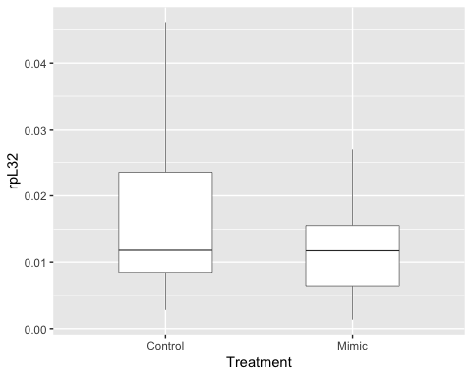

hist(dtf$rpL32)

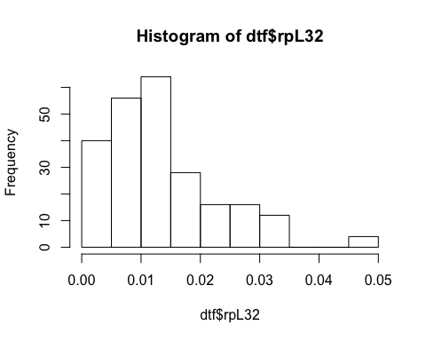

hist(log10(dtf$rpL32))

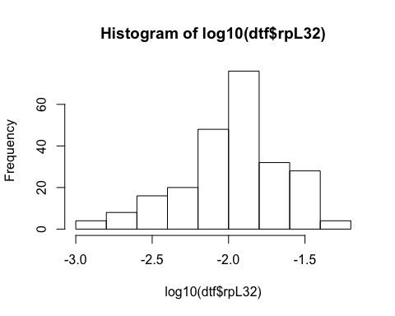

#test normality  
shapiro.test(dtf$rpL32) ## not normal distribution

##   
## Shapiro-Wilk normality test  
##   
## data: dtf$rpL32  
## W = 0.90843, p-value = 7.701e-11

#non parametric test, Mann Whitney U test  
wilcox.test(data=dtf, dtf$rpL32~dtf$Treatment, paired=FALSE) ## difference not significant

##   
## Wilcoxon rank sum test with continuity correction  
##   
## data: dtf$rpL32 by dtf$Treatment  
## W = 8056, p-value = 0.03665  
## alternative hypothesis: true location shift is not equal to 0

### Female dataset for PkKr-h1

#all female dataset Kr-h1  
dtfkrh1<-subset(dtf, Gene=="Kr.h1")  
dtfkrh1$Gene

## [1] "Kr.h1" "Kr.h1" "Kr.h1" "Kr.h1" "Kr.h1" "Kr.h1" "Kr.h1" "Kr.h1"  
## [9] "Kr.h1" "Kr.h1" "Kr.h1" "Kr.h1" "Kr.h1" "Kr.h1" "Kr.h1" "Kr.h1"  
## [17] "Kr.h1" "Kr.h1" "Kr.h1" "Kr.h1" "Kr.h1" "Kr.h1" "Kr.h1" "Kr.h1"  
## [25] "Kr.h1" "Kr.h1" "Kr.h1" "Kr.h1" "Kr.h1" "Kr.h1" "Kr.h1" "Kr.h1"  
## [33] "Kr.h1" "Kr.h1" "Kr.h1" "Kr.h1" "Kr.h1" "Kr.h1" "Kr.h1" "Kr.h1"  
## [41] "Kr.h1" "Kr.h1" "Kr.h1" "Kr.h1" "Kr.h1" "Kr.h1" "Kr.h1" "Kr.h1"  
## [49] "Kr.h1" "Kr.h1" "Kr.h1" "Kr.h1" "Kr.h1" "Kr.h1" "Kr.h1" "Kr.h1"  
## [57] "Kr.h1" "Kr.h1" "Kr.h1"

hist(dtfkrh1$SDM/dtfkrh1$rpL32, main="Distribution of all data PkKr-h1/rpL32, regardless of treatment type")#not normal

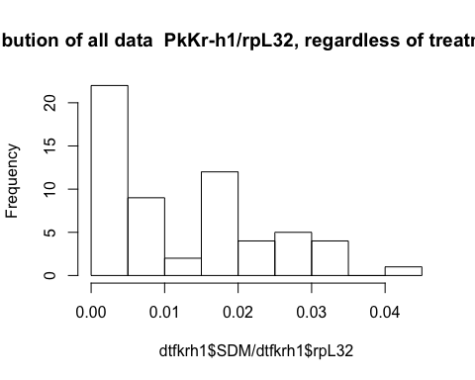

The distribution of qPCR data collected for relative expression of PkKr-h1 is not normal. We decided to transform the data to log10.

#log transformed  
hist(log10(dtfkrh1$SDM/dtfkrh1$rpL32)) #more or less normal

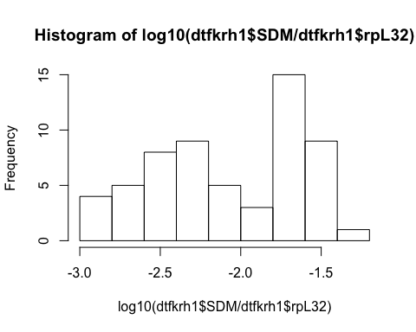

We also checked data distribution by treatment

#by treatment  
dtfkrh1CT<-subset(dtfkrh1,Treatment=="Control")  
dtfkrh1CT$Treatment

## [1] Control Control Control Control Control Control Control Control  
## [9] Control Control Control Control Control Control Control Control  
## [17] Control Control Control Control Control Control Control Control  
## [25] Control Control Control Control Control  
## Levels: Control Mimic

dtfkrh1JHM<-subset(dtfkrh1,Treatment=="Mimic")  
dtfkrh1JHM$Treatment

## [1] Mimic Mimic Mimic Mimic Mimic Mimic Mimic Mimic Mimic Mimic Mimic  
## [12] Mimic Mimic Mimic Mimic Mimic Mimic Mimic Mimic Mimic Mimic Mimic  
## [23] Mimic Mimic Mimic Mimic Mimic Mimic Mimic Mimic  
## Levels: Control Mimic

hist(dtfkrh1CT$SDM/dtfkrh1CT$rpL32, main="Distribution of PkKr-h1/rpL32 data, including only control treatments")

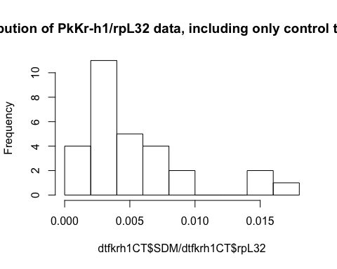

hist(dtfkrh1JHM$SDM/dtfkrh1JHM$rpL32, main="Distribution of PkKr-h1/rpL32 data, including only mimic treatments")

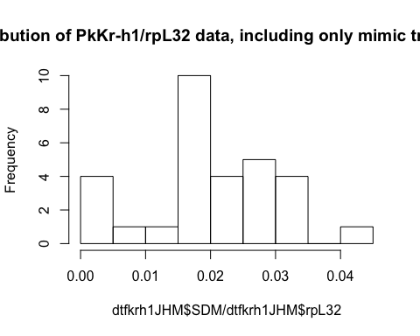

#log transformed  
hist(log10(dtfkrh1CT$SDM/dtfkrh1CT$rpL32)) #ok

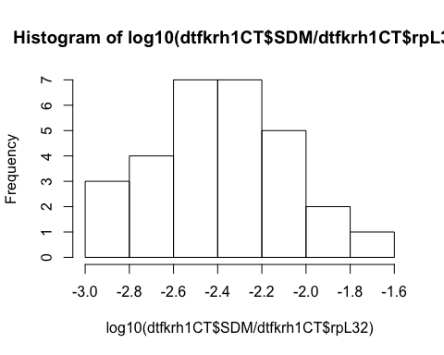

hist(log10(dtfkrh1JHM$SDM/dtfkrh1JHM$rpL32)) #skewed normal

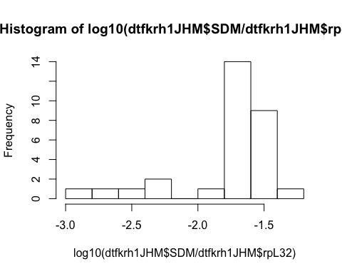

#all female dataset E93 1  
  
dtfE931<-subset(dtf, Gene=="PkE93.1")  
dtfE931$Gene

## [1] "PkE93.1" "PkE93.1" "PkE93.1" "PkE93.1" "PkE93.1" "PkE93.1" "PkE93.1"  
## [8] "PkE93.1" "PkE93.1" "PkE93.1" "PkE93.1" "PkE93.1" "PkE93.1" "PkE93.1"  
## [15] "PkE93.1" "PkE93.1" "PkE93.1" "PkE93.1" "PkE93.1" "PkE93.1" "PkE93.1"  
## [22] "PkE93.1" "PkE93.1" "PkE93.1" "PkE93.1" "PkE93.1" "PkE93.1" "PkE93.1"  
## [29] "PkE93.1" "PkE93.1" "PkE93.1" "PkE93.1" "PkE93.1" "PkE93.1" "PkE93.1"  
## [36] "PkE93.1" "PkE93.1" "PkE93.1" "PkE93.1" "PkE93.1" "PkE93.1" "PkE93.1"  
## [43] "PkE93.1" "PkE93.1" "PkE93.1" "PkE93.1" "PkE93.1" "PkE93.1" "PkE93.1"  
## [50] "PkE93.1" "PkE93.1" "PkE93.1" "PkE93.1" "PkE93.1" "PkE93.1" "PkE93.1"  
## [57] "PkE93.1" "PkE93.1" "PkE93.1"

hist(dtfE931$SDM/dtfE931$rpL32) #distribution not normal

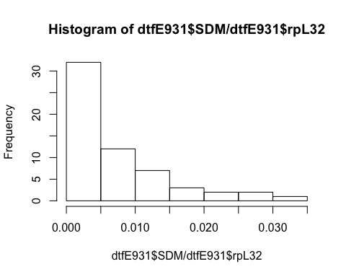

#log transformed  
hist(log10(dtfE931$SDM/dtfE931$rpL32))

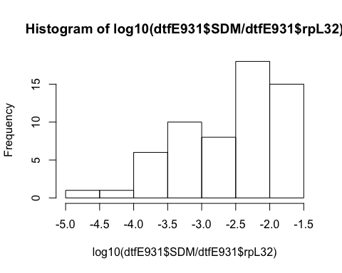

#by treatment  
dtfE931CT<-subset(dtfE931,Treatment=="Control")  
dtfE931CT$Treatment

## [1] Control Control Control Control Control Control Control Control  
## [9] Control Control Control Control Control Control Control Control  
## [17] Control Control Control Control Control Control Control Control  
## [25] Control Control Control Control Control  
## Levels: Control Mimic

dtfE931JHM<-subset(dtfE931,Treatment=="Mimic")  
dtfE931JHM$Treatment

## [1] Mimic Mimic Mimic Mimic Mimic Mimic Mimic Mimic Mimic Mimic Mimic  
## [12] Mimic Mimic Mimic Mimic Mimic Mimic Mimic Mimic Mimic Mimic Mimic  
## [23] Mimic Mimic Mimic Mimic Mimic Mimic Mimic Mimic  
## Levels: Control Mimic

hist(dtfE931CT$SDM/dtfE931CT$rpL32) #not normal

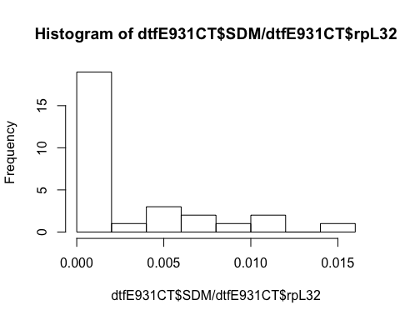

hist(dtfE931JHM$SDM/dtfE931JHM$rpL32)

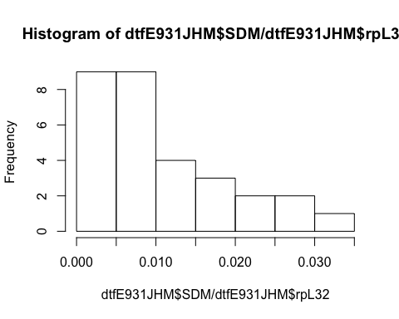

#log transformed  
hist(log10(dtfE931CT$SDM/dtfE931CT$rpL32)) #two peaks

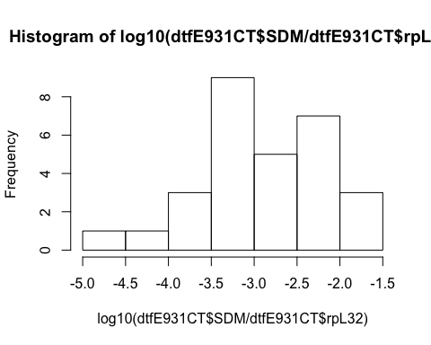

hist(log10(dtfE931JHM$SDM/dtfE931JHM$rpL32)) #weird!

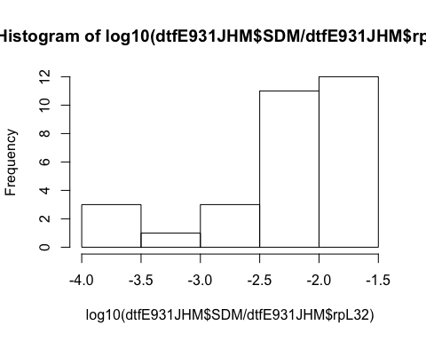

#all female dataset E93 1  
dtfE932<-subset(dtf, Gene=="PkE93.2")  
dtfE932$Gene

## [1] "PkE93.2" "PkE93.2" "PkE93.2" "PkE93.2" "PkE93.2" "PkE93.2" "PkE93.2"  
## [8] "PkE93.2" "PkE93.2" "PkE93.2" "PkE93.2" "PkE93.2" "PkE93.2" "PkE93.2"  
## [15] "PkE93.2" "PkE93.2" "PkE93.2" "PkE93.2" "PkE93.2" "PkE93.2" "PkE93.2"  
## [22] "PkE93.2" "PkE93.2" "PkE93.2" "PkE93.2" "PkE93.2" "PkE93.2" "PkE93.2"  
## [29] "PkE93.2" "PkE93.2" "PkE93.2" "PkE93.2" "PkE93.2" "PkE93.2" "PkE93.2"  
## [36] "PkE93.2" "PkE93.2" "PkE93.2" "PkE93.2" "PkE93.2" "PkE93.2" "PkE93.2"  
## [43] "PkE93.2" "PkE93.2" "PkE93.2" "PkE93.2" "PkE93.2" "PkE93.2" "PkE93.2"  
## [50] "PkE93.2" "PkE93.2" "PkE93.2" "PkE93.2" "PkE93.2" "PkE93.2" "PkE93.2"  
## [57] "PkE93.2" "PkE93.2" "PkE93.2"

hist(dtfE932$SDM/dtfE932$rpL32) #distribution not normal

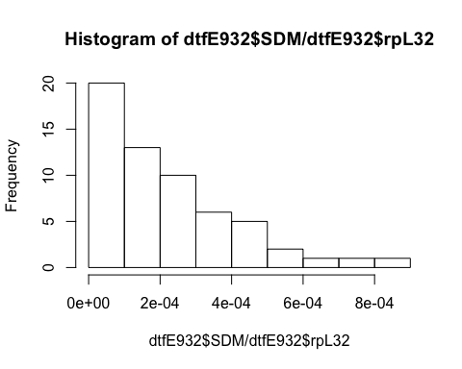

#log transformed  
hist(log10(dtfE932$SDM/dtfE932$rpL32) )

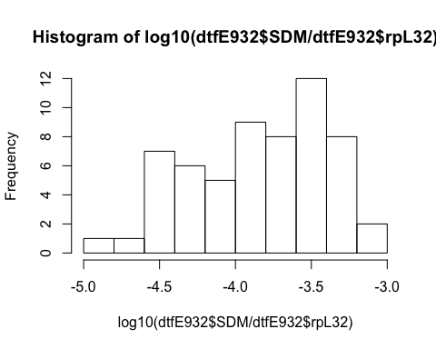

#by treatment  
dtfE932CT<-subset(dtfE931,Treatment=="Control")  
dtfE932CT$Treatment

## [1] Control Control Control Control Control Control Control Control  
## [9] Control Control Control Control Control Control Control Control  
## [17] Control Control Control Control Control Control Control Control  
## [25] Control Control Control Control Control  
## Levels: Control Mimic

dtfE932JHM<-subset(dtfE931,Treatment=="Mimic")  
dtfE931JHM$Treatment

## [1] Mimic Mimic Mimic Mimic Mimic Mimic Mimic Mimic Mimic Mimic Mimic  
## [12] Mimic Mimic Mimic Mimic Mimic Mimic Mimic Mimic Mimic Mimic Mimic  
## [23] Mimic Mimic Mimic Mimic Mimic Mimic Mimic Mimic  
## Levels: Control Mimic

hist(dtfE931CT$SDM/dtfE931CT$rpL32) #not normal



hist(dtfE931JHM$SDM/dtfE931JHM$rpL32)



#log transformed  
hist(log10(dtfE931CT$SDM/dtfE931CT$rpL32)) #two peaks



hist(log10(dtfE931JHM$SDM/dtfE931JHM$rpL32)) #weird!



#male dataset subset Krh1 and E93 1  
head(dtm)

## Sample.ID treatment Day DayL Gene SDM.Gene SDM.rpL32  
## 1 299 Control 1 A Kr-h1 3.91e-05 0.00116  
## 2 300 Control 2 B Kr-h1 1.05e-05 0.00148  
## 3 301 Control 3 C Kr-h1 2.82e-06 0.00221  
## 4 302 Control 4 D Kr-h1 3.03e-06 0.00206  
## 5 303 Control 4 D Kr-h1 7.78e-06 0.00238  
## 6 304 Mimic 4 D Kr-h1 1.50e-04 0.00197

#subsetting Kr-h1 and E93 1  
dtm<-subset(dtm, Gene=="Kr-h1" | Gene=="PkE93-1"| Gene=="PkE93-2"| Gene=="PkE93-3")  
dtm$Gene

## [1] Kr-h1 Kr-h1 Kr-h1 Kr-h1 Kr-h1 Kr-h1 Kr-h1 Kr-h1   
## [9] Kr-h1 Kr-h1 Kr-h1 Kr-h1 Kr-h1 Kr-h1 Kr-h1 Kr-h1   
## [17] Kr-h1 Kr-h1 Kr-h1 Kr-h1 Kr-h1 Kr-h1 Kr-h1 Kr-h1   
## [25] Kr-h1 Kr-h1 Kr-h1 Kr-h1 Kr-h1 Kr-h1 Kr-h1 Kr-h1   
## [33] Kr-h1 Kr-h1 Kr-h1 Kr-h1 Kr-h1 Kr-h1 Kr-h1 Kr-h1   
## [41] Kr-h1 Kr-h1 Kr-h1 Kr-h1 PkE93-1 PkE93-1 PkE93-1 PkE93-1  
## [49] PkE93-1 PkE93-1 PkE93-1 PkE93-1 PkE93-1 PkE93-1 PkE93-1 PkE93-1  
## [57] PkE93-1 PkE93-1 PkE93-1 PkE93-1 PkE93-1 PkE93-1 PkE93-1 PkE93-1  
## [65] PkE93-1 PkE93-1 PkE93-1 PkE93-1 PkE93-1 PkE93-1 PkE93-1 PkE93-1  
## [73] PkE93-1 PkE93-1 PkE93-1 PkE93-1 PkE93-1 PkE93-1 PkE93-1 PkE93-1  
## [81] PkE93-1 PkE93-1 PkE93-1 PkE93-1 PkE93-1 PkE93-1 PkE93-1 PkE93-1  
## [89] PkE93-2 PkE93-2 PkE93-2 PkE93-2 PkE93-2 PkE93-2 PkE93-2 PkE93-2  
## [97] PkE93-2 PkE93-2 PkE93-2 PkE93-2 PkE93-2 PkE93-2 PkE93-2 PkE93-2  
## [105] PkE93-2 PkE93-2 PkE93-2 PkE93-2 PkE93-2 PkE93-2 PkE93-2 PkE93-2  
## [113] PkE93-2 PkE93-2 PkE93-2 PkE93-2 PkE93-2 PkE93-2 PkE93-2 PkE93-2  
## [121] PkE93-2 PkE93-2 PkE93-2 PkE93-2 PkE93-2 PkE93-2 PkE93-2 PkE93-2  
## [129] PkE93-2 PkE93-2 PkE93-2 PkE93-2 PkE93-3 PkE93-3 PkE93-3 PkE93-3  
## [137] PkE93-3 PkE93-3 PkE93-3 PkE93-3 PkE93-3 PkE93-3 PkE93-3 PkE93-3  
## [145] PkE93-3 PkE93-3 PkE93-3 PkE93-3 PkE93-3 PkE93-3 PkE93-3 PkE93-3  
## [153] PkE93-3 PkE93-3 PkE93-3 PkE93-3 PkE93-3 PkE93-3 PkE93-3 PkE93-3  
## [161] PkE93-3 PkE93-3 PkE93-3 PkE93-3 PkE93-3 PkE93-3 PkE93-3 PkE93-3  
## [169] PkE93-3 PkE93-3 PkE93-3 PkE93-3 PkE93-3 PkE93-3 PkE93-3 PkE93-3  
## Levels: Kr-h1 PkE93-1 PkE93-2 PkE93-3

dtm$Day

## [1] 1 2 3 4 4 4 4 6 5 5 5 5 5 5 5 5 5 5 5 5 4 4 6 6 6 4 4 6 6 2 2 2 2 2 3  
## [36] 3 3 3 3 1 1 1 1 1 1 2 3 4 4 4 4 6 5 5 5 5 5 5 5 5 5 5 5 5 4 4 6 6 6 4  
## [71] 4 6 6 2 2 2 2 2 3 3 3 3 3 1 1 1 1 1 1 2 3 4 4 4 4 6 5 5 5 5 5 5 5 5 5  
## [106] 5 5 5 4 4 6 6 6 4 4 6 6 2 2 2 2 2 3 3 3 3 3 1 1 1 1 1 1 2 3 4 4 4 4 6  
## [141] 5 5 5 5 5 5 5 5 5 5 5 5 4 4 6 6 6 4 4 6 6 2 2 2 2 2 3 3 3 3 3 1 1 1 1  
## [176] 1

#all male krh1  
dtmkrh1<-subset(dtm, Gene=="Kr-h1")  
dtmkrh1$Gene

## [1] Kr-h1 Kr-h1 Kr-h1 Kr-h1 Kr-h1 Kr-h1 Kr-h1 Kr-h1 Kr-h1 Kr-h1 Kr-h1  
## [12] Kr-h1 Kr-h1 Kr-h1 Kr-h1 Kr-h1 Kr-h1 Kr-h1 Kr-h1 Kr-h1 Kr-h1 Kr-h1  
## [23] Kr-h1 Kr-h1 Kr-h1 Kr-h1 Kr-h1 Kr-h1 Kr-h1 Kr-h1 Kr-h1 Kr-h1 Kr-h1  
## [34] Kr-h1 Kr-h1 Kr-h1 Kr-h1 Kr-h1 Kr-h1 Kr-h1 Kr-h1 Kr-h1 Kr-h1 Kr-h1  
## Levels: Kr-h1 PkE93-1 PkE93-2 PkE93-3

names(dtmkrh1)

## [1] "Sample.ID" "treatment" "Day" "DayL" "Gene" "SDM.Gene"   
## [7] "SDM.rpL32"

hist(dtmkrh1$SDM.Gene/dtmkrh1$SDM.rpL32) #not normally distributed

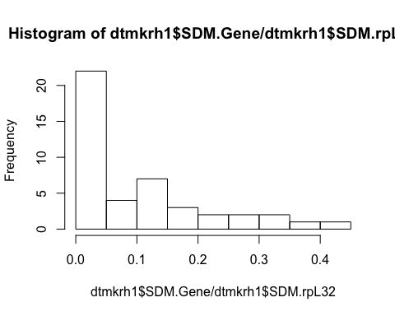

#log transformed  
hist(log10(dtmkrh1$SDM.Gene/dtmkrh1$SDM.rpL32)) #not normally distributed

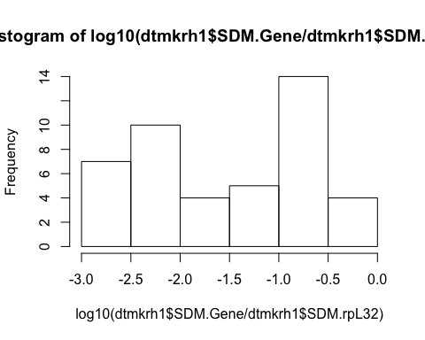

#male Krh1 by treatment  
#by treatment  
dtmkrh1CT<-subset(dtmkrh1,treatment=="Control")  
dtmkrh1CT$treatment

## [1] Control Control Control Control Control Control Control Control  
## [9] Control Control Control Control Control Control Control Control  
## [17] Control Control Control Control Control Control  
## Levels: Control Mimic

dtmkrh1JHM<-subset(dtmkrh1,treatment=="Mimic")  
dtmkrh1JHM$treatment

## [1] Mimic Mimic Mimic Mimic Mimic Mimic Mimic Mimic Mimic Mimic Mimic  
## [12] Mimic Mimic Mimic Mimic Mimic Mimic Mimic Mimic Mimic Mimic Mimic  
## Levels: Control Mimic

names(dtmkrh1CT)

## [1] "Sample.ID" "treatment" "Day" "DayL" "Gene" "SDM.Gene"   
## [7] "SDM.rpL32"

hist(dtmkrh1CT$SDM.Gene/dtmkrh1CT$SDM.rpL32)

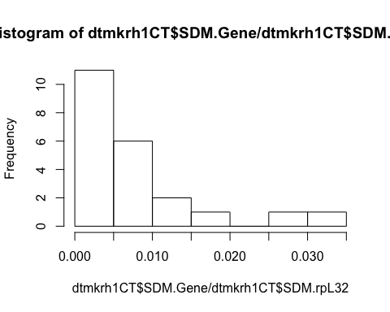

hist(dtmkrh1JHM$SDM.Gene/dtmkrh1JHM$SDM.rpL32)

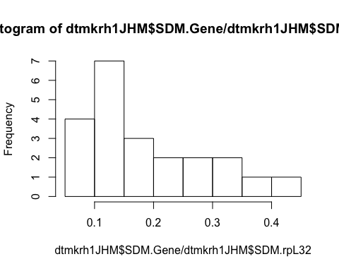

#log transformed  
hist(log(dtmkrh1CT$SDM.Gene/dtmkrh1CT$SDM.rpL32)) #ok

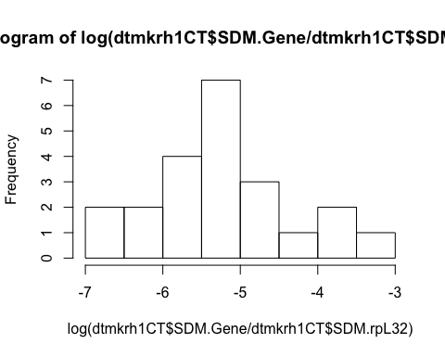

hist(log(dtmkrh1JHM$SDM.Gene/dtmkrh1JHM$SDM.rpL32)) #ok

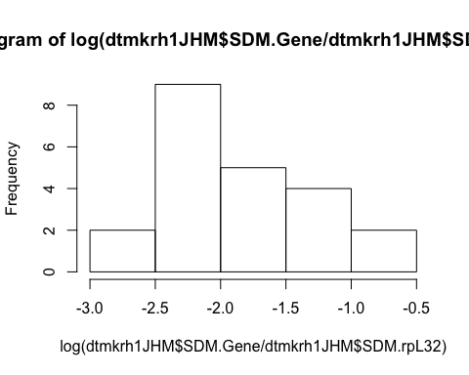 We decided to use a log10 transformation of our absolute values normalized by the reference gene because the histograms did not show a normal distribution.

# statistical tests: general effect of JHM

## male on Kr-h1 expression by treatment and by day

par(mfrow=c(2,2))  
#dtm  
dtkrh1<-subset(dtm,Gene=="Kr-h1") #subsetting the dataset to have only Kr-h1  
dtkrh1$Gene

## [1] Kr-h1 Kr-h1 Kr-h1 Kr-h1 Kr-h1 Kr-h1 Kr-h1 Kr-h1 Kr-h1 Kr-h1 Kr-h1  
## [12] Kr-h1 Kr-h1 Kr-h1 Kr-h1 Kr-h1 Kr-h1 Kr-h1 Kr-h1 Kr-h1 Kr-h1 Kr-h1  
## [23] Kr-h1 Kr-h1 Kr-h1 Kr-h1 Kr-h1 Kr-h1 Kr-h1 Kr-h1 Kr-h1 Kr-h1 Kr-h1  
## [34] Kr-h1 Kr-h1 Kr-h1 Kr-h1 Kr-h1 Kr-h1 Kr-h1 Kr-h1 Kr-h1 Kr-h1 Kr-h1  
## Levels: Kr-h1 PkE93-1 PkE93-2 PkE93-3

names(dtkrh1)

## [1] "Sample.ID" "treatment" "Day" "DayL" "Gene" "SDM.Gene"   
## [7] "SDM.rpL32"

is.numeric(dtkrh1$Day)

## [1] TRUE

dtkrh1$treatment

## [1] Control Control Control Control Control Mimic Mimic Control  
## [9] Control Control Control Control Control Control Mimic Mimic   
## [17] Mimic Mimic Mimic Mimic Control Control Mimic Mimic   
## [25] Mimic Mimic Mimic Control Control Control Control Mimic   
## [33] Mimic Mimic Control Control Mimic Mimic Mimic Control  
## [41] Control Mimic Mimic Mimic   
## Levels: Control Mimic

names(dtkrh1)

## [1] "Sample.ID" "treatment" "Day" "DayL" "Gene" "SDM.Gene"   
## [7] "SDM.rpL32"

#fitting linear model on transformed data  
malelmkrh1<-lm(log10((dtkrh1$SDM.Gene/dtkrh1$SDM.rpL32))~dtkrh1$treatment+dtkrh1$Day+dtkrh1$treatment:dtkrh1$Day)  
summary.lm(malelmkrh1) # there is an interaction between time and treatment

##   
## Call:  
## lm(formula = log10((dtkrh1$SDM.Gene/dtkrh1$SDM.rpL32)) ~ dtkrh1$treatment +   
## dtkrh1$Day + dtkrh1$treatment:dtkrh1$Day)  
##   
## Residuals:  
## Min 1Q Median 3Q Max   
## -0.63424 -0.11723 0.00956 0.08791 0.73408   
##   
## Coefficients:  
## Estimate Std. Error t value Pr(>|t|)   
## (Intercept) -2.17959 0.15857 -13.746 < 2e-16 ***  
## dtkrh1$treatmentMimic 0.99819 0.22425 4.451 6.67e-05 ***  
## dtkrh1$Day -0.02677 0.03898 -0.687 0.4962   
## dtkrh1$treatmentMimic:dtkrh1$Day 0.13097 0.05513 2.376 0.0224 *   
## ---  
## Signif. codes: 0 '***' 0.001 '**' 0.01 '*' 0.05 '.' 0.1 ' ' 1  
##   
## Residual standard error: 0.2978 on 40 degrees of freedom  
## Multiple R-squared: 0.8756, Adjusted R-squared: 0.8663   
## F-statistic: 93.87 on 3 and 40 DF, p-value: < 2.2e-16

plot(malelmkrh1)

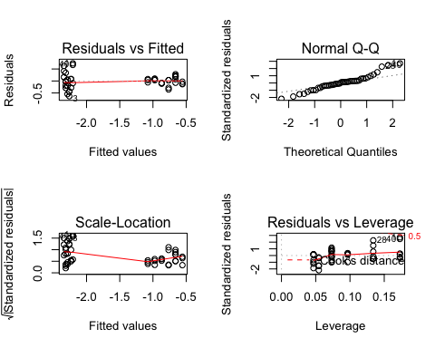

The treatment has a significant effect on PkKr-h1 expression (p-value 6.67e-5), gene expression doesn’t seem to change significantly over time after treatment (0.4962), but an interaction between type of treatment and day after treatment was observed (0.0224). I therefore kept the interaction of variables in the model.

## male on E93-1 expression by treatment and by day

par(mfrow=c(2,2))  
dtE931<-subset(dtm,Gene=="PkE93-1")  
dtE931$Gene

## [1] PkE93-1 PkE93-1 PkE93-1 PkE93-1 PkE93-1 PkE93-1 PkE93-1 PkE93-1  
## [9] PkE93-1 PkE93-1 PkE93-1 PkE93-1 PkE93-1 PkE93-1 PkE93-1 PkE93-1  
## [17] PkE93-1 PkE93-1 PkE93-1 PkE93-1 PkE93-1 PkE93-1 PkE93-1 PkE93-1  
## [25] PkE93-1 PkE93-1 PkE93-1 PkE93-1 PkE93-1 PkE93-1 PkE93-1 PkE93-1  
## [33] PkE93-1 PkE93-1 PkE93-1 PkE93-1 PkE93-1 PkE93-1 PkE93-1 PkE93-1  
## [41] PkE93-1 PkE93-1 PkE93-1 PkE93-1  
## Levels: Kr-h1 PkE93-1 PkE93-2 PkE93-3

dtE931$Day

## [1] 1 2 3 4 4 4 4 6 5 5 5 5 5 5 5 5 5 5 5 5 4 4 6 6 6 4 4 6 6 2 2 2 2 2 3  
## [36] 3 3 3 3 1 1 1 1 1

is.numeric(dtE931$Day)

## [1] TRUE

names(dtE931)

## [1] "Sample.ID" "treatment" "Day" "DayL" "Gene" "SDM.Gene"   
## [7] "SDM.rpL32"

#transformed lm  
malelmE931<-lm(log10((dtE931$SDM.Gene/dtE931$SDM.rpL32))~dtE931$treatment+dtE931$Day+dtE931$treatment:dtE931$Day)  
summary.lm(malelmE931) # no significant interaction

##   
## Call:  
## lm(formula = log10((dtE931$SDM.Gene/dtE931$SDM.rpL32)) ~ dtE931$treatment +   
## dtE931$Day + dtE931$treatment:dtE931$Day)  
##   
## Residuals:  
## Min 1Q Median 3Q Max   
## -0.38530 -0.12448 -0.02058 0.15167 0.46154   
##   
## Coefficients:  
## Estimate Std. Error t value Pr(>|t|)   
## (Intercept) -0.88820 0.10564 -8.408 2.23e-10 ***  
## dtE931$treatmentMimic -0.28274 0.14939 -1.893 0.0657 .   
## dtE931$Day 0.16079 0.02597 6.192 2.54e-07 ***  
## dtE931$treatmentMimic:dtE931$Day -0.04946 0.03673 -1.347 0.1857   
## ---  
## Signif. codes: 0 '***' 0.001 '**' 0.01 '*' 0.05 '.' 0.1 ' ' 1  
##   
## Residual standard error: 0.1984 on 40 degrees of freedom  
## Multiple R-squared: 0.7463, Adjusted R-squared: 0.7273   
## F-statistic: 39.23 on 3 and 40 DF, p-value: 5.453e-12

If we consider the linear model including an interaction between variables, the JHM treatment does not have a significant effect, but there is a change over time in gene expression. Because the interaction between these two variables are not significant, I removed it from the model considering only the two variables separately.

#remove interaction  
malelmE9312<-lm(log10((dtE931$SDM.Gene/dtE931$SDM.rpL32))~dtE931$treatment+dtE931$Day)  
summary.lm(malelmE9312)

##   
## Call:  
## lm(formula = log10((dtE931$SDM.Gene/dtE931$SDM.rpL32)) ~ dtE931$treatment +   
## dtE931$Day)  
##   
## Residuals:  
## Min 1Q Median 3Q Max   
## -0.45274 -0.13596 -0.00738 0.17144 0.43007   
##   
## Coefficients:  
## Estimate Std. Error t value Pr(>|t|)   
## (Intercept) -0.79603 0.08126 -9.797 2.67e-12 ***  
## dtE931$treatmentMimic -0.46707 0.06041 -7.732 1.56e-09 ***  
## dtE931$Day 0.13607 0.01854 7.337 5.53e-09 ***  
## ---  
## Signif. codes: 0 '***' 0.001 '**' 0.01 '*' 0.05 '.' 0.1 ' ' 1  
##   
## Residual standard error: 0.2004 on 41 degrees of freedom  
## Multiple R-squared: 0.7348, Adjusted R-squared: 0.7219   
## F-statistic: 56.81 on 2 and 41 DF, p-value: 1.523e-12

plot(malelmE931)

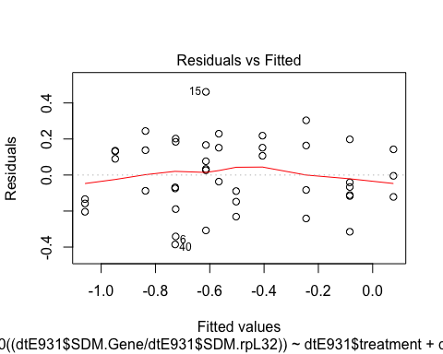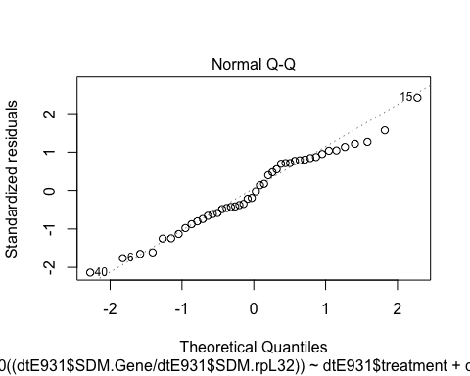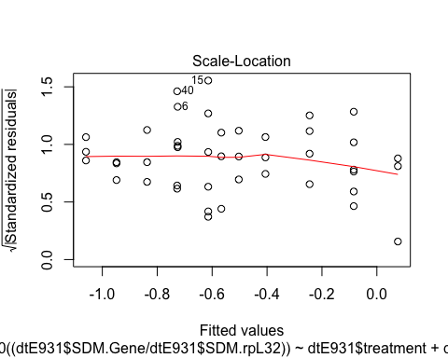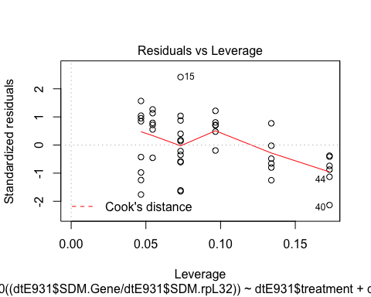 After removing the interaction, the JHM treatment has asignificant effect on gene expression and the expression changes over time in CT and JHM.

## male on E93-2 expression by treatment and by day

par(mfrow=c(2,2))  
dtE932<-subset(dtm,Gene=="PkE93-2")  
dtE932$Gene

## [1] PkE93-2 PkE93-2 PkE93-2 PkE93-2 PkE93-2 PkE93-2 PkE93-2 PkE93-2  
## [9] PkE93-2 PkE93-2 PkE93-2 PkE93-2 PkE93-2 PkE93-2 PkE93-2 PkE93-2  
## [17] PkE93-2 PkE93-2 PkE93-2 PkE93-2 PkE93-2 PkE93-2 PkE93-2 PkE93-2  
## [25] PkE93-2 PkE93-2 PkE93-2 PkE93-2 PkE93-2 PkE93-2 PkE93-2 PkE93-2  
## [33] PkE93-2 PkE93-2 PkE93-2 PkE93-2 PkE93-2 PkE93-2 PkE93-2 PkE93-2  
## [41] PkE93-2 PkE93-2 PkE93-2 PkE93-2  
## Levels: Kr-h1 PkE93-1 PkE93-2 PkE93-3

dtE932$Day

## [1] 1 2 3 4 4 4 4 6 5 5 5 5 5 5 5 5 5 5 5 5 4 4 6 6 6 4 4 6 6 2 2 2 2 2 3  
## [36] 3 3 3 3 1 1 1 1 1

is.numeric(dtE932$Day)

## [1] TRUE

names(dtE932)

## [1] "Sample.ID" "treatment" "Day" "DayL" "Gene" "SDM.Gene"   
## [7] "SDM.rpL32"

#transformed lm  
malelmE932<-lm(log10((dtE932$SDM.Gene/dtE932$SDM.rpL32))~dtE932$treatment+dtE932$Day+dtE932$treatment:dtE932$Day)  
summary.lm(malelmE932)

##   
## Call:  
## lm(formula = log10((dtE932$SDM.Gene/dtE932$SDM.rpL32)) ~ dtE932$treatment +   
## dtE932$Day + dtE932$treatment:dtE932$Day)  
##   
## Residuals:  
## Min 1Q Median 3Q Max   
## -0.37406 -0.15091 -0.03297 0.16791 0.41903   
##   
## Coefficients:  
## Estimate Std. Error t value Pr(>|t|)   
## (Intercept) -2.36978 0.10958 -21.627 < 2e-16 ***  
## dtE932$treatmentMimic -0.41872 0.15496 -2.702 0.010062 *   
## dtE932$Day 0.11545 0.02694 4.286 0.000111 ***  
## dtE932$treatmentMimic:dtE932$Day -0.06036 0.03810 -1.584 0.120959   
## ---  
## Signif. codes: 0 '***' 0.001 '**' 0.01 '*' 0.05 '.' 0.1 ' ' 1  
##   
## Residual standard error: 0.2058 on 40 degrees of freedom  
## Multiple R-squared: 0.7649, Adjusted R-squared: 0.7473   
## F-statistic: 43.39 on 3 and 40 DF, p-value: 1.201e-12

If we consider the linear model including an interaction between variables, the JHM treatment does not have a significant effect, but there is a change over time in gene expression. Because the interaction between these two variables are not significant, I removed it from the model considering only the two variables separately.

#remove interaction  
malelmE932<-lm(log10((dtE932$SDM.Gene/dtE932$SDM.rpL32))~dtE932$treatment+dtE932$Day)  
summary.lm(malelmE932)

##   
## Call:  
## lm(formula = log10((dtE932$SDM.Gene/dtE932$SDM.rpL32)) ~ dtE932$treatment +   
## dtE932$Day)  
##   
## Residuals:  
## Min 1Q Median 3Q Max   
## -0.45637 -0.13384 -0.01933 0.18042 0.36690   
##   
## Coefficients:  
## Estimate Std. Error t value Pr(>|t|)   
## (Intercept) -2.25729 0.08499 -26.561 < 2e-16 ***  
## dtE932$treatmentMimic -0.64371 0.06318 -10.188 8.47e-13 ***  
## dtE932$Day 0.08527 0.01940 4.396 7.62e-05 ***  
## ---  
## Signif. codes: 0 '***' 0.001 '**' 0.01 '*' 0.05 '.' 0.1 ' ' 1  
##   
## Residual standard error: 0.2096 on 41 degrees of freedom  
## Multiple R-squared: 0.7502, Adjusted R-squared: 0.738   
## F-statistic: 61.56 on 2 and 41 DF, p-value: 4.48e-13

plot(malelmE932)

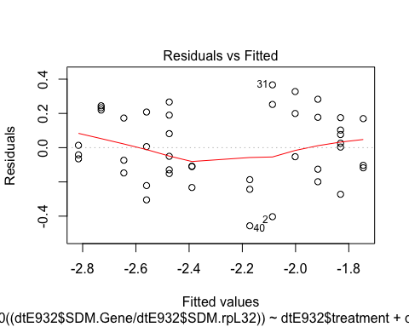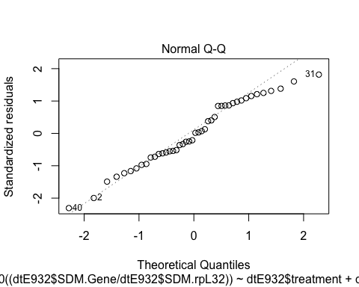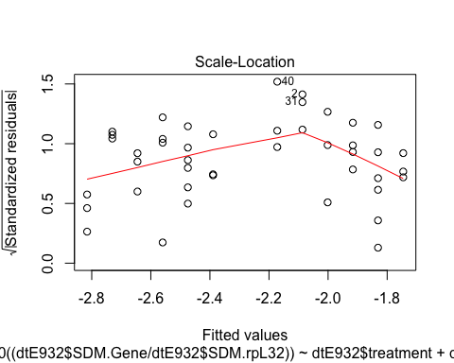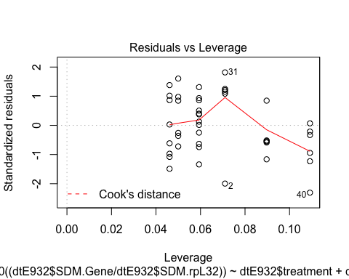 After removing the interaction, the JHM treatment has a significant effect on gene expression and the expression changes over time in CT and JHM.

## male on E93-3 expression by treatment and by day

par(mfrow=c(2,2))  
dtE933<-subset(dtm,Gene=="PkE93-3")  
dtE933$Gene

## [1] PkE93-3 PkE93-3 PkE93-3 PkE93-3 PkE93-3 PkE93-3 PkE93-3 PkE93-3  
## [9] PkE93-3 PkE93-3 PkE93-3 PkE93-3 PkE93-3 PkE93-3 PkE93-3 PkE93-3  
## [17] PkE93-3 PkE93-3 PkE93-3 PkE93-3 PkE93-3 PkE93-3 PkE93-3 PkE93-3  
## [25] PkE93-3 PkE93-3 PkE93-3 PkE93-3 PkE93-3 PkE93-3 PkE93-3 PkE93-3  
## [33] PkE93-3 PkE93-3 PkE93-3 PkE93-3 PkE93-3 PkE93-3 PkE93-3 PkE93-3  
## [41] PkE93-3 PkE93-3 PkE93-3 PkE93-3  
## Levels: Kr-h1 PkE93-1 PkE93-2 PkE93-3

dtE933$Day

## [1] 1 2 3 4 4 4 4 6 5 5 5 5 5 5 5 5 5 5 5 5 4 4 6 6 6 4 4 6 6 2 2 2 2 2 3  
## [36] 3 3 3 3 1 1 1 1 1

is.numeric(dtE933$Day)

## [1] TRUE

names(dtE933)

## [1] "Sample.ID" "treatment" "Day" "DayL" "Gene" "SDM.Gene"   
## [7] "SDM.rpL32"

#transformed lm  
malelmE933<-lm(log10((dtE933$SDM.Gene/dtE933$SDM.rpL32))~dtE933$treatment+dtE933$Day+dtE933$treatment:dtE933$Day)  
summary.lm(malelmE933)

##   
## Call:  
## lm(formula = log10((dtE933$SDM.Gene/dtE933$SDM.rpL32)) ~ dtE933$treatment +   
## dtE933$Day + dtE933$treatment:dtE933$Day)  
##   
## Residuals:  
## Min 1Q Median 3Q Max   
## -0.48090 -0.09223 0.03876 0.15458 0.28137   
##   
## Coefficients:  
## Estimate Std. Error t value Pr(>|t|)   
## (Intercept) -2.84799 0.10028 -28.400 <2e-16 ***  
## dtE933$treatmentMimic 0.05089 0.14182 0.359 0.722   
## dtE933$Day -0.03547 0.02465 -1.439 0.158   
## dtE933$treatmentMimic:dtE933$Day 0.01844 0.03487 0.529 0.600   
## ---  
## Signif. codes: 0 '***' 0.001 '**' 0.01 '*' 0.05 '.' 0.1 ' ' 1  
##   
## Residual standard error: 0.1883 on 40 degrees of freedom  
## Multiple R-squared: 0.1487, Adjusted R-squared: 0.08483   
## F-statistic: 2.329 on 3 and 40 DF, p-value: 0.08898

If we consider the linear model including an interaction between variables, the JHM treatment does not have a significant effect, but there is a change over time in gene expression. Because the interaction between these two variables are not significant, I removed it from the model considering only the two variables separately.

#remove interaction  
malelmE933<-lm(log10((dtE933$SDM.Gene/dtE933$SDM.rpL32))~dtE933$treatment+dtE933$Day)  
summary.lm(malelmE933)

##   
## Call:  
## lm(formula = log10((dtE933$SDM.Gene/dtE933$SDM.rpL32)) ~ dtE933$treatment +   
## dtE933$Day)  
##   
## Residuals:  
## Min 1Q Median 3Q Max   
## -0.48342 -0.08483 0.03620 0.14774 0.26041   
##   
## Coefficients:  
## Estimate Std. Error t value Pr(>|t|)   
## (Intercept) -2.88236 0.07571 -38.071 <2e-16 ***  
## dtE933$treatmentMimic 0.11964 0.05629 2.126 0.0396 *   
## dtE933$Day -0.02625 0.01728 -1.519 0.1364   
## ---  
## Signif. codes: 0 '***' 0.001 '**' 0.01 '*' 0.05 '.' 0.1 ' ' 1  
##   
## Residual standard error: 0.1867 on 41 degrees of freedom  
## Multiple R-squared: 0.1427, Adjusted R-squared: 0.1009   
## F-statistic: 3.413 on 2 and 41 DF, p-value: 0.04256

plot(malelmE933)

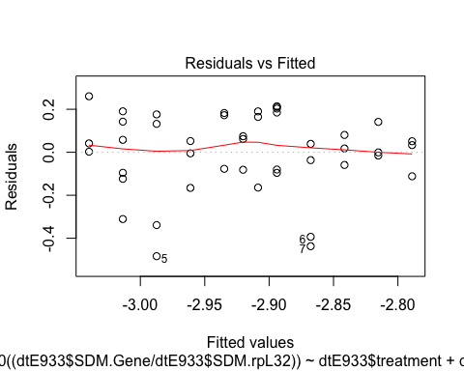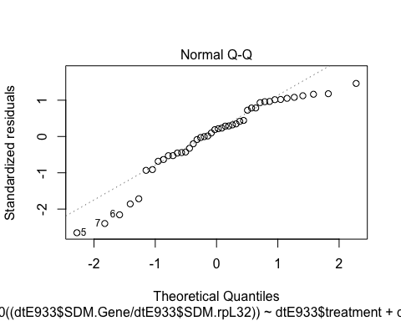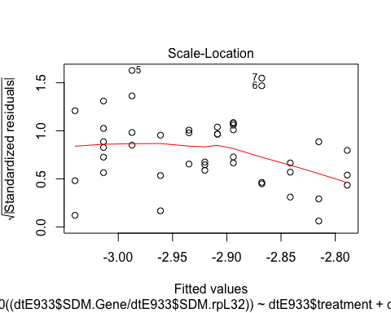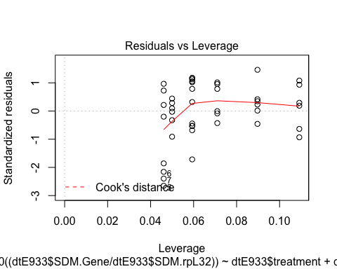 After removing the interaction between variables, there is a significant effect of the treatment on E93 isoform 3 in males.

## Female on Kr-h1 expression by treatment and by day

par(mfrow=c(2,2))  
dtfkrh1<-subset(dtf,Gene=="Kr.h1")  
dtfkrh1$Gene

## [1] "Kr.h1" "Kr.h1" "Kr.h1" "Kr.h1" "Kr.h1" "Kr.h1" "Kr.h1" "Kr.h1"  
## [9] "Kr.h1" "Kr.h1" "Kr.h1" "Kr.h1" "Kr.h1" "Kr.h1" "Kr.h1" "Kr.h1"  
## [17] "Kr.h1" "Kr.h1" "Kr.h1" "Kr.h1" "Kr.h1" "Kr.h1" "Kr.h1" "Kr.h1"  
## [25] "Kr.h1" "Kr.h1" "Kr.h1" "Kr.h1" "Kr.h1" "Kr.h1" "Kr.h1" "Kr.h1"  
## [33] "Kr.h1" "Kr.h1" "Kr.h1" "Kr.h1" "Kr.h1" "Kr.h1" "Kr.h1" "Kr.h1"  
## [41] "Kr.h1" "Kr.h1" "Kr.h1" "Kr.h1" "Kr.h1" "Kr.h1" "Kr.h1" "Kr.h1"  
## [49] "Kr.h1" "Kr.h1" "Kr.h1" "Kr.h1" "Kr.h1" "Kr.h1" "Kr.h1" "Kr.h1"  
## [57] "Kr.h1" "Kr.h1" "Kr.h1"

dtfkrh1$DAT

## [1] 1 1 1 1 2 2 2 3 3 3 4 4 4 5 5 5 6 6 6 7 7 7 8 8 8 8 8 8 8 1 1 1 1 2 2  
## [36] 2 3 3 3 4 4 4 5 5 5 6 6 6 7 7 7 8 8 8 8 8 8 8 8

is.numeric(dtfkrh1$DAT)

## [1] TRUE

names(dtfkrh1)

## [1] "cDNA." "Compound" "Treatment" "TreatmentStage"  
## [5] "Sex" "DAT" "DayL" "N"   
## [9] "rpL32" "Gene" "SDM"

femalelmkrh1<-lm(log10((dtfkrh1$SDM/dtfkrh1$rpL32))~dtfkrh1$Treatment+dtfkrh1$DAT+dtfkrh1$Treatment:dtfkrh1$DAT)  
summary.lm(femalelmkrh1)

##   
## Call:  
## lm(formula = log10((dtfkrh1$SDM/dtfkrh1$rpL32)) ~ dtfkrh1$Treatment +   
## dtfkrh1$DAT + dtfkrh1$Treatment:dtfkrh1$DAT)  
##   
## Residuals:  
## Min 1Q Median 3Q Max   
## -1.01977 -0.15038 0.00834 0.16204 0.53314   
##   
## Coefficients:  
## Estimate Std. Error t value Pr(>|t|)  
## (Intercept) -2.11974 0.12717 -16.669 < 2e-16  
## dtfkrh1$TreatmentMimic 0.05606 0.17924 0.313 0.75564  
## dtfkrh1$DAT -0.05306 0.02323 -2.284 0.02626  
## dtfkrh1$TreatmentMimic:dtfkrh1$DAT 0.10756 0.03245 3.315 0.00163  
##   
## (Intercept) ***  
## dtfkrh1$TreatmentMimic   
## dtfkrh1$DAT *   
## dtfkrh1$TreatmentMimic:dtfkrh1$DAT **   
## ---  
## Signif. codes: 0 '***' 0.001 '**' 0.01 '*' 0.05 '.' 0.1 ' ' 1  
##   
## Residual standard error: 0.3146 on 55 degrees of freedom  
## Multiple R-squared: 0.5296, Adjusted R-squared: 0.504   
## F-statistic: 20.64 on 3 and 55 DF, p-value: 4.347e-09

When including the interaction between the two variables, there is a significant change in expression over time between the control and JHM groups. We therefore kept this model for PkKr-h1 in females.

## female on E93-1 expression by treatment and by day

par(mfrow=c(2,2))  
dtf$Gene

## [1] "Kr.h1" "Kr.h1" "Kr.h1" "Kr.h1" "Kr.h1" "Kr.h1" "Kr.h1"   
## [8] "Kr.h1" "Kr.h1" "Kr.h1" "Kr.h1" "Kr.h1" "Kr.h1" "Kr.h1"   
## [15] "Kr.h1" "Kr.h1" "Kr.h1" "Kr.h1" "Kr.h1" "Kr.h1" "Kr.h1"   
## [22] "Kr.h1" "Kr.h1" "Kr.h1" "Kr.h1" "Kr.h1" "Kr.h1" "Kr.h1"   
## [29] "Kr.h1" "Kr.h1" "Kr.h1" "Kr.h1" "Kr.h1" "Kr.h1" "Kr.h1"   
## [36] "Kr.h1" "Kr.h1" "Kr.h1" "Kr.h1" "Kr.h1" "Kr.h1" "Kr.h1"   
## [43] "Kr.h1" "Kr.h1" "Kr.h1" "Kr.h1" "Kr.h1" "Kr.h1" "Kr.h1"   
## [50] "Kr.h1" "Kr.h1" "Kr.h1" "Kr.h1" "Kr.h1" "Kr.h1" "Kr.h1"   
## [57] "Kr.h1" "Kr.h1" "Kr.h1" "PkE93.1" "PkE93.1" "PkE93.1" "PkE93.1"  
## [64] "PkE93.1" "PkE93.1" "PkE93.1" "PkE93.1" "PkE93.1" "PkE93.1" "PkE93.1"  
## [71] "PkE93.1" "PkE93.1" "PkE93.1" "PkE93.1" "PkE93.1" "PkE93.1" "PkE93.1"  
## [78] "PkE93.1" "PkE93.1" "PkE93.1" "PkE93.1" "PkE93.1" "PkE93.1" "PkE93.1"  
## [85] "PkE93.1" "PkE93.1" "PkE93.1" "PkE93.1" "PkE93.1" "PkE93.1" "PkE93.1"  
## [92] "PkE93.1" "PkE93.1" "PkE93.1" "PkE93.1" "PkE93.1" "PkE93.1" "PkE93.1"  
## [99] "PkE93.1" "PkE93.1" "PkE93.1" "PkE93.1" "PkE93.1" "PkE93.1" "PkE93.1"  
## [106] "PkE93.1" "PkE93.1" "PkE93.1" "PkE93.1" "PkE93.1" "PkE93.1" "PkE93.1"  
## [113] "PkE93.1" "PkE93.1" "PkE93.1" "PkE93.1" "PkE93.1" "PkE93.1" "PkE93.2"  
## [120] "PkE93.2" "PkE93.2" "PkE93.2" "PkE93.2" "PkE93.2" "PkE93.2" "PkE93.2"  
## [127] "PkE93.2" "PkE93.2" "PkE93.2" "PkE93.2" "PkE93.2" "PkE93.2" "PkE93.2"  
## [134] "PkE93.2" "PkE93.2" "PkE93.2" "PkE93.2" "PkE93.2" "PkE93.2" "PkE93.2"  
## [141] "PkE93.2" "PkE93.2" "PkE93.2" "PkE93.2" "PkE93.2" "PkE93.2" "PkE93.2"  
## [148] "PkE93.2" "PkE93.2" "PkE93.2" "PkE93.2" "PkE93.2" "PkE93.2" "PkE93.2"  
## [155] "PkE93.2" "PkE93.2" "PkE93.2" "PkE93.2" "PkE93.2" "PkE93.2" "PkE93.2"  
## [162] "PkE93.2" "PkE93.2" "PkE93.2" "PkE93.2" "PkE93.2" "PkE93.2" "PkE93.2"  
## [169] "PkE93.2" "PkE93.2" "PkE93.2" "PkE93.2" "PkE93.2" "PkE93.2" "PkE93.2"  
## [176] "PkE93.2" "PkE93.2" "PkE93.3" "PkE93.3" "PkE93.3" "PkE93.3" "PkE93.3"  
## [183] "PkE93.3" "PkE93.3" "PkE93.3" "PkE93.3" "PkE93.3" "PkE93.3" "PkE93.3"  
## [190] "PkE93.3" "PkE93.3" "PkE93.3" "PkE93.3" "PkE93.3" "PkE93.3" "PkE93.3"  
## [197] "PkE93.3" "PkE93.3" "PkE93.3" "PkE93.3" "PkE93.3" "PkE93.3" "PkE93.3"  
## [204] "PkE93.3" "PkE93.3" "PkE93.3" "PkE93.3" "PkE93.3" "PkE93.3" "PkE93.3"  
## [211] "PkE93.3" "PkE93.3" "PkE93.3" "PkE93.3" "PkE93.3" "PkE93.3" "PkE93.3"  
## [218] "PkE93.3" "PkE93.3" "PkE93.3" "PkE93.3" "PkE93.3" "PkE93.3" "PkE93.3"  
## [225] "PkE93.3" "PkE93.3" "PkE93.3" "PkE93.3" "PkE93.3" "PkE93.3" "PkE93.3"  
## [232] "PkE93.3" "PkE93.3" "PkE93.3" "PkE93.3" "PkE93.3"

dtfE931<-subset(dtf,Gene=="PkE93.1")  
dtfE931$Gene

## [1] "PkE93.1" "PkE93.1" "PkE93.1" "PkE93.1" "PkE93.1" "PkE93.1" "PkE93.1"  
## [8] "PkE93.1" "PkE93.1" "PkE93.1" "PkE93.1" "PkE93.1" "PkE93.1" "PkE93.1"  
## [15] "PkE93.1" "PkE93.1" "PkE93.1" "PkE93.1" "PkE93.1" "PkE93.1" "PkE93.1"  
## [22] "PkE93.1" "PkE93.1" "PkE93.1" "PkE93.1" "PkE93.1" "PkE93.1" "PkE93.1"  
## [29] "PkE93.1" "PkE93.1" "PkE93.1" "PkE93.1" "PkE93.1" "PkE93.1" "PkE93.1"  
## [36] "PkE93.1" "PkE93.1" "PkE93.1" "PkE93.1" "PkE93.1" "PkE93.1" "PkE93.1"  
## [43] "PkE93.1" "PkE93.1" "PkE93.1" "PkE93.1" "PkE93.1" "PkE93.1" "PkE93.1"  
## [50] "PkE93.1" "PkE93.1" "PkE93.1" "PkE93.1" "PkE93.1" "PkE93.1" "PkE93.1"  
## [57] "PkE93.1" "PkE93.1" "PkE93.1"

is.numeric(dtfE931$DAT)

## [1] TRUE

names(dtfE931)

## [1] "cDNA." "Compound" "Treatment" "TreatmentStage"  
## [5] "Sex" "DAT" "DayL" "N"   
## [9] "rpL32" "Gene" "SDM"

#with interaction  
femalelmE931<-lm(log10((dtfE931$SDM/dtfE931$rpL32))~dtfE931$Treatment+dtfE931$DAT+dtfE931$Treatment:dtfE931$DAT)  
summary.lm(femalelmE931) #no interaction

##   
## Call:  
## lm(formula = log10((dtfE931$SDM/dtfE931$rpL32)) ~ dtfE931$Treatment +   
## dtfE931$DAT + dtfE931$Treatment:dtfE931$DAT)  
##   
## Residuals:  
## Min 1Q Median 3Q Max   
## -1.2176 -0.3248 0.1133 0.4035 0.8157   
##   
## Coefficients:  
## Estimate Std. Error t value Pr(>|t|)  
## (Intercept) -3.61000 0.22445 -16.083 < 2e-16  
## dtfE931$TreatmentMimic 0.56776 0.31637 1.795 0.078207  
## dtfE931$DAT 0.14505 0.04100 3.538 0.000829  
## dtfE931$TreatmentMimic:dtfE931$DAT 0.01604 0.05727 0.280 0.780514  
##   
## (Intercept) ***  
## dtfE931$TreatmentMimic .   
## dtfE931$DAT ***  
## dtfE931$TreatmentMimic:dtfE931$DAT   
## ---  
## Signif. codes: 0 '***' 0.001 '**' 0.01 '*' 0.05 '.' 0.1 ' ' 1  
##   
## Residual standard error: 0.5554 on 55 degrees of freedom  
## Multiple R-squared: 0.4749, Adjusted R-squared: 0.4462   
## F-statistic: 16.58 on 3 and 55 DF, p-value: 8.538e-08

If we consider the linear model including an interaction between variables, the JHM treatment does not have a significant effect, but there is a change over time in gene expression. Because the interaction between these two variables are not significant, I removed it from the model considering only the two variables separately.

#remove interaction  
femalelmE931<-lm(log10((dtfE931$SDM/dtfE931$rpL32))~dtfE931$Treatment+dtfE931$DAT)  
summary.lm(femalelmE931)

##   
## Call:  
## lm(formula = log10((dtfE931$SDM/dtfE931$rpL32)) ~ dtfE931$Treatment +   
## dtfE931$DAT)  
##   
## Residuals:  
## Min 1Q Median 3Q Max   
## -1.1941 -0.3258 0.1304 0.3957 0.8064   
##   
## Coefficients:  
## Estimate Std. Error t value Pr(>|t|)   
## (Intercept) -3.64997 0.17179 -21.247 < 2e-16 ***  
## dtfE931$TreatmentMimic 0.64655 0.14346 4.507 3.40e-05 ***  
## dtfE931$DAT 0.15327 0.02839 5.399 1.41e-06 ***  
## ---  
## Signif. codes: 0 '***' 0.001 '**' 0.01 '*' 0.05 '.' 0.1 ' ' 1  
##   
## Residual standard error: 0.5508 on 56 degrees of freedom  
## Multiple R-squared: 0.4741, Adjusted R-squared: 0.4554   
## F-statistic: 25.25 on 2 and 56 DF, p-value: 1.529e-08

plot(femalelmE931)

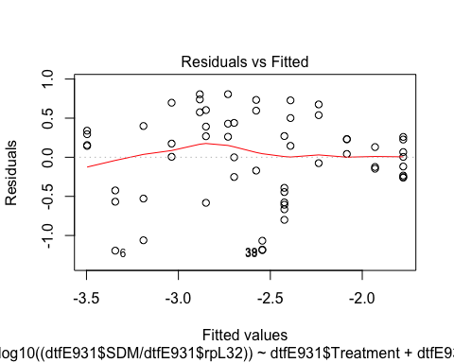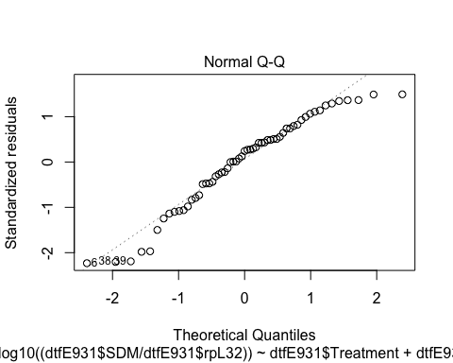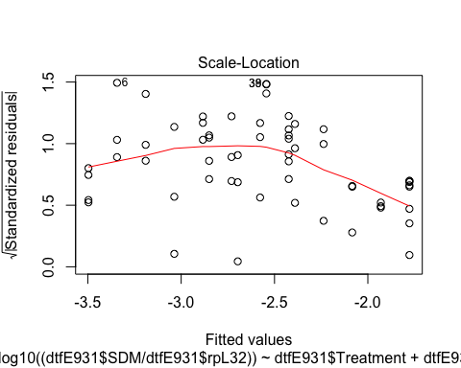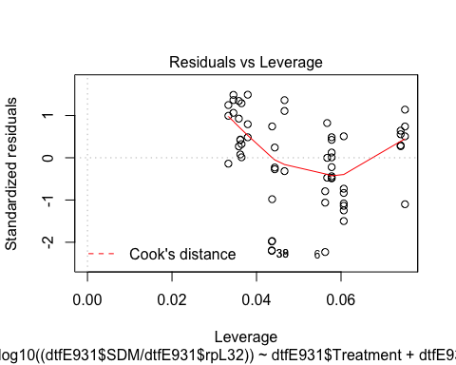 There is a significant overall effect of the treatment on E93 isoform 1.

## female on E93-2 expression by treatment and by day

par(mfrow=c(2,2))  
dtf$Gene

## [1] "Kr.h1" "Kr.h1" "Kr.h1" "Kr.h1" "Kr.h1" "Kr.h1" "Kr.h1"   
## [8] "Kr.h1" "Kr.h1" "Kr.h1" "Kr.h1" "Kr.h1" "Kr.h1" "Kr.h1"   
## [15] "Kr.h1" "Kr.h1" "Kr.h1" "Kr.h1" "Kr.h1" "Kr.h1" "Kr.h1"   
## [22] "Kr.h1" "Kr.h1" "Kr.h1" "Kr.h1" "Kr.h1" "Kr.h1" "Kr.h1"   
## [29] "Kr.h1" "Kr.h1" "Kr.h1" "Kr.h1" "Kr.h1" "Kr.h1" "Kr.h1"   
## [36] "Kr.h1" "Kr.h1" "Kr.h1" "Kr.h1" "Kr.h1" "Kr.h1" "Kr.h1"   
## [43] "Kr.h1" "Kr.h1" "Kr.h1" "Kr.h1" "Kr.h1" "Kr.h1" "Kr.h1"   
## [50] "Kr.h1" "Kr.h1" "Kr.h1" "Kr.h1" "Kr.h1" "Kr.h1" "Kr.h1"   
## [57] "Kr.h1" "Kr.h1" "Kr.h1" "PkE93.1" "PkE93.1" "PkE93.1" "PkE93.1"  
## [64] "PkE93.1" "PkE93.1" "PkE93.1" "PkE93.1" "PkE93.1" "PkE93.1" "PkE93.1"  
## [71] "PkE93.1" "PkE93.1" "PkE93.1" "PkE93.1" "PkE93.1" "PkE93.1" "PkE93.1"  
## [78] "PkE93.1" "PkE93.1" "PkE93.1" "PkE93.1" "PkE93.1" "PkE93.1" "PkE93.1"  
## [85] "PkE93.1" "PkE93.1" "PkE93.1" "PkE93.1" "PkE93.1" "PkE93.1" "PkE93.1"  
## [92] "PkE93.1" "PkE93.1" "PkE93.1" "PkE93.1" "PkE93.1" "PkE93.1" "PkE93.1"  
## [99] "PkE93.1" "PkE93.1" "PkE93.1" "PkE93.1" "PkE93.1" "PkE93.1" "PkE93.1"  
## [106] "PkE93.1" "PkE93.1" "PkE93.1" "PkE93.1" "PkE93.1" "PkE93.1" "PkE93.1"  
## [113] "PkE93.1" "PkE93.1" "PkE93.1" "PkE93.1" "PkE93.1" "PkE93.1" "PkE93.2"  
## [120] "PkE93.2" "PkE93.2" "PkE93.2" "PkE93.2" "PkE93.2" "PkE93.2" "PkE93.2"  
## [127] "PkE93.2" "PkE93.2" "PkE93.2" "PkE93.2" "PkE93.2" "PkE93.2" "PkE93.2"  
## [134] "PkE93.2" "PkE93.2" "PkE93.2" "PkE93.2" "PkE93.2" "PkE93.2" "PkE93.2"  
## [141] "PkE93.2" "PkE93.2" "PkE93.2" "PkE93.2" "PkE93.2" "PkE93.2" "PkE93.2"  
## [148] "PkE93.2" "PkE93.2" "PkE93.2" "PkE93.2" "PkE93.2" "PkE93.2" "PkE93.2"  
## [155] "PkE93.2" "PkE93.2" "PkE93.2" "PkE93.2" "PkE93.2" "PkE93.2" "PkE93.2"  
## [162] "PkE93.2" "PkE93.2" "PkE93.2" "PkE93.2" "PkE93.2" "PkE93.2" "PkE93.2"  
## [169] "PkE93.2" "PkE93.2" "PkE93.2" "PkE93.2" "PkE93.2" "PkE93.2" "PkE93.2"  
## [176] "PkE93.2" "PkE93.2" "PkE93.3" "PkE93.3" "PkE93.3" "PkE93.3" "PkE93.3"  
## [183] "PkE93.3" "PkE93.3" "PkE93.3" "PkE93.3" "PkE93.3" "PkE93.3" "PkE93.3"  
## [190] "PkE93.3" "PkE93.3" "PkE93.3" "PkE93.3" "PkE93.3" "PkE93.3" "PkE93.3"  
## [197] "PkE93.3" "PkE93.3" "PkE93.3" "PkE93.3" "PkE93.3" "PkE93.3" "PkE93.3"  
## [204] "PkE93.3" "PkE93.3" "PkE93.3" "PkE93.3" "PkE93.3" "PkE93.3" "PkE93.3"  
## [211] "PkE93.3" "PkE93.3" "PkE93.3" "PkE93.3" "PkE93.3" "PkE93.3" "PkE93.3"  
## [218] "PkE93.3" "PkE93.3" "PkE93.3" "PkE93.3" "PkE93.3" "PkE93.3" "PkE93.3"  
## [225] "PkE93.3" "PkE93.3" "PkE93.3" "PkE93.3" "PkE93.3" "PkE93.3" "PkE93.3"  
## [232] "PkE93.3" "PkE93.3" "PkE93.3" "PkE93.3" "PkE93.3"

dtfE932<-subset(dtf,Gene=="PkE93.2")  
dtfE932$Gene

## [1] "PkE93.2" "PkE93.2" "PkE93.2" "PkE93.2" "PkE93.2" "PkE93.2" "PkE93.2"  
## [8] "PkE93.2" "PkE93.2" "PkE93.2" "PkE93.2" "PkE93.2" "PkE93.2" "PkE93.2"  
## [15] "PkE93.2" "PkE93.2" "PkE93.2" "PkE93.2" "PkE93.2" "PkE93.2" "PkE93.2"  
## [22] "PkE93.2" "PkE93.2" "PkE93.2" "PkE93.2" "PkE93.2" "PkE93.2" "PkE93.2"  
## [29] "PkE93.2" "PkE93.2" "PkE93.2" "PkE93.2" "PkE93.2" "PkE93.2" "PkE93.2"  
## [36] "PkE93.2" "PkE93.2" "PkE93.2" "PkE93.2" "PkE93.2" "PkE93.2" "PkE93.2"  
## [43] "PkE93.2" "PkE93.2" "PkE93.2" "PkE93.2" "PkE93.2" "PkE93.2" "PkE93.2"  
## [50] "PkE93.2" "PkE93.2" "PkE93.2" "PkE93.2" "PkE93.2" "PkE93.2" "PkE93.2"  
## [57] "PkE93.2" "PkE93.2" "PkE93.2"

is.numeric(dtfE932$DAT)

## [1] TRUE

names(dtfE932)

## [1] "cDNA." "Compound" "Treatment" "TreatmentStage"  
## [5] "Sex" "DAT" "DayL" "N"   
## [9] "rpL32" "Gene" "SDM"

femalelmE932<-lm(log10((dtfE932$SDM/dtfE932$rpL32))~dtfE932$Treatment+dtfE932$DAT+dtfE932$Treatment:dtfE932$DAT)  
summary.lm(femalelmE932)# no effect of interaction

##   
## Call:  
## lm(formula = log10((dtfE932$SDM/dtfE932$rpL32)) ~ dtfE932$Treatment +   
## dtfE932$DAT + dtfE932$Treatment:dtfE932$DAT)  
##   
## Residuals:  
## Min 1Q Median 3Q Max   
## -0.7435 -0.2709 0.0300 0.2391 0.8091   
##   
## Coefficients:  
## Estimate Std. Error t value Pr(>|t|)  
## (Intercept) -4.25219 0.16026 -26.534 <2e-16  
## dtfE932$TreatmentMimic 0.44856 0.22588 1.986 0.052  
## dtfE932$DAT 0.04958 0.02928 1.694 0.096  
## dtfE932$TreatmentMimic:dtfE932$DAT -0.02363 0.04089 -0.578 0.566  
##   
## (Intercept) ***  
## dtfE932$TreatmentMimic .   
## dtfE932$DAT .   
## dtfE932$TreatmentMimic:dtfE932$DAT   
## ---  
## Signif. codes: 0 '***' 0.001 '**' 0.01 '*' 0.05 '.' 0.1 ' ' 1  
##   
## Residual standard error: 0.3965 on 55 degrees of freedom  
## Multiple R-squared: 0.2065, Adjusted R-squared: 0.1632   
## F-statistic: 4.77 on 3 and 55 DF, p-value: 0.005016

No significant effect when including the interaction between both variable, we therefore removed the interaction in the model.

femalelmE932<-lm(log10((dtfE932$SDM/dtfE932$rpL32))~dtfE932$Treatment+dtfE932$DAT)  
summary.lm(femalelmE932)

##   
## Call:  
## lm(formula = log10((dtfE932$SDM/dtfE932$rpL32)) ~ dtfE932$Treatment +   
## dtfE932$DAT)  
##   
## Residuals:  
## Min 1Q Median 3Q Max   
## -0.74772 -0.29996 0.03022 0.23098 0.83503   
##   
## Coefficients:  
## Estimate Std. Error t value Pr(>|t|)   
## (Intercept) -4.19330 0.12294 -34.109 < 2e-16 ***  
## dtfE932$TreatmentMimic 0.33249 0.10267 3.239 0.00202 **   
## dtfE932$DAT 0.03747 0.02032 1.845 0.07040 .   
## ---  
## Signif. codes: 0 '***' 0.001 '**' 0.01 '*' 0.05 '.' 0.1 ' ' 1  
##   
## Residual standard error: 0.3942 on 56 degrees of freedom  
## Multiple R-squared: 0.2016, Adjusted R-squared: 0.1731   
## F-statistic: 7.072 on 2 and 56 DF, p-value: 0.001826

plot(femalelmE932)

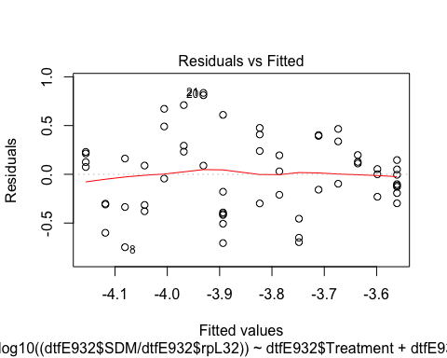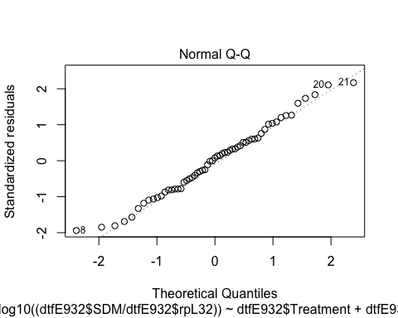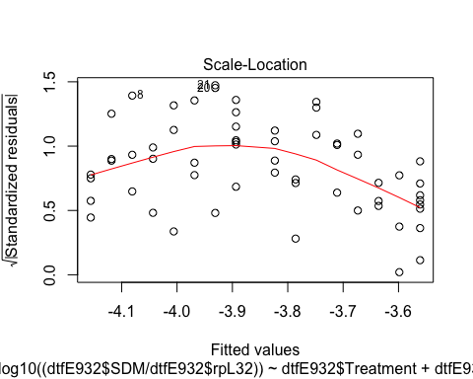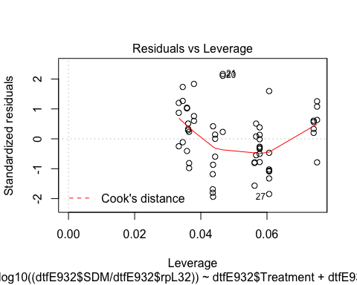 The overall effect of treatment is significant, probably due to day 2, day 4 and Day 8

## female on E93-3 expression by treatment and by day

par(mfrow=c(2,2))  
dtf$Gene

## [1] "Kr.h1" "Kr.h1" "Kr.h1" "Kr.h1" "Kr.h1" "Kr.h1" "Kr.h1"   
## [8] "Kr.h1" "Kr.h1" "Kr.h1" "Kr.h1" "Kr.h1" "Kr.h1" "Kr.h1"   
## [15] "Kr.h1" "Kr.h1" "Kr.h1" "Kr.h1" "Kr.h1" "Kr.h1" "Kr.h1"   
## [22] "Kr.h1" "Kr.h1" "Kr.h1" "Kr.h1" "Kr.h1" "Kr.h1" "Kr.h1"   
## [29] "Kr.h1" "Kr.h1" "Kr.h1" "Kr.h1" "Kr.h1" "Kr.h1" "Kr.h1"   
## [36] "Kr.h1" "Kr.h1" "Kr.h1" "Kr.h1" "Kr.h1" "Kr.h1" "Kr.h1"   
## [43] "Kr.h1" "Kr.h1" "Kr.h1" "Kr.h1" "Kr.h1" "Kr.h1" "Kr.h1"   
## [50] "Kr.h1" "Kr.h1" "Kr.h1" "Kr.h1" "Kr.h1" "Kr.h1" "Kr.h1"   
## [57] "Kr.h1" "Kr.h1" "Kr.h1" "PkE93.1" "PkE93.1" "PkE93.1" "PkE93.1"  
## [64] "PkE93.1" "PkE93.1" "PkE93.1" "PkE93.1" "PkE93.1" "PkE93.1" "PkE93.1"  
## [71] "PkE93.1" "PkE93.1" "PkE93.1" "PkE93.1" "PkE93.1" "PkE93.1" "PkE93.1"  
## [78] "PkE93.1" "PkE93.1" "PkE93.1" "PkE93.1" "PkE93.1" "PkE93.1" "PkE93.1"  
## [85] "PkE93.1" "PkE93.1" "PkE93.1" "PkE93.1" "PkE93.1" "PkE93.1" "PkE93.1"  
## [92] "PkE93.1" "PkE93.1" "PkE93.1" "PkE93.1" "PkE93.1" "PkE93.1" "PkE93.1"  
## [99] "PkE93.1" "PkE93.1" "PkE93.1" "PkE93.1" "PkE93.1" "PkE93.1" "PkE93.1"  
## [106] "PkE93.1" "PkE93.1" "PkE93.1" "PkE93.1" "PkE93.1" "PkE93.1" "PkE93.1"  
## [113] "PkE93.1" "PkE93.1" "PkE93.1" "PkE93.1" "PkE93.1" "PkE93.1" "PkE93.2"  
## [120] "PkE93.2" "PkE93.2" "PkE93.2" "PkE93.2" "PkE93.2" "PkE93.2" "PkE93.2"  
## [127] "PkE93.2" "PkE93.2" "PkE93.2" "PkE93.2" "PkE93.2" "PkE93.2" "PkE93.2"  
## [134] "PkE93.2" "PkE93.2" "PkE93.2" "PkE93.2" "PkE93.2" "PkE93.2" "PkE93.2"  
## [141] "PkE93.2" "PkE93.2" "PkE93.2" "PkE93.2" "PkE93.2" "PkE93.2" "PkE93.2"  
## [148] "PkE93.2" "PkE93.2" "PkE93.2" "PkE93.2" "PkE93.2" "PkE93.2" "PkE93.2"  
## [155] "PkE93.2" "PkE93.2" "PkE93.2" "PkE93.2" "PkE93.2" "PkE93.2" "PkE93.2"  
## [162] "PkE93.2" "PkE93.2" "PkE93.2" "PkE93.2" "PkE93.2" "PkE93.2" "PkE93.2"  
## [169] "PkE93.2" "PkE93.2" "PkE93.2" "PkE93.2" "PkE93.2" "PkE93.2" "PkE93.2"  
## [176] "PkE93.2" "PkE93.2" "PkE93.3" "PkE93.3" "PkE93.3" "PkE93.3" "PkE93.3"  
## [183] "PkE93.3" "PkE93.3" "PkE93.3" "PkE93.3" "PkE93.3" "PkE93.3" "PkE93.3"  
## [190] "PkE93.3" "PkE93.3" "PkE93.3" "PkE93.3" "PkE93.3" "PkE93.3" "PkE93.3"  
## [197] "PkE93.3" "PkE93.3" "PkE93.3" "PkE93.3" "PkE93.3" "PkE93.3" "PkE93.3"  
## [204] "PkE93.3" "PkE93.3" "PkE93.3" "PkE93.3" "PkE93.3" "PkE93.3" "PkE93.3"  
## [211] "PkE93.3" "PkE93.3" "PkE93.3" "PkE93.3" "PkE93.3" "PkE93.3" "PkE93.3"  
## [218] "PkE93.3" "PkE93.3" "PkE93.3" "PkE93.3" "PkE93.3" "PkE93.3" "PkE93.3"  
## [225] "PkE93.3" "PkE93.3" "PkE93.3" "PkE93.3" "PkE93.3" "PkE93.3" "PkE93.3"  
## [232] "PkE93.3" "PkE93.3" "PkE93.3" "PkE93.3" "PkE93.3"

dtfE933<-subset(dtf,Gene=="PkE93.3")  
dtfE933$Gene

## [1] "PkE93.3" "PkE93.3" "PkE93.3" "PkE93.3" "PkE93.3" "PkE93.3" "PkE93.3"  
## [8] "PkE93.3" "PkE93.3" "PkE93.3" "PkE93.3" "PkE93.3" "PkE93.3" "PkE93.3"  
## [15] "PkE93.3" "PkE93.3" "PkE93.3" "PkE93.3" "PkE93.3" "PkE93.3" "PkE93.3"  
## [22] "PkE93.3" "PkE93.3" "PkE93.3" "PkE93.3" "PkE93.3" "PkE93.3" "PkE93.3"  
## [29] "PkE93.3" "PkE93.3" "PkE93.3" "PkE93.3" "PkE93.3" "PkE93.3" "PkE93.3"  
## [36] "PkE93.3" "PkE93.3" "PkE93.3" "PkE93.3" "PkE93.3" "PkE93.3" "PkE93.3"  
## [43] "PkE93.3" "PkE93.3" "PkE93.3" "PkE93.3" "PkE93.3" "PkE93.3" "PkE93.3"  
## [50] "PkE93.3" "PkE93.3" "PkE93.3" "PkE93.3" "PkE93.3" "PkE93.3" "PkE93.3"  
## [57] "PkE93.3" "PkE93.3" "PkE93.3"

is.numeric(dtfE933$DAT)

## [1] TRUE

names(dtfE933)

## [1] "cDNA." "Compound" "Treatment" "TreatmentStage"  
## [5] "Sex" "DAT" "DayL" "N"   
## [9] "rpL32" "Gene" "SDM"

femalelmE933<-lm(log((dtfE933$SDM/dtfE933$rpL32))~dtfE933$Treatment+dtfE933$DAT+dtfE933$Treatment:dtfE933$DAT)  
summary.lm(femalelmE933)

##   
## Call:  
## lm(formula = log((dtfE933$SDM/dtfE933$rpL32)) ~ dtfE933$Treatment +   
## dtfE933$DAT + dtfE933$Treatment:dtfE933$DAT)  
##   
## Residuals:  
## Min 1Q Median 3Q Max   
## -2.17560 -0.36848 0.03189 0.47401 1.39781   
##   
## Coefficients:  
## Estimate Std. Error t value Pr(>|t|)  
## (Intercept) -10.87383 0.29185 -37.258 <2e-16  
## dtfE933$TreatmentMimic 0.43605 0.41136 1.060 0.2938  
## dtfE933$DAT -0.13646 0.05332 -2.559 0.0133  
## dtfE933$TreatmentMimic:dtfE933$DAT -0.01514 0.07446 -0.203 0.8396  
##   
## (Intercept) ***  
## dtfE933$TreatmentMimic   
## dtfE933$DAT *   
## dtfE933$TreatmentMimic:dtfE933$DAT   
## ---  
## Signif. codes: 0 '***' 0.001 '**' 0.01 '*' 0.05 '.' 0.1 ' ' 1  
##   
## Residual standard error: 0.7221 on 55 degrees of freedom  
## Multiple R-squared: 0.2512, Adjusted R-squared: 0.2104   
## F-statistic: 6.151 on 3 and 55 DF, p-value: 0.001106

If we consider the linear model including an interaction between variables, the JHM treatment does not have a significant effect, but there is a change over time in gene expression. Because the interaction between these two variables are not significant, I removed it from the model considering only the two variables separately.

femalelmE933<-lm(log((dtfE933$SDM/dtfE933$rpL32))~dtfE933$Treatment+dtfE933$DAT)  
summary.lm(femalelmE933)

##   
## Call:  
## lm(formula = log((dtfE933$SDM/dtfE933$rpL32)) ~ dtfE933$Treatment +   
## dtfE933$DAT)  
##   
## Residuals:  
## Min 1Q Median 3Q Max   
## -2.16109 -0.38249 0.02754 0.48114 1.40494   
##   
## Coefficients:  
## Estimate Std. Error t value Pr(>|t|)   
## (Intercept) -10.8361 0.2233 -48.528 < 2e-16 ***  
## dtfE933$TreatmentMimic 0.3617 0.1865 1.939 0.057492 .   
## dtfE933$DAT -0.1442 0.0369 -3.908 0.000253 ***  
## ---  
## Signif. codes: 0 '***' 0.001 '**' 0.01 '*' 0.05 '.' 0.1 ' ' 1  
##   
## Residual standard error: 0.7159 on 56 degrees of freedom  
## Multiple R-squared: 0.2507, Adjusted R-squared: 0.2239   
## F-statistic: 9.366 on 2 and 56 DF, p-value: 0.0003098

plot(femalelmE933)

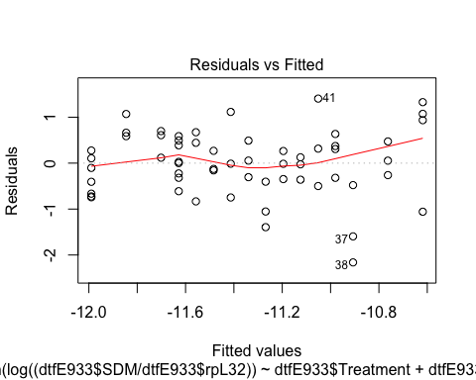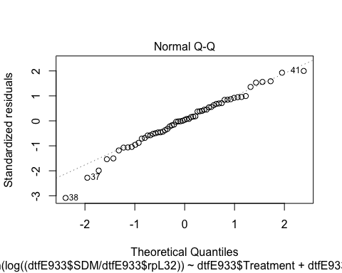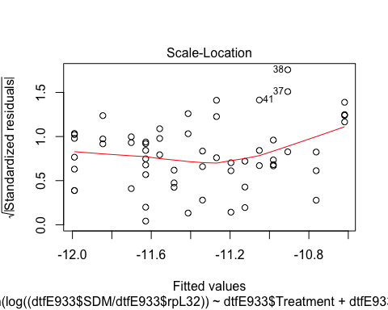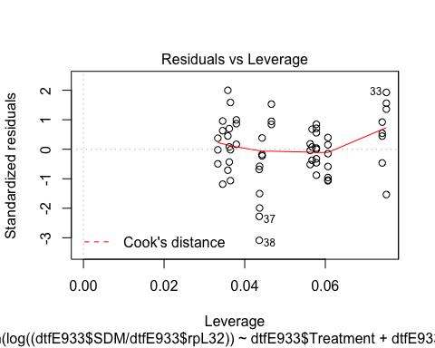

Although E93 isoform 3 expression changes over time, there is no significant effect of the treatment.