Fundamentals of Computer Programming
Assignment 1 — Solutions & Source Code (26CSU223)
Link: https://github.com/thecodecaveman/FOCP-Assignment/tree/main/Assignment1
Module 1
Question 1
Problem: Read from STDIN, Write to STDOUT
Screenshot:
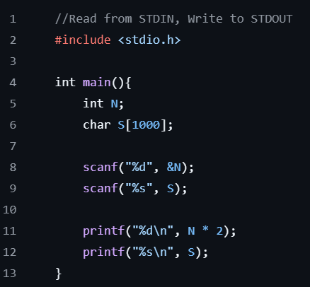
Source Code:
#include <stdio.h>
int main(){
int N;
char S[1000];
scanf("%d", &N);
scanf("%s", S);
printf("%d\n", N * 2);
printf("%s\n", S);
}
Question 2
Problem: Solve Me First
Screenshot:
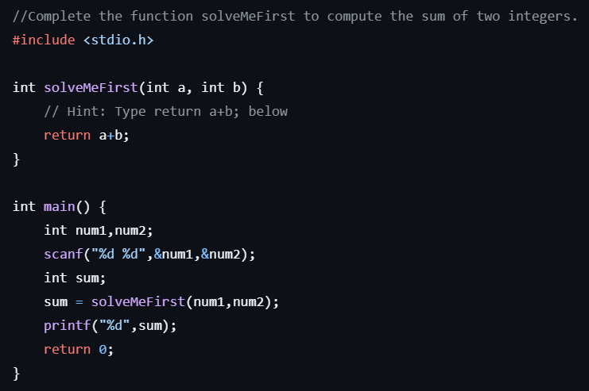
Source Code:
#include <stdio.h>
int solveMeFirst(int a, int b) {
// Hint: Type return a+b; below
return a+b;
}
int main() {
int num1,num2;
scanf("%d %d",&num1,&num2);
int sum;
sum = solveMeFirst(num1,num2);
printf("%d",sum);
return 0;
}
Question 3
Problem: 2235 — Add Two Integers
Screenshot:
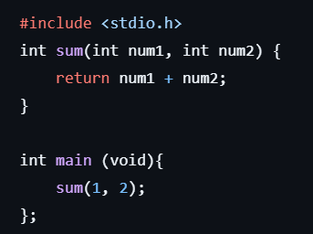
Source Code:
#include <stdio.h>
int sum(int num1, int num2) {
return num1 + num2;
}
int main (void){
sum(1, 2);
};
Question 4
Problem: 2651 — Calculate Delayed Arrival Time
Screenshot:
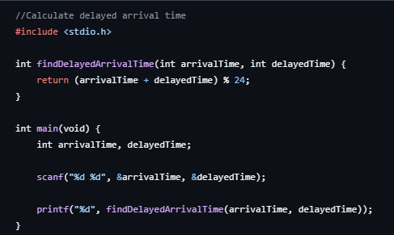
Source Code:
#include <stdio.h>
int findDelayedArrivalTime(int arrivalTime, int delayedTime) {
return (arrivalTime + delayedTime) % 24;
}
int main(void) {
int arrivalTime, delayedTime;
scanf("%d %d", &arrivalTime, &delayedTime);
printf("%d", findDelayedArrivalTime(arrivalTime, delayedTime));
}
Question 5
Problem: 2739 — Total Distance Traveled
Screenshot:
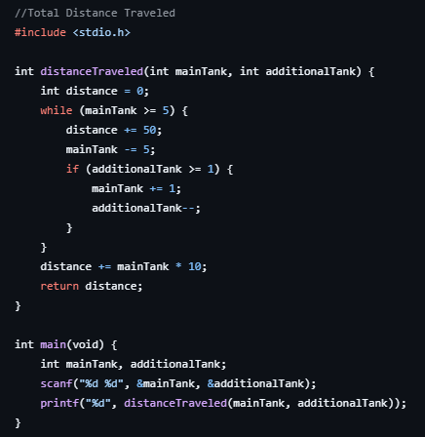
Source Code:
#include <stdio.h>
int distanceTraveled(int mainTank, int additionalTank) {
int distance = 0;
while (mainTank >= 5) {
distance += 50;
mainTank -= 5;
if (additionalTank >= 1) {
mainTank += 1;
additionalTank--;
}
}
distance += mainTank * 10;
return distance;
}
int main(void) {
int mainTank, additionalTank;
scanf("%d %d", &mainTank, &additionalTank);
printf("%d", distanceTraveled(mainTank, additionalTank));
}
Module 2
Question 1
Problem: Conditional Statements in C
Screenshot:
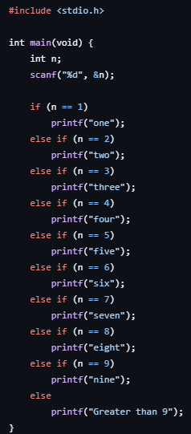
Source Code:
#include <stdio.h>
int main(void) {
int n;
scanf("%d", &n);
if (n == 1)
printf("one");
else if (n == 2)
printf("two");
else if (n == 3)
printf("three");
else if (n == 4)
printf("four");
else if (n == 5)
printf("five");
else if (n == 6)
printf("six");
else if (n == 7)
printf("seven");
else if (n == 8)
printf("eight");
else if (n == 9)
printf("nine");
else
printf("Greater than 9");
}
Question 2
Problem: 2413 — Smallest Even Multiple
Screenshot:
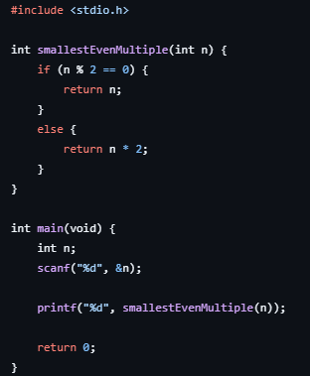
Source Code:
#include <stdio.h>
int smallestEvenMultiple(int n) {
if (n % 2 == 0) {
return n;
}
else {
return n * 2;
}
}
int main(void) {
int n;
scanf("%d", &n);
printf("%d", smallestEvenMultiple(n));
return 0;
}
Question 3
Problem: Grading Students
Screenshot:
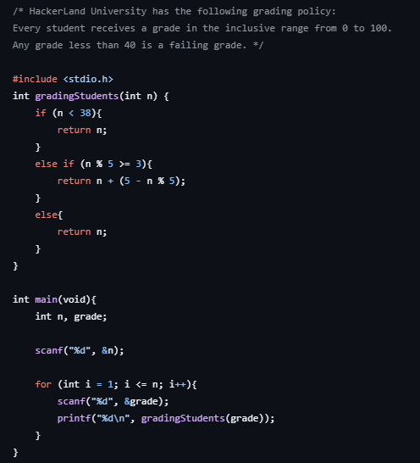
Source Code:
#include <stdio.h>
int gradingStudents(int n) {
if (n < 38){
return n;
}
else if (n % 5 >= 3){
return n + (5 - n % 5);
}
else{
return n;
}
}
int main(void){
int n, grade;
scanf("%d", &n);
for (int i = 1; i <= n; i++){
scanf("%d", &grade);
printf("%d\n", gradingStudents(grade));
}
}
Question 4
Problem: Roy and Profile Picture
Screenshot:
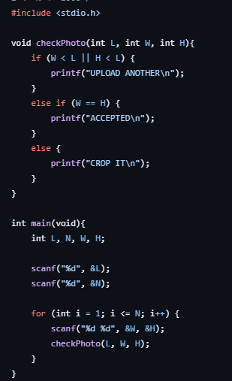
Source Code:
#include <stdio.h>
void checkPhoto(int L, int W, int H){
if (W < L || H < L) {
printf("UPLOAD ANOTHER\n");
}
else if (W == H) {
printf("ACCEPTED\n");
}
else {
printf("CROP IT\n");
}
}
int main(void){
int L, N, W, H;
scanf("%d", &L);
scanf("%d", &N);
for (int i = 1; i <= N; i++) {
scanf("%d %d", &W, &H);
checkPhoto(L, W, H);
}
}
Question 5
Problem: FizzBuzz
Screenshot:
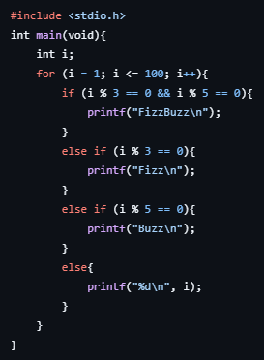
Source Code:
#include <stdio.h>
int main(void){
int i;
for (i = 1; i <= 100; i++){
if (i % 3 == 0 && i % 5 == 0){
printf("FizzBuzz\n");
}
else if (i % 3 == 0){
printf("Fizz\n");
}
else if (i % 5 == 0){
printf("Buzz\n");
}
else{
printf("%d\n", i);
}
}
}
Module 3
Question 1
Problem: For Loop in C
Screenshot:
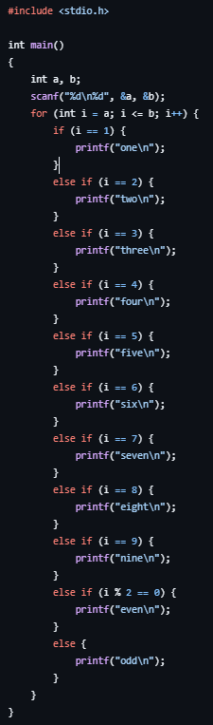
Source Code:
#include <stdio.h>
int main()
{
int a, b;
scanf("%d\n%d", &a, &b);
for (int i = a; i <= b; i++) {
if (i == 1) {
printf("one\n");
}
else if (i == 2) {
printf("two\n");
}
else if (i == 3) {
printf("three\n");
}
else if (i == 4) {
printf("four\n");
}
else if (i == 5) {
printf("five\n");
}
else if (i == 6) {
printf("six\n");
}
else if (i == 7) {
printf("seven\n");
}
else if (i == 8) {
printf("eight\n");
}
else if (i == 9) {
printf("nine\n");
}
else if (i % 2 == 0) {
printf("even\n");
}
else {
printf("odd\n");
}
}
}

Question 2
Problem: 1342 — Number of Steps to Reduce a Number to Zero
Screenshot:
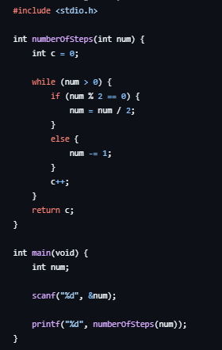
Source Code:
#include <stdio.h>
int numberOfSteps(int num) {
int c = 0;
while (num > 0) {
if (num % 2 == 0) {
num = num / 2;
}
else {
num -= 1;
}
c++;
}
return c;
}
int main(void) {
int num;
scanf("%d", &num);
printf("%d", numberOfSteps(num));
}
Question 3
Problem: 2169 — Count Operations to Obtain Zero
Screenshot:
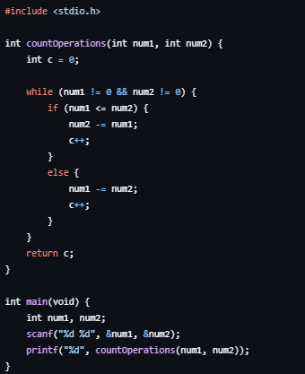
Source Code:
#include <stdio.h>
int countOperations(int num1, int num2) {
int c = 0;
while (num1 != 0 && num2 != 0) {
if (num1 <= num2) {
num2 -= num1;
c++;
}
else {
num1 -= num2;
c++;
}
}
return c;
}
int main(void) {
int num1, num2;
scanf("%d %d", &num1, &num2);
printf("%d", countOperations(num1, num2));
}
Question 4
Problem: 1523 — Count Odd Numbers in an Interval Range
Screenshot:
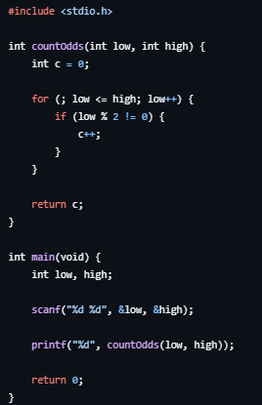
Source Code:
#include <stdio.h>
int countOdds(int low, int high) {
int c = 0;
for (; low <= high; low++) {
if (low % 2 != 0) {
c++;
}
}
return c;
}
int main(void) {
int low, high;
scanf("%d %d", &low, &high);
printf("%d", countOdds(low, high));
return 0;
}
Question 5
Problem: 2652 — Sum Multiples
Screenshot:
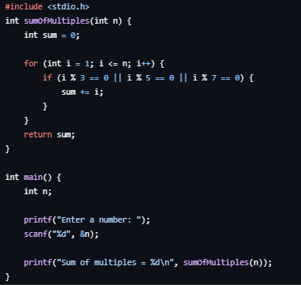
Source Code:
#include <stdio.h>
int sumOfMultiples(int n) {
int sum = 0;
for (int i = 1; i <= n; i++) {
if (i % 3 == 0 || i % 5 == 0 || i % 7 == 0) {
sum += i;
}
}
return sum;
}
int main() {
int n;
printf("Enter a number: ");
scanf("%d", &n);
printf("Sum of multiples = %d\n", sumOfMultiples(n));
}
Question 6
Problem: Number Line Jumps
Screenshot:
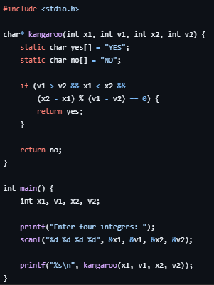
Source Code:
#include <stdio.h>
char* kangaroo(int x1, int v1, int x2, int v2) {
static char yes[] = "YES";
static char no[] = "NO";
if (v1 > v2 && x1 < x2 &&
(x2 - x1) % (v1 - v2) == 0) {
return yes;
}
return no;
}
int main() {
int x1, v1, x2, v2;
printf("Enter four integers: ");
scanf("%d %d %d %d", &x1, &v1, &x2, &v2);
printf("%s\n", kangaroo(x1, v1, x2, v2));
}
Module 4
Question 1
Problem: Digit Sum
Screenshot:
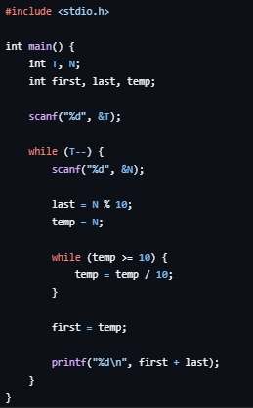
Source Code:
#include <stdio.h>
int main() {
int T, N;
int first, last, temp;
scanf("%d", &T);
while (T--) {
scanf("%d", &N);
last = N % 10;
temp = N;
while (temp >= 10) {
temp = temp / 10;
}
first = temp;
printf("%d\n", first + last);
}
}
Question 2
Problem: Find Digits
Screenshot:
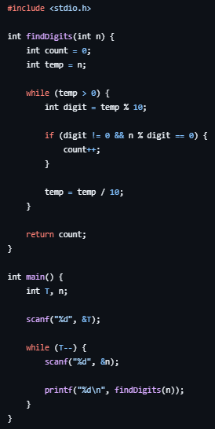
Source Code:
#include <stdio.h>
int findDigits(int n) {
int count = 0;
int temp = n;
while (temp > 0) {
int digit = temp % 10;
if (digit != 0 && n % digit == 0) {
count++;
}
temp = temp / 10;
}
return count;
}
int main() {
int T, n;
scanf("%d", &T);
while (T--) {
scanf("%d", &n);
printf("%d\n", findDigits(n));
}
}
Question 3
Problem: 1281 — Subtract the Product and Sum of Digits
Screenshot:
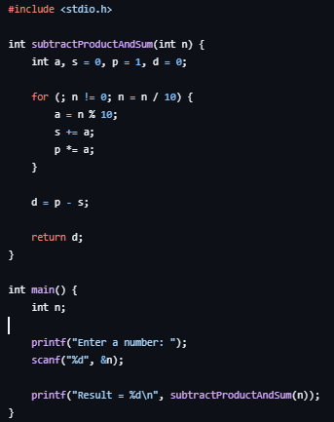
Source Code:
#include <stdio.h>
int subtractProductAndSum(int n) {
int a, s = 0, p = 1, d = 0;
for (; n != 0; n = n / 10) {
a = n % 10;
s += a;
p *= a;
}
d = p - s;
return d;
}
int main() {
int n;
printf("Enter a number: ");
scanf("%d", &n);
printf("Result = %d\n", subtractProductAndSum(n));
}
Question 4
Problem: 2520 — Count the Digits That Divide a Number
Screenshot:
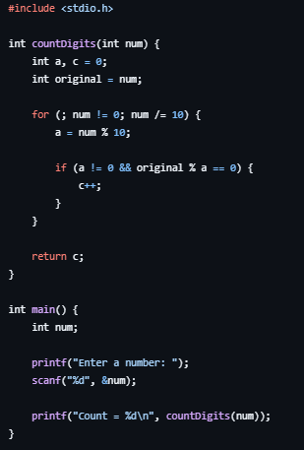
Source Code:
#include <stdio.h>
int countDigits(int num) {
int a, c = 0;
int original = num;
for (; num != 0; num /= 10) {
a = num % 10;
if (a != 0 && original % a == 0) {
c++;
}
}
return c;
}
int main() {
int num;
printf("Enter a number: ");
scanf("%d", &num);
printf("Count = %d\n", countDigits(num));
}
Question 5
Problem: 9 — Palindrome Number
Screenshot:
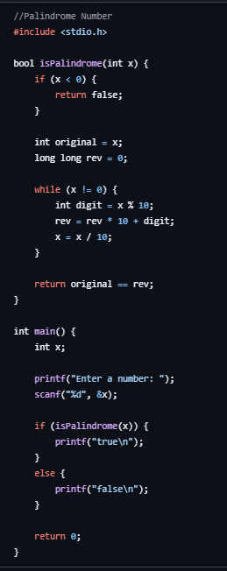
Source Code:
#include <stdio.h>
bool isPalindrome(int x) {
if (x < 0) {
return false;
}
int original = x;
long long rev = 0;
while (x != 0) {
int digit = x % 10;
rev = rev * 10 + digit;
x = x / 10;
}
return original == rev;
}
int main() {
int x;
printf("Enter a number: ");
scanf("%d", &x);
if (isPalindrome(x)) {
printf("true\n");
}
else {
printf("false\n");
}
return 0;
}
Question 6
Problem: 7 — Reverse Integer
Screenshot:
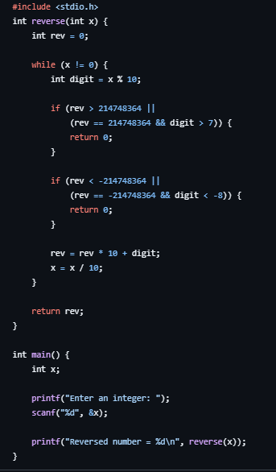
Source Code:
#include <stdio.h>
int reverse(int x) {
int rev = 0;
while (x != 0) {
int digit = x % 10;
if (rev > 214748364 ||
(rev == 214748364 && digit > 7)) {
return 0;
}
if (rev < -214748364 ||
(rev == -214748364 && digit < -8)) {
return 0;
}
rev = rev * 10 + digit;
x = x / 10;
}
return rev;
}
int main() {
int x;
printf("Enter an integer: ");
scanf("%d", &x);
printf("Reversed number = %d\n", reverse(x));
}
Module 5
Question 1
Problem: 231 — Power of Two
Screenshot:
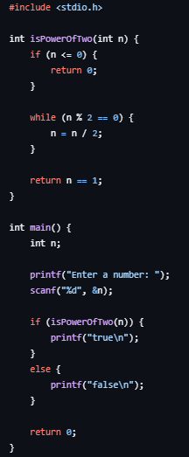
Source Code:
#include <stdio.h>
int isPowerOfTwo(int n) {
if (n <= 0) {
return 0;
}
while (n % 2 == 0) {
n = n / 2;
}
return n == 1;
}
int main() {
int n;
printf("Enter a number: ");
scanf("%d", &n);
if (isPowerOfTwo(n)) {
printf("true\n");
}
else {
printf("false\n");
}
return 0;
}
Question 2
Problem: 326 — Power of Three
Screenshot:
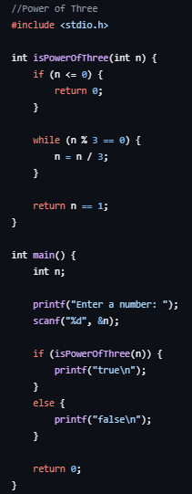
Source Code:
#include <stdio.h>
int isPowerOfThree(int n) {
if (n <= 0) {
return 0;
}
while (n % 3 == 0) {
n = n / 3;
}
return n == 1;
}
int main() {
int n;
printf("Enter a number: ");
scanf("%d", &n);
if (isPowerOfThree(n)) {
printf("true\n");
}
else {
printf("false\n");
}
return 0;
}
Question 3
Problem: Factorial!
Screenshot:
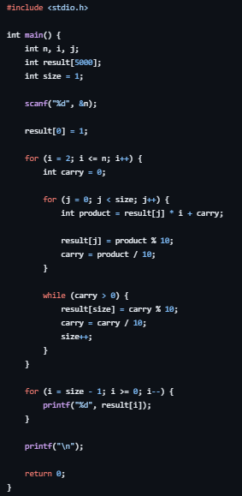
Source Code:
#include <stdio.h>
int main() {
int n, i, j;
int result[5000];
int size = 1;
scanf("%d", &n);
result[0] = 1;
for (i = 2; i <= n; i++) {
int carry = 0;
for (j = 0; j < size; j++) {
int product = result[j] * i + carry;
result[j] = product % 10;
carry = product / 10;
}
while (carry > 0) {
result[size] = carry % 10;
carry = carry / 10;
size++;
}
}
for (i = size - 1; i >= 0; i--) {
printf("%d", result[i]);
}
printf("\n");
return 0;
}
Question 4
Problem: Count Divisors
Screenshot:
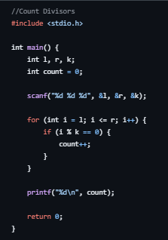
Source Code:
#include <stdio.h>
int main() {
int l, r, k;
int count = 0;
scanf("%d %d %d", &l, &r, &k);
for (int i = l; i <= r; i++) {
if (i % k == 0) {
count++;
}
}
printf("%d\n", count);
return 0;
}
Question 5
Problem: Prime Numbers
Screenshot:
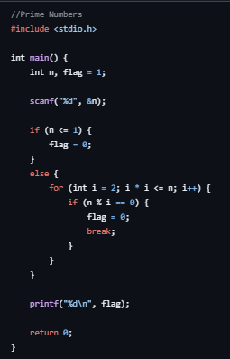
Source Code:
#include <stdio.h>
int main() {
int n, flag = 1;
scanf("%d", &n);
if (n <= 1) {
flag = 0;
}
else {
for (int i = 2; i * i <= n; i++) {
if (n % i == 0) {
flag = 0;
break;
}
}
}
printf("%d\n", flag);
return 0;
}
Question 6
Problem: 507 — Perfect Number
Screenshot:
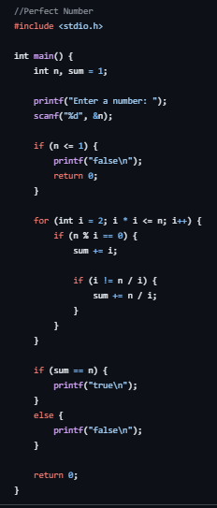
Source Code:
#include <stdio.h>
int main() {
int n, sum = 1;
printf("Enter a number: ");
scanf("%d", &n);
if (n <= 1) {
printf("false\n");
return 0;
}
for (int i = 2; i * i <= n; i++) {
if (n % i == 0) {
sum += i;
if (i != n / i) {
sum += n / i;
}
}
}
if (sum == n) {
printf("true\n");
}
else {
printf("false\n");
}
return 0;
}
Module 6
Question 1
Problem: Staircase
Screenshot:
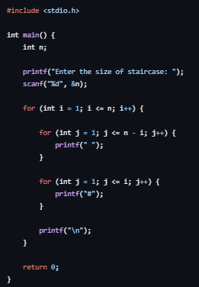
Source Code:
#include <stdio.h>
int main() {
int n;
printf("Enter the size of staircase: ");
scanf("%d", &n);
for (int i = 1; i <= n; i++) {
for (int j = 1; j <= n - i; j++) {
printf(" ");
}
for (int j = 1; j <= i; j++) {
printf("#");
}
printf("\n");
}
return 0;
}
Question 2
Problem: Printing Pattern Using Loops
Screenshot:
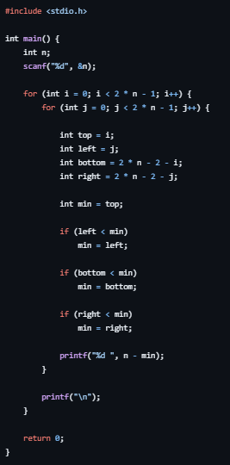
Source Code:
#include <stdio.h>
int main(){
int n;
scanf("%d", &n);
for (int i = 0; i < 2 * n - 1; i++) {
for (int j = 0; j < 2 * n - 1; j++) {
int top = i;
int left = j;
int bottom = 2 * n - 2 - i;
int right = 2 * n - 2 - j;
int min = top;
if (left < min)
min = left;
if (bottom < min)
min = bottom;
if (right < min)
min = right;
printf("%d ", n - min);
}
printf("\n");
}
}
Module 7
Question 1
Problem: Given a positive integer n, print a square containing n rows and n columns of asterisks (*). Do not print spaces between asterisks.
Screenshot:
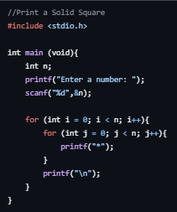
Source Code:
#include <stdio.h>
int main (void){
int n;
printf("Enter a number: ");
scanf("%d",&n);
for (int i = 0; i < n; i++){
for (int j = 0; j < n; j++){
printf("*");
}
printf("\n");
}
}
Question 2
Problem: Given n, print a left-aligned triangle. Row i must contain exactly i asterisks, for i from 1 to n.
Screenshot:
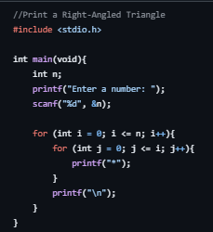
Source Code:
#include <stdio.h>
int main(void){
int n;
printf("Enter a number: ");
scanf("%d", &n);
for (int i = 0; i <= n; i++){
for (int j = 0; j <= i; j++){
printf("*");
}
printf("\n");
}
}
Question 3
Problem: Given n, print a left-aligned inverted triangle. The first row contains n asterisks; each following row contains one fewer.
Screenshot:
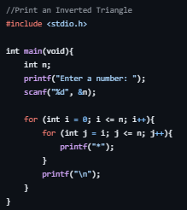
Source Code:
#include <stdio.h>
int main(void){
int n;
printf("Enter a number: ");
scanf("%d", &n);
for (int i = 0; i <= n; i++){
for (int j = i; j <= n; j++){
printf("*");
}
printf("\n");
}
}
Question 4
Problem: Given n, print n rows. On row i, print integers from 1 through i, separated by one space.
Screenshot:
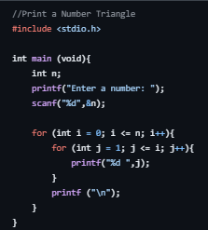
Source Code:
#include <stdio.h>
int main (void){
int n;
printf("Enter a number: ");
scanf("%d",&n);
for (int i = 0; i <= n; i++){
for (int j = 1; j <= i; j++){
printf("%d ",j);
}
printf ("\n");
}
}
Question 5
Problem: Given n, print n rows. On row i, print the number i exactly i times, separated by one space.
Screenshot:
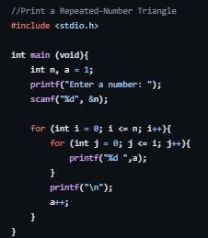
Source Code:
#include <stdio.h>
int main (void){
int n, a = 1;
printf("Enter a number: ");
scanf("%d", &n);
for (int i = 0; i <= n; i++){
for (int j = 0; j <= i; j++){
printf("%d ",a);
}
printf("\n");
a++;
}
}
Question 6
Problem: Print consecutive positive integers across triangular rows. Row 1 has one number, row 2 has two, and so on. Counting starts at 1 and continues across rows.
Screenshot:
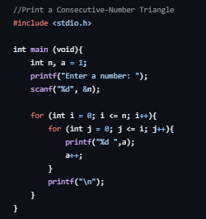
Source Code:
#include <stdio.h>
int main (void){
int n, a = 1;
printf("Enter a number: ");
scanf("%d", &n);
for (int i = 0; i <= n; i++){
for (int j = 0; j <= i; j++){
printf("%d ",a);
a++;
}
printf("\n");
}
}
Question 7
Problem: Given n, print a right-aligned triangle. Row 1 has one asterisk and row n has n asterisks. Use leading spaces to align the right edges.
Screenshot:
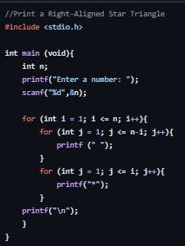
Source Code:
#include <stdio.h>
int main (void){
int n;
printf("Enter a number: ");
scanf("%d",&n);
for (int i = 1; i <= n; i++){
for (int j = 1; j <= n-i; j++){
printf (" ");
}
for (int j = 1; j <= i; j++){
printf("*");
}
printf("\n");
}
}
Question 8
Problem: Given n, print a centered pyramid with n rows. Row i contains 2i - 1 asterisks, preceded by enough spaces to center it.
Screenshot:
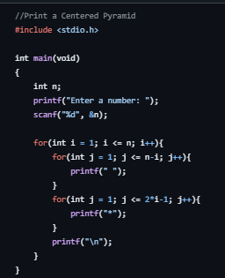
Source Code:
#include <stdio.h>
int main(void)
{
int n;
printf("Enter a number: ");
scanf("%d", &n);
for(int i = 1; i <= n; i++){
for(int j = 1; j <= n-i; j++){
printf(" ");
}
for(int j = 1; j <= 2*i-1; j++){
printf("*");
}
printf("\n");
}
}
Question 9
Problem: Given n, print an inverted centered pyramid. The first row contains 2n - 1 asterisks; each next row has two fewer and one more leading space.
Screenshot:
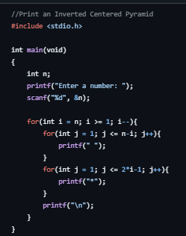
Source Code:
#include <stdio.h>
int main(void)
{
int n;
printf("Enter a number: ");
scanf("%d", &n);
for(int i = n; i >= 1; i--){
for(int j = 1; j <= n-i; j++){
printf(" ");
}
for(int j = 1; j <= 2*i-1; j++){
printf("*");
}
printf("\n");
}
}
Question 10
Problem: Given n, print an n-by-n hollow square. Print an asterisk on the first row, last row, first column, or last column. Print a space inside.
Screenshot:
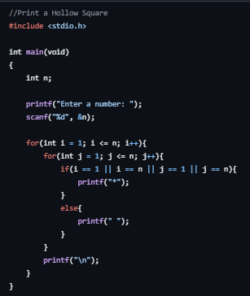
Source Code:
#include <stdio.h>
int main(void)
{
int n;
printf("Enter a number: ");
scanf("%d", &n);
for(int i = 1; i <= n; i++){
for(int j = 1; j <= n; j++){
if(i == 1 || i == n || j == 1 || j == n){
printf("*");
}
else{
printf(" ");
}
}
printf("\n");
}
}
Question 11
Problem: Given n, print the outline of a left-aligned right-angled triangle. Print asterisks in the first column, on the diagonal boundary, and across the final row. Print spaces inside.
Screenshot:
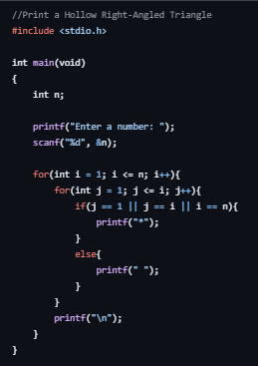
Source Code:
#include <stdio.h>
int main(void)
{
int n;
printf("Enter a number: ");
scanf("%d", &n);
for(int i = 1; i <= n; i++){
for(int j = 1; j <= i; j++){
if(j == 1 || j == i || i == n){
printf("*");
}
else{
printf(" ");
}
}
printf("\n");
}
}
Question 12
Problem: Given n, print an n-by-n multiplication grid. At row i and column j, print i multiplied by j. Separate values with one space.
Screenshot:
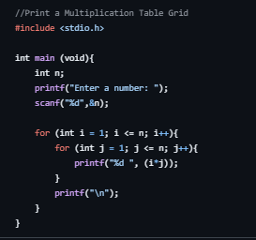
Source Code:
#include <stdio.h>
int main (void){
int n;
printf("Enter a number: ");
scanf("%d",&n);
for (int i = 1; i <= n; i++){
for (int j = 1; j <= n; j++){
printf("%d ", (i*j));
}
printf("\n");
}
}
Question 13
Problem: Given n, print an n-by-n checkerboard using X and O. The top-left character must be X; adjacent horizontal and vertical cells alternate.
Screenshot:
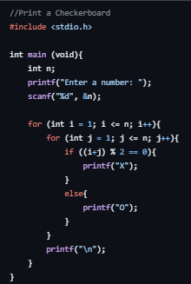
Source Code:
#include <stdio.h>
int main (void){
int n;
printf("Enter a number: ");
scanf("%d", &n);
for (int i = 1; i <= n; i++){
for (int j = 1; j <= n; j++){
if ((i+j) % 2 == 0){
printf("X");
}
else{
printf("O");
}
}
printf("\n");
}
}
Question 14
Problem: Given n, print Floyd's triangle with n rows. Fill it with consecutive positive integers starting at 1, placing one number on row 1, two on row 2, and so on.
Screenshot:
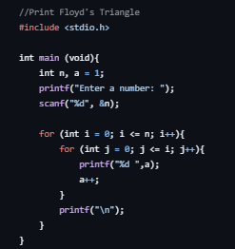
Source Code:
#include <stdio.h>
int main (void){
int n, a = 1;
printf("Enter a number: ");
scanf("%d", &n);
for (int i = 0; i <= n; i++){
for (int j = 0; j <= i; j++){
printf("%d ",a);
a++;
}
printf("\n");
}
}
Question 15
Problem: Given an odd integer n, print a butterfly made of asterisks. The top half widens row by row and the lower half mirrors it. Use spaces between the left and right wings.
Screenshot:
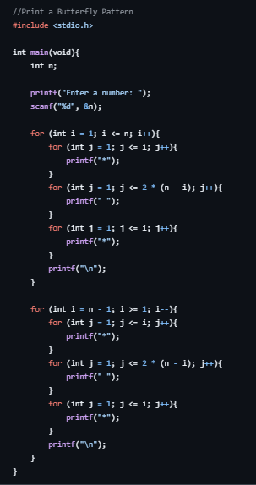
Source Code:
#include <stdio.h>
int main(void){
int n;
printf("Enter a number: ");
scanf("%d", &n);
for (int i = 1; i <= n; i++){
for (int j = 1; j <= i; j++){
printf("*");
}
for (int j = 1; j <= 2 * (n - i); j++){
printf(" ");
}
for (int j = 1; j <= i; j++){
printf("*");
}
printf("\n");
}
for (int i = n - 1; i >= 1; i--){
for (int j = 1; j <= i; j++){
printf("*");
}
for (int j = 1; j <= 2 * (n - i); j++){
printf(" ");
}
for (int j = 1; j <= i; j++){
printf("*");
}
printf("\n");
}
}
Question 16
Problem: Given n, print a centered diamond. The upper half has n rows including the widest row; then print n - 1 rows in decreasing width.
Screenshot:
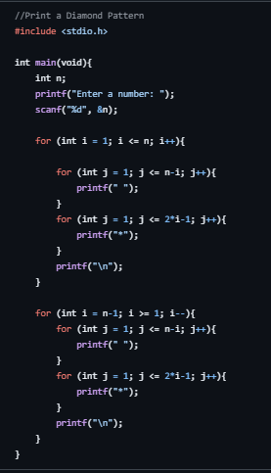
Source Code:
#include <stdio.h>
int main(void){
int n;
printf("Enter a number: ");
scanf("%d", &n);
for (int i = 1; i <= n; i++){
for (int j = 1; j <= n-i; j++){
printf(" ");
}
for (int j = 1; j <= 2*i-1; j++){
printf("*");
}
printf("\n");
}
for (int i = n-1; i >= 1; i--){
for (int j = 1; j <= n-i; j++){
printf(" ");
}
for (int j = 1; j <= 2*i-1; j++){
printf("*");
}
printf("\n");
}
}

