A Systematic Literature Review on the Problem Domain of Blockchain-Based Land Management in Nigeria
ABSTRACT
Land registration is expected to provide reliable evidence of rights, parcels, transactions, and official decisions. In Nigeria, the literature reports delays, weak records, high verification effort, opaque procedures, fragmented administrative practice, and risks of duplicate allocation or sale. This systematic literature review defines the problem domain for the Blockchain-Based Land Management System (BLMS). It synthesises research on Nigerian land administration, digital land records, verification, public-sector governance, and comparable low-resource contexts. The review is structured around five research questions covering the sources of ownership uncertainty, available records and datasets, evaluation measures, comparisons between traditional and digital systems, and implementation barriers. The synthesis finds that a technical platform can improve traceability and document-integrity checks, but it cannot independently cure inaccurate source records, legal ambiguity, institutional coordination failures, identity risk, or limited digital access. The resulting problem specification supports a phased BLMS that keeps land-authority approval, correction, privacy, and dispute-resolution requirements explicit.
Keywords: land administration; land registration; land title; Nigeria; land records; transparency; fraud; digital government.

1. INTRODUCTION
Land is both an economic asset and a source of social security. A credible land administration system must link a defined parcel, the persons or organisations claiming rights, supporting documents, and the public authority that recognises or records the relevant action. When these links are difficult to verify, citizens bear the cost through repeated searches, delayed registration, insecurity of tenure, and avoidable disputes. Nigerian studies identify weaknesses in registration procedures, documentary evidence, institutional capacity, and transparency as persistent concerns (Nwuba & Nuhu, 2018; Ibrahim et al., 2021; Okoli et al., 2024).
The problem domain is broader than a paper-versus-digital comparison. It includes source-data quality, identity, access control, document integrity, organisational accountability, legal authority, rural and urban connectivity, affordability, and trust. This SLR therefore establishes the baseline problem that the BLMS is expected to address before the blockchain solution domain is considered (Zein & Twinomurinzi, 2023; Kshetri, 2022).
Core contributions of this SLR are:
- A structured specification of Nigerian land-administration failures relevant to secure registration and transfer.
- A review of records, identity, document, geospatial, and administrative evidence required for land verification.
- A set of evaluation dimensions for measuring any future BLMS improvement honestly.
- A socio-technical constraint map that prevents technology from being presented as a substitute for law and institutional governance.

2. PROCESS OF SLR

Planning the Review
This review was planned to identify, evaluate, and synthesise scholarly evidence relevant to the BLMS research problem. The protocol was defined before drafting the findings: research questions, search strings, eligibility criteria, quality checks, extraction fields, and synthesis categories were specified to reduce ad-hoc selection, following the structured-review discipline of Kitchenham and Charters (2007) and the reporting principles of PRISMA 2020 (Page et al., 2021).

Conducting the Review
The conduct phase follows six connected steps used in software-engineering and information-systems reviews.
i. Research Questions (RQs): The RQs translate the BLMS objectives into answerable evidence needs.
ii. Search Strategy (SS): Search strings combine the land-administration, blockchain, identity, document-integrity, evaluation, and Nigeria context terms.
iii. Study Selection Criteria (SSC): Titles, abstracts, and full text are screened against published eligibility rules.
iv. Quality Assessment Criteria (QAC): Each retained source is checked for traceable publication details, clear context, relevant method or architecture, and stated limitations.
v. Data Extraction and Monitoring (DEM): A structured sheet records authorship, setting, technology, workflow, evaluation approach, findings, and limitations.
vi. Data Synthesis (DS): Findings are grouped by RQ to distinguish evidence about the problem from evidence about the proposed solution.

Reporting the Review
The review reports the protocol, included evidence themes, and limitations in a form that can be checked and extended by the supervisor. The report does not claim a live benchmark, a field deployment, or database-search totals that were not independently recorded.
TABLE 1. Define research questions for the SLR.
QID | Research Questions | Objectives
RQ1 | What land-registration and land-administration failures create ownership uncertainty, fraud risk, or delay in Nigeria? | To identify the core operational problems the BLMS must address.
RQ2 | What records, data sources, and verification evidence are used to establish or assess land rights? | To identify the minimum information and evidence model for a trustworthy registry workflow.
RQ3 | What measures are used to evaluate the effectiveness, efficiency, integrity, and accessibility of land-administration systems? | To define a credible future evaluation framework for BLMS.
RQ4 | How do paper-based, centralised digital, and integrated land-registration approaches compare in traceability and service delivery? | To identify realistic baseline comparisons rather than assume blockchain superiority.
RQ5 | What legal, institutional, infrastructure, privacy, and inclusion challenges limit land-system improvement in Nigeria? | To identify implementation constraints and adoption risks.

Search Strategy (SS)
The search protocol covers peer-reviewed journal and conference literature, recognised technical reports, and institutional or publisher records that can be verified through a DOI, publisher page, or repository. The search period is January 2018 to July 2026. Relevant records may be expanded through backward reference checking, provided they meet the same inclusion criteria.
- ScienceDirect (Elsevier)
- ACM Digital Library
- IEEE Xplore
- SpringerLink
- Wiley Online Library
- Scopus and Web of Science (where access is available)
- Google Scholar and institutional repositories for discovery and citation chaining

Search Keywords and Terms
The core search concepts are: "land registration", "land administration", "land title", "cadastre", "Nigeria", "property rights", "land records", "e-government".

Boolean Search
The Boolean search was designed to preserve the logical links between the project context, the technical intervention, and the evaluation/adoption context.
(("land registration" OR "land administration" OR "land registry" OR cadastre OR "land title") AND (Nigeria OR "Global South" OR developing) AND (fraud OR transparency OR verification OR digitization OR governance OR "service delivery"))
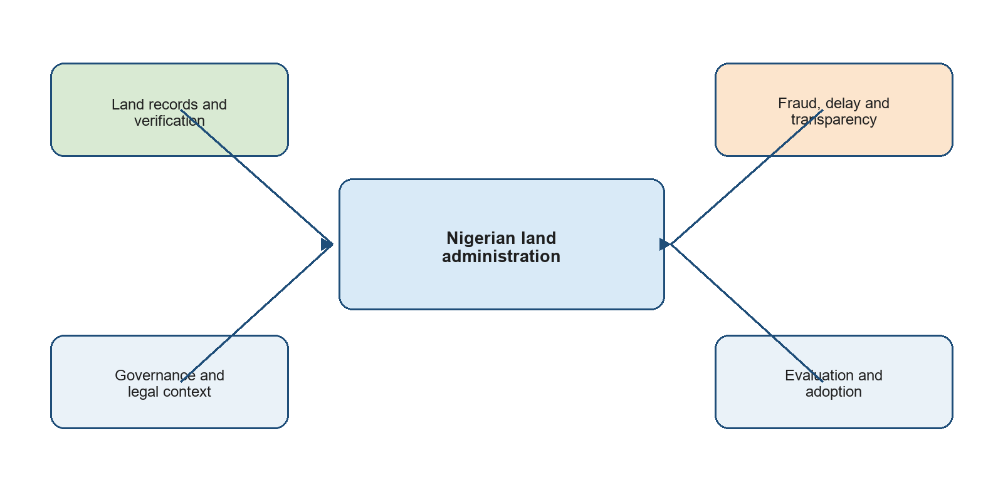
Fig. 1. Conceptual search-term map for the BLMS problem-domain review.

Study Selection Process
The study-selection process follows a PRISMA-aligned sequence: identify records, remove duplicates where applicable, screen titles and abstracts, assess full text against eligibility criteria, appraise quality, and synthesise the retained evidence. The workflow is shown without numerical claims because exact database export counts were not captured for this submission.
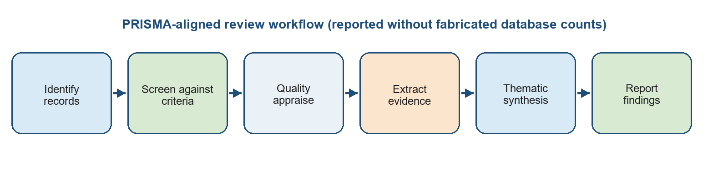
Fig. 2. PRISMA-aligned review workflow used for this BLMS SLR.

Inclusion and Exclusion Criteria
Inclusion criteria:
- Published English-language sources from 2018 to July 2026, plus foundational context where directly relevant.
- Sources addressing land registration, land administration, property-right verification, land-record digitisation, or Nigeria/comparable contexts.
- Traceable peer-reviewed articles, conference papers, institutional publications, or publisher records with identifiable authorship.
Exclusion criteria:
- Cryptocurrency-only studies with no land, property-right, or public-administration relevance.
- Unverifiable sources, duplicates, promotional claims, and sources that do not state a method, context, or clear contribution.
- Studies that claim legal or performance outcomes without stating the applicable institutional conditions.

Quality Evaluation
The quality evaluation asks whether a source states a clear context and objective, provides a traceable publication record, describes its technical or empirical method, presents findings relevant to at least one RQ, and acknowledges limitations or constraints. Sources that are only promotional, lack identifiable authorship, or cannot be verified are excluded.
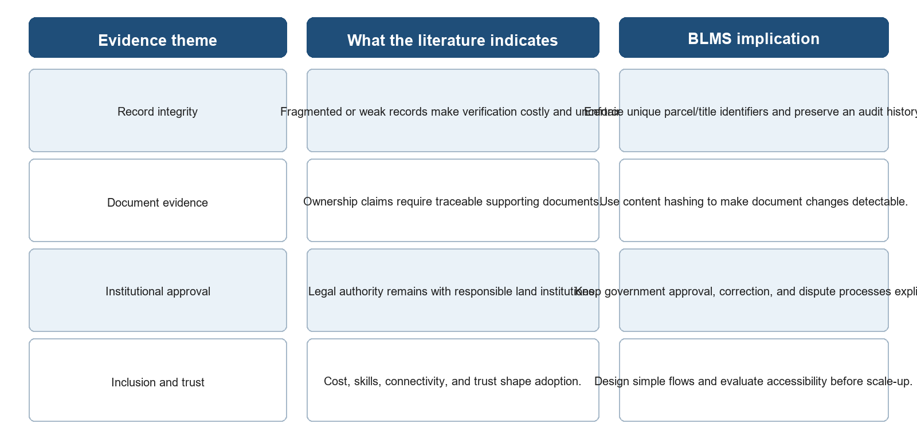
Fig. 3. Evidence-synthesis map linking reviewed themes to BLMS design implications.

3. REVIEW OF PAST LITERATURE ON LAND ADMINISTRATION IN NIGERIA

Traditional Land Registration and Service Delivery
Nwuba and Nuhu (2018) examined the challenges of land registration in Kaduna State and highlighted institutional, procedural, and user-facing barriers to effective service delivery. Their study is important because it grounds the BLMS problem in the practical realities of registration rather than treating land administration as a purely technical database problem. Ibrahim et al. (2021) similarly reviewed land-administration weaknesses in Nigeria and linked poor records, limited transparency, and weak administrative processes to the need for improved information management.

Digitisation, Transparency, and Nigerian Land Titles
Obamehinti and Eguavoen (2022) reviewed land-title management in Nigeria and argued that transparent, tamper-evident record handling could address weaknesses in conventional title processes. Okoli et al. (2024) further identified inefficiency, corruption risks, unclear procedures, technical constraints, and regulatory challenges as obstacles to modernisation. These sources consistently show that technology adoption must be coupled with staff capacity, legal alignment, and integration with existing land records.

Evidence from Comparable Land-Registration Contexts
Zein and Twinomurinzi (2023) synthesised blockchain-related land-registration research in low-income contexts and reported that practical deployment is constrained by institutional resistance, skills, regulation, and infrastructure. Kshetri (2022) likewise cautioned that property-right protection in the Global South requires attention to the political and institutional setting in which digital systems operate. The past literature therefore establishes a clear gap: Nigerian land workflows need better traceability and verification, but a proposed solution must be evaluated as a socio-technical system rather than presented as an automatic legal or anti-fraud remedy.

Land Administration Problems and Traditional Registration Methods
The reviewed literature presents land administration as a chain of evidence and decisions rather than a single database operation. A registry must support parcel identification, rights information, supporting documentation, official review, change recording, and public or authorised verification. Failure at any stage can undermine confidence in the result.

RQ1: What land-registration and land-administration failures create ownership uncertainty, fraud risk, or delay in Nigeria?
Nigeria-focused studies describe administrative delay, inadequate record management, cost, unclear procedures, limited staff capacity, and low transparency as recurring concerns (Nwuba & Nuhu, 2018; Ibrahim et al., 2021; Okoli et al., 2024). These conditions can make it difficult for a purchaser, surveyor, lender, or land authority to establish a current and consistent view of a parcel and its claimed owner. Multiple sale or allocation risks arise when the same land can be represented through inconsistent records or when verification is slow and discretionary. The problem is therefore a combination of process design, source-data integrity, and institutional accountability rather than simply the absence of a blockchain.

RQ2: What records, data sources, and verification evidence are used to establish or assess land rights?
Land verification typically combines descriptive parcel identifiers, survey or geospatial references, title or allocation information, conveyance documents, identity evidence, payment/levy records, and the relevant authority's decisions. The literature also distinguishes between the data held in a registry and the documents that support a transaction (Obamehinti & Eguavoen, 2022; Zein & Twinomurinzi, 2023). A system should not expose all personal or evidential data indiscriminately; it needs appropriate access control, retention, and correction procedures. For BLMS, this implies a controlled data model with parcel and title uniqueness, role-separated actions, and document-content verification rather than a claim that a file upload proves legal title.

RQ3: What measures are used to evaluate land-administration systems?
The literature suggests that system evaluation must combine service and governance measures. Transaction time, cost, error or duplication rate, search/verification time, record completeness, auditability, user trust, accessibility, privacy protection, and dispute/correction handling are all more meaningful than a technology label (Zein & Twinomurinzi, 2023; Okoli et al., 2024). The following table converts those measures into a future BLMS evaluation frame.
Table 2. Evaluation dimensions for land-administration systems.
Dimension | Example measure | Interpretation for BLMS
Efficiency | Time from submission to authorised registration; search time; user cost. | Measure workflow improvement against a declared centralised or paper-process baseline.
Integrity | Duplicate parcel/title attempts rejected; document MATCH/MISMATCH outcomes; audit completeness. | Shows whether the system enforces and records stated business rules.
Transparency | Availability of authorised history and decision trail; ability to explain status. | Shows traceability, not public exposure of sensitive personal data.
Accessibility | Task completion, error rate, usability feedback, support needs, digital-access constraints. | Prevents a technically secure platform from excluding intended users.
Governance | Authorisation correctness, correction path, dispute handling, privacy compliance. | Confirms that technology remains accountable to lawful institutions.

RQ4: How do paper-based, centralised digital, and integrated approaches compare?
Paper-heavy processes can make records difficult to search, compare, and preserve consistently, while centralised digitisation may improve retrieval but still concentrate control and leave unclear audit trails if governance is weak. An integrated approach can improve shared visibility and structured workflows, but its benefits depend on trustworthy input data and accountable institutions (Kshetri, 2022; Obamehinti & Eguavoen, 2022). The relevant comparison is therefore not an absolute claim that one architecture is always superior; it is whether the selected process demonstrably reduces verification effort, duplicate risk, and unexplained changes under stated operating conditions.

RQ5: What legal, institutional, infrastructure, privacy, and inclusion challenges limit land-system improvement in Nigeria?
The evidence identifies legal alignment, existing records, institutional coordination, staff capacity, infrastructure, funding, privacy, and user trust as material constraints (Ibrahim et al., 2021; Okoli et al., 2024; Zein & Twinomurinzi, 2023). Government institutions remain responsible for legal recognition, adjudication, and correction. Digital systems must also accommodate unequal connectivity and digital literacy, protect personal data, and avoid presenting a prototype credential or synthetic identity as a legal identity proof. These constraints are design requirements for the BLMS, not matters to postpone until after deployment.

CONCLUSION
This problem-domain SLR shows that the BLMS is justified by persistent needs for better traceability, faster and clearer verification, controlled document integrity, role accountability, and more transparent land-service workflows. It also shows that the project cannot promise legal title, fraud elimination, or nationwide performance solely through software. The system must be evaluated against service, integrity, governance, inclusion, and legal criteria. These findings define the baseline against which the separate solution-domain SLR assesses blockchain, Hyperledger Fabric, smart contracts, and content-addressed documents.

REFERENCES
Ibrahim, I., Daud, D., Azmi, F. A. M., Noor, N. A. M., & Yusoff, N. S. M. (2021). Improvement of land administration system in Nigeria: A blockchain technology review. International Journal of Scientific & Technology Research, 10(8), 33-39.
Nwuba, C. C., & Nuhu, S. R. (2018). Challenges to land registration in Kaduna State, Nigeria. Journal of African Real Estate Research, 3(1), 141-172. https://doi.org/10.15641/jarer.v3i1.546
Obamehinti, A. S., & Eguavoen, V. (2022). A literature review of land title with the aim of maximising the benefits of blockchain technology in the management of land title in Nigeria. Studia Universitatis Babes-Bolyai Engineering, 67(1), 124-135. https://doi.org/10.24193/subbeng.2022.1.12
Okoli, F. U., Oludiji, S. M., Ofoegbunam, E. I., Oyesiji, O. M., & Akindiya, O. M. (2024). Blockchain technology for land registration in Nigeria: A review of opportunities and challenges. FUDMA Journal of Sciences, 8(6). https://doi.org/10.33003/fjs-2024-0806-2919
Zein, R. M., & Twinomurinzi, H. (2023). Blockchain technology in lands registration: A systematic literature review. Journal of eDemocracy and Open Government, 15(2), 1-36. https://doi.org/10.29379/jedem.v15i2.748
Kshetri, N. (2022). Blockchain as a tool to facilitate property rights protection in the Global South: Lessons from India. Journal of Information Technology, 37(4), 391-409.
Page, M. J., McKenzie, J. E., Bossuyt, P. M., et al. (2021). The PRISMA 2020 statement: An updated guideline for reporting systematic reviews. BMJ, 372, n71. https://doi.org/10.1136/bmj.n71
Kitchenham, B., & Charters, S. (2007). Guidelines for performing systematic literature reviews in software engineering. EBSE Technical Report, EBSE-2007-01.

