A Systematic Literature Review on the Solution Domain of a Blockchain-Based Land Management System
ABSTRACT
This systematic literature review examines the solution domain for the Blockchain-Based Land Management System (BLMS): permissioned blockchain architecture, Hyperledger Fabric, Go chaincode, smart contracts, content-addressed document verification, identity, privacy, and evaluation. The review follows a structured protocol and addresses five questions about blockchain architectures for land registration, relevant data and evidence models, evaluation metrics, comparisons with centralised approaches, and adoption constraints. The evidence supports blockchain most strongly as a controlled shared audit and coordination layer where several authorised parties need a consistent transaction history. Hyperledger Fabric is especially relevant to a citizen-government model because it provides permissioned membership, organisational identities, endorsement policies, and programmable contract rules. Content-addressed document checks can make file changes detectable without storing large documents on-chain. The review also finds that blockchain does not validate false source data, remove legal authority, guarantee performance, or eliminate governance and privacy obligations. The resulting implications support a phased BLMS prototype and a separate, measurable Fabric-integration phase.
Keywords: blockchain; Hyperledger Fabric; smart contracts; Go chaincode; IPFS; content addressing; land registration; digital identity.

1. INTRODUCTION
The solution domain addresses the technology and governance mechanisms that may improve the land-administration problems identified in the companion review. A land registry is not improved merely by copying records to a ledger. It requires controlled identities, defined roles, transaction rules, privacy safeguards, documentary evidence, institutional approval, and a way to investigate or correct disputed entries. Blockchain must therefore be assessed as one architectural component in a wider socio-technical system (Batubara et al., 2018; Zein & Twinomurinzi, 2023).
BLMS proposes a permissioned design in which citizen and government actors have distinct roles. The local prototype demonstrates the workflow without requiring Docker or an external service, while the repository contains Go chaincode as a future Fabric research artifact. This SLR explains what those technologies can contribute, what they cannot prove, and how future evaluation should be designed (Androulaki et al., 2018; Zein & Twinomurinzi, 2024).
Core contributions of this SLR are:
- A comparison of blockchain, permissioned-ledger, smart-contract, identity, and document-integrity roles in land registration.
- A BLMS-specific interpretation of why Hyperledger Fabric and Go chaincode are appropriate for a two-organisation research architecture.
- A clear evaluation frame for later Fabric tests without claiming benchmarks that have not been run.
- An adoption and governance map covering legal authority, privacy, interoperability, skills, infrastructure, and data quality.

2. PROCESS OF SLR

Planning the Review
This review was planned to identify, evaluate, and synthesise scholarly evidence relevant to the BLMS research problem. The protocol was defined before drafting the findings: research questions, search strings, eligibility criteria, quality checks, extraction fields, and synthesis categories were specified to reduce ad-hoc selection, following the structured-review discipline of Kitchenham and Charters (2007) and the reporting principles of PRISMA 2020 (Page et al., 2021).

Conducting the Review
The conduct phase follows six connected steps used in software-engineering and information-systems reviews.
i. Research Questions (RQs): The RQs translate the BLMS objectives into answerable evidence needs.
ii. Search Strategy (SS): Search strings combine the land-administration, blockchain, identity, document-integrity, evaluation, and Nigeria context terms.
iii. Study Selection Criteria (SSC): Titles, abstracts, and full text are screened against published eligibility rules.
iv. Quality Assessment Criteria (QAC): Each retained source is checked for traceable publication details, clear context, relevant method or architecture, and stated limitations.
v. Data Extraction and Monitoring (DEM): A structured sheet records authorship, setting, technology, workflow, evaluation approach, findings, and limitations.
vi. Data Synthesis (DS): Findings are grouped by RQ to distinguish evidence about the problem from evidence about the proposed solution.

Reporting the Review
The review reports the protocol, included evidence themes, and limitations in a form that can be checked and extended by the supervisor. The report does not claim a live benchmark, a field deployment, or database-search totals that were not independently recorded.
TABLE 1. Define research questions for the SLR.
QID | Research Questions | Objectives
RQ1 | How are blockchain and permissioned-ledger architectures applied to land registration and property-right workflows? | To identify the architectural patterns relevant to BLMS.
RQ2 | What data, identity, document, and geospatial evidence models are used in blockchain-enabled land systems? | To define which information should be on-chain, off-chain, or content-addressed.
RQ3 | What metrics are used to evaluate blockchain land-registration and Hyperledger Fabric systems? | To define honest future performance and correctness evaluation.
RQ4 | How do blockchain-enabled land systems compare with centralised or conventional approaches? | To assess reported benefits and trade-offs without assuming superiority.
RQ5 | What infrastructure, governance, legal, privacy, and adoption challenges constrain deployment? | To identify the conditions required before a Fabric-connected BLMS can be claimed as operational.

Search Strategy (SS)
The search protocol covers peer-reviewed journal and conference literature, recognised technical reports, and institutional or publisher records that can be verified through a DOI, publisher page, or repository. The search period is January 2018 to July 2026. Relevant records may be expanded through backward reference checking, provided they meet the same inclusion criteria.
- ScienceDirect (Elsevier)
- ACM Digital Library
- IEEE Xplore
- SpringerLink
- Wiley Online Library
- Scopus and Web of Science (where access is available)
- Google Scholar and institutional repositories for discovery and citation chaining

Search Keywords and Terms
The core search concepts are: "blockchain", "Hyperledger Fabric", "land registration", "land registry", "smart contract", "IPFS", "content addressing", "digital identity".

Boolean Search
The Boolean search was designed to preserve the logical links between the project context, the technical intervention, and the evaluation/adoption context.
(("land registration" OR "land registry" OR "land title" OR "property registration") AND (blockchain OR "distributed ledger" OR "Hyperledger Fabric" OR "smart contract" OR IPFS) AND (identity OR document OR performance OR governance OR privacy OR adoption))
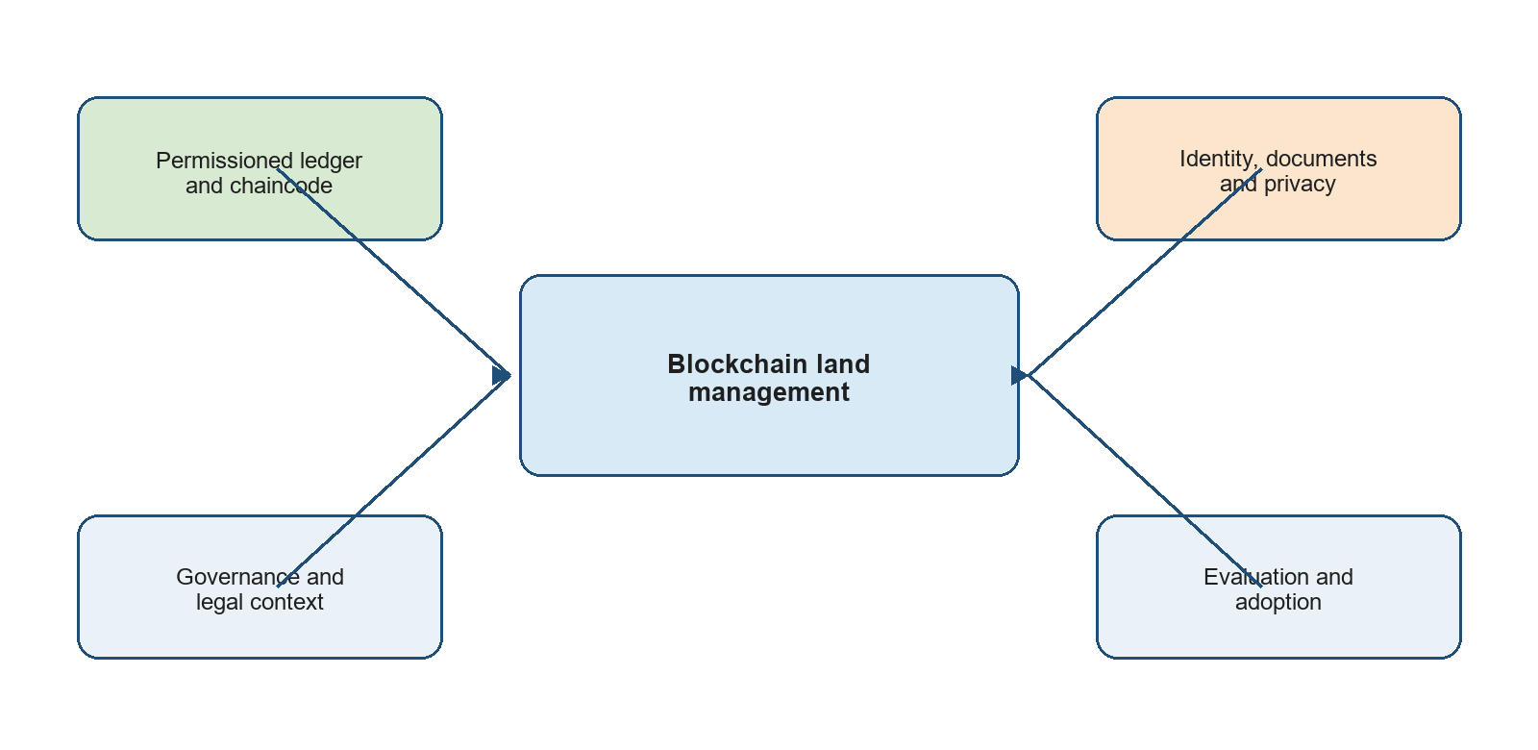
Fig. 1. Conceptual search-term map for the BLMS solution-domain review.

Study Selection Process
The study-selection process follows a PRISMA-aligned sequence: identify records, remove duplicates where applicable, screen titles and abstracts, assess full text against eligibility criteria, appraise quality, and synthesise the retained evidence. The workflow is shown without numerical claims because exact database export counts were not captured for this submission.
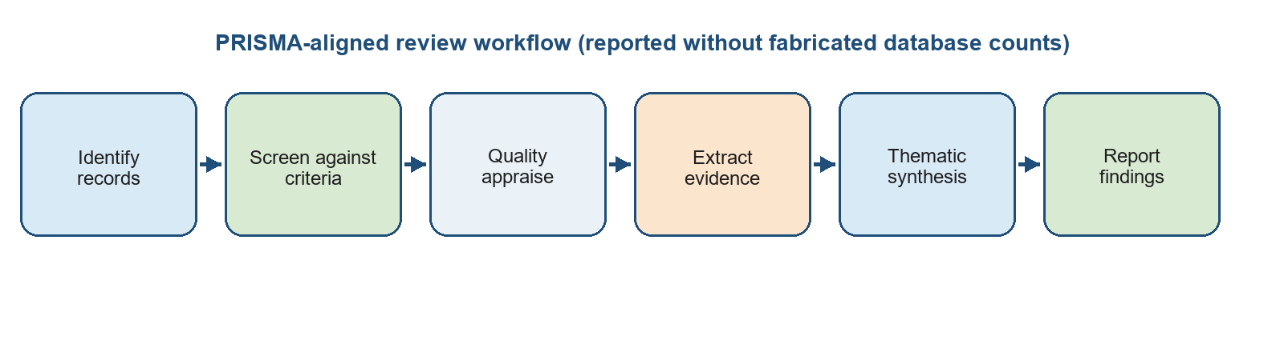
Fig. 2. PRISMA-aligned review workflow used for this BLMS SLR.

Inclusion and Exclusion Criteria
Inclusion criteria:
- Published English-language work from 2018 to July 2026, plus foundational Fabric or review-method work directly needed for the RQs.
- Sources that address land/property registration, permissioned or public blockchain, smart contracts, document integrity, identity, or blockchain evaluation.
- Traceable journal articles, conference papers, recognised technical publications, and publisher or institutional records.
Exclusion criteria:
- Blockchain studies unrelated to land/property workflows or public administration.
- Unverifiable repositories, duplicated records, marketing material, and sources without an identifiable method, architecture, or limitation.
- Claims of legal transfer, real identity verification, or benchmark performance without stated conditions and evidence.

Quality Evaluation
The quality evaluation asks whether a source states a clear context and objective, provides a traceable publication record, describes its technical or empirical method, presents findings relevant to at least one RQ, and acknowledges limitations or constraints. Sources that are only promotional, lack identifiable authorship, or cannot be verified are excluded.
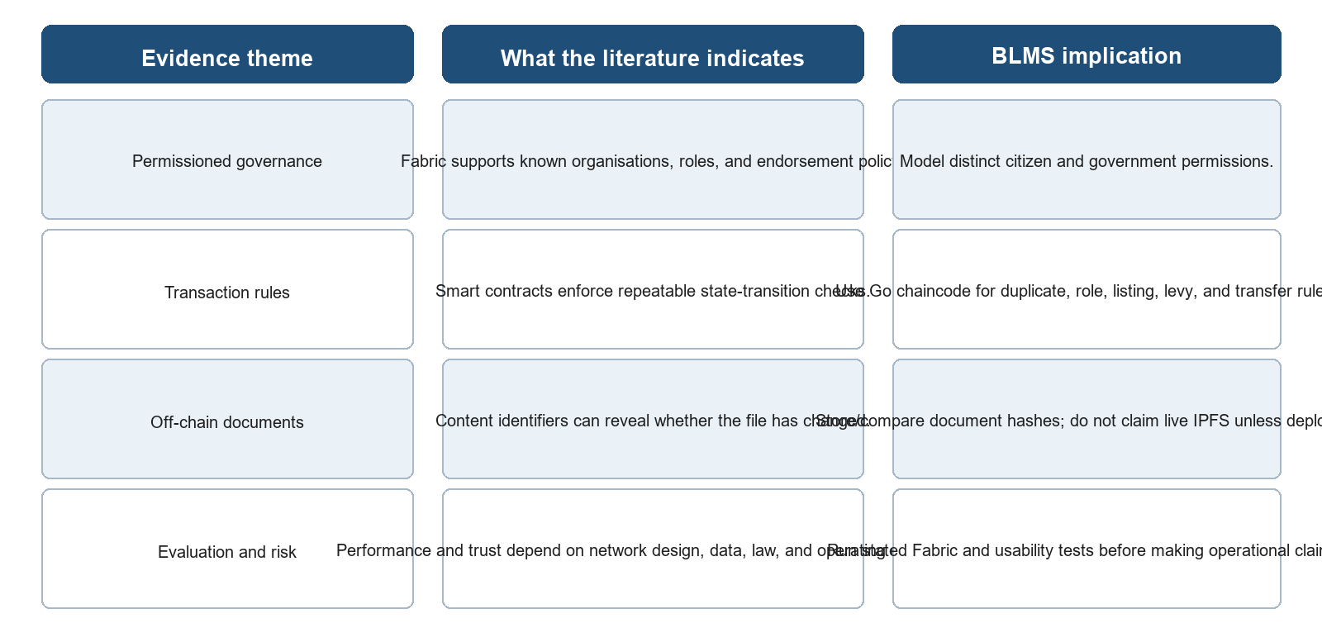
Fig. 3. Evidence-synthesis map linking reviewed themes to BLMS design implications.

3. REVIEW OF PAST LITERATURE ON BLOCKCHAIN-BASED LAND MANAGEMENT

Blockchain Land-Registry Proposals
Early land-registry proposals established the main technical idea: represent a parcel or title as a digital asset, record changes as transactions, and use cryptographic links to produce an auditable history. Gupta et al. (2019) proposed LandLedger for land-property administration, while Krishnapriya and Sarath (2020) and Biswas et al. (2021) presented blockchain-based approaches to secure land registration. Alam et al. (2022) developed a land-title management design for Bangladesh. Together, these studies show that blockchain can support traceability and rule-based workflow, but most are architecture proposals or prototypes rather than evidence of nationwide legal deployment.

Permissioned Blockchain and Hyperledger Fabric
Androulaki et al. (2018) described Hyperledger Fabric as a permissioned blockchain platform with organisational identities, endorsement policies, and programmable chaincode. These features make Fabric relevant to public-service workflows in which participants are known and responsibilities must be separated. Zein and Twinomurinzi (2024) applied Fabric to information sharing in land registration, demonstrating why a permissioned design is more appropriate than an unrestricted public network when land agencies must control membership, data access, and approval rules.

Document Integrity, Identity, and Adoption Literature
Banerjee et al. (2022) combined blockchain and IPFS for a reliable land-registry design, illustrating the use of content identifiers to make document changes detectable. Liu et al. (2020) reviewed blockchain-based identity management and highlighted the importance of identity, privacy, and credential governance. Batubara et al. (2018) reviewed e-government adoption challenges and found that governance, legal frameworks, skills, and infrastructure can be as significant as the technical platform. This literature gives BLMS a concrete solution direction but also identifies a gap: a locally demonstrable land workflow must be followed by a separately evaluated permissioned-network deployment rather than assuming that source code alone proves production suitability.

Blockchain-Enabled Land Registration and Solution Architectures
The solution literature presents several recurring patterns: a ledger records land-state changes and transactions; contracts check business rules; documents and geospatial data remain outside the ledger or are represented by hashes; identities and roles control who can propose or approve changes; and an authority or consortium governs the network. These patterns differ in whether they use public chains, private chains, or permissioned consortium platforms (Alam et al., 2022; Gupta et al., 2019; Krishnapriya & Sarath, 2020). For a land-administration context, the main design question is how to balance integrity, privacy, legal authority, cost, and operational feasibility.

RQ1: How are blockchain and permissioned-ledger architectures applied to land registration and property-right workflows?
Land-registry proposals commonly model a parcel or title as an asset and represent registration, transfer, verification, and update as transactions. Permissioned systems are attractive where the participants are known public or institutional actors because membership, roles, and transaction approval can be governed. Hyperledger Fabric provides a modular permissioned architecture with identities, channels or private data options, endorsement policies, and chaincode (Androulaki et al., 2018; Zein & Twinomurinzi, 2024). These features align with a two-organisation BLMS research model in which citizen and government actors have different permissions. They do not by themselves establish legal title or make a bad source record correct.

RQ2: What data, identity, document, and geospatial evidence models are used?
The literature generally advises against placing every document and personal data item directly on a blockchain. A practical model separates land-state metadata from supporting files and sensitive identity information. The ledger can hold a parcel identifier, title reference, owner reference or pseudonymous key, status, timestamps, transaction history, and a content identifier for an associated document (Banerjee et al., 2022; Liu et al., 2020). IPFS is one option for content-addressed storage; the core integrity mechanism is that the identifier changes when the file content changes. Geospatial coordinates and survey data may be recorded as structured references subject to validation. Privacy and access rules remain essential, especially where a land record links identity, location, and economic information.

RQ3: What metrics are used to evaluate blockchain land-registration and Hyperledger Fabric systems?
Blockchain evaluation must include both software performance and business correctness. Throughput, latency, success rate, query response time, resource use, scalability, and fault behaviour are common systems metrics (Thakkar et al., 2018; Wang & Chu, 2020). For a land workflow, duplicate prevention, authorisation correctness, history availability, document-verification correctness, and error handling are equally important. Comparisons require a declared workload, network topology, hardware, payload size, endorsement policy, data volume, and baseline. Without those conditions, a transaction-per-second statement is not transferable to BLMS.
Table 2. Evaluation metrics for a future Fabric-connected BLMS.
Metric family | Illustrative measure | Interpretation
Ledger performance | Submit/commit latency, throughput, failed transaction rate, query response time. | Report with workload, organisation/peer topology, hardware, payload, and policy.
Functional correctness | Duplicate attempts rejected; role violations rejected; valid workflow completion. | Confirms chaincode and application rules behave as specified.
Integrity and audit | History retrieval, event delivery, document MATCH/MISMATCH accuracy. | Shows traceability and evidence consistency, not legal finality.
Security and privacy | Authorisation test results, sensitive-data exposure, key/identity lifecycle coverage. | Tests controls appropriate to a permissioned public-service system.
Adoption and service | Task success, user error, training/support needs, cost, accessibility feedback. | Captures whether technical design is usable in its operational context.

RQ4: How do blockchain-enabled land systems compare with centralised or conventional approaches?
Studies often report improved auditability, traceability, and resistance to unauthorised alteration when a distributed or permissioned ledger is used (Zein & Twinomurinzi, 2023; Khalid et al., 2022). These are plausible design advantages where more than one authorised organisation must reconcile changes. At the same time, a centralised registry can be faster, simpler, and cheaper to operate when it already has effective governance and high-quality data. The strongest defensible comparison is therefore conditional: blockchain may add value where shared control, independent verification, and a consistent transaction history are genuine requirements. It imposes additional complexity in governance, certificates, policy configuration, monitoring, and integration.

RQ5: What infrastructure, governance, legal, privacy, and adoption challenges constrain deployment?
The most important deployment barriers are rarely solved by chaincode alone. They include legal recognition of electronic processes, the handling of legacy records, institutional ownership of nodes and keys, identity assurance, data-protection obligations, network availability, operating skills, procurement cost, interoperability, and clear correction/dispute procedures (Batubara et al., 2018; Liu et al., 2020; Zein & Twinomurinzi, 2024). The local BLMS prototype intentionally avoids these dependencies so it can be tested without Docker or external services. A later Fabric phase must explicitly introduce and evaluate these dependencies rather than treating them as invisible implementation details.

CONCLUSION
This solution-domain SLR supports a permissioned, phased BLMS architecture. Hyperledger Fabric is appropriate for the research direction because it can encode organisational membership, role-aware policy, and deterministic land-workflow rules in Go chaincode. Content-addressed documents can support integrity checks without putting full files on the ledger. The evidence also establishes clear limits: a blockchain cannot validate false inputs, replace statutory decision-making, establish real identity without an authorised integration, or prove performance without a measured workload. The current local prototype is therefore a valid workflow demonstration; the next research result must be a transparent Fabric deployment and evaluation under stated conditions.

REFERENCES
Alam, K. M., Rahman, J. A., Tasnim, A., & Akther, A. (2022). A blockchain-based land title management system for Bangladesh. Journal of King Saud University - Computer and Information Sciences, 34(6), 3096-3110. https://doi.org/10.1016/j.jksuci.2020.10.011
Androulaki, E., Barger, A., Bortnikov, V., et al. (2018). Hyperledger Fabric: A distributed operating system for permissioned blockchains. Proceedings of the Thirteenth EuroSys Conference, 1-15. https://doi.org/10.1145/3190508.3190538
Banerjee, S., Kumar, K., Masulkar, P., Amin, R., & Dwivedi, S. K. (2022). Blockchain and IPFS-based reliable land registry system. Security and Privacy, 5(5), e236. https://doi.org/10.1002/spy2.236
Batubara, F. R., Ubacht, J., & Janssen, M. (2018). Challenges of blockchain technology adoption for e-government: A systematic literature review. Proceedings of the 19th Annual International Conference on Digital Government Research, 1-9. https://doi.org/10.1145/3209281.3209317
Biswas, M., Al Faysal, J., & Ahmed, K. A. (2021). LandChain: A blockchain-based secured land registration system. 2021 International Conference on Science & Contemporary Technologies, 1-6. https://doi.org/10.1109/ICSCT53883.2021.9642669
Gupta, N., Das, M. L., & Nandi, S. (2019). LandLedger: Blockchain-powered land property administration system. 2019 IEEE International Conference on Advanced Networks and Telecommunications Systems, 1-6. https://doi.org/10.1109/ANTS47819.2019.9118071
Khalid, M. I., Iqbal, J., Alturki, A., Hussain, S., Alabrah, A., & Ullah, S. S. (2022). Blockchain-based land registration system: A conceptual framework. Applied Bionics and Biomechanics, 2022, 3859629. https://doi.org/10.1155/2022/3859629
Krishnapriya, S., & Sarath, G. (2020). Securing land registration using blockchain. Procedia Computer Science, 171, 1708-1715. https://doi.org/10.1016/j.procs.2020.04.183
Liu, Y., He, D., Obaidat, M. S., Kumar, N., Khan, M. K., & Choo, K.-K. R. (2020). Blockchain-based identity management systems: A review. Journal of Network and Computer Applications, 166, 102731. https://doi.org/10.1016/j.jnca.2020.102731
Thakkar, P., Nathan, S., & Viswanathan, B. (2018). Performance benchmarking and optimizing Hyperledger Fabric blockchain platform. 2018 IEEE 26th International Symposium on Modeling, Analysis, and Simulation of Computer and Telecommunication Systems, 264-276. https://doi.org/10.1109/MASCOTS.2018.00034
Wang, C., & Chu, X. (2020). Performance characterization and bottleneck analysis of Hyperledger Fabric. 2020 IEEE 40th International Conference on Distributed Computing Systems, 1281-1286. https://doi.org/10.1109/ICDCS47774.2020.00165
Zein, R. M., & Twinomurinzi, H. (2024). Information sharing in land registration using Hyperledger Fabric blockchain. Digital, 2(2), 6. https://doi.org/10.3390/digital2020006

