**Client – Server Architecture:**

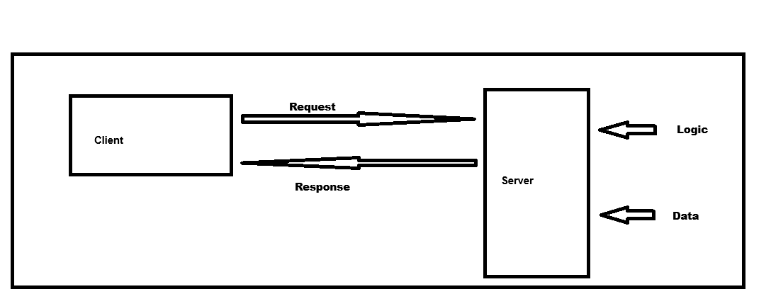Diagram :

Client – Server Architecture is where task or process are distributed structure that partition task between client request and servers response.

Client : The Device or application who initiates or raised the request to the server.

Server : A remote machine who is use to process the request receives from the client or application by doing some complex logical operations and after that providing the server response.