2. Histogram Equalization

* (a)  Write a function hist_eq.m that performs histogram equalization on an intensity image. The function should take as inputs an intensity image and the number of gray level value bins. Create a separte m-file for this function.

function [ g ] = hist_eq( image, graylevels )

%HISTOEQ Equalizes the histogram of an input image

% Detailed explanation goes here

% Variables

rk = zeros(512,512);

sk = zeros(graylevels,1);

nk = zeros(graylevels,1);

enk = zeros(graylevels,1);

prk = zeros(graylevels,1);

psk = zeros(graylevels,1);

img_size = size(image,1) * size(image,2);

%Normalize

% Find the number of pixels that have intensity

% rk. (Generate Histogram)

nk = imhist(image(:,:,1),graylevels);

for i = 1:graylevels

%nk(i,1) = sum(sum(image(:,:,1) == i));

prk(i,1) = nk(i,1)/img_size;

end

% Perform transformation on input image

for k = 1:graylevels

sk(k,1) = round((graylevels - 1) * dsum(prk, 1, k));

enk(sk(k,1)+1,1) = enk(sk(k,1)+1,1) + nk(k,1);

end

% Equalize Histogram

for k = 1:graylevels

psk(k,1) = enk(k,1)/img_size;

end

% Create new image

for row = 1 : 512

for col = 1 : 512

norm_value = normalize(double(image(row,col,1)),0,255,graylevels);

rk(row,col) = denormalize(sk(norm_value,1),0,255,graylevels);

end

end

g = uint8(rk);

end

%*************************************************

function [ y ] = normalize(x, A, B, range)

%Y Normalized value

y = uint8(1 + ((x - A) * (range - 1))/(B-A));

end

%*************************************************

function [ x ] = denormalize(y, A, B, range)

%X Denormalized value

x = uint8(A + ((B-A)*(y-1))/(range - 1));

end

%*************************************************

function [ sum ] = dsum(f,a,b)

%DSUM Performs a definite summation

% Detailed explanation goes here

sum = 0;

for j = a:b

sum = sum + f(j);

end

end

* (b)  Perform histogram equalization on the jetplane image using 256, 128, and 64 bins. Com- pare the original image and the histogram equalized images by plotting the corresponding histograms and images side-by-side in a 2 × 2 subplot matrix.

**L = 256**

EDU>> f = imread('jetplane.tif');

EDU>> g = hist_eq(f,256);

EDU>> subplot(2,2,1), imhist(f(:,:,1));

subplot(2,2,2), imshow(f(:,:,1));

subplot(2,2,3), imhist(g);

subplot(2,2,4), imshow(g);

**Output:** 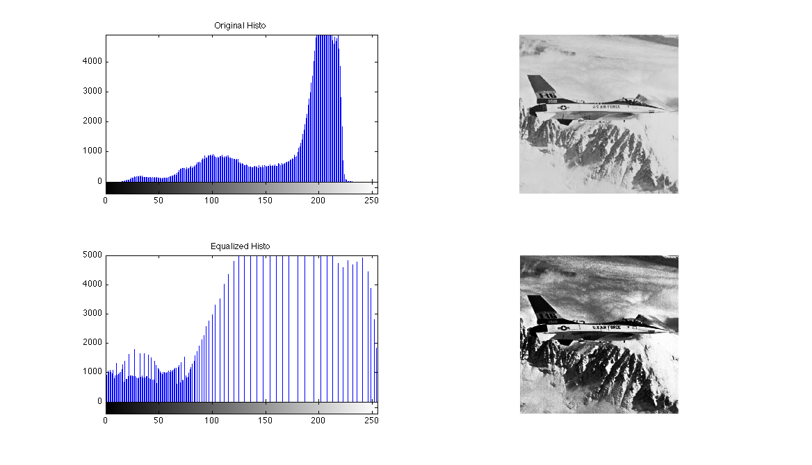

**L = 128**

EDU>> f = imread('jetplane.tif');

EDU>> g = hist_eq(f,128);

EDU>> subplot(2,2,1), imhist(f(:,:,1));

subplot(2,2,2), imshow(f(:,:,1));

subplot(2,2,3), imhist(g);

subplot(2,2,4), imshow(g);

**Output:**

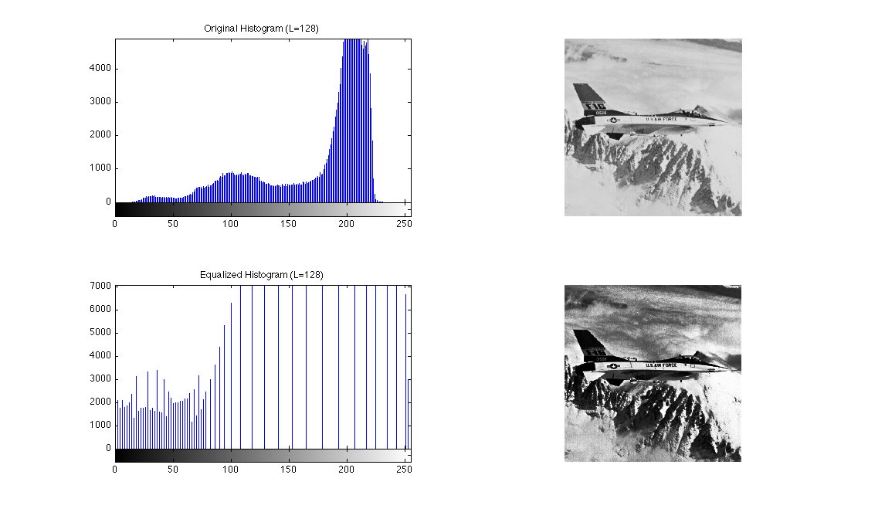

**L = 64**

EDU>> f = imread('jetplane.tif');

EDU>> g = hist_eq(f,64);

EDU>> subplot(2,2,1), imhist(f(:,:,1));

subplot(2,2,2), imshow(f(:,:,1));

subplot(2,2,3), imhist(g);

subplot(2,2,4), imshow(g);

**Output:**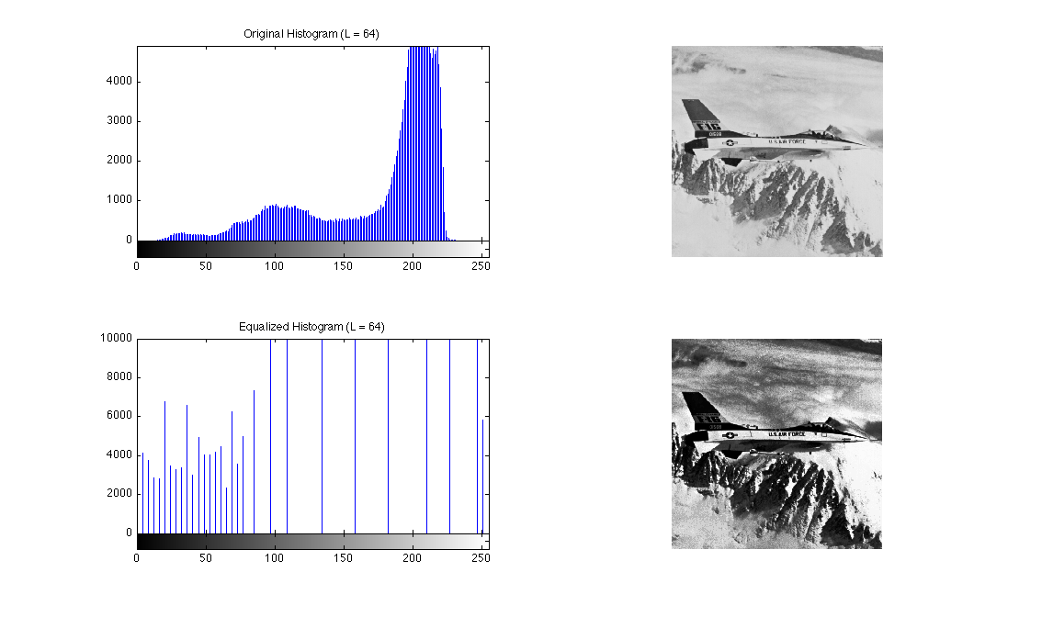

* (c)  Perform the equalization in 32 × 32 blocks. Display the output image. You will find blockproc.m useful.

**L = 256**

EDU>> fun = @(block_struct) hist_eq(block_struct.data, 256);

EDU>> f = imread('jetplane.tif');

EDU>> b = blockproc(f(:,:,1),[32 32],fun);

EDU>> imshow(b);

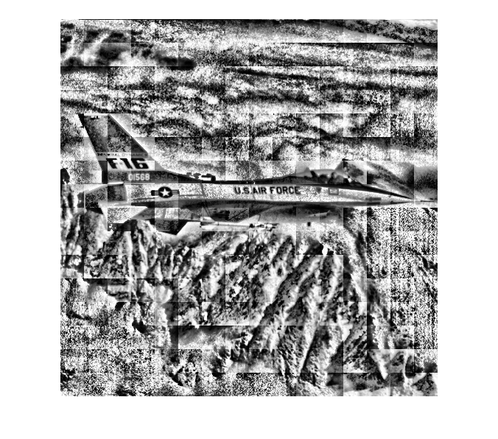

**L = 128**

EDU>> fun = @(block_struct) hist_eq(block_struct.data, 128);

EDU>> f = imread('jetplane.tif');

EDU>> b = blockproc(f(:,:,1),[32 32],fun);

EDU>> imshow(b);

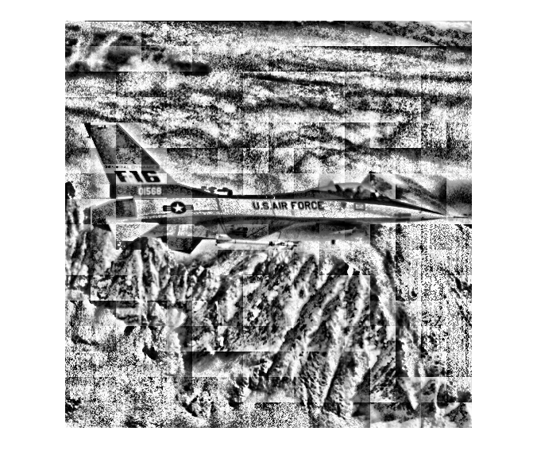

**L = 64**

EDU>> fun = @(block_struct) hist_eq(block_struct.data, 64);

EDU>> f = imread('jetplane.tif');

EDU>> b = blockproc(f(:,:,1),[32 32],fun);

EDU>> imshow(b);

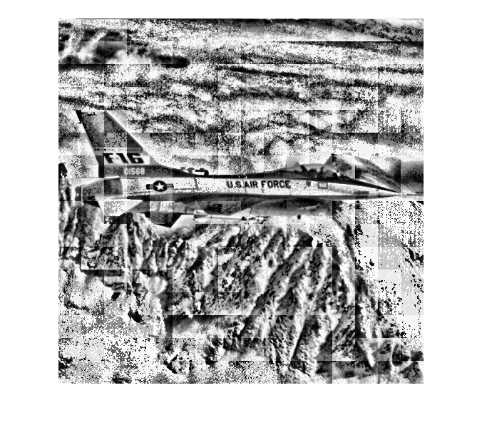

3. Morphology

* (a)  Threshold the image SJEarthquakesteampic.jpg to detect faces. Be sure to describe how you obtained your threshold. You may find this is easier in another colorspace such as HSV.

function [ g ] = imthreshold( f, T1 )

%G Provides a thresholded version of the input

% Based on a threshold value, the input image

% is rasterized pixel-by-pixel, generating an

% output image that's either 0(Black) or 1(White)

%Grab some stats on image

ROWS = size(f,1);

COLS = size(f,2);

%RGB = size(f,3);

%IMG_SIZE = ROWS * COLS;

hsv_img = rgb2hsv(f);

bw = zeros(ROWS,COLS);

%Threshold Input

for row = 1:ROWS

for cols = 1:COLS

if(hsv_img(row,cols,1) < T1 )

bw(row,cols) = 1;

else

bw(row,cols) = 0;

end

end

end

%MN = [3,3];

%S = strel('rectangle', MN);

%Pattern that resembles the makeup of a face

MN = [0, 0, 1, 1, 1, 1, 1, 1, 0, 0;

0, 1, 1, 1, 1, 1, 1, 1, 1, 0;

1, 1, 1, 1, 1, 1, 1, 1, 1, 1;

1, 1, 1, 1, 1, 1, 1, 1, 1, 1;

1, 1, 1, 1, 1, 1, 1, 1, 1, 1;

1, 1, 1, 1, 1, 1, 1, 1, 1, 1;

1, 1, 1, 1, 1, 1, 1, 1, 1, 1;

1, 1, 1, 1, 1, 1, 1, 1, 1, 1;

1, 1, 1, 1, 1, 1, 1, 1, 1, 1;

1, 1, 1, 1, 1, 1, 1, 1, 1, 1;

1, 1, 1, 1, 1, 1, 1, 1, 1, 1;

1, 1, 1, 1, 1, 1, 1, 1, 1, 1;

1, 1, 1, 1, 1, 1, 1, 1, 1, 1;

1, 1, 1, 1, 1, 1, 1, 1, 1, 1;

0, 1, 1, 1, 1, 1, 1, 1, 1, 0;

0, 0, 1, 1, 1, 1, 1, 1, 0, 0;

0, 0, 0, 1, 1, 1, 1, 0, 0, 0;

0, 0, 0, 0, 1, 1, 0, 0, 0, 0;

0, 0, 0, 0, 0, 1, 0, 0, 0, 0;

0, 0, 0, 0, 0, 1, 0, 0, 0, 0];

S = strel(MN);

eroded_output = imerode(bw,S);

opened_output = imdilate(eroded_output,S);

dilated_output = imdilate(opened_output,S);

imshow(dilated_output);

%imshow(bw);

%Look for connected components and bound (NOT WORKING)

cc = bwconncomp(dilated_output);

stats = regionprops(cc, 'Area', 'BoundingBox');

bb = cat(1, stats.BoundingBox);

idx = find([stats.Area] > 900);

bw2 = ismember(labelmatrix(cc), idx);

imshow(bw2);

hold on

for elements = 1:numel(idx)

%bb = find([stats.BoundingBox] == idx(elements));

plot(bb(idx(elements),1), bb(idx(elements),2), bb(idx(elements),3), bb(idx(elements),4), 'b*');

end

hold off

L = labelmatrix(cc);

L2 = bwlabel(bw);

g = L2;

end

Threshold was attained by evaluating the hue levels on the image histogram of the input image and determining what value best corresponds with the skin color of the players. I settled for T = 0.1.

The code above isn’t quite complete as I was trying to explore some of the different properties of the regionprops method.

* (b)  Use morphological operations to clean the image and count the number of players in the image.

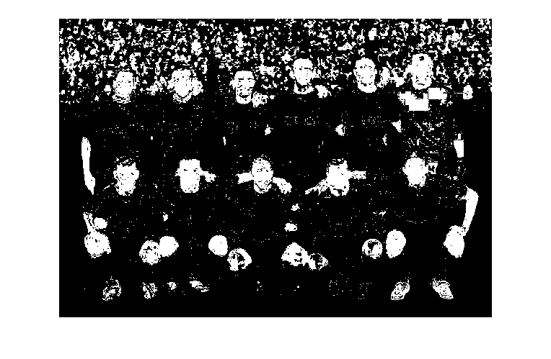

Figure - Thresholded Image at T = 0.1

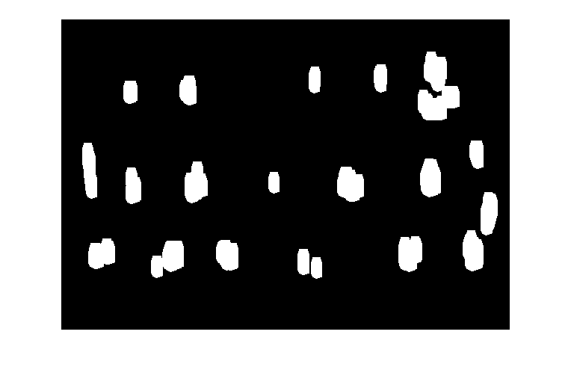

Figure - Tinkered with Opening and then dilating the image using an SE that sort of matches a facial pattern. You can see some of the players heads, upper and lower limbs.



Figure - Wanted to see if I could label the components. This image was taken with the same threshold, but you'll notice the pattern is different. Some of the faces and limbs are not there as depicted in Figure 2. Went more for 'V' pattern on the face.

* (c)  Create an output image that has a bounding box around each face. Use regionprops.m.

**Sorry, didn’t have much luck here. ☹**

4. Filtering

* (a)  Consider image DSCN0479-001.JPG as a perfect image. Add white Gaussian noise with variance 0.005.

Code:

function [ g ] = box_filter( f, MN, v )

%G Summary of this function goes here

% Detailed explanation goes here

%Add Gaussian Noise to image

img = imnoise(f,'gaussian', 0, v);

%Perform MxN Filtering

filter = fspecial('average',MN);

fimg = imfilter(img, filter, 'replicate');

g = fimg;

end

%%%%%%%%%%%%%%%%%%%%%%%%%%%%%%%%%%%%%%%%%%%%%%

function [ g ] = median_filter( f, MN, v )

%G Summary of this function goes here

% Detailed explanation goes here

%Add Gaussian Noise to image

img = imnoise(f,'gaussian', 0, v);

%Perform MxN Median Filtering

fimg = medfilt2(rgb2gray(img), MN);

g = fimg;

end

Smooth with a 3 × 3 and 7 × 7 box filter and a median filter.

**3x3 Box**

EDU>> g = box_filter(f,[3 3],0.005);

EDU>> imshow(g)

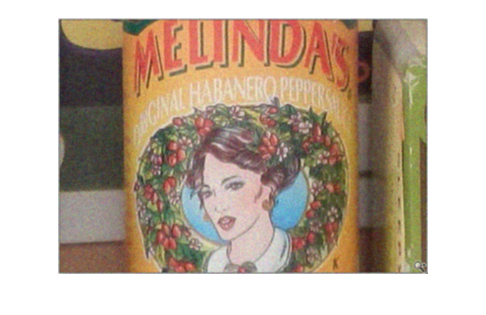

**7x7 Box**

EDU>> g = box_filter(f,[7 7],0.005);

EDU>> imshow(g)

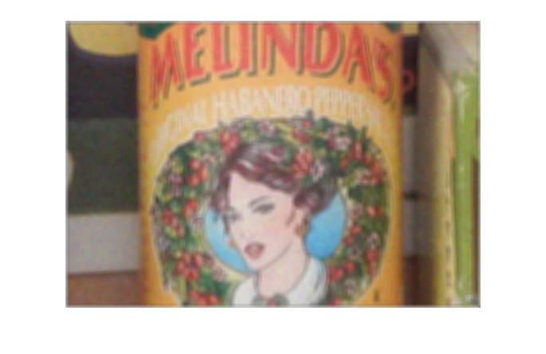

**3x3 Median**

EDU>> g = median_filter(f, [3 3],0.005);

EDU>> imshow(g)

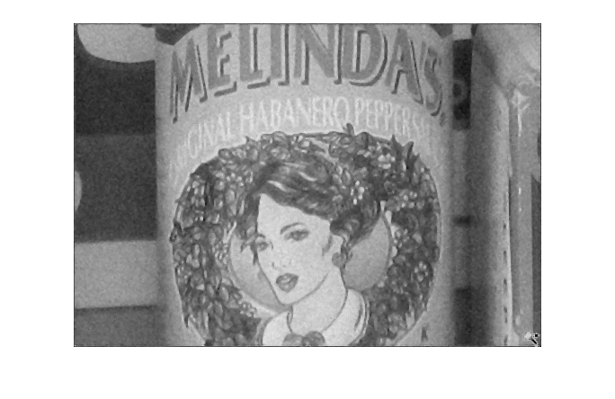

**7x7 Median**

EDU>> g = median_filter(f, [7 7],0.005);

EDU>> imshow(g)

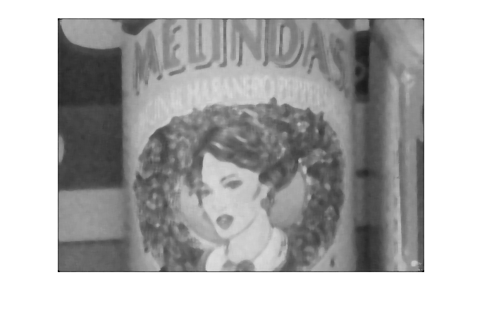

Compute the mean squared error (MSE)   and the peak signal-to-noise ratio (PSNR) for the noise reduced images. Which filter has the best results based on the error measures? How do the results compare visually?

function [ e ] = mse(f1,f2)

%E Mean Squared Error

% Detailed explanation goes here

[M N] = size(img1);

diff = (double(f1) - double(f2)).^2;

MSE = mean(mean(diff,2),1)/(M * N);

e = MSE;

end

%%%%%%%%%%%%%%%%%%%%%%%%%%%%%%%%%%%%%%%%%%%%%%

function [ res ] = psnr( mse )

%RES Peak Signal To Noise Ratio

% Detailed explanation goes here

res = 20 * log10(255/sqrt(mse));

end

**Results starting on next page:**

**3x3 Box**

EDU>> f = imread('DSCN0479-001.jpg');

EDU>> g = box_filter(f,[3 3],0.005);

EDU>> e = mse(f,g);

EDU>> e

e(:,:,1) =

2.8967e-04

e(:,:,2) =

2.7165e-04

e(:,:,3) =

2.6750e-04

EDU>> psnr = psnr(e);

EDU>> psnr

psnr(:,:,1) =

83.5118

psnr(:,:,2) =

83.7907

psnr(:,:,3) =

83.8575

**7x7 Box**

EDU>> f = imread(‘DSCN0479-001.jpg’);

EDU>> g = box_filter(f,[7 7],0.005);

EDU>> e = mse(f,g);

EDU>> e

e(:,:,1) =

6.1865e-04

e(:,:,2) =

5.9147e-04

e(:,:,3) =

5.9707e-04

EDU>> psnr = psnr(e);

EDU>> psnr

ans(:,:,1) =

80.2163

ans(:,:,2) =

80.4115

ans(:,:,3) =

80.3706

**3x3 Median**

EDU>> f = imread('DSCN0479-001.jpg');

EDU>> g = median_filter(f, [3 3],0.005);

EDU>> e = mse(f,g);

EDU>> e = mse(f(:,:,1),g);

EDU>> e

e =

0.0066

EDU>> psnr = psnr(e);

EDU>> psnr

psnr =

69.9477

**7x7 Median**

EDU>> g = median_filter(f, [7 7],0.005);

EDU>> e = mse(f(:,:,1),g);

EDU>> e

e =

0.0073

EDU>> psnr = psnr(e);

EDU>> psnr

ans =

69.5041

* (b)  Repeat (a) with salt and pepper noise with noise density 0.05.

function [ g ] = box_filterSP( f, MN, d )

%G Summary of this function goes here

% Detailed explanation goes here

%Add Gaussian Noise to image

img = imnoise(f,'salt & pepper', d);

%Perform MxN Filtering

filter = fspecial('average',MN);

fimg = imfilter(img, filter, 'replicate');

g = fimg;

end

%%%%%%%%%%%%%%%%%%%%%%%%%%%%%%%%%%%%%%%%%%%%%%

function [ g ] = median_filterSP( f, MN, d )

%G Summary of this function goes here

% Detailed explanation goes here

%Add Gaussian Noise to image

img = imnoise(f,'salt & pepper', d);

%Perform MxN Median Filtering

fimg = medfilt2(rgb2gray(img), MN);

g = fimg;

end

**3x3 Box**

EDU>> g = box_filterSP(f, [3 3], 0.05);

EDU>> imshow(g);

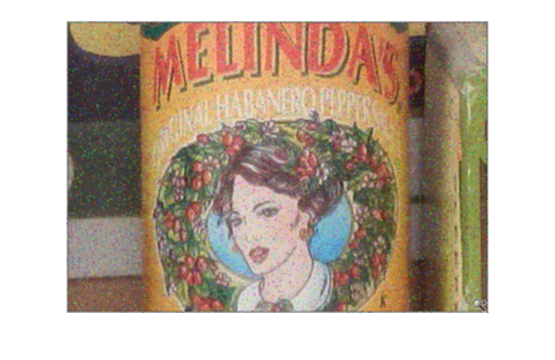

**EDU>> e = mse(f,g);**

**EDU>> psnr = psnr(e);**

**EDU>> e**

**e(:,:,1) =**

**4.4759e-04**

**e(:,:,2) =**

**4.1406e-04**

**e(:,:,3) =**

**4.1651e-04**

**EDU>> psnr**

**psnr(:,:,1) =**

**81.6220**

**psnr(:,:,2) =**

**81.9602**

**psnr(:,:,3) =**

**81.9345**

**7x7 Box**

EDU>> g = box_filterSP(f, [7 7], 0.05);

EDU>> imshow(g);

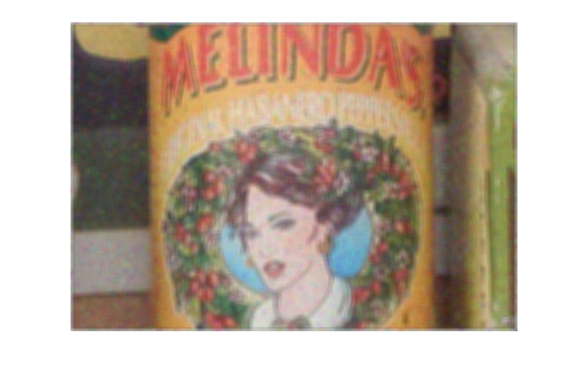

**EDU>> e = mse(f,g);**

**EDU>> e**

**e(:,:,1) =**

**6.6548e-04**

**e(:,:,2) =**

**6.3068e-04**

**e(:,:,3) =**

**6.4416e-04**

**EDU>> psnr = psnr(e);**

**EDU>> psnr**

**ans(:,:,1) =**

**79.8994**

**ans(:,:,2) =**

**80.1327**

**ans(:,:,3) =**

**80.0408**

**3x3 Median**

EDU>> g = median_filterSP(f, [3 3], 0.05);

EDU>> imshow(g);

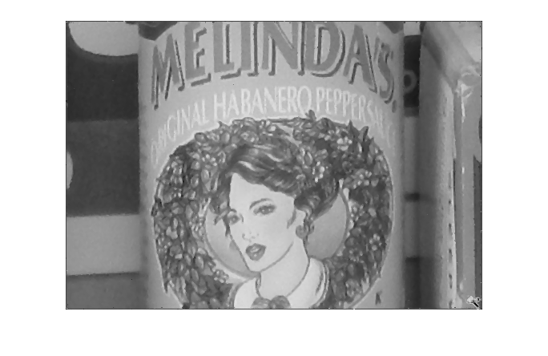

**EDU>> e = mse(f(:,:,1),g);**

**EDU>> e**

**e =**

**0.0065**

**EDU>> psnr = psnr(e);**

**EDU>> psnr**

**ans =**

**70.0307**

**7x7 Median**

EDU>> g = median_filterSP(f, [7 7], 0.05);

EDU>> imshow(g);

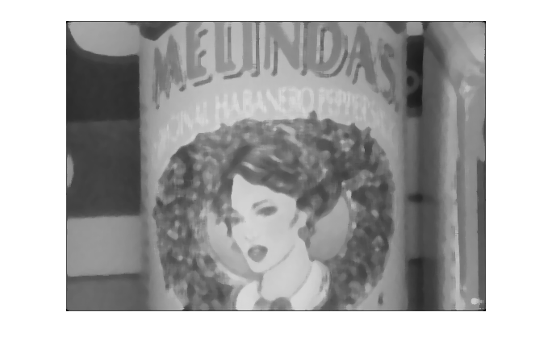

**EDU>> e = mse(f(:,:,1),g)**

**e =**

**0.0073**

**EDU>> psnr = psnr(e)**

**ans =**

**69.5176**

* (c)  Do the filtering again but this time on a real noisy image DSCN0482-001.JPG obtained at higher ISO. Compare the results visually only this time. Which filter works best for “real” noise?
* **3x3 Box**

**EDU>> f = imread('DSCN0482-001.jpg');**

**EDU>> g = box_filter(f,[3 3], 0);**

**EDU>> imshow(g)**

**EDU>> e = mse(f,g);**

**EDU>> e**

**e(:,:,1) =**

**1.9546e-04**

**e(:,:,2) =**

**1.7728e-04**

**e(:,:,3) =**

**1.7465e-04**

**EDU>> psnr = psnr(e)**

**ans(:,:,1) =**

**85.2202**

**ans(:,:,2) =**

**85.6441**

**ans(:,:,3) =**

**85.7090**

* **7x7 Box**

**EDU>> g = box_filter(f,[7 7], 0);**

**EDU>> e = mse(f,g);**

**EDU>> e**

**e(:,:,1) =**

**4.0753e-04**

**e(:,:,2) =**

**3.8336e-04**

**e(:,:,3) =**

**3.9420e-04**

**EDU>> psnr = psnr(e)**

**ans(:,:,1) =**

**82.0292**

**ans(:,:,2) =**

**82.2947**

**ans(:,:,3) =**

**82.1736**

* **3x3 Median**

**EDU>> g = median_filter(f, [3 3], 0);**

**EDU>> e = mse(f,g);**

**EDU>> e = mse(f(:,:,1),g);**

**EDU>> e**

**e =**

**0.0055**

**EDU>> 20 * log10(255/sqrt(e))**

**ans =**

**70.7040**

**7x7 Median**

**EDU>> g = median_filter(f, [7 7], 0);**

**EDU>> e = mse(f(:,:,1),g);**

**EDU>> e**

**e =**

**0.0059**

**EDU>> 20 * log10(255/sqrt(e))**

**ans =**

**70.4405**

3x3 Box has a higher PSNR for this noisy image, thus performing better for real noise.