1.

**a) Normalized Cross Correlation Detection function**

function [ list ] = corr_detect( template, timg, threshold )

%LIST Returns a list of image locations that are > than threshold

% Detailed explanation goes here

%Step 1: Perform normalized correlation

g = normxcorr2(template, timg);

%Step 2: Look for locations that are > threshold and return

list = zeros(size(g,1), size(g,2));

for row=1:size(g,1)

for col=1:size(g,2)

if(g(row,col) > threshold)

list(row, col) = g(row,col);

end

end

end

end

**b) Tried following the VOC documentation for computing the overlap, but had some issues trying to get the ROC plotted.**

function [ roc ] = problem1( template, threshold, total_imgs, truedatafile )

%ROC Summary of this function goes here

% Detailed explanation goes here

%Create a total_imgs x 2 table for ROC consisting of TP, FP

outcome_table = zeros(total_imgs, 2);

bounding_box = zeros(1,4);

previous_tp = 0;

previous_fp = 0;

rate = 0;

%Read in and parse the true data set

truetable = cardata_parser(truedatafile);

for img = 0:total_imgs

%Grab image

imgnum = int2str(img);

path = strcat('CarData/TestImages/test-',imgnum,'.pgm');

f = imread(path);

%Run correlation and determine bounds

list = corr_detect(template,f,threshold);

label = bwlabel(list);

s = regionprops(label,'Area','BoundingBox');

%Grab true coordinate for image x

index = find(truetable(:,3) == img+1, 3);

truecoord = truetable(index,[1,2]);

%Create bounding box (position vector) for true location

bounding_box(1) = truecoord(1);

bounding_box(2) = truecoord(2);

bounding_box(3) = 100;

bounding_box(4) = 40;

%Compute ROC components

if(~isempty(s))

for i=1:size(s,1)

area1 = sum(intersect(bounding_box,s(i).BoundingBox));

area2 = sum(union(bounding_box, s(i).BoundingBox));

rate = area1 / area2;

%fishing for TP's :)

if(rate > 0.5)

break

end

end

end

if(rate > 0.5)

%TP

outcome_table(img+1,:) = [rate previous_fp];

previous_tp = rate;

else

%FP

outcome_table(img+1,:) = [previous_tp rate];

previous_fp = rate;

end

%Run NMS on list (part c)

end

imshow(f)

hold on

axis equal

if(~isempty(s))

for i=1:size(s,1)

rectangle('Position', s(i).BoundingBox, 'EdgeColor', 'r');

end

end

rectangle('Position', bounding_box, 'EdgeColor', 'g');

hold off

roc = outcome_table;

end

**cardata_parser.m**

function [ table ] = cardata_parser( datafile )

%TABLE Parses out trueLocations.txt file only and returns a matrix

% Each line is read from the datafile and parsed out for

% coordinates. Each coordinate has a tag that denotes which

% image that coordinate belongs to. Images with multiple

% coordinates have the same tag on multiple rows. The tag

% is the third column in the matrix.

%Step 1: Open the file with read access

fileID = fopen(datafile, 'r');

truetable = [];

row = 1;

while(feof(fileID) ~= 1)

%Step 2: Grab a line from the datafile

% and determine how many coordinates there are

% by looking at commas

str = fgetl(fileID);

commas = strfind(str,',');

%Step 3: Pre Tokenize, if only one comma we're done...

[token, remain] = strtok(str);

if(size(commas(:),1) == 1)

xy = textscan(remain, '(%d16,%d16)');

xy = horzcat(xy, row);

truetable = vertcat(truetable,xy);

else

%Step 4: Otherwise... keep breaking into tokens

for i = 1:size(commas(:),1)

[token, remain] = strtok(remain);

xy = textscan(token, '(%d16,%d16)');

xy = horzcat(xy, row);

truetable = vertcat(truetable,xy);

end

end

row = row + 1;

end

fclose(fileID);

%Step 5: Convert your cell to a matrix.

data = cellfun(@int16,truetable,'UniformOutput',false);

table = cell2mat(data);

%Example: How to find an image coordinates:

% >> index = find(table(:,3) == 21, 3);

%

% Here, we're looking in the third column for image 21,

% which for the trueLocations.txt file returns index 34

% in our new matrix table above.

% >> table(index,[1,2]);

%

% Once you know the index, you can extract the coordinates

% and do what you want with the values.

end

2. Corner Detection

**a) Show that the eigenvalues of A are given by:**

**Given:**

**(2 x 2 matrix)**

**(Characteristic Equation)**

**Show:**

**We know:**

**(Identity Matrix)**

**Therefore:**

**Using Quadratic Equation, we get:**

**b)**

**problem2.m**

function [ f ] = problem2( image )

%F Returns image with keypoints denoting corners found

% Detailed explanation goes here

%Find corners

ret = corner_detector(image);

%Plot keypoints

imshow(image); %# Display your image

hold on; %# Add subsequent plots to the image

for i=1:size(ret,1)

x = ret(i,1);

y = ret(i,2);

plot(y,x,'o'); %# NOTE: x_p and y_p are switched (see note below)!

end

hold off; %# Any subsequent plotting will overwrite the image!

f = image;

end

**corner_detector.m**

function [ s ] = corner_detector( image )

%X Finds the minimum eigenvalues greater than a certain threshold

% Detailed explanation goes here

% Step 1: Read in image

%I = imread(image);

%f = im2double(I(:,:,1));

f = imread(image);

ROWS = size(f,1);

COLS = size(f,2);

lammax = zeros(ROWS,COLS);

lammin = zeros(ROWS,COLS);

angle = zeros(ROWS,COLS);

% Step 2: Compute the Image Gradient of image

[Ix Iy] = imgrad(f);

Ix2 = Ix .* Ix;

Iy2 = Iy .* Iy;

IxIy = Ix .* Iy;

% Step 3: Filter gradients with weight

w = [1 1 1; 1 1 1; 1 1 1];

a = double(imfilter(Ix2, w));

b = double(imfilter(IxIy,w));

c = double(imfilter(Iy2, w));

% Step 4: Compute Autocorrelation Matrix and Lambdas (eig)

for i=1:ROWS

for j=1:COLS

A = [a(i,j) b(i,j); b(i,j) c(i,j)];

lambda = eig(A);

lammin(i,j) = min(lambda);

lammax(i,j) = max(lambda);

angle(i,j) = 0.5.*atan((2.*b(i,j))/(a(i,j) - c(i,j)));

end

end

% Step 5: Look for lammin's greater than max(lammin) * 80%

threshold = (max(lammin(:)) .* 0.80);

[rows, cols] = find(lammin > threshold);

% Step 6: Plot keypoints and vector

imshow(image);

hold on;

u = zeros(size(rows,1),1);

v = zeros(size(rows,1),1);

scale = zeros(size(rows, 1),1);

for i=1:size(rows,1)

x = rows(i);

y = cols(i);

u(i) = Ix(x);

v(i) = Iy(y);

scale(i) = lammin(x,y);

plot(y,x,'o');

end

quiver(cols,rows,v,u);

hold off;

% Step 7: Package and return

s = struct('Ix',Ix, 'Iy', Iy,'LambdaMin',lammin,'LambdaMax',lammax,'Angle',angle,'Threshold',threshold','KeypointsRows',rows,'KeypointsCols',cols);

end

Results:

Checkerboard:

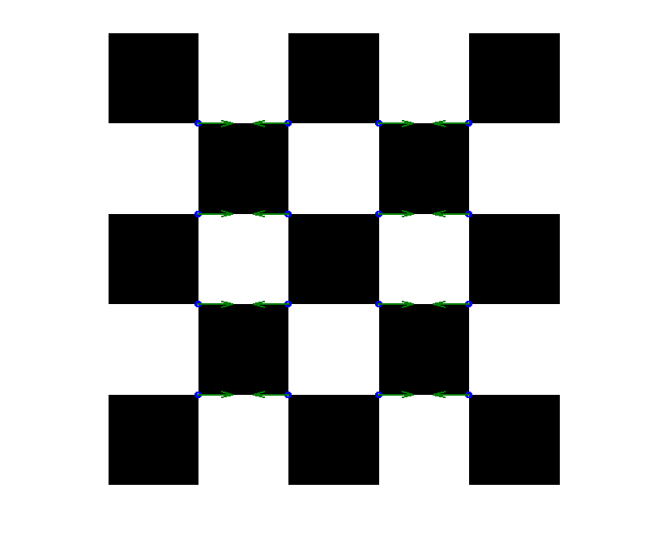

**c)**

**Fingerprint with vectors:**

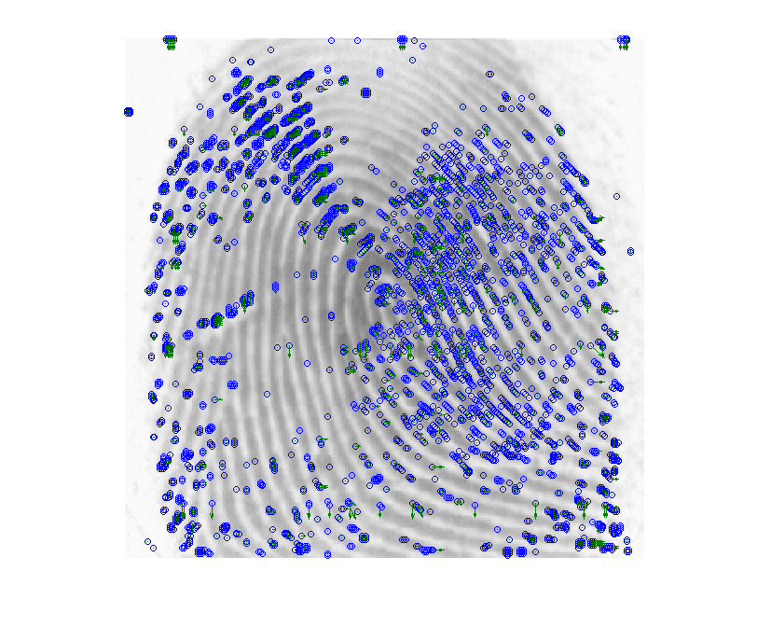

**3.**

**a) Keypoints in both graffiti images**

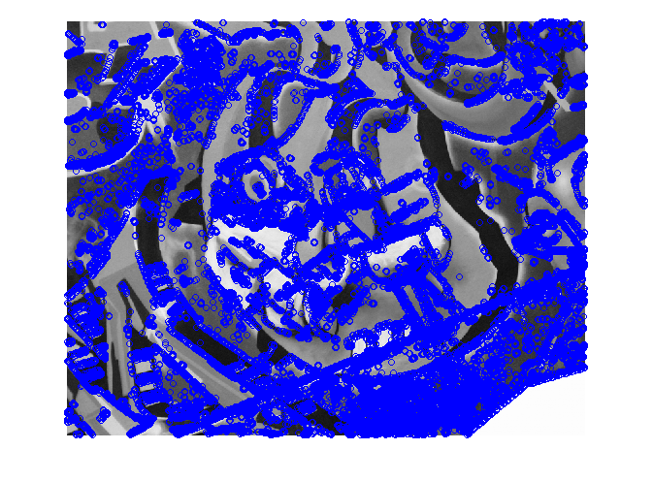

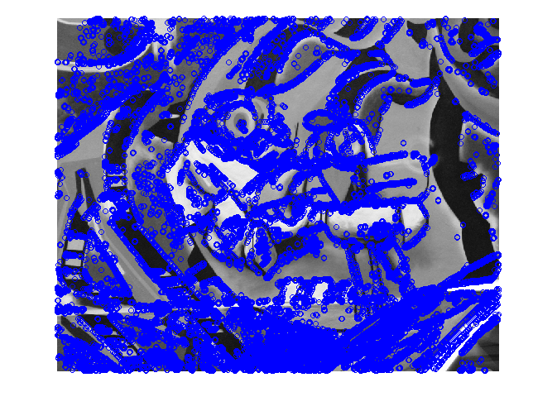Figure 1 img1.ppm

Figure 2 img2.ppm

**b)Incomplete… Understood the concept but got lost in the Matlab.**

function [ D ] = sift_descriptor( image1, image2)

%D Returns 128 Dimension vector of keypoints in both images

% Detailed explanation goes here

% Step 1: Find keypoints in image 1

s1 = corner_detector(image1);

% Step 2: Find keypoints in image 2

s2 = corner_detector(image2);

% Step 3: Construct 16x16 matrix grid around keypoints (image 1)

D1 = sift_bin8(s1);

% Step 4: Construct 16x16 matrix grid around keypoints (image 2)

D2 = sift_bin8(s2);

% Step 5: Compare vectors

end

function [ D ] = sift_bin8( s1 )

GRID_16 = zeros(16,16);

rows = s1(1).KeypointsRows;

cols = s1(1).KeypointsCols;

angles = s1(1).Angle;

%for k = 1:size(rows(:),1) %Takes forever to compute... 36,000+ keypoints!

for k = 1:1000 %Just look at first 1000 for time being...

%Grab next keypoint

if(k < size(rows(:),1))

x1 = rows(k) - 8;

y1 = cols(k) - 8;

else

break;

end

% Step 4: Run through grid and grab angles

if(x1 > 0 && y1 > 0)

for i=1:16

for j=1:16

if((x1+i > 0) && (x1+i < size(angles(:,1),1)) && (y1+i > 0) &&

(y1+i < size(angles(1,:),2)))

%Still in image bounds...

if(angles(x1+i, y1+j) < 0)

%Negative radian, add 2pi

GRID_16(i,j) = ((2 .* pi) + angles(x1+i,y1+j));

else

GRID_16(i,j) = angles(x1+i,y1+j);

end

else

%Out of bounds!

GRID_16(i,j) = 0;

end

end

end

end

% Step 5: Take 4x4 of 16x16 grid and place angles in 8 bins from 0 to 2pi

% to get 128D vector.

a = 0;

b = 0;

d128Vector = zeros(128,1);

while(a < 16)

while(b < 16)

for c = 1:4

for d = 1:4

d128Vector(a+c) = GRID_16(a+c,b+d);

end

end

b = b + 4;

end

a = a + 4;

b = 0;

end

end

D = d128Vector;

end

**c)Incomplete… Depended on b)**

**4.**

**a) Needed some assistance on this code. I’ve referenced the URL for where I found the basis of the implementation and also tried to follow szeliski.**

%Used HoughTransform from RosettaCode and Szeliski as guidance/example

%Link: http://rosettacode.org/wiki/Example:Hough_transform/MATLAB

function [ space ] = hough_T( img, theta_freq )

%SPACE Hough Space

% Detailed explanation goes here

RGB = imread(img);

I = rgb2gray(RGB);

I = flipud(I);

[w, h] = size(I);

rhoLimit = norm([w, h]);

rho = (-rhoLimit:1:rhoLimit);

theta = (-pi:theta_freq:pi);

totalThetas = numel(theta);

space = zeros(numel(rho),totalThetas);

%Look for the edge pixels

[x, y] = find(I);

%Allocate space for accumulator

totalEdges = numel(x);

accumulator = zeros(totalEdges, totalThetas);

%Allocate cosine and sine calculations

cosine = (0:w - 1)'*cos(theta);

sine = (0:h - 1)'*sin(theta);

accumulator((1:totalEdges),:) = cosine(x,:) + sine(y,:);

%Bin the rhos

for i = (1:totalThetas)

space(:,i) = hist(accumulator(:,i),rho);

end

pcolor(theta, rho, space);

shading flat;

title('Hough Transform');

xlabel('Theta (radians)');

ylabel('Rho (pixels)');

colormap(hot);

end

Since I couldn’t find the city image, I just found one online of San Francisco.

Command:

EDU>> hough_T('San_Francisco_City.jpg', 0.5)

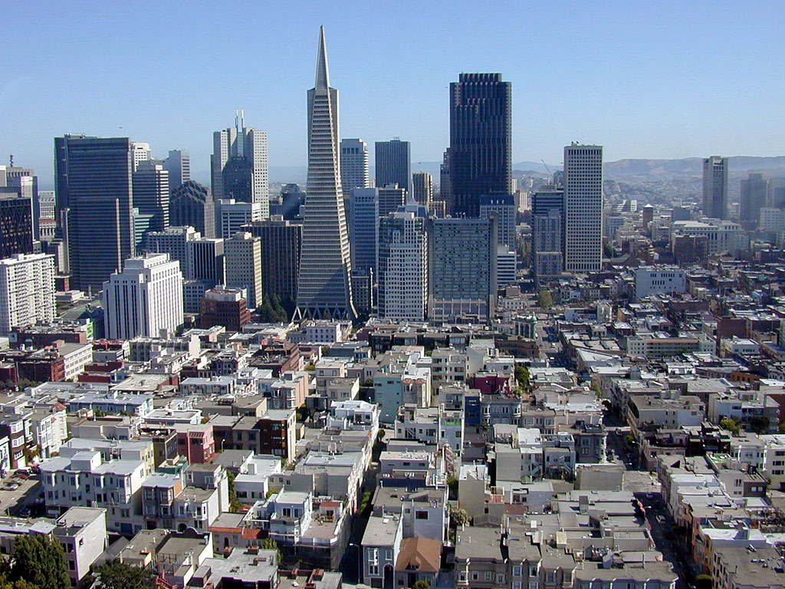

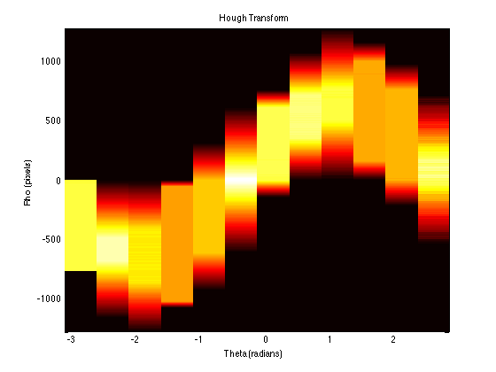

b)

c) Matlab results:

Command:

EDU>> RGB = imread('San_Francisco_City.jpg');

EDU>> I = rgb2gray(RGB);

EDU>> hough(I);

EDU>> BW = edge(I,'canny');

EDU>> [H,T,R] = hough(BW,'RhoResolution',0.5,'Theta',-90:0.5:89.5);

EDU>> subplot(2,1,1);

EDU>> imshow(RGB);

EDU>> title('Original Image');

EDU>> subplot(2,1,2);

EDU>> imshow(imadjust(mat2gray(H)),'XData',T,'YData',R,...

'InitialMagnification','fit');

EDU>> title('Hough Transform of San Francisco');

EDU>> xlabel('\theta'), ylabel('\rho');

EDU>> axis on, axis normal, hold on;

EDU>> colormap(hot);

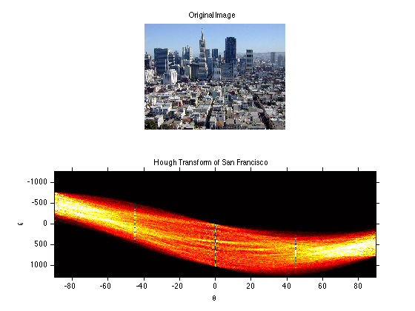Result: