B♭ Trumpet — A Composer's Field Guide
Everything you need to write idiomatically for the instrument without ever having played one.
The B♭ trumpet is the standard trumpet in concert band, brass quintet, jazz of every flavour, and most orchestral writing from the late nineteenth century onward. It is a piston-valve, mostly cylindrical-bore brass instrument with a bright, projecting sound. Three valves give the player full chromatic access; lip-and-air alone select the harmonic series above each fingering. The single thing you must internalize before writing for it
the B♭ trumpet sounds a major 2nd lower than written.

Reading & writing the part
Transposition (in plain English)
Write the trumpet part one whole step (M2) HIGHER than the concert pitch you want to hear. If you want to hear concert C, write D for the trumpet. Key signatures shift by the same amount: concert F major (1 flat) is written as G major (1 sharp) for the trumpet.
Written vs. sounding — a one-bar demo
WRITTEN (B♭ Trumpet part)  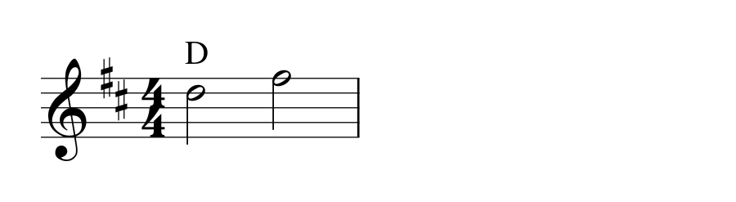 | SOUNDS (concert pitch)  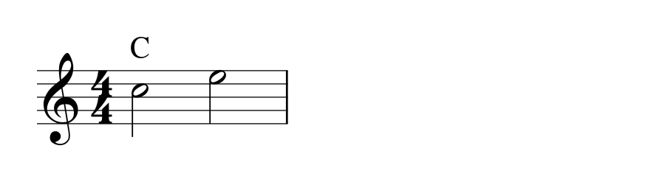
Both bars sound the SAME pitches. The trumpet/transposing part is notated so the player reads what feels natural under the fingers; the score sounds at concert. Notation software handles this automatically — but as a composer you should be able to do it in your head for sketching.
Pedestal of Pedantry — Why B♭?
Trumpets used to come in many lengths (C, D, E♭, F, G, A, B♭) so a single horn could match any key. The B♭ length won out for orchestral and band work because it sits in a sweet spot of tubing length: short enough to be brilliant, long enough to be warm, and centred on the keys most band music sits in. C trumpets are common in orchestral and chamber work; piccolo (high B♭/A) and E♭ trumpets show up for specific repertoire. Treat 'the trumpet' as B♭ unless told otherwise.

Range, registers, and danger zones
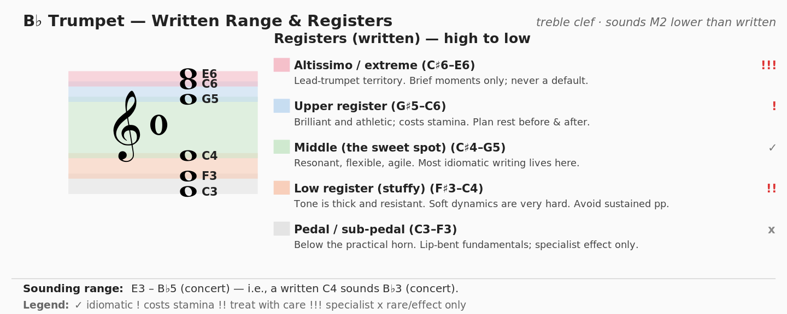
The chart above is in WRITTEN pitch. The practical professional range is F♯3 to C6 (written). Skilled players go higher — and student players don't. When in doubt, write in the green band (the middle register). Reserve C5 and above for moments of genuine arrival; reserve everything above G5 for short, prepared statements. The high register costs stamina nonlinearly: a single high B♭ can be cheap, while two minutes of writing in the upper register will exhaust even a strong player.

Articulation & playing techniques
- Single tongue — default articulation. Effective up to roughly ♩=144 in 16ths.
- Double tongue (T-K-T-K) — for fast 16th-note passages above ♩≈144. Standard, expected technique.
- Triple tongue (T-T-K or T-K-T) — for fast triplets. Equally standard.
- Slurs / lip slurs — smooth slurs across the same fingering (between partials) are the most legato gesture available.
- Flutter tongue (Frullato / Flz.) — rolled R against the air stream; reads as 'growl'. Stays in lower-to-middle register; difficult above the staff.
- Half-valve — pitch becomes pinched and ambiguous; classic jazz colour, also useful for ghost notes and bent gestures.
- Pitch bends, glissandi, falls, doits, scoops — readily available, especially in jazz writing. A true valve glissando spans only the partials available on a single fingering.
- Vibrato — almost always present; controlled by lip and (in jazz) hand. You generally do NOT need to ask for it.

Mutes — the instrument's wardrobe
Mute | Sound character | Notation
Straight | Bright, focused, slightly nasal — the default 'muted' trumpet. | con sord. (straight) … senza sord.
Cup | Soft, distant, gauzy — pulls the edge off everything. | con sord. (cup)
Harmon (no stem) | Buzzy, bee-in-a-jar — Miles Davis sound; very intimate. | (harmon, no stem)
Harmon (with stem) | Brighter, more cutting; stem can be moved for wah effect. | (harmon, stem in/out)
Plunger | Player covers the bell with a rubber plunger; vocal 'wah' shapes. | + (closed) o (open)
Bucket | Dark, woolly, mellow — like the sound is wrapped in felt. | (bucket mute)
Two universal rules: (1) it takes a player 1–2 seconds to insert or remove a mute — leave a rest. (2) Always specify which mute by name; 'con sord.' alone defaults to a straight mute, which may not be what you want.

Breath, stamina, and phrasing
- Reasonable breath at moderate dynamic: 4–8 bars at ♩=72. Less when loud, less again when high.
- Stamina is the silent killer. The lips are a muscle and they tire. Long unbroken passages, especially above the staff, are the chief cause of bad performances.
- Build in rest. Even 4–8 bars of silence between intense moments lets the player recover. Trumpet players will love you for this.
- After a long high passage, give the player 1–2 bars before any exposed soft entrance — the lips need to 'set' again.
Composer's first-pass checklist
✓ Did you transpose? Wrote the part one whole step higher than concert?
✓ Stay in the green zone unless you have a reason. Save high register for arrivals.
✓ Counted rests by minute. If you can't, the player can't either.
✓ Specified the mute by name and left time to put it in.
✓ No sustained pp below the staff. No sustained ff in the altissimo.
— prepared for composition students · D. Smith · THE COMMON TONE

