The Common Tone Project
An overview for non-technical readers

What this is
The Common Tone Project is the research library behind a popular-music-theory textbook I'm writing, called The Sound and the Theory. The book is the visible tip; the rest of the iceberg is a digital vault I've been building in parallel — one that supports every chapter, every claim, and every musical example the book points to.
The ambition is simple to state and unusual to execute: take the serious music-theory apparatus usually reserved for Bach chorales and Beethoven sonatas, and turn it on the music people actually listen to — Beatles, Motown, Coltrane, Joni Mitchell, Radiohead, Kendrick Lamar, Björk. Do it with real rigor. Make it beautiful. Keep my voice in the room.
The vault is how that ambition stays honest. Every idea in the book can be traced backward to a source, sideways to a song, and forward to wherever else it appears. Nothing floats.

The shape of the thing, in numbers
Before the tour, a look at the scale — because the interesting question isn't “is there enough material,” it's “how is it organized.”
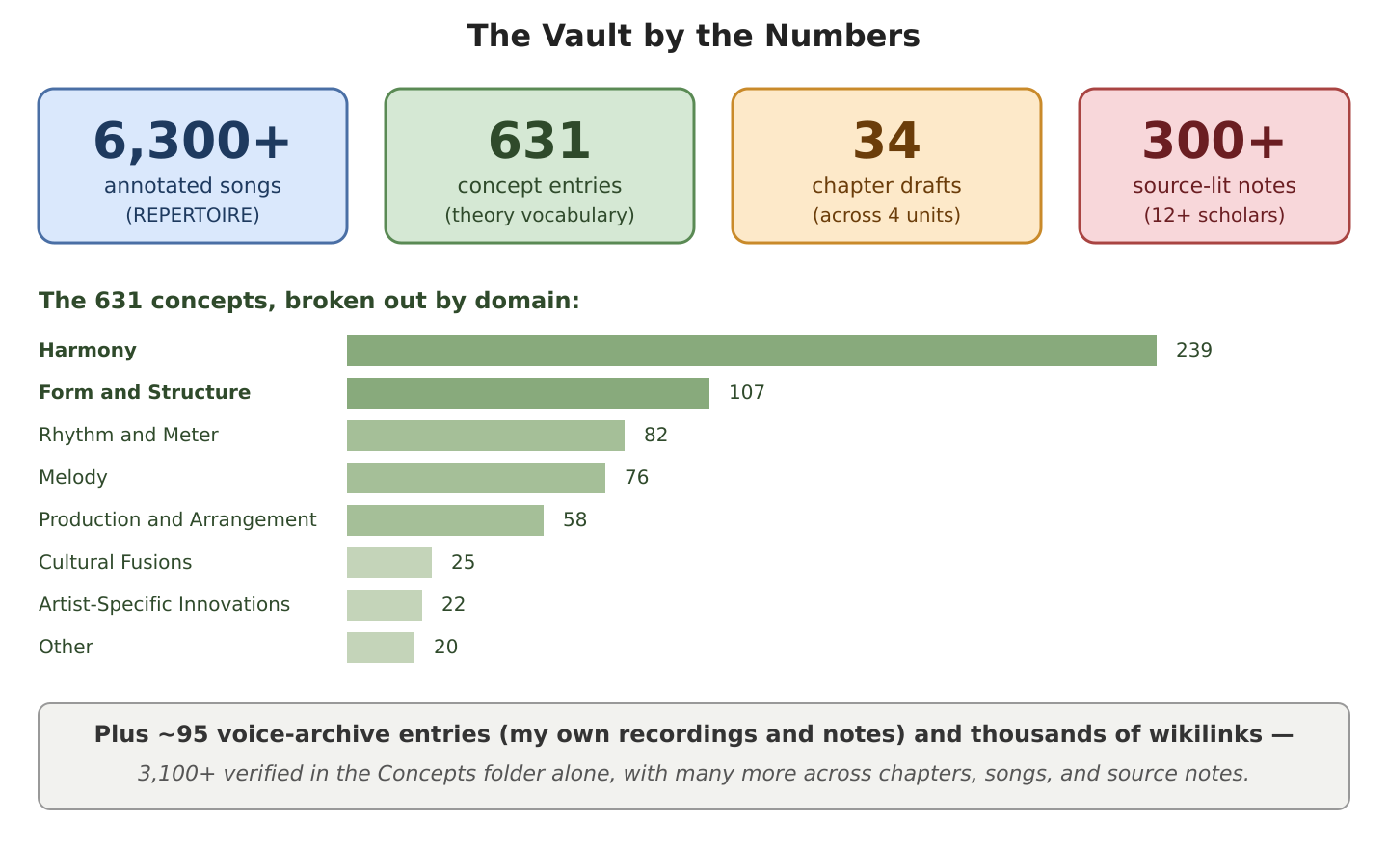
Figure 1 — The Vault by the Numbers
A few things worth noticing here. The Harmony bar is the longest for a reason — harmony is where popular music does its most interesting work, and the book leans into that weight. Song coverage is roughly ten-to-one against concept coverage, which is intentional: every idea in the book should have many examples to pick from, not one. And the concept breakdown maps almost exactly onto the book's table of contents, so the research and the pedagogy reinforce each other instead of drifting apart.

What's inside the vault
The vault is organized into four layers that all talk to one another.
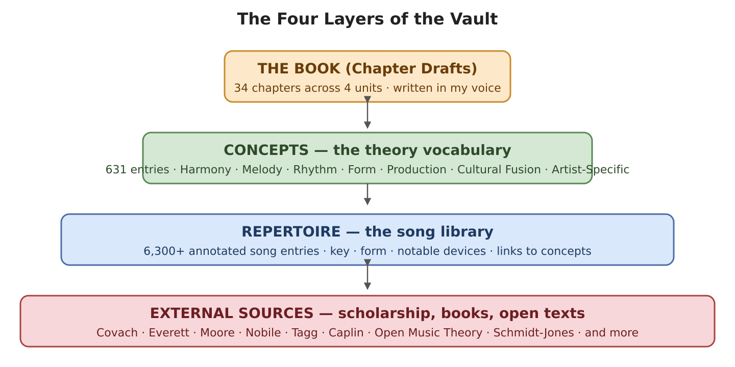
Figure 2 — The Four Layers of the Vault
The Book (Chapter Drafts). Thirty-four chapter files across four units — Fundamentals, Diatonic Practice, Chromatic Practice, Advanced Concepts. These are the public-facing prose, written the way I'd teach it in a room: plain-spoken, a little wry, and without the pretense that the music belongs in a glass case.
Concepts. 631 entries, each one a single music-theory idea — a chord type, a progression, a voice-leading habit, a rhythmic feel. They range from textbook-standard (Suspended Chords, Voiceleading, Roman Numeral Analysis) to original contributions like the Stuttering ii–V Pattern, a harmonic idea I developed and then corroborated by querying a 124,000-chord research corpus.
Repertoire. 6,300+ individual song entries, each naming the artist, year, key, form, and a set of theoretical tags. This is the living anthology the textbook draws from — any time the book needs to show, rather than tell, it reaches into here.
External Sources. Notes and excerpts from the scholarly literature, digested into the vault so their ideas can be referenced the same way a song can. The heavy hitters: Walter Everett on the Beatles (36 entries), the full Open Music Theory textbook (134 entries), Catherine Schmidt-Jones' music primers (42), Philip Tagg on popular-music semiotics (13), plus Allan Moore, John Covach, Drew Nobile, William Caplin, Kevin Holm-Hudson, David Bennett, Alan Belkin, Jeremy Krerowicz, and others — roughly a dozen major scholarly voices, around 300 source-literature notes in all.

How it holds together: the wikilink
A wikilink is a piece of text surrounded by double brackets that behaves like a hyperlink: [[The Beatles - A Day in the Life]] becomes a live pointer to that song's file. Click it and you're there.
Wikilinks are the connective tissue. A chapter says the harmonic trick here is a flat-VII, and the phrase flat-VII is a wikilink to the concept file, which lists thirty example songs, each of them wikilinks, each song pointing back to the concepts it demonstrates. The whole vault is a web.
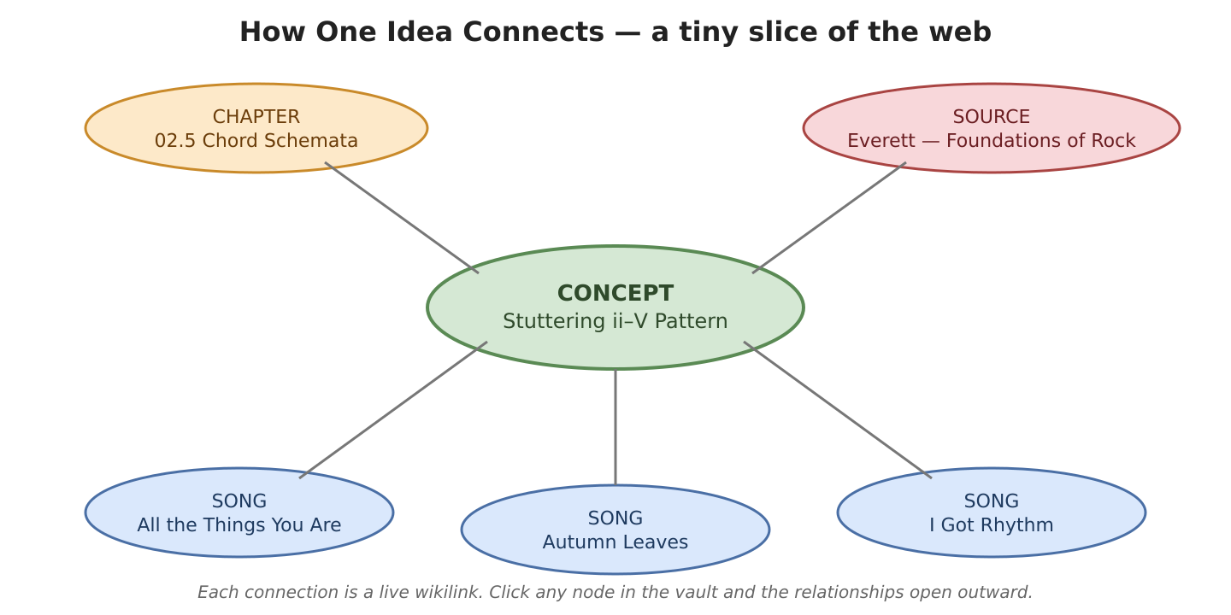
Figure 3 — How one idea connects
The linking is not a vague aspiration — I build it, folder by folder, and measure it. As of this writing the vault holds several thousand verified wikilinks: 806 in the Harmony concepts folder alone, 489 in Form and Structure, 1,332 across five more concept categories, 258 in the chapter drafts, hundreds more across the topical research folders. Every pass is logged. Every broken link gets repaired.

Where the material comes from
The vault is fed from two streams, which meet in the middle.
The external stream is scholarship. Books and academic articles are read, excerpted, and converted into structured notes that live in the vault alongside everything else. When Walter Everett makes a claim about Beatles voice-leading, that claim becomes a linkable node in the web — available to be cited in a chapter, pointed to from a concept, confirmed or contested by a song.
The internal stream is my own voice — the recordings I make, the teaching notes I keep, the pontifications I write out long-hand when an idea is too slippery to hold any other way, and the original theoretical concepts that come out of all that. The Stuttering ii–V Pattern is one of those — repeated dominant-preparation motion deliberately interrupted before it resolves, a pattern I identified, named, and then verified across a thousand-song chord corpus. Ninety-odd voice-archive entries and counting.
Where the external stream brings rigor and precedent, the internal stream brings a point of view. The book is what emerges when the two converge on a single topic.

Why this matters
Most music-theory books face a quiet problem: the examples, the concepts, and the source citations live in three different filing cabinets. The author holds them together by memory and typing. When the author moves on, the connections evaporate.
I wanted the connections to be the work. The songs, the ideas, the citations, and the prose aren't separate documents that happen to reference each other — they're one interconnected document that happens to be stored across many files. A reader of the finished book gets a textbook. A reader of the vault gets the textbook plus its argument, its examples, and its receipts, all walkable.
In plain terms: The Sound and the Theory is a popular-music-theory textbook that can show its work. That's the theory. And, as the vault itself demonstrates, it's also the practice.

Prepared for non-technical readers. For deeper technical detail, see the vault's VAULT_MAPS/ and the per-folder wikilinker logs under 01_ADMIN_AND_POLICY/.

