AWS Cloud Security Assessment: Prowler Audit Execution Guide
Document ID: SOP-AWS-AUDIT-INTERNAL | Date: July 10, 2026 | Version: 1.0

1. Introduction
This guide details how to execute security scans on AWS using Prowler CLI and deploy the Prowler Web App using Docker Compose.

2. Running Scans via Prowler CLI
Set the customer's shared Access Key credentials as environment variables and run:
export AWS_ACCESS_KEY_ID="<CUSTOMER_ACCESS_KEY>"
export AWS_SECRET_ACCESS_KEY="<CUSTOMER_SECRET_KEY>"
prowler aws
Alternatively, if the customer provided an IAM Role ARN, run:
prowler aws --role arn:aws:iam::<ACCOUNT_ID>:role/security-audit-role

3. Setting up the Prowler Web App
Download the Docker configuration files:
curl -LO https://raw.githubusercontent.com/prowler-cloud/prowler/refs/heads/master/docker-compose.yml
curl -LO https://raw.githubusercontent.com/prowler-cloud/prowler/refs/heads/master/.env
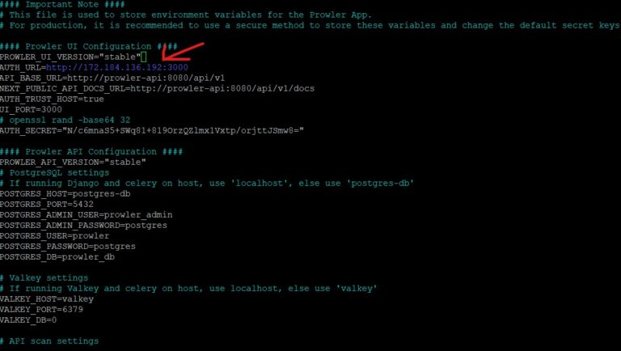
Figure: Prowler environment config showing port settings and environment options
Spin up the Docker containers in detached mode:
sudo docker compose up -d
Open browser to http://localhost:3000. Under 'Cloud Providers', select AWS, enter your keys or Role details:
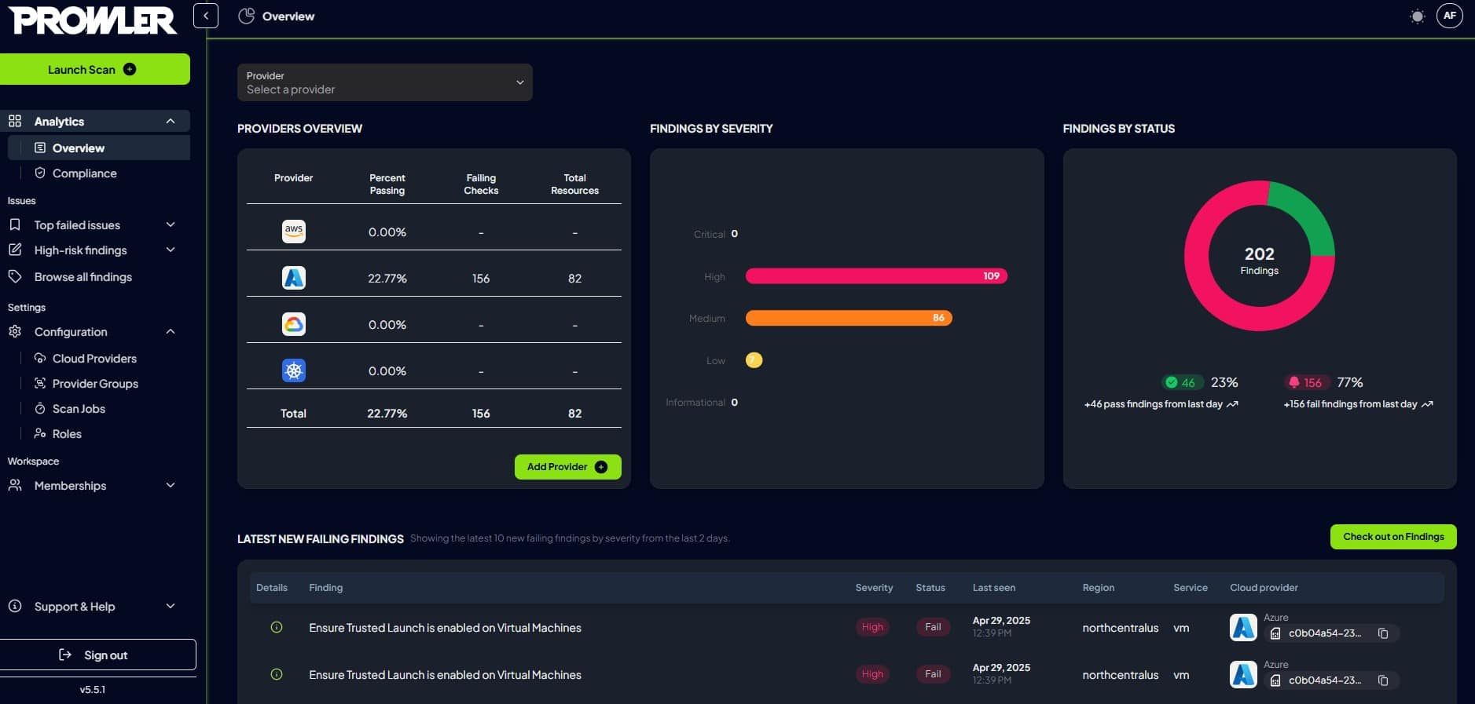
Figure: Prowler App main login/providers page

4. Prowler App Web UI Views
Once the scan is complete, view the dashboards and compliance results:
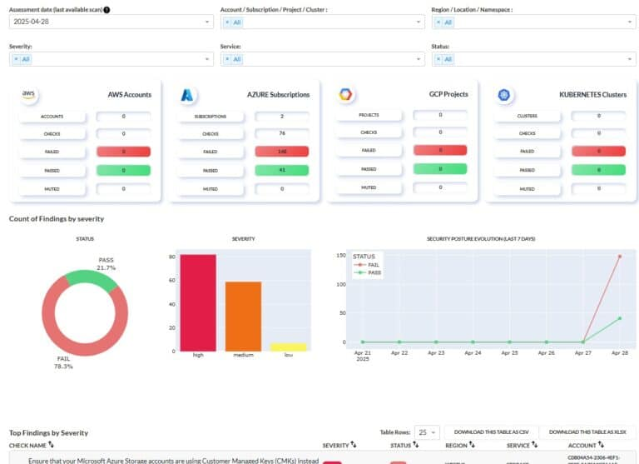
Figure: Interactive Prowler App Dashboard UI
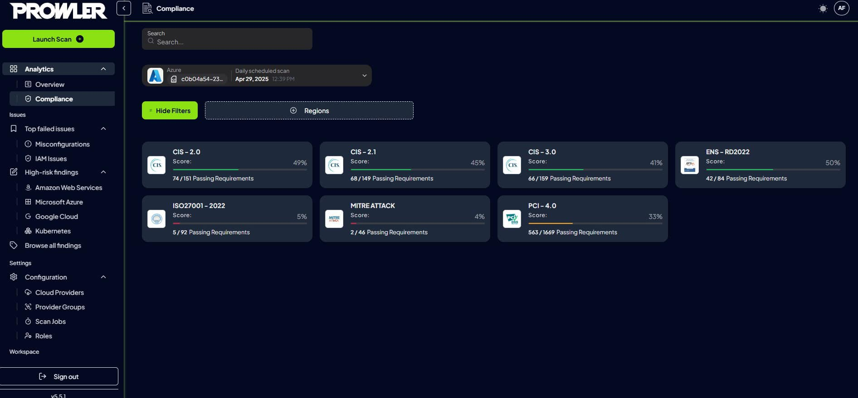
Figure: Compliance dashboard detailing CIS standard posture ratios

