AWS Prerequisites Setup for Cloud Security Assessment
Document ID: SOP-AWS-PREREQUISITES-CUSTOMER | Date: July 10, 2026 | Version: 1.0

1. Introduction
This document outlines the steps required to configure read-only access for a cloud security posture assessment in Amazon Web Services (AWS). All steps are performed on the customer side prior to the assessment.

2. Setup Access via CloudFormation Role (Recommended)
Deploying a CloudFormation stack is the easiest way to generate the required read-only assessment role:
- Open AWS Console and navigate to CloudFormation > Click 'Create stack' (with new resources).
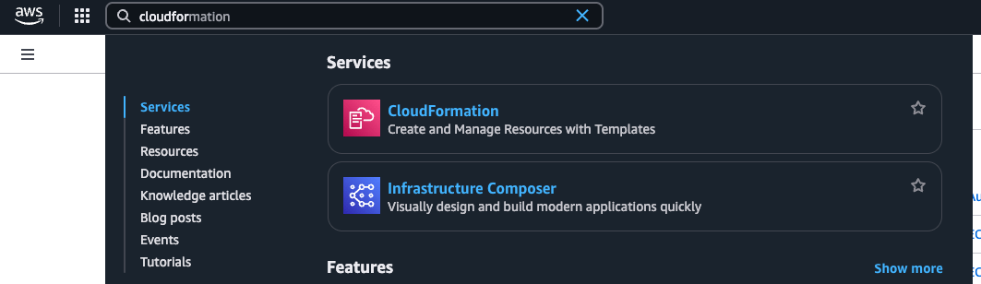
Figure: CloudFormation Dashboard in AWS Console
- Select 'Upload a template file' and upload the audit template YAML file.
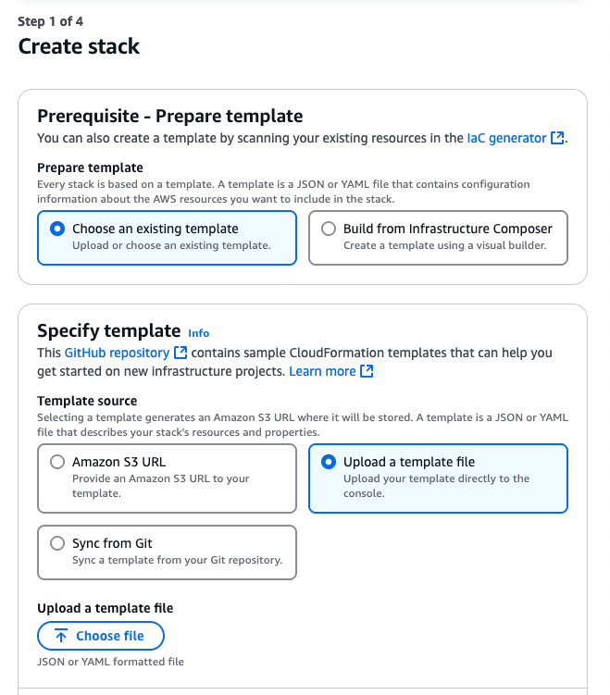
Figure: Uploading the CloudFormation template file
- Enter a stack name (e.g. 'security-audit-role-stack') and enter the target Assessment Account ID if cross-account access is required.
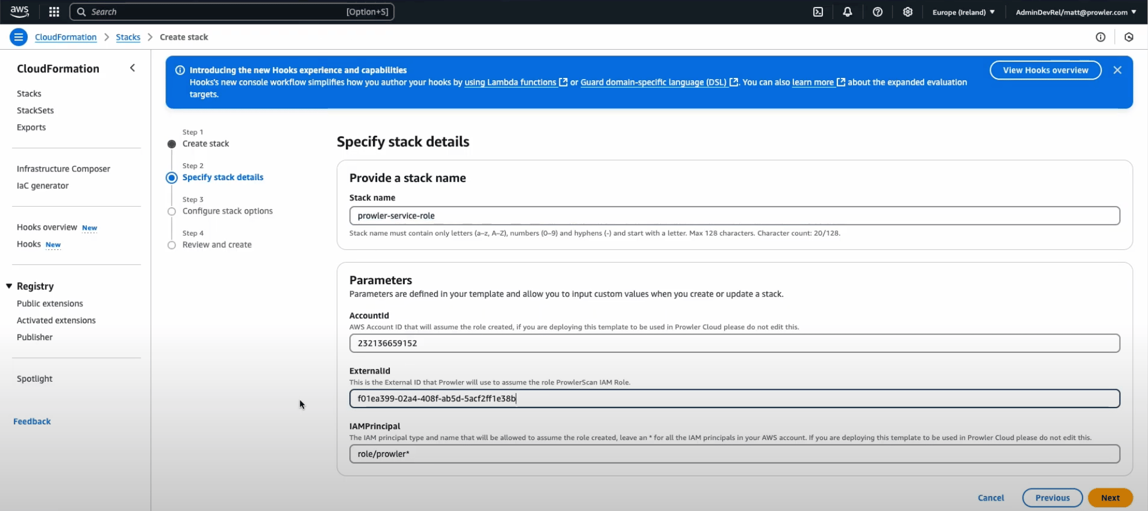
Figure: Entering the Stack Parameters
- Review settings, check 'I acknowledge that AWS CloudFormation might create IAM resources', and click 'Submit'.
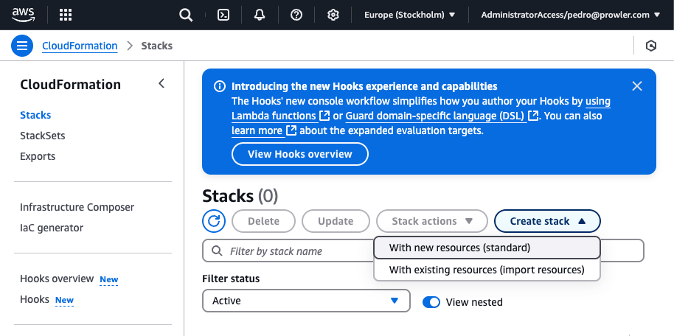
Figure: Deploying the Stack
- Once status shows CREATE_COMPLETE, go to Outputs and copy the Role ARN (e.g. arn:aws:iam::<ACCOUNT_ID>:role/security-audit-role).

3. Setup Access via IAM User Access Keys (Alternative)
If role assumption is not supported, create a local IAM User:
- Navigate to IAM > Users > Click 'Create user'.
- Name the user 'security-audit-user' and click Next.
- Select 'Attach policies directly' > Attach the standard 'SecurityAudit' and 'ViewOnlyAccess' policies.
- Click Create user > Select the created user > 'Security credentials' tab > Click 'Create access key'.
- Select 'Command Line Interface (CLI)' > Copy the Access Key ID and Secret Access Key.
Deliver the Role ARN OR the Access Key credentials securely to the assessment team.

