Azure Cloud Security Assessment: Prowler Audit Execution Guide
Document ID: SOP-AZURE-AUDIT-INTERNAL | Date: July 10, 2026 | Version: 1.0

1. Introduction
This guide details how to execute security scans on Azure using Prowler CLI and deploy the Prowler Web App using Docker Compose.

2. Running Scans via Prowler CLI
Configure the customer's tenant, client ID, and secret as environment variables and run Prowler with the Service Principal flag:
export AZURE_CLIENT_ID="<CUSTOMER_CLIENT_ID>"
export AZURE_TENANT_ID="<CUSTOMER_TENANT_ID>"
export AZURE_CLIENT_SECRET="<CUSTOMER_CLIENT_SECRET>"
prowler azure --sp-env-auth

3. Setting up the Prowler Web App
Download the Docker configuration files:
curl -LO https://raw.githubusercontent.com/prowler-cloud/prowler/refs/heads/master/docker-compose.yml
curl -LO https://raw.githubusercontent.com/prowler-cloud/prowler/refs/heads/master/.env
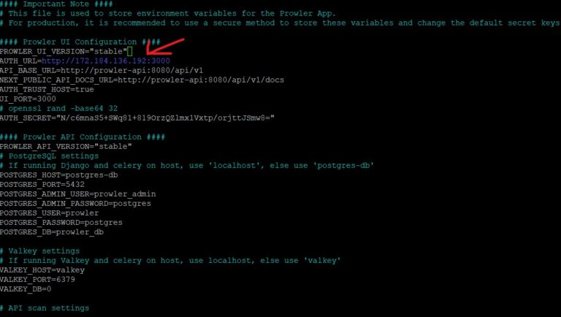
Figure: Prowler environment config showing port settings and environment options
Spin up the Docker containers in detached mode:
sudo docker compose up -d
Open browser to http://localhost:3000. Under 'Cloud Providers', select Azure and enter the App credentials:
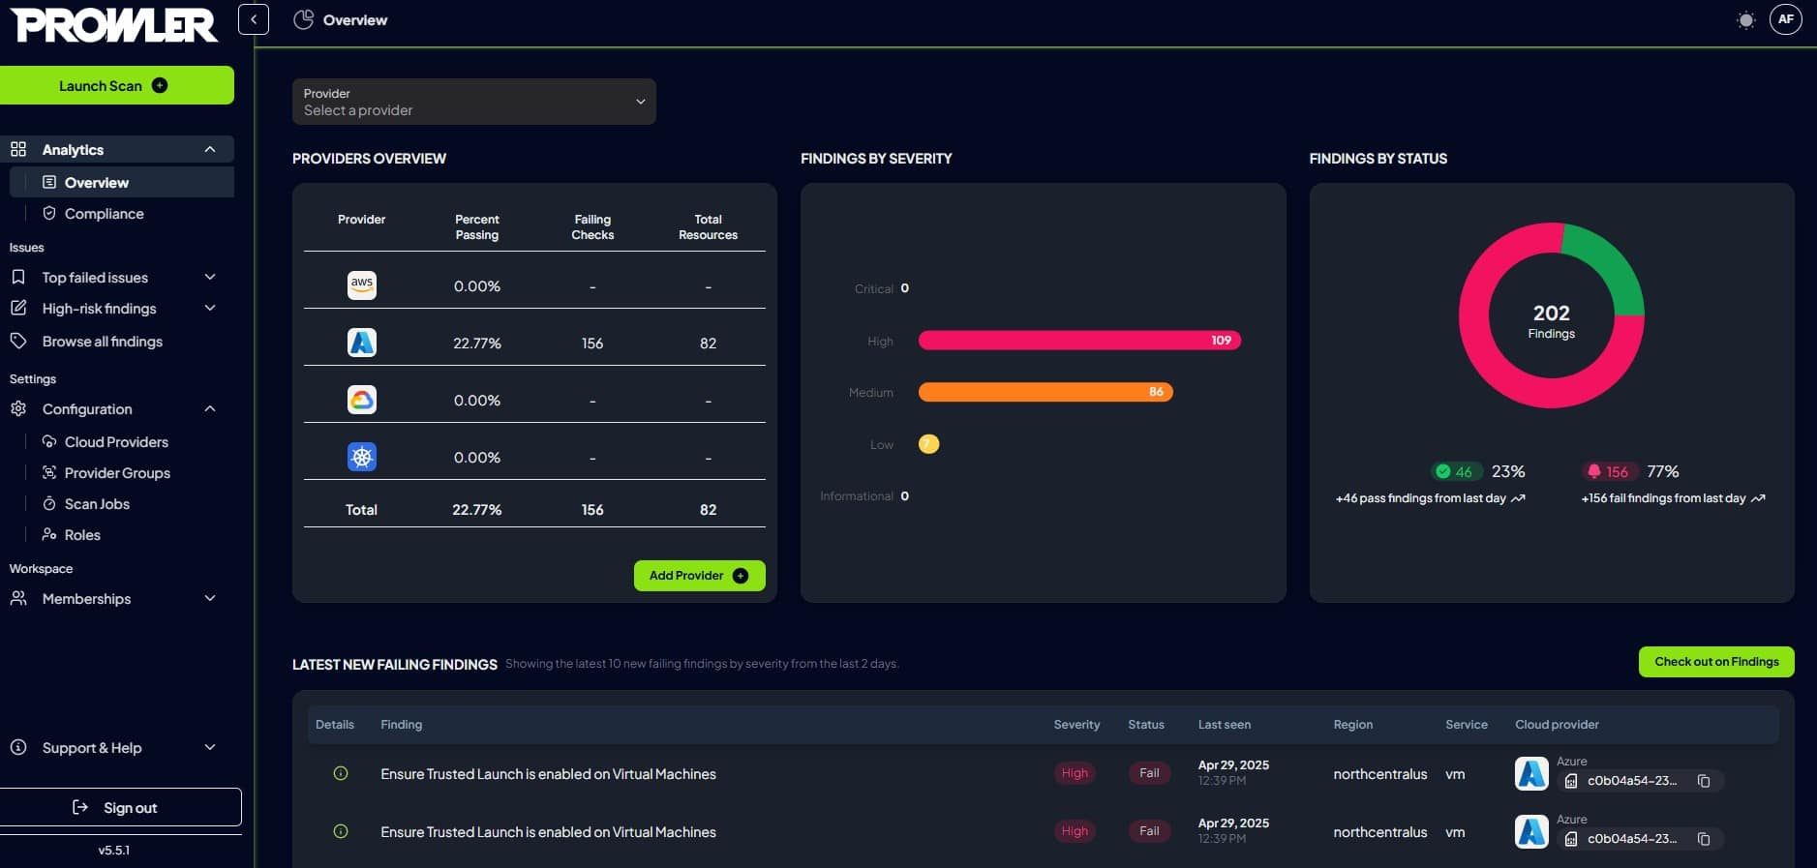
Figure: Prowler App main login/providers page

4. Prowler App Web UI Views
Once the scan is complete, view the dashboards and compliance results:
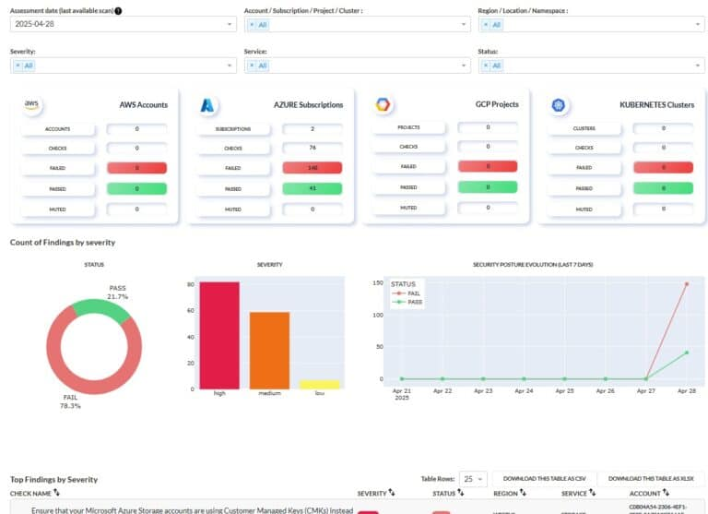
Figure: Interactive Prowler App Dashboard UI
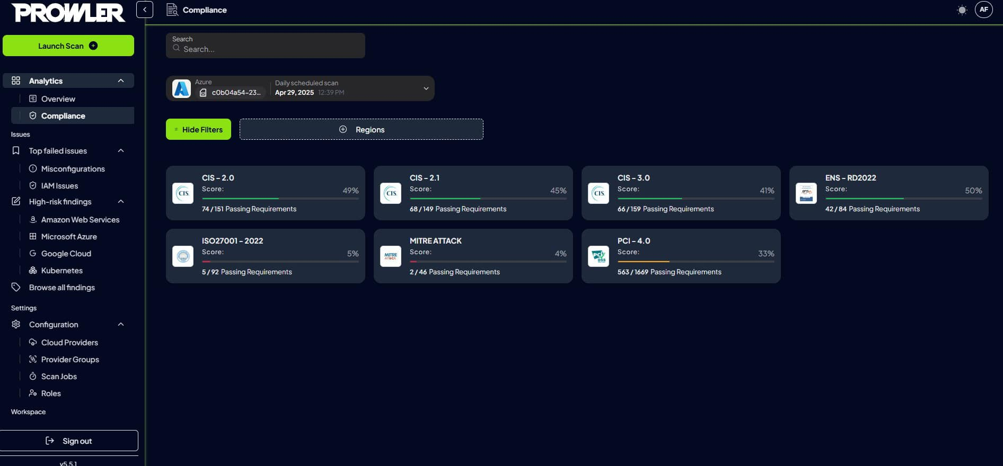
Figure: Compliance dashboard detailing CIS standard posture ratios
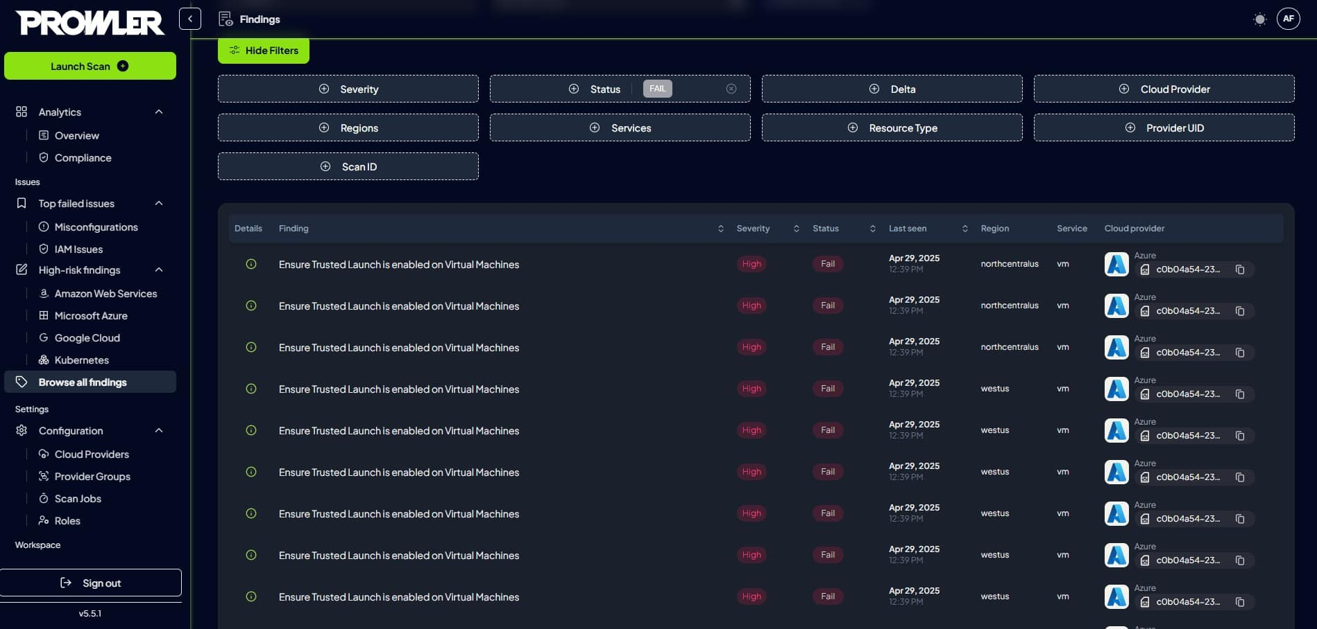
Figure: Reviewing Azure misconfigurations list in UI

