Azure Prerequisites Setup for Cloud Security Assessment
Document ID: SOP-AZURE-PREREQUISITES-CUSTOMER | Date: July 10, 2026 | Version: 1.0

1. Introduction
This document outlines the steps required to configure read-only access for a cloud security posture assessment in Microsoft Azure. All steps are performed on the customer side prior to the assessment.

2. App Registration (Microsoft Entra ID)
Register a new application in Entra ID (formerly Azure Active Directory) to allow API access:
- Navigate to Microsoft Entra ID > App registrations > Click '+ New registration'.
- Name it 'security-audit-app' and select 'Accounts in this organizational directory only'.
- Copy and save the Application (client) ID and Directory (tenant) ID from the App details page.
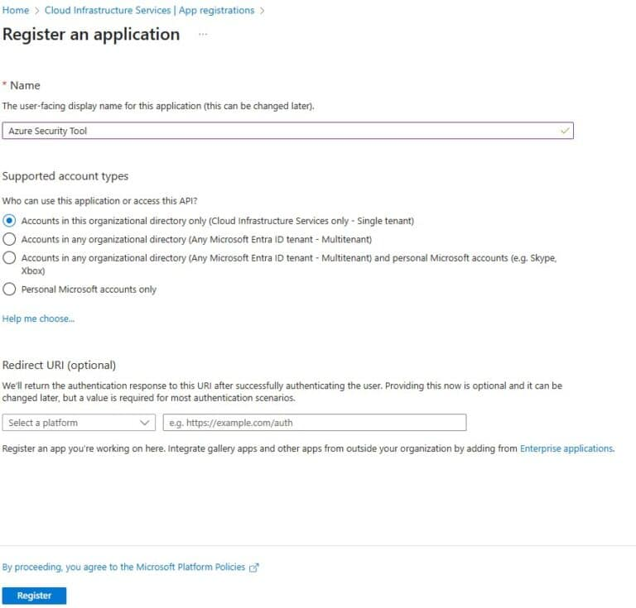
Figure: Azure App Registration details screen showing IDs

3. Generate Client Secret
Generate a client secret key to authenticate the App Registration:
- Go to Certificates & secrets > Click '+ New client secret'.
- Copy the secret 'Value' immediately (it will be hidden after you navigate away).

4. Assign Subscription Reader Role
Grant the App Registration access to read subscription resource configurations:
- Navigate to Subscriptions > Select your subscription > Access control (IAM).
- Click 'Add role assignment' > Search for and select the 'Reader' role.
- Assign access to 'User, group, or service principal' and select 'security-audit-app'.
- Review and click Save to apply the permissions.
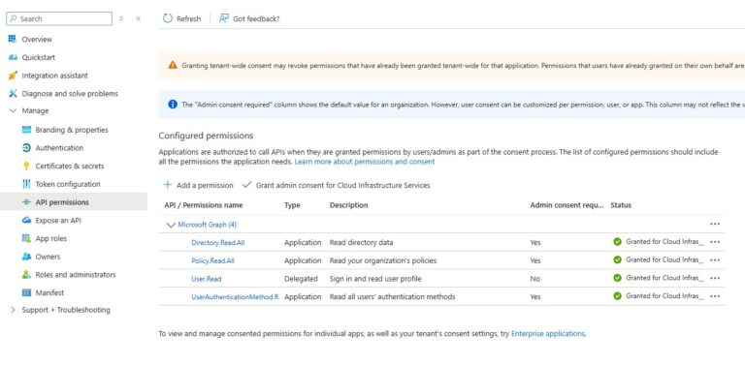
Figure: Assigning Subscription Reader Permissions to App Principal
Deliver the Application ID, Tenant ID, and Client Secret safely to the security assessment team.

