Cloud Security Assessment: Prowler AWS & Azure Audit Execution Guide
Document ID: SOP-Prowler-AWS-AZURE-AUDIT-INTERNAL | Date: July 10, 2026 | Version: 1.0

1. Introduction
This internal guide details how to execute security assessment scans using Prowler CLI and how to set up the interactive self-hosted Prowler App using Docker Compose.

2. Running Scans via Prowler CLI

2.1 AWS Scan Execution
To run the AWS audit using Access Keys, set environment variables and run:
export AWS_ACCESS_KEY_ID="<CUSTOMER_ACCESS_KEY>"
export AWS_SECRET_ACCESS_KEY="<CUSTOMER_SECRET_KEY>"
prowler aws
Alternatively, if the customer provided an IAM Role ARN for cross-account scans, run:
prowler aws --role arn:aws:iam::<ACCOUNT_ID>:role/security-audit-role

2.2 Azure Scan Execution
To run the Azure audit, configure the customer's tenant, client ID, and secret as environment variables and run Prowler with the Service Principal flag:
export AZURE_CLIENT_ID="<CUSTOMER_CLIENT_ID>"
export AZURE_TENANT_ID="<CUSTOMER_TENANT_ID>"
export AZURE_CLIENT_SECRET="<CUSTOMER_CLIENT_SECRET>"
prowler azure --sp-env-auth

3. Setting up the Prowler Web App
The Prowler App provides a clean, collaborative dashboard web UI for multi-cloud audits.

3.1 Download Docker Compose Files
Use curl to download the official Prowler Docker configuration files:
curl -LO https://raw.githubusercontent.com/prowler-cloud/prowler/refs/heads/master/docker-compose.yml
curl -LO https://raw.githubusercontent.com/prowler-cloud/prowler/refs/heads/master/.env

3.2 Configure Environment (.env)
Open the '.env' file to configure system settings, users, and passwords:
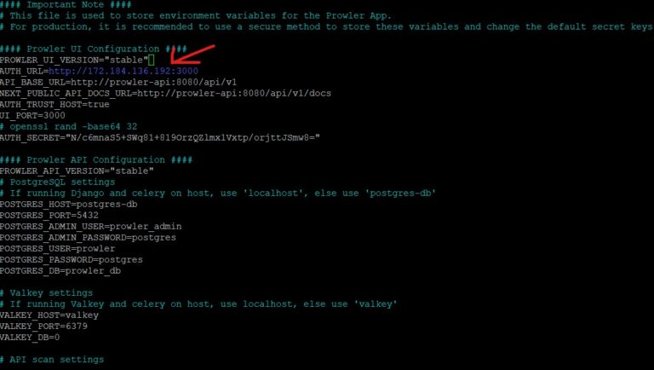
Figure: Prowler environment config showing port settings and environment options

3.3 Run the Web App
Spin up the Docker containers in detached mode:
sudo docker compose up -d
Access the web panel in your browser at http://localhost:3000 (or http://SERVER_IP:3000). Create an admin login upon initial startup.

4. Prowler App Web UI Usage

4.1 Connecting Cloud Accounts
Log into the Prowler App, navigate to Cloud Providers, select AWS or Azure, and enter the client keys or IAM Role details:
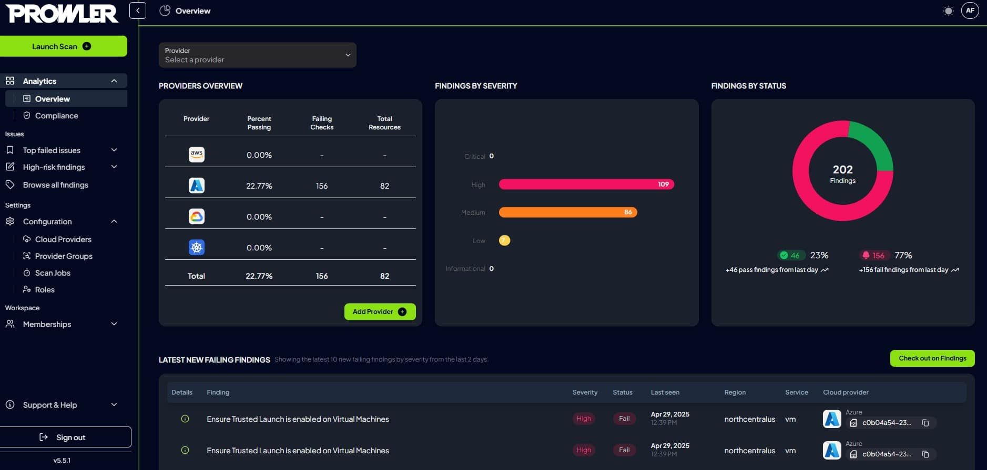
Figure: Prowler App main login/providers page

4.2 Performing Assessments and Dashboard Views
Run the assessment job. The Prowler Dashboard will populate showing Findings by Severity and findings by provider:
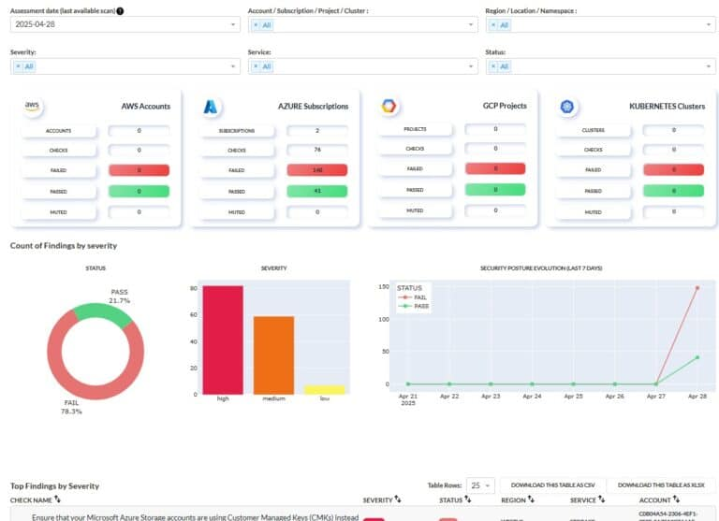
Figure: Interactive Prowler App Dashboard UI

4.3 Compliance Mappings
Navigate to Compliance > Select CIS Benchmark, NIST, or ISO 27001 to view compliance ratios:
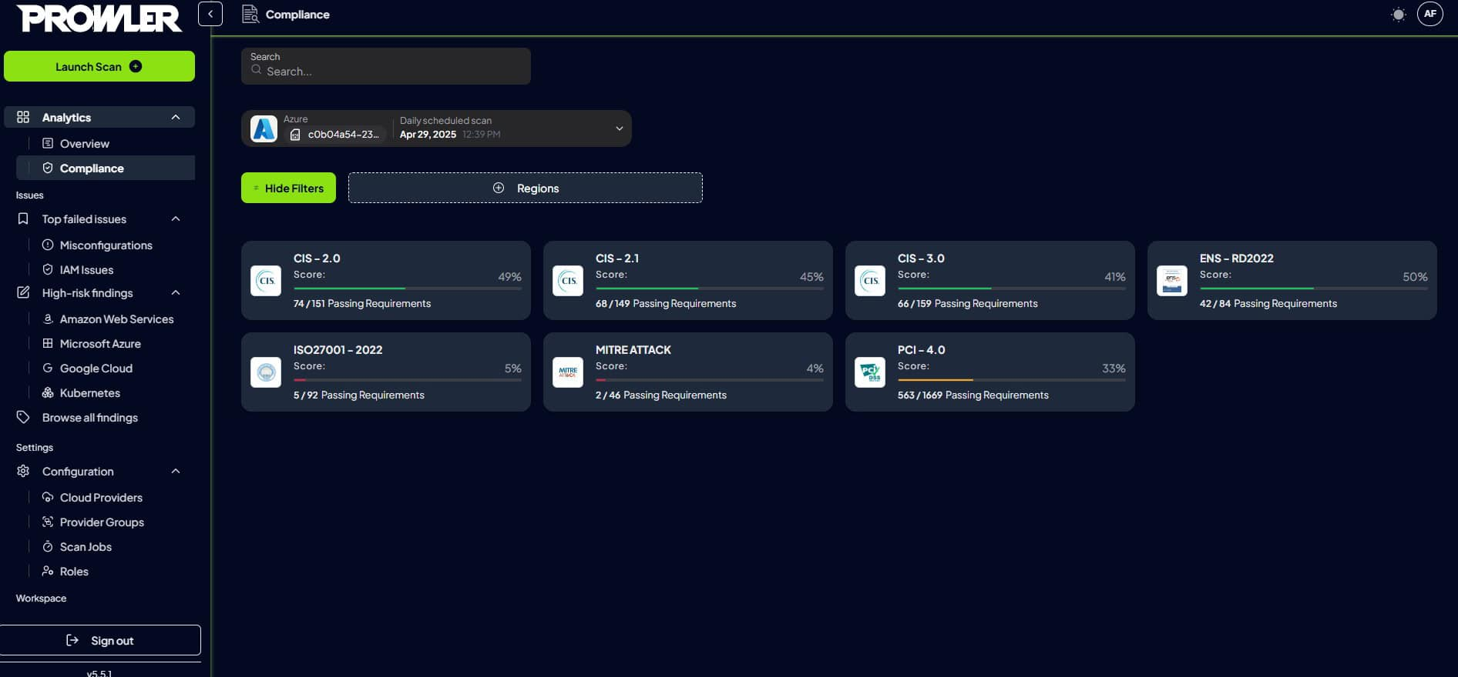
Figure: Compliance dashboard detailing CIS standard posture ratios

4.4 Reviewing Misconfigurations
Review the active failures listing directly from the UI and download reports:
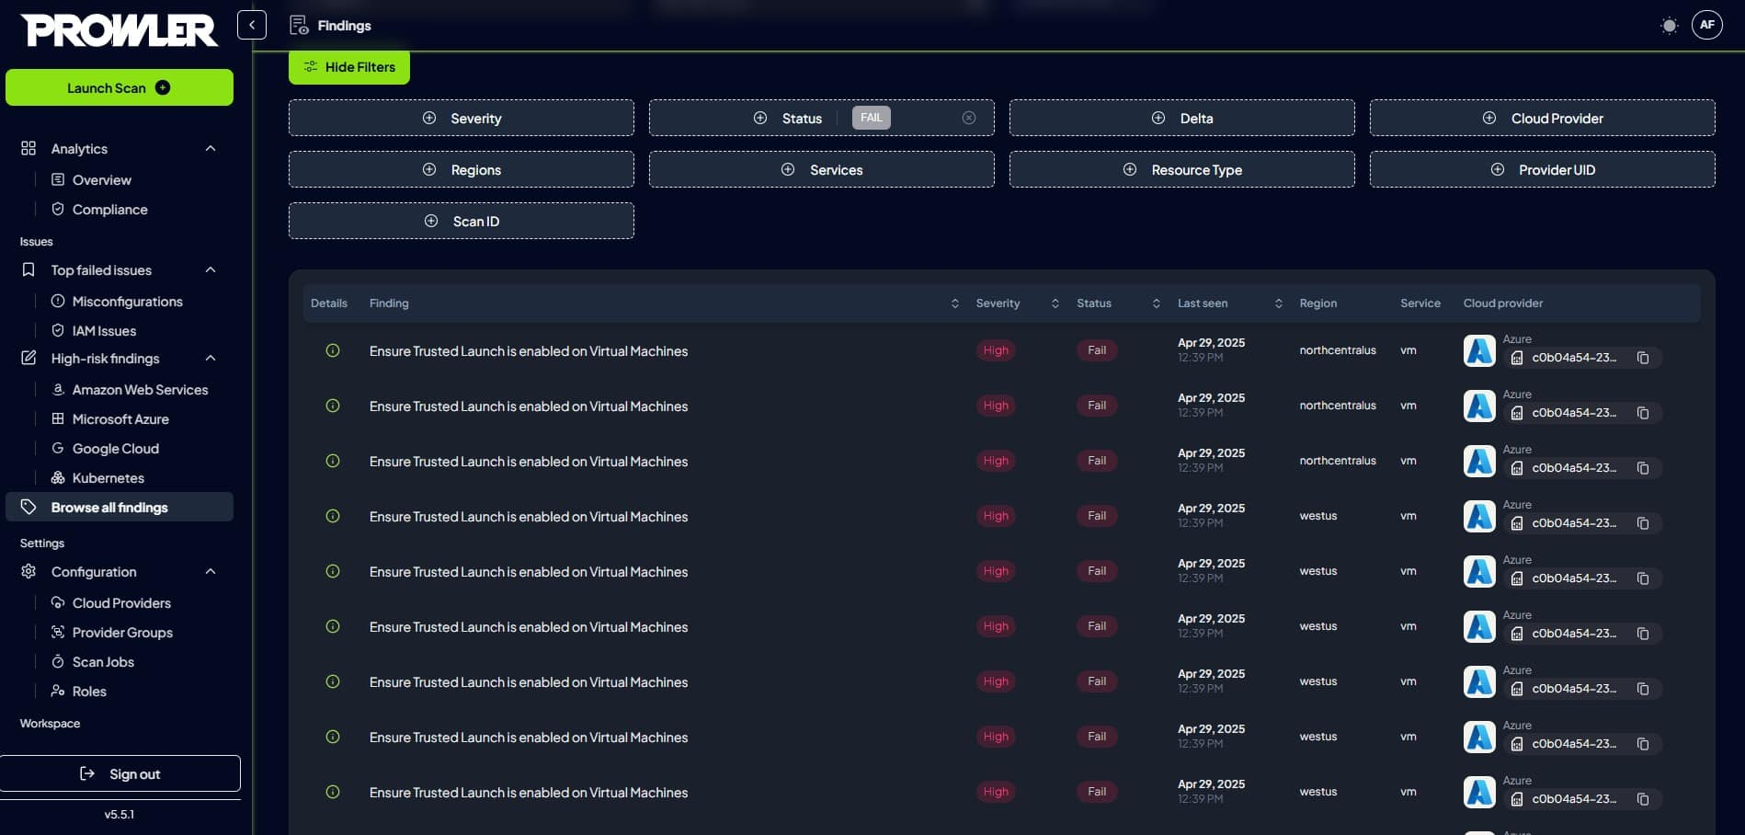
Figure: Misconfigurations page showing status, severity, and mitigation instructions

