AWS & Azure Prerequisites Setup for Cloud Security Assessment
Document ID: SOP-AWS-AZURE-SECURITY-PREREQS | Date: July 10, 2026 | Version: 1.0

1. Introduction
This document outlines the steps required to configure read-only access for a cloud security posture assessment across Amazon Web Services (AWS) and Microsoft Azure. These configurations are performed on the customer side prior to the assessment.

2. Amazon Web Services (AWS) Setup Steps
To perform the security assessment on AWS, we require read-only access to your AWS metadata. You can configure this either by deploying an IAM Role (Recommended) or creating an IAM User with Access Keys.

2.1 Method A: Create IAM Role via CloudFormation (Recommended)
Using a CloudFormation template is the fastest way to create the read-only assessment role:
- Open AWS Console and navigate to CloudFormation > Click 'Create stack' (with new resources).
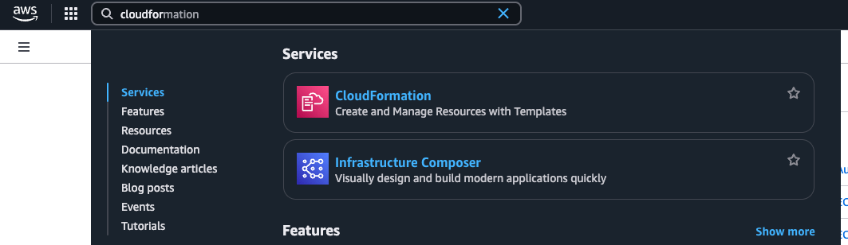
Figure: CloudFormation Dashboard in AWS Console
- Select 'Upload a template file' and upload the assessment role template YAML file.
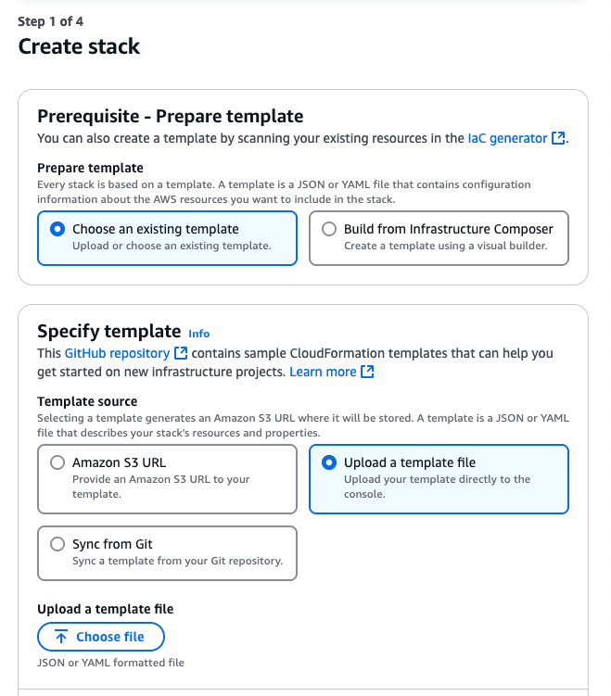
Figure: Uploading the CloudFormation template file
- Specify a stack name (e.g. 'security-audit-role-stack') and enter the target Assessment Account ID if doing cross-account role assumption.
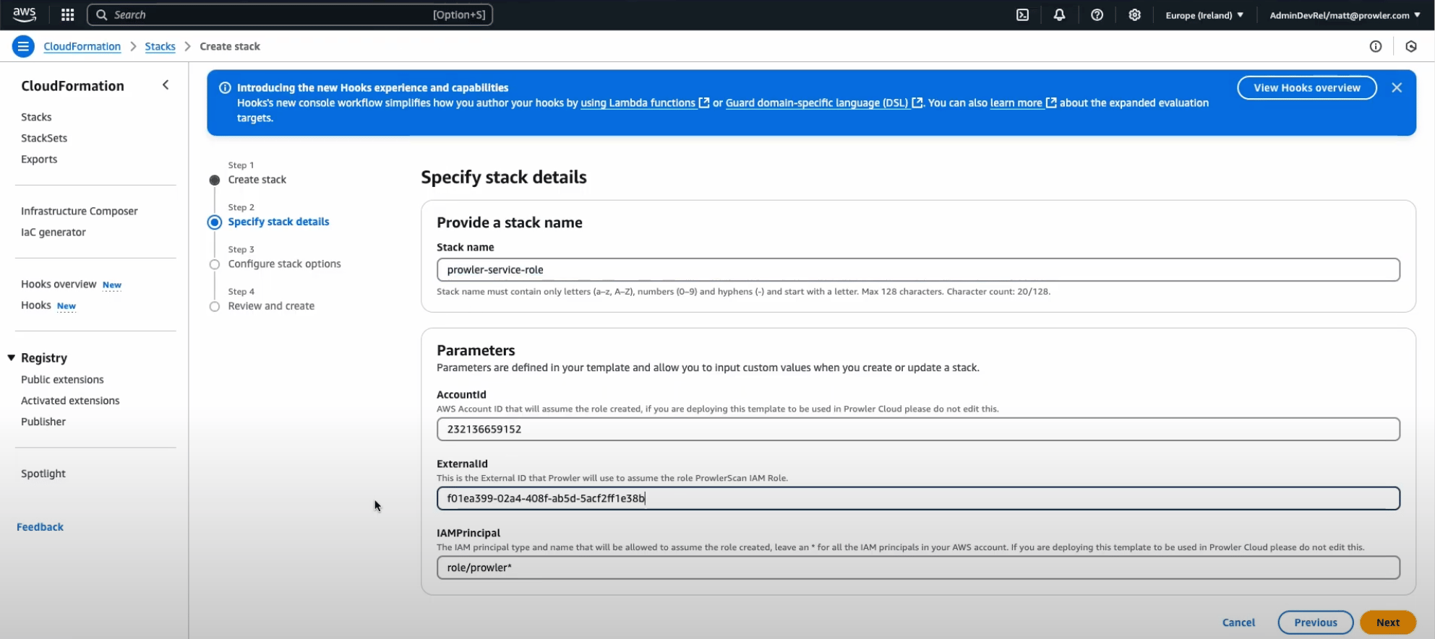
Figure: Entering the Stack Parameters
- Review the settings, check the box 'I acknowledge that AWS CloudFormation might create IAM resources', and click 'Submit' (or Create stack).
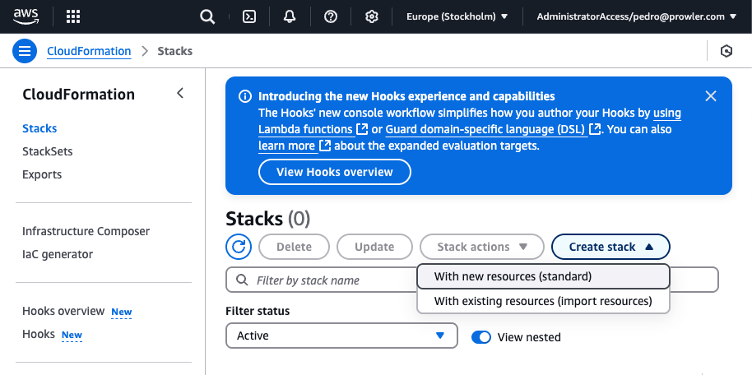
Figure: Deploying the Stack
- Once the stack status is CREATE_COMPLETE, go to Outputs and copy the Role ARN (e.g. arn:aws:iam::<ACCOUNT_ID>:role/security-audit-role).

2.2 Method B: Create IAM User with Access Keys (Alternative)
If role assumption is not possible, create a local IAM User:
- Navigate to IAM > Users > Click 'Create user'.
- Name the user 'security-audit-user' and click Next.
- Select 'Attach policies directly' > Search for and attach the standard 'SecurityAudit' and 'ViewOnlyAccess' policies.
- Review and click 'Create user'.
- Select the created user > Go to 'Security credentials' tab > Click 'Create access key'.
- Select 'Command Line Interface (CLI)' > Copy the Access Key ID and Secret Access Key.
Deliver the Role ARN (Method A) OR the Access Key ID and Secret Access Key (Method B) securely to the assessment team.

3. Microsoft Azure Setup Steps

3.1 App Registration (Microsoft Entra ID)
Register a new application in Entra ID (formerly Azure Active Directory) to allow API access:
- Navigate to Microsoft Entra ID > App registrations > Click '+ New registration'.
- Name it 'security-audit-app' and select 'Accounts in this organizational directory only'.
- Copy and save the Application (client) ID and Directory (tenant) ID from the App details page.
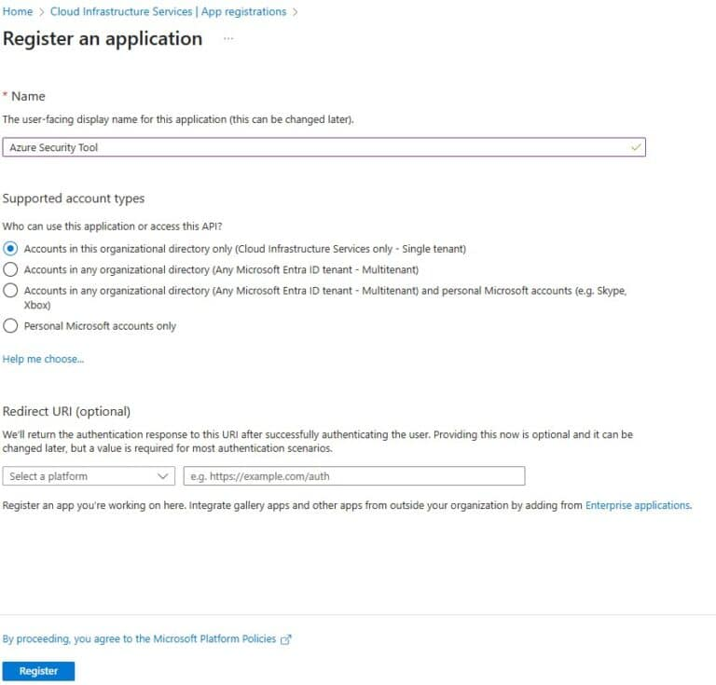
Figure: Azure App Registration details screen showing IDs

3.2 Generate Client Secret
Generate a client secret key to authenticate the App Registration:
- Go to Certificates & secrets > Click '+ New client secret'.
- Copy the secret 'Value' immediately (it will be hidden after you navigate away).

3.3 Assign Subscription Reader Role
Grant the App Registration access to read subscription resource configurations:
- Navigate to Subscriptions > Select your subscription > Access control (IAM).
- Click 'Add role assignment' > Search for and select the 'Reader' role.
- Assign access to 'User, group, or service principal' and select 'security-audit-app'.
- Review and click Save to apply the permissions.
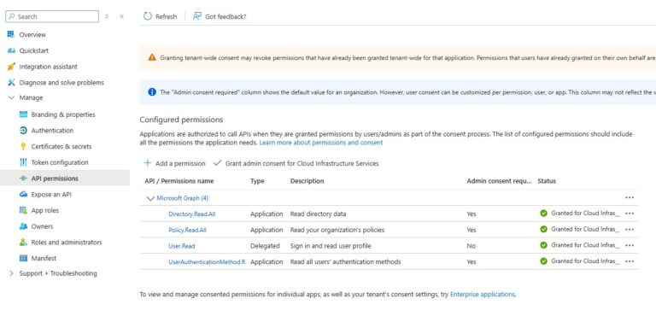
Figure: Assigning Subscription Reader Permissions to App Principal
Deliver the Application ID, Tenant ID, and Client Secret safely to the security assessment team.

