GCP & Azure Prerequisites Setup for Cloud Security Assessment
Document ID: SOP-CLOUD-SECURITY-PREREQS-CUSTOMER | Date: July 10, 2026 | Version: 1.0

1. Introduction
This document outlines the steps required to configure read-only access for a cloud security assessment across Google Cloud Platform (GCP) and Microsoft Azure. These configurations are performed on the customer side prior to the assessment.

2. Google Cloud Platform (GCP) Setup Steps

2.1 Enable Required APIs
You must enable the Identity and Access Management (IAM) API and Cloud Resource Manager API in your target project. You can enable them via Cloud Console or using these commands:
gcloud services enable iam.googleapis.com --project <YOUR_PROJECT_ID>
gcloud services enable cloudresourcemanager.googleapis.com --project <YOUR_PROJECT_ID>

2.2 Create Service Account
Create a dedicated service account that the assessment team will use:
gcloud iam service-accounts create security-audit-sa --display-name="Security Audit Service Account" --project=<YOUR_PROJECT_ID>
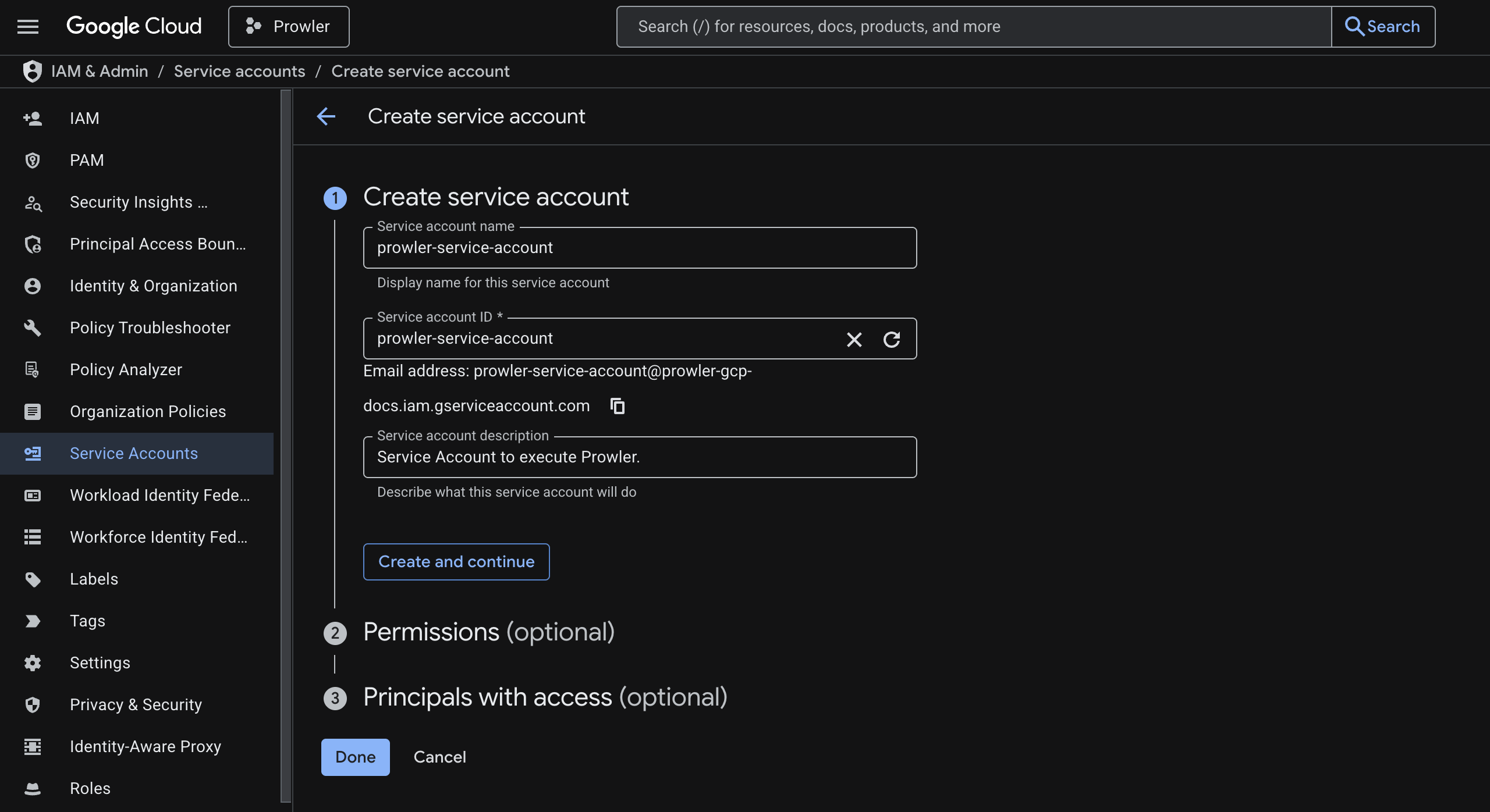
Figure: Creating the Service Account in Google Cloud Console

2.3 Assign Read-Only Permissions
Assign 'Viewer' and 'Service Usage Consumer' roles to the service account:
gcloud projects add-iam-policy-binding <YOUR_PROJECT_ID> --member="serviceAccount:security-audit-sa@<YOUR_PROJECT_ID>.iam.gserviceaccount.com" --role="roles/viewer"
gcloud projects add-iam-policy-binding <YOUR_PROJECT_ID> --member="serviceAccount:security-audit-sa@<YOUR_PROJECT_ID>.iam.gserviceaccount.com" --role="roles/serviceusage.serviceUsageConsumer"
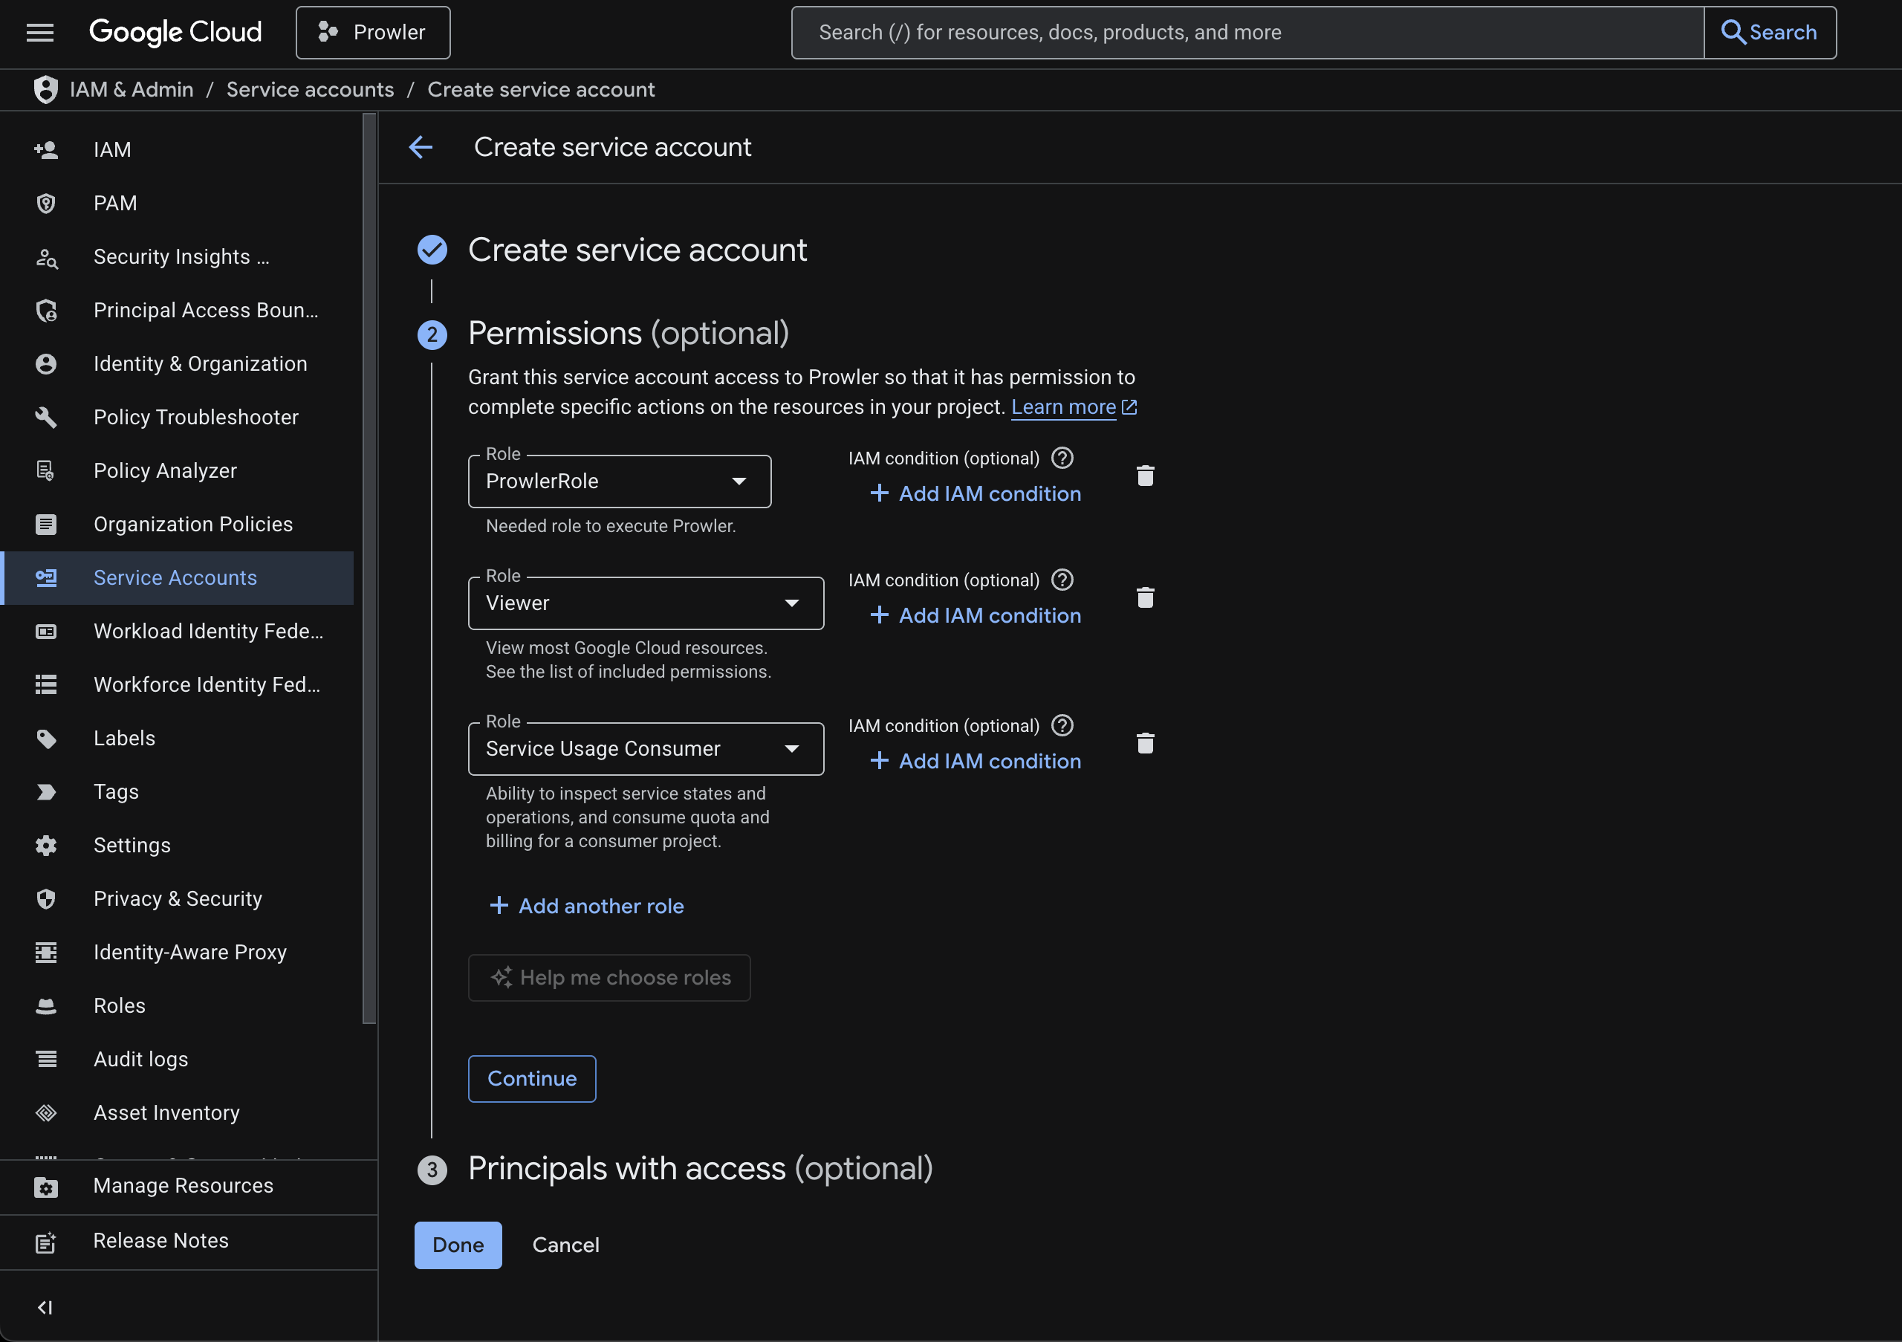
Figure: Assigning Roles in IAM Console

2.4 Generate JSON Key Credentials
Navigate to the Keys tab under the service account, click 'ADD KEY', choose 'Create new key', and select JSON format:
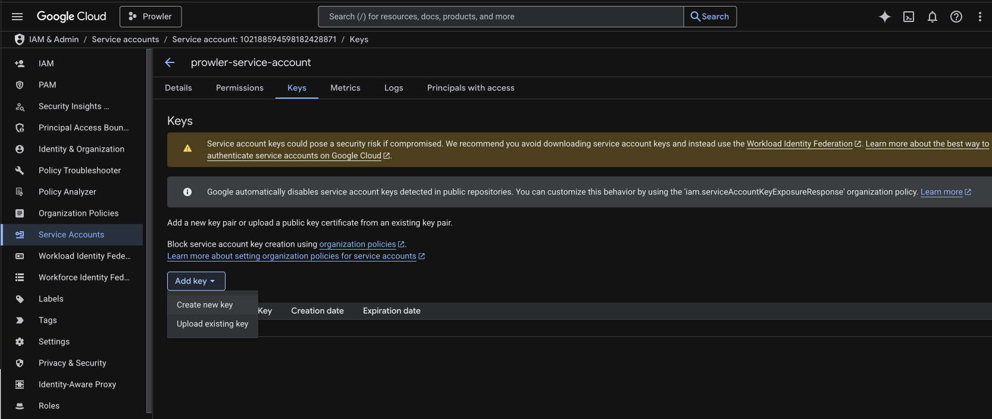
Figure: Adding a Key to the Service Account
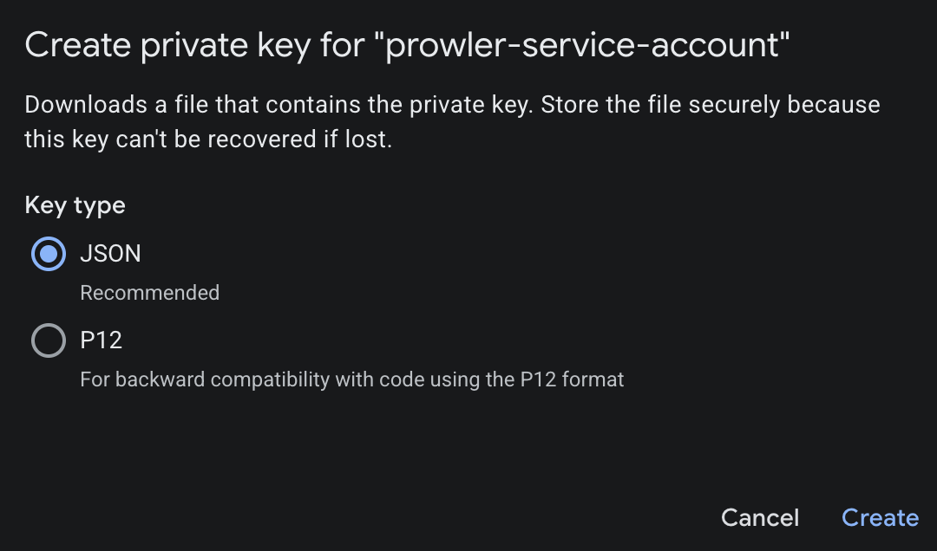
Figure: Downloading the JSON Key File
This downloads a credential JSON file. Share this file securely with the assessment team.

3. Microsoft Azure Setup Steps

3.1 App Registration (Microsoft Entra ID)
Register a new application in Entra ID (formerly Azure Active Directory) to allow API access:
- Navigate to Microsoft Entra ID > App registrations > Click '+ New registration'.
- Name it 'security-audit-app' and select 'Accounts in this organizational directory only'.
- Copy and save the Application (client) ID and Directory (tenant) ID from the App details page.
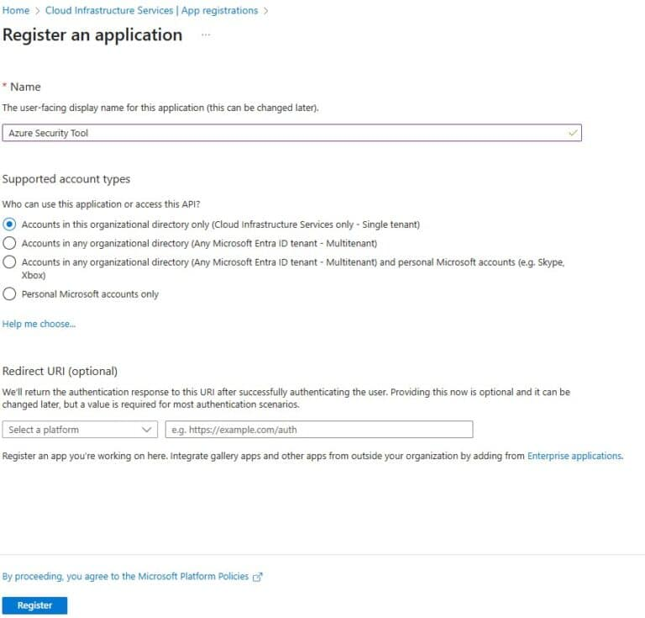
Figure: Azure App Registration details screen showing IDs

3.2 Generate Client Secret
Generate a client secret key to authenticate the App Registration:
- Go to Certificates & secrets > Click '+ New client secret'.
- Copy the secret 'Value' immediately (it will be hidden after you navigate away).

3.3 Assign Subscription Reader Role
Grant the App Registration access to read subscription resource configurations:
- Navigate to Subscriptions > Select your subscription > Access control (IAM).
- Click 'Add role assignment' > Search for and select the 'Reader' role.
- Assign access to 'User, group, or service principal' and select 'security-audit-app'.
- Review and click Save to apply the permissions.
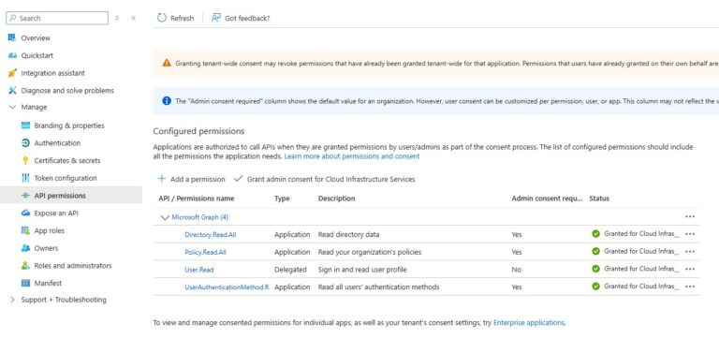
Figure: Assigning Subscription Reader Permissions to App Principal
Deliver the Application ID, Tenant ID, and Client Secret safely to the security assessment team.

