GCP Prerequisites Setup for Cloud Security Assessment
Document ID: SOP-GCP-SECURITY-ASSESSMENT-PREREQS | Date: July 10, 2026 | Version: 1.0

1. Introduction
This document outlines the steps required to prepare your Google Cloud Platform (GCP) environment for a third-party read-only cloud security posture assessment. All steps are performed on the customer side prior to the audit.

2. Requirements
- A GCP account with administrative access to the target projects.
- Google Cloud SDK (gcloud CLI) installed and configured on your machine, or access to GCP Cloud Shell.

3. Enable Required GCP APIs
You must enable the Identity and Access Management (IAM) API in your target project to allow resource discovery.
You can enable this in the Google Cloud Console (APIs & Services > Library > Search for IAM API) or run the following command:
gcloud services enable iam.googleapis.com --project <YOUR_PROJECT_ID>
It is also recommended to enable the Cloud Resource Manager API:
gcloud services enable cloudresourcemanager.googleapis.com --project <YOUR_PROJECT_ID>

4. Create a Service Account
Create a dedicated service account that the assessment team will use to access your project resource configurations.
You can do this by navigating to IAM & Admin > Service Accounts in the GCP Console.
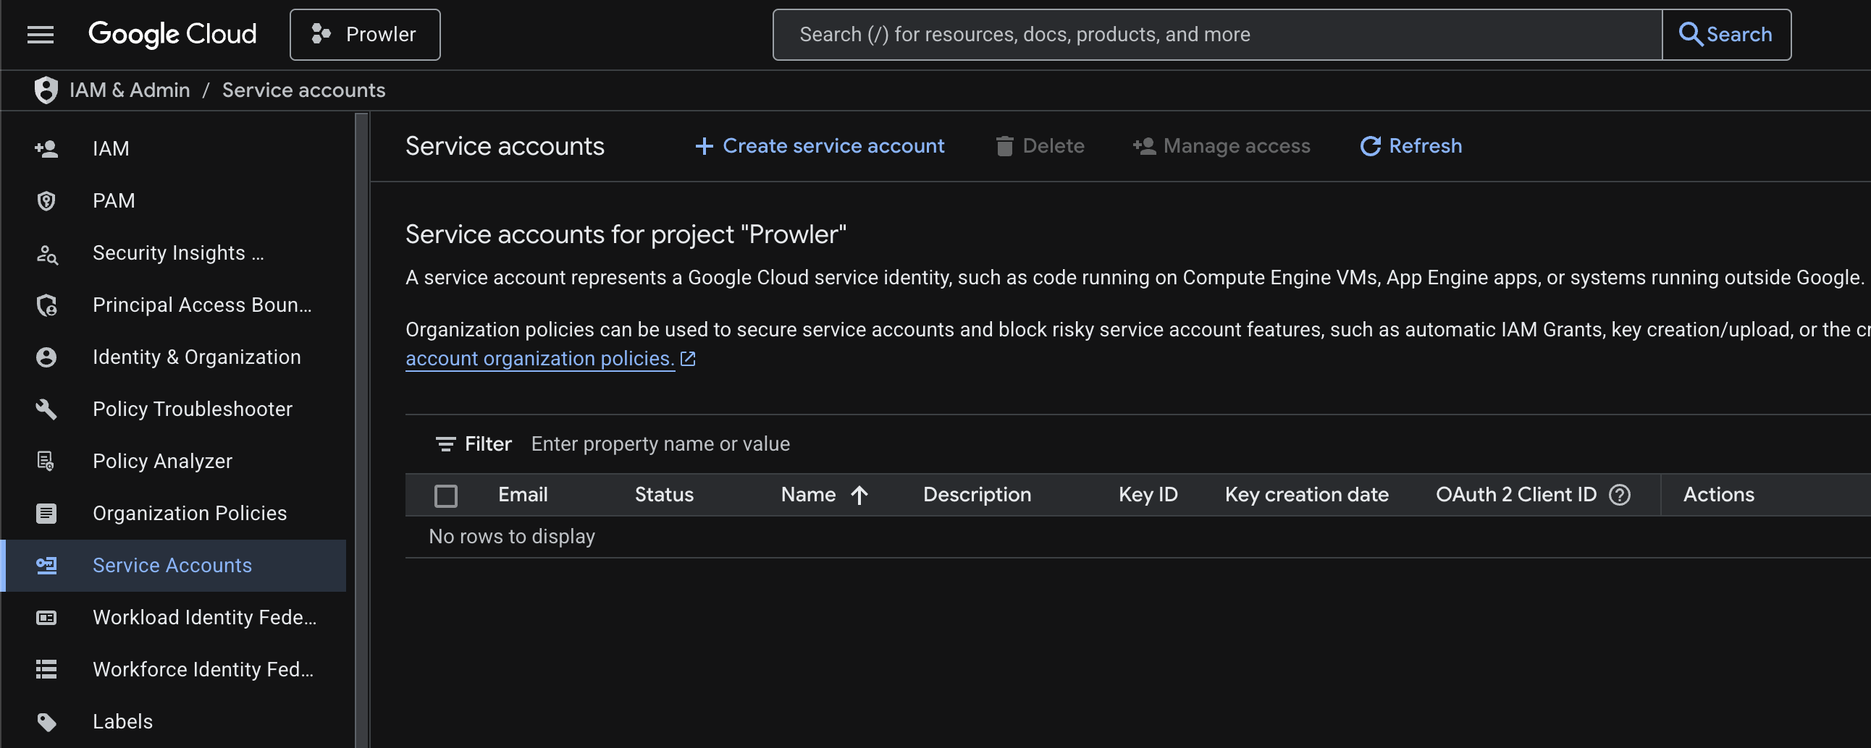
Figure: Service Accounts Page in Google Cloud Console
Run the following command to create the service account, or use the '+ CREATE SERVICE ACCOUNT' button in the Console:
gcloud iam service-accounts create security-audit-sa --display-name="Security Audit Service Account" --project=<YOUR_PROJECT_ID>
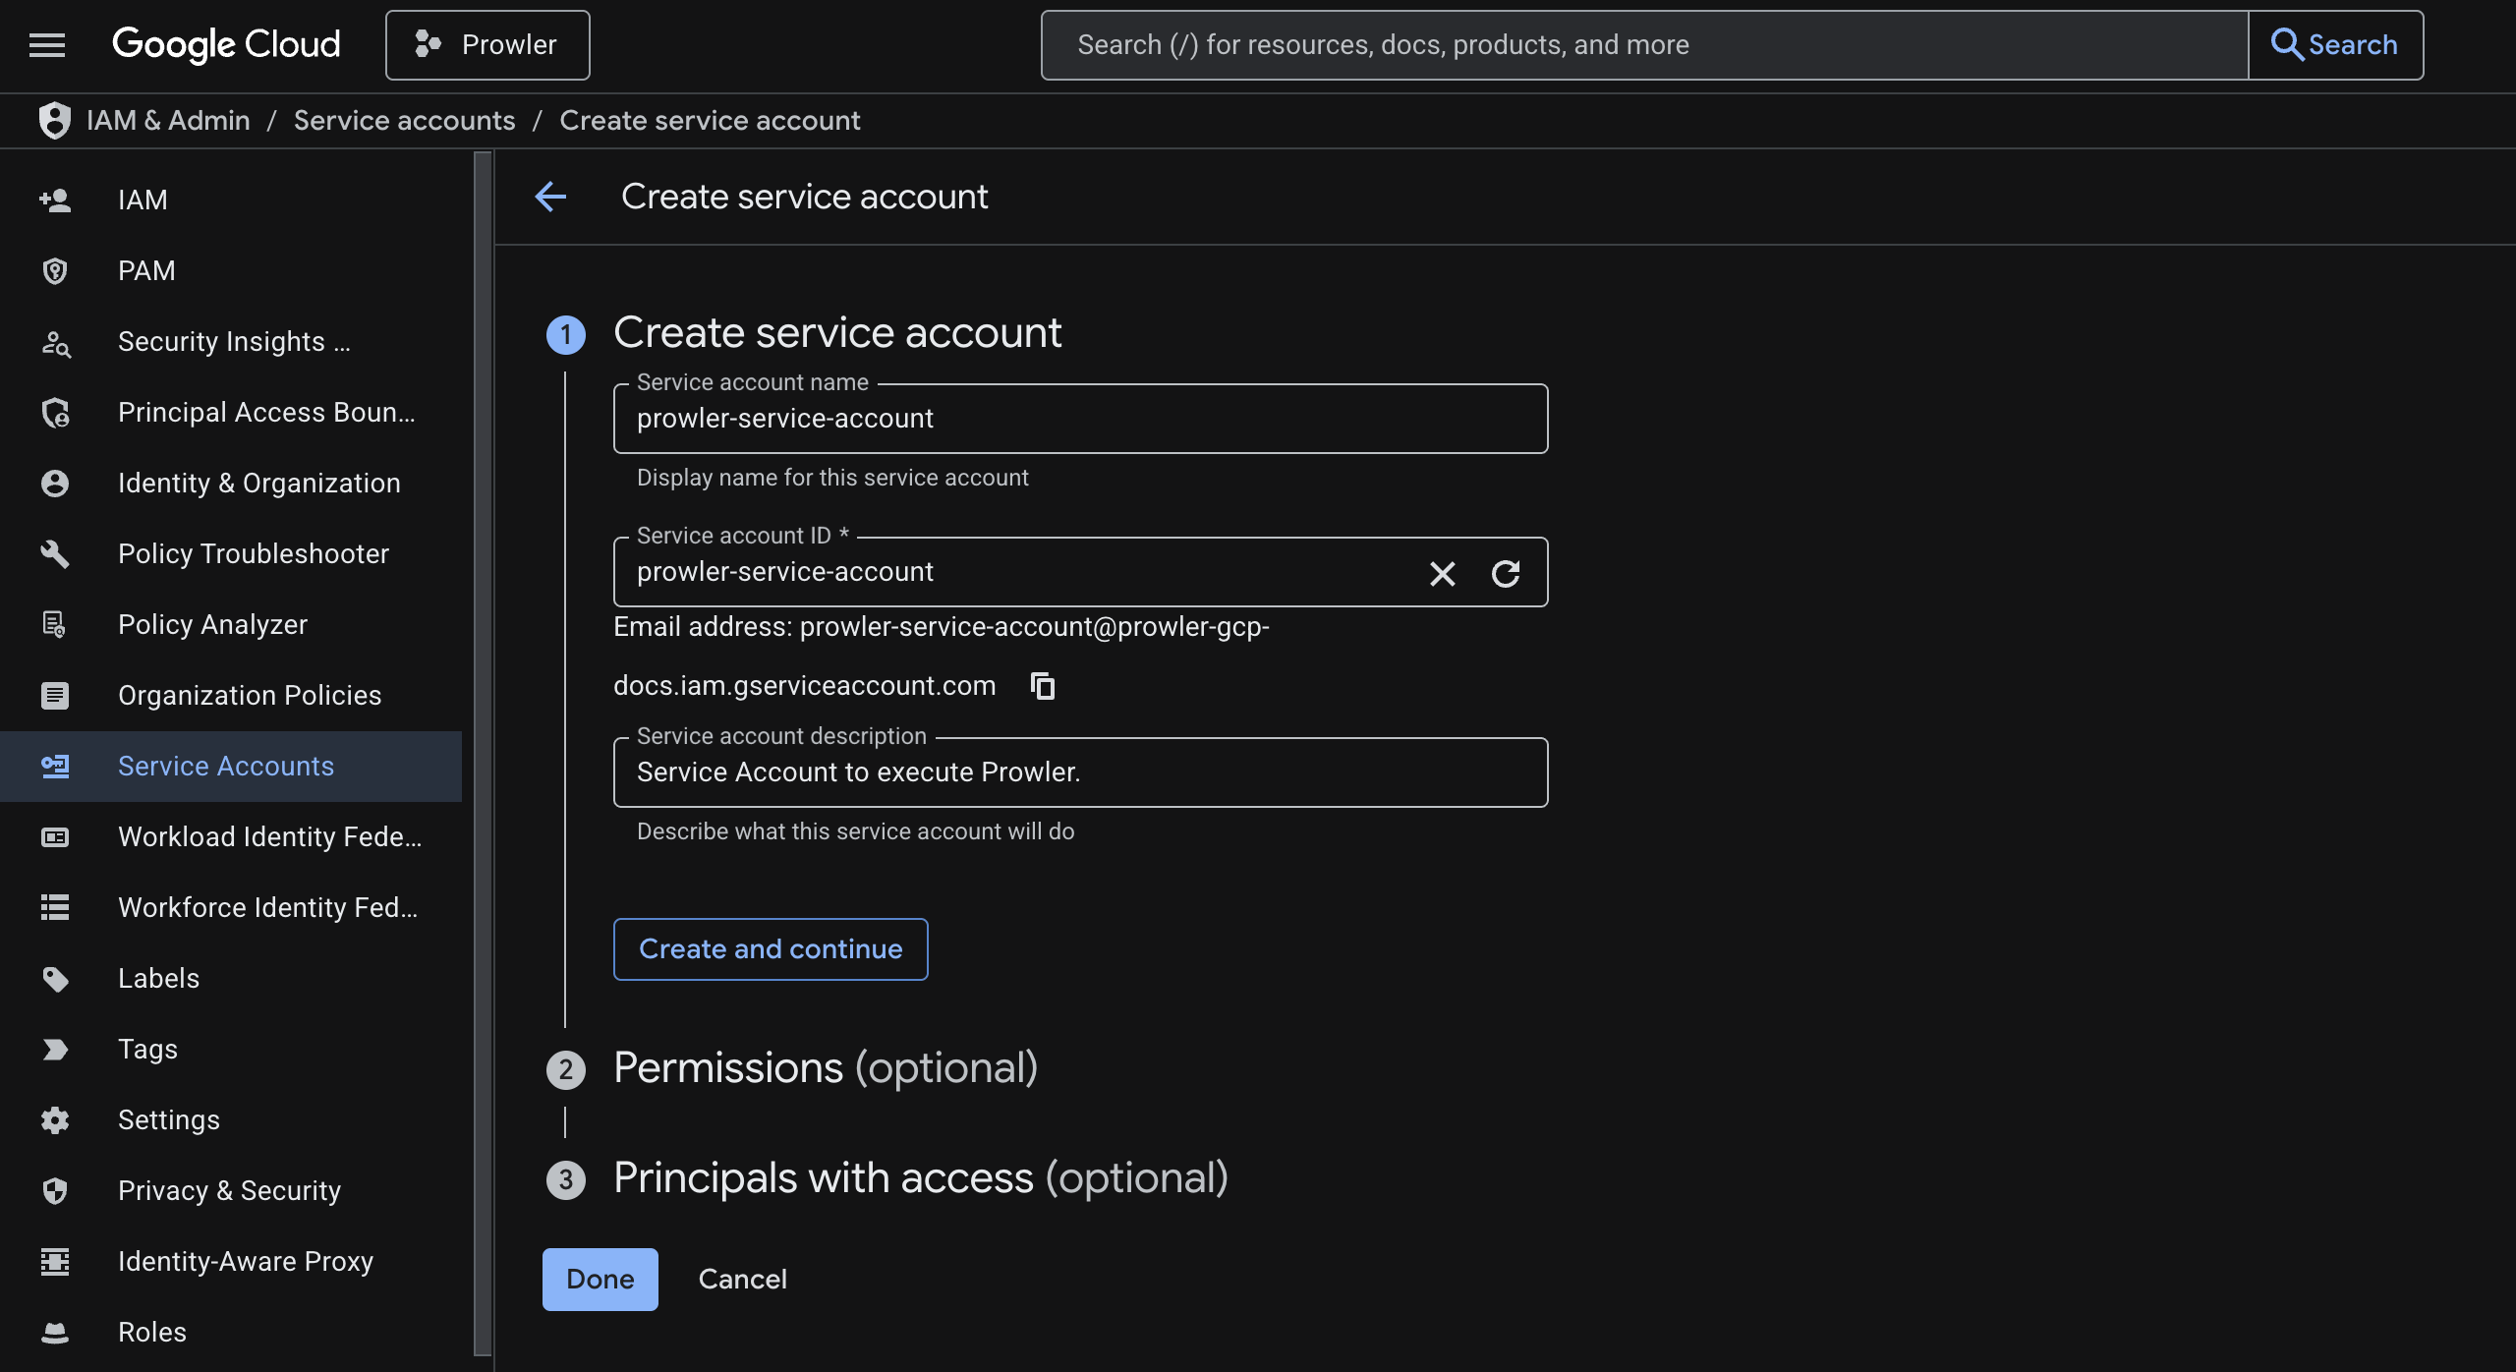
Figure: Creating a Service Account in the GCP Console

5. Assign IAM Permissions
The assessment team requires read-only permissions. Assign the standard 'Viewer' and 'Service Usage Consumer' roles to the service account.
Run these commands to bind the roles to the service account, or assign them under the 'Grant access' dialog in IAM:
gcloud projects add-iam-policy-binding <YOUR_PROJECT_ID> --member="serviceAccount:security-audit-sa@<YOUR_PROJECT_ID>.iam.gserviceaccount.com" --role="roles/viewer"
gcloud projects add-iam-policy-binding <YOUR_PROJECT_ID> --member="serviceAccount:security-audit-sa@<YOUR_PROJECT_ID>.iam.gserviceaccount.com" --role="roles/serviceusage.serviceUsageConsumer"
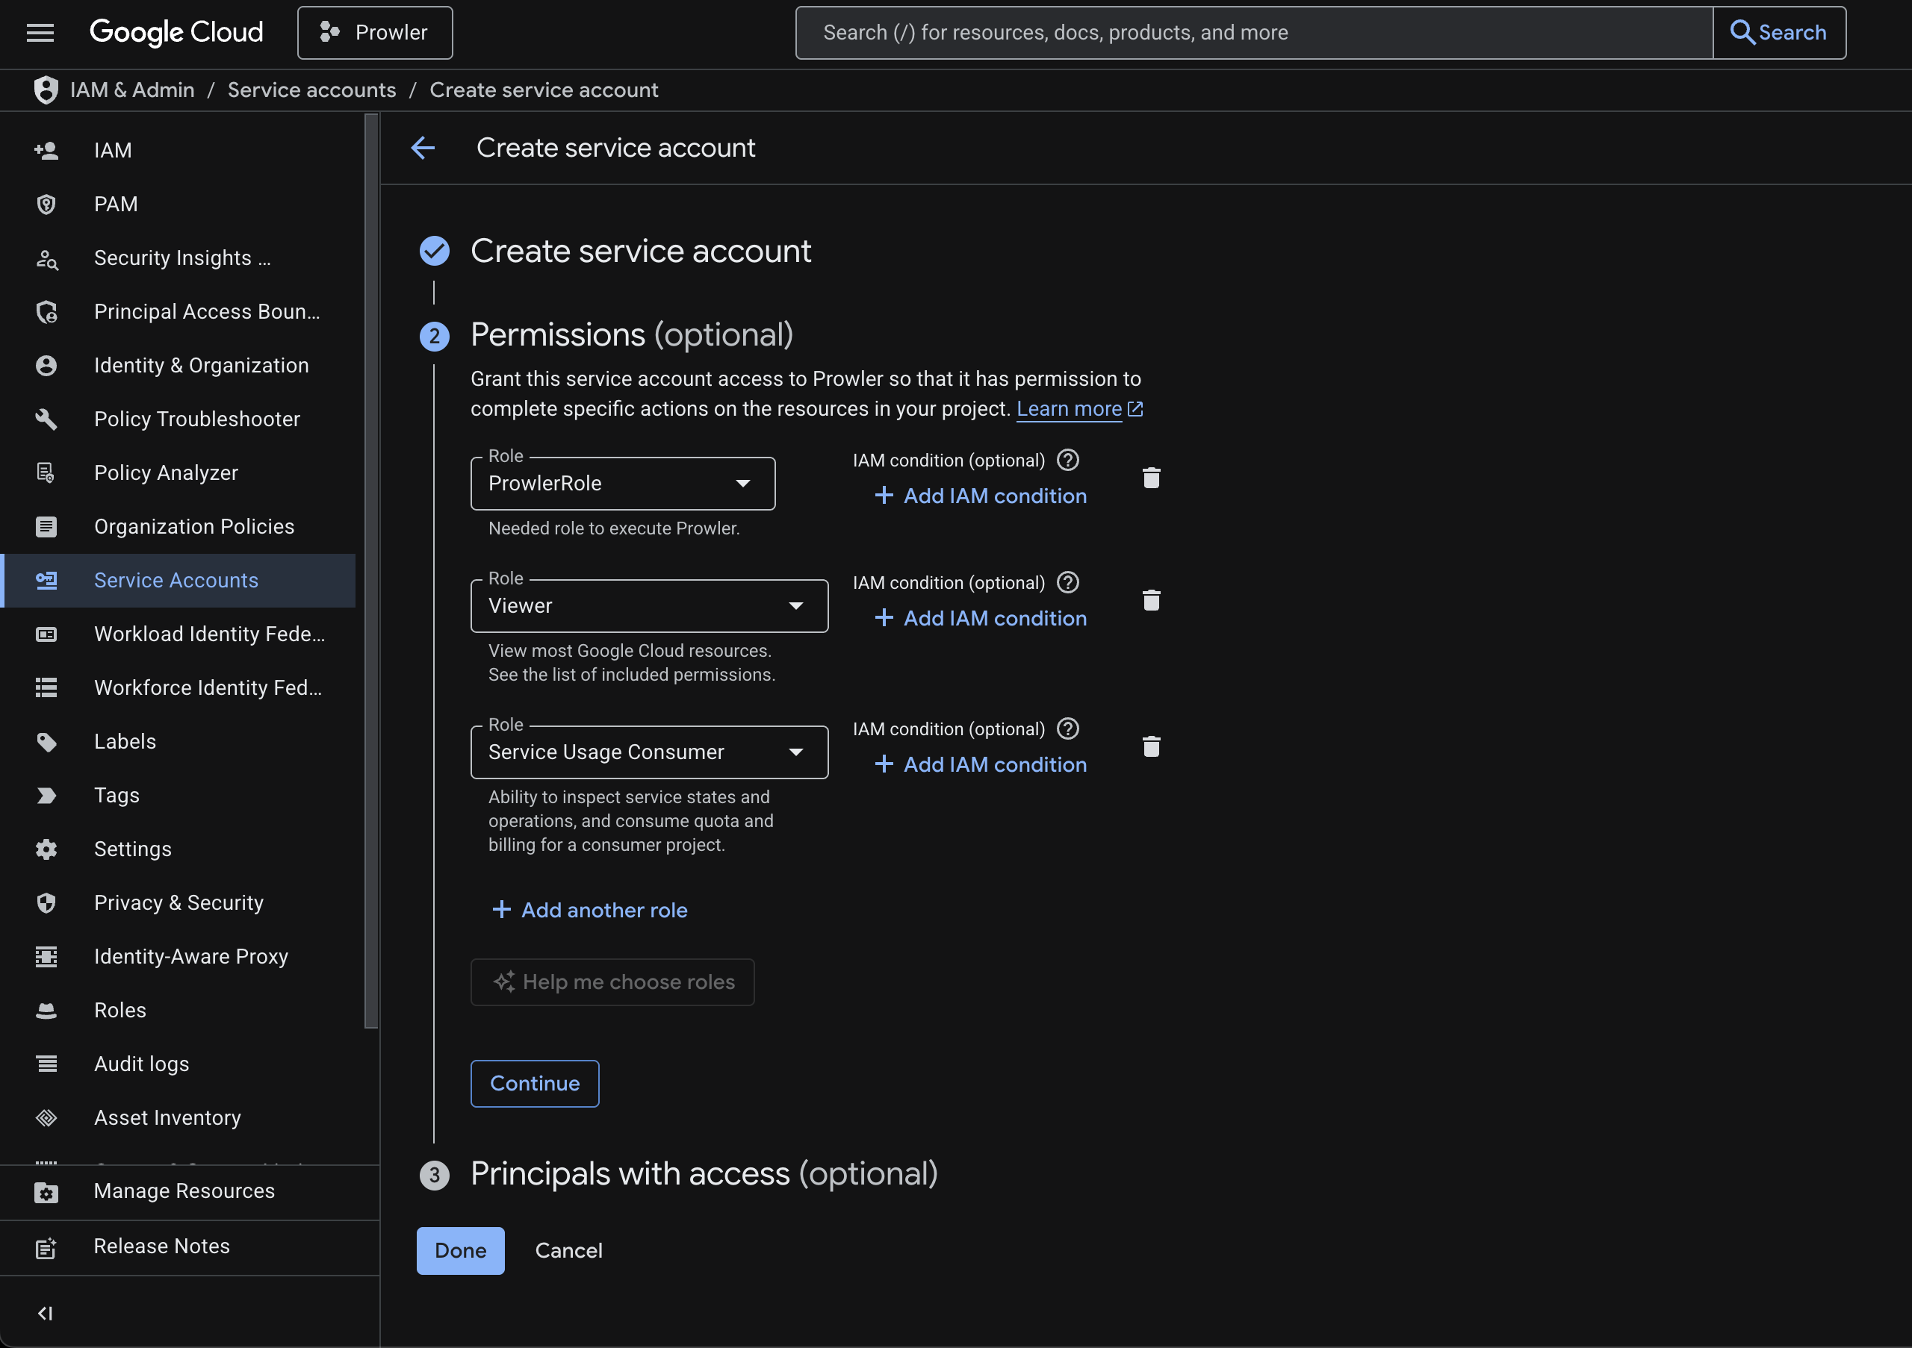
Figure: Assigning IAM Roles and Permissions in GCP
Important: Replace <YOUR_PROJECT_ID> in all commands with your actual GCP Project ID.

6. Generate JSON Key Credentials
You must generate and download a JSON key file for the service account to provide to the assessment team.
Navigate to the Keys tab under the service account details, click 'ADD KEY', and select 'Create new key':
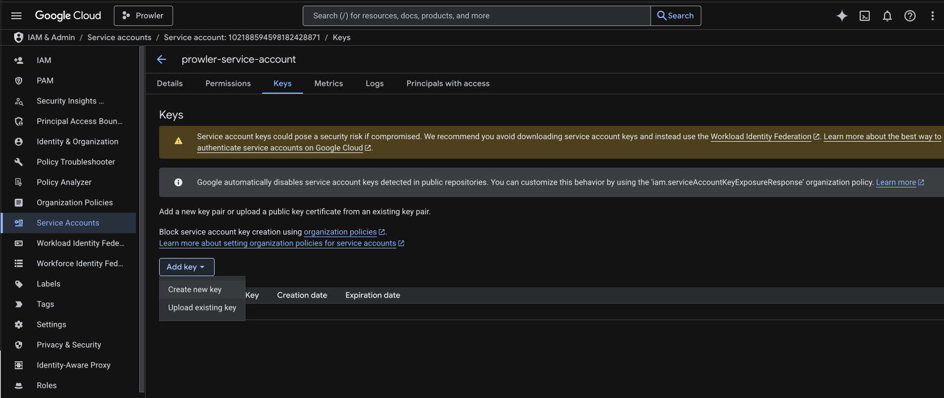
Figure: Adding a Key to the Service Account
Select JSON as the format and click 'CREATE':
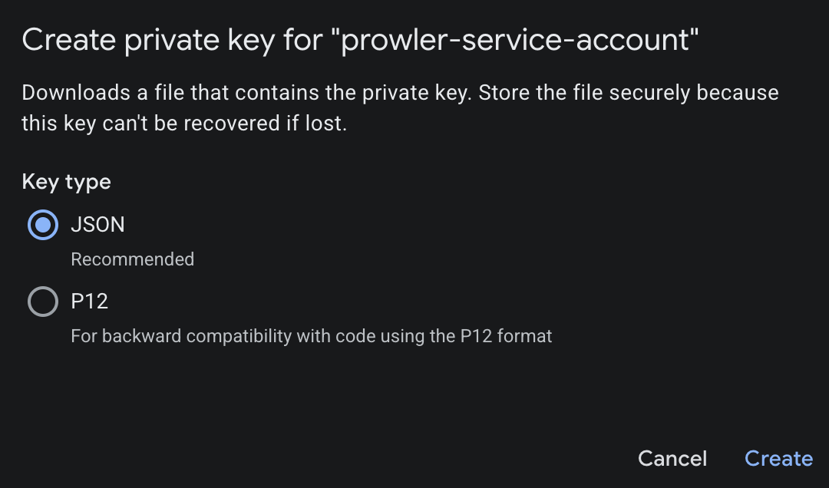
Figure: Selecting the JSON Key Format
Alternatively, run the following command to generate the key:
gcloud iam service-accounts keys create security-audit-key.json --iam-account=security-audit-sa@<YOUR_PROJECT_ID>.iam.gserviceaccount.com
This downloads a file named 'security-audit-key.json' to your current working directory. Share this file securely with the security assessment team.

