*1. SOFA

**SOFA DOONA**

$2200

##### **Price does not include VAT**

* Material: Wood, fabric
* Color: Many colors
* Origin: Imported
* Warranty: 100% brand new, 1 year warranty
* Available Left Arm (shown) or Right Arm

**SOFA DORA**

$2400

##### **Price does not include VAT**

* Material: Wood, fabric
* Color: Many colors
* Origin: Imported
* Warranty: 100% brand new, 1 year warranty
* Available Left Arm (shown) or Right Arm

**SOFA LADO**

$1750

##### **Price does not include VAT**

* Material: Wood, fabric
* Color: Many colors
* Origin: Imported
* Warranty: 100% brand new, 1 year warranty
* Available Left Arm (shown) or Right Arm

**SOFA LEVIS**

$1900

##### **Price does not include VAT**

* Material: Wood, fabric, inox
* Color: Many colors
* Origin: Imported
* Warranty: 100% brand new, 1 year warranty
* Available Left Arm (shown) or Right Arm

**SOFA MASA**

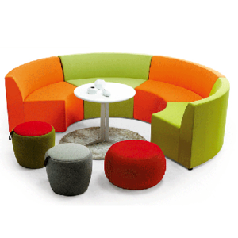

$1930

##### **Price does not include VAT**

* Material: Wood, fabric
* Color: Many colors
* Origin: Imported
* Warranty: 100% brand new, 1 year warranty
* Available Left Arm (shown) or Right Arm

**SOFA MIXO**

$1830

##### **Price does not include VAT**

* Material: Wood, fabric, inox
* Color: Many colors
* Origin: Imported
* Warranty: 100% brand new, 1 year warranty
* Available Left Arm (shown) or Right Arm

**SOFA POLI**

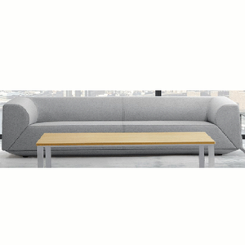

$2004

##### **Price does not include VAT**

* Material: Wood, fabric,inox
* Color: Many colors
* Origin: Imported
* Warranty: 100% brand new, 1 year warranty
* Available Left Arm (shown) or Right Arm

**SOFA RON**

$1850

##### **Price does not include VAT**

* Material: Wood, fabric,inox
* Color: Many colors
* Origin: Imported
* Warranty: 100% brand new, 1 year warranty
* Available Left Arm (shown) or Right Arm

**SOFA WIKO**

$1200

##### **Price does not include VAT**

* Material: Wood, fabric,inox
* Color: Many colors
* Origin: Imported
* Warranty: 100% brand new, 1 year warranty
* Available Left Arm (shown) or Right Arm