Case Number: 2729-473-2016

To the OSIRIS Police Organization and any authorized Detective of OSIRIS Investigative Services.

I there by make an Affidavit to the incident of Murder or Death of Candice Deyte, who was a Presidential Candidate, and had “Collapsed mid stride on stage of OSIRIS Studios” as said by the witnesses present at the location.

It was said that she had been there to give a speech on an Influenced Hacker “Pat Rogers”.

The physical forensic reports and another proof that is the smart watch she was wearing during the incident, both state the fact that she had died due to a heart attack which was caused by excess stress and the trauma of an incident relating to her opponent.

When the two suspects, Chris Snell and Meghan Rowley were asked to comment on the incident, they however refused, thereby **increasing the percentage of them being involved in the case.**

Investigation Proofs:

After going to her own website that is <http://voteforme.csaw.io/> and scrolling down till the end, we see another related link under “Connect” - <http://fedlink.csaw.io/>. Here we are able to recognize that this is a LinkedIn for the feds where we can view their profiles.

By using a bit of recon, we come to know that there are 100 profiles and of those 100, we identify that 3 emails are ending with “@gmail.com” domain whereas the rest comprise of a “@usss.dhs.gov”.

These 3 emails belong to Chris Snell, Meghan Rowley and Candice Deyte herself.

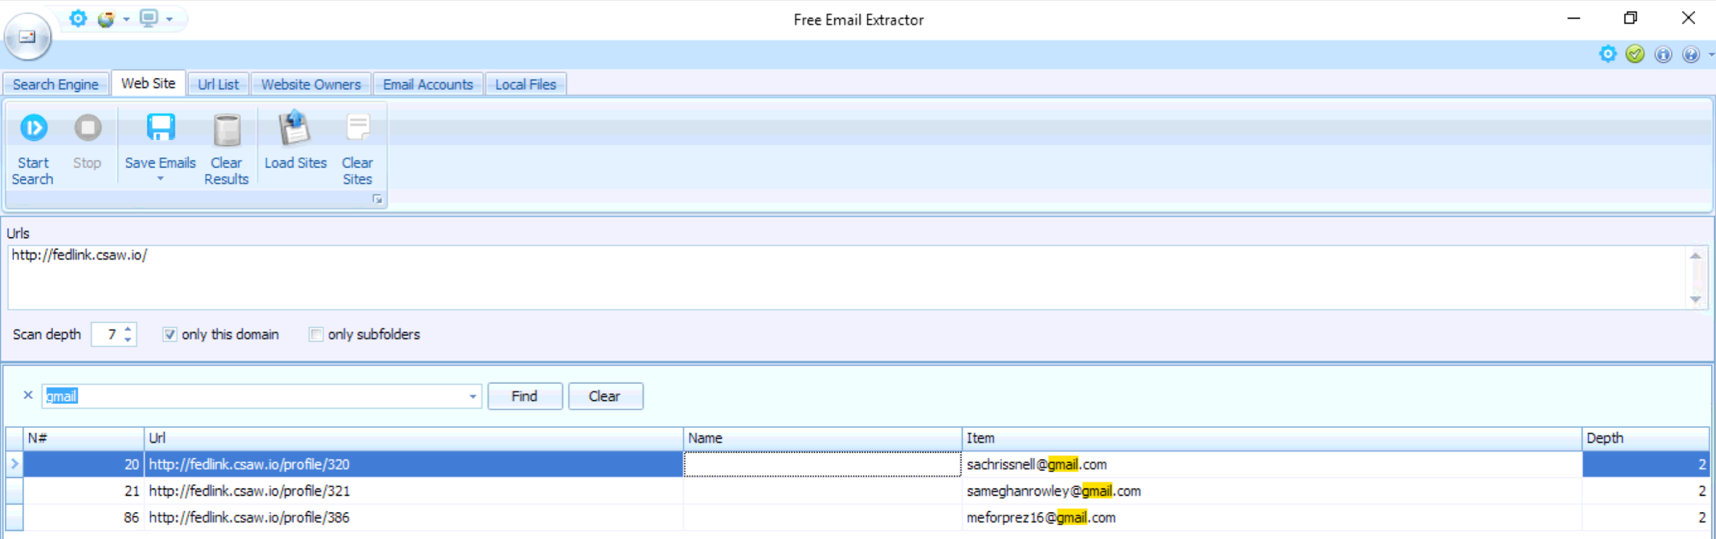

URLs:

<http://fedlink.csaw.io/profile/320>

<http://fedlink.csaw.io/profile/321>

<http://fedlink.csaw.io/profile/386>

Emails:

[sachrissnell@gmail.com](mailto:sachrissnell@gmail.com)

[sameghanrowley@gmail.com](mailto:sameghanrowley@gmail.com)

[meforprez16@gmail.com](mailto:meforprez16@gmail.com)

Looking at these emails we found a common starting with ‘sa’ in both email addresses (of Chris Snell and Meghan Rowley) which might be a short form of "SECRET AGENTS" or " Société Anonyme" (which means an anonymous company).

This makes a relation between Meghan Rowley and Chris Nell.

Furthermore, if we go deeper and try to check if those emails are valid, we went to <https://tools.verifyemailaddress.io/> and wrote down both of the emails. The email addresses did exist as according to the website.

We tried to check the recovery methods of Meghan and Chris’s gmail accounts, we come to the fact that they both have a phone number ending with 19. As displayed by the google phone verification page – “••••••••19”

Page Source materials:

If we go into the page source of the website <http://voteforme.csaw.io/> and view page source (included in developer tools) and scroll down a bit, we see an html comment which is having a URL "fedlocker.csaw.io". This then takes us to another website namely “FEDLocker”. Then again when inspect the source of the website "http://fedlocker.csaw.io" we see a comment saying "aVolition" and "in sqlmap we trust" which gives us a hint that we need/have find a vulnerability in the website SQL database using the python script sqlmap.