**TEMPERATUE BASED FAN SPEED CONTROL SYSTEM**

Project Synopsis Report submitted in partial fulfilment of

The requirements for the degree of

BACHELOR OF TECHNOLOGY

In

COMPUTER SCIENCE & ENGINEERING

Of

MAULANA ABUL KALAM AZAD UNIVERSITY OF TECHNOLOGY

By

ROHAN TIWARI, Roll no – 10900115075

SOUJANYA RAY, Roll no – 10900115094

SOUMYA GHOSH, Roll no - 10900115097

SOUMYADEEP DEWAN, Roll no - 10900115097

SUBHADEEP GHOSH, Roll no – 10900115102

SAUNAK DAS, Roll no - 10900116010

Under the guidance of

Mr. Rictor Bhowmick

DEPARTMENT OF

COMPUTER SCIENCE & ENGINEERING



**NETAJI SUBHASH ENGINEERING COLLEGE**

**TECHNO CITY, GARIA, KOLKATA – 700 152**

Academic year of pass out - 2018-19

**Certificate**

This is to certify that this project report **Temperature Based Fan Speed Control System**

submitted in partial fulfilment of requirements for award of the degree Bachelor of Technology (B. Tech) in computer science and engineering of Maulana Abul Kalam Azad University of Technology is a faithful record of the original work carried out by,

**Rohan Tiwari**, **Roll no**.-10900115075, **Regd. No.**-151090110076

**Soujanya Ray**, **Roll no**.-10900115094, **Regd. No.**-151090110095

**Soumya Ghosh**, **Roll no**.-10900115097, **Regd. No.**-151090110098

**Soumyadeep Dewan**, **Roll no**.-10900115098, **Regd. No.**- 151090110099

**Subhadeep Ghosh**, **Roll no**.-10900115102, **Regd. No.**- 151090110103

**Saunak Das**, **Roll no**.-10900116010, **Regd. No.**-

under my guidance and supervision.

--------------------------------------

*(signature of Project guide)*

**Rictor Bhowmick**

Assistant Professor

CSE Department

Netaji Subhas Engineering College.

Garia, Kolkata - 700152

**Acknowledgement**

We take this opportunity to express our profound gratitude and deep regards to our mentor **Mr.** **Rictor Bhowmick** for his exemplary guidance, monitoring and constant encouragement throughoutthe course of this project. The blessing, help and guidance given by him time to time shall carry us a long way in the journey of life on which we are about to embark.

We are obliged to our project team members for the valuable information provided by them in their respective fields. We are grateful for their cooperation during the period of our assignment.

*(Names of all the members of the Project group)*

1. **Rohan Tiwari**
2. **Soujanya Ray**
3. **Soumya Ghosh**
4. **Soumyadeep Dewan**
5. **Subhadeep Ghosh**
6. **Saunak Das**

*(Signatures of all the members of the Project group)*

**1.**

**2.**

**3.**

**4.**

**5.**

**6.**

**Abstract**

In day to day, there are various necessities of common man. Internet of Things is going to play a vital role in applications such as smart home, smart cities, Industrial internet, healthcare systems etc. In this paper, we are presenting the module developed for controlling fan speed based on room temperature and also accessing temperature remotely through cloud. Temperature of the room can be sensed by using DHT11 temperature sensor. If the temperature is low then fan rotates slowly and vice-versa. Temperature of a particular room can be found from anywhere using DHT11 sensor and hosting on cloud. The proposed approach is accurate in terms of processing time, less circuit size, no external clock required and programming an Arduino is easy when compared to 8051 microprocessors. The developed approach is benefited in terms of preventing the waste of energy when it is not hot enough to use a fan and assist the disabled to switch on or off fan automatically. Experimental evaluation shows that the proposed approach is accurate and also takes less time

**Content**

***Chapter name Page no***

1. Introduction

2. Equipment

3. Circuit Diagram

4. Project Flow

5. Test Case

6. Conclusion

7. References

**Introduction**

In these days everything is being automated and smarter. A microcontroller is used to make a thing smart. A microcontroller called Arduino is used to control and automate processes. It is a single chip that executes code. This paper displays the one of the outputs which is the speed of fan using Pulse Width Modulation (PWM) on 16x2 LCD. A sensor called DHT11 is used to sense the temperature so as to vary the fan speed. To sense temperature from a particular place, connect the ESP8266 Wi-Fi module to the Arduino board. So the sensed temperature will be stored in cloud and we can be viewed from some other place.

This paper represents a module in the home automation system. This is used for reducing the power consumption. A micro controller called Arduino Uno board is used to control all the functions. In this paper, we are going to sense the room temperature using DHT11 sensor. This sensed temperature is used for controlling the fan speed. If the temperature is low then fan rotates slowly and if temperature is high then fan rotates speedily. If the temperature is less than 25 degrees centigrade then fan automatically off. If the temperature is less than or equal to 30 degrees centigrade then fan rotates with 20% speed and if temperature is less than or equal to 35 degrees centigrade then fan rotates with 40% speed. If the temperature is less than or equal to 40 degrees centigrade then fan rotates with 60% speed. If the temperature is less than or equal to 45 degrees centigrade then fan rotates with 80% speed and if the temperature is more than 45 degrees centigrade then fan rotates with 100% speed. We display the temperature of a particular place from another place using cloud. For this, we are used DHT11 sensor and a ESP8266 Wi-Fi module.

**Equipment**

* **NodeMCU (ESP8266) :**

ESP8266 module is a device which is interfaced with the Arduino board gives the Wi-Fi ability which works similar to Wi-Fi shield. It works with AT command set. This module has a powerful on-board processing and storage capability that allows it to be integrated with the sensors and other application through its GPIOs.



Below table gives NodeMCU Dev Kit IO pins and ESP8266 internal GPIO pins mapping

| **Pin Names on NodeMCU Development Kit** | **ESP8266 Internal GPIO Pin number** |
| --- | --- |
| D0 | GPIO16 |
| D1 | GPIO5 |
| D2 | GPIO4 |
| D3 | GPIO0 |
| D4 | GPIO2 |
| D5 | GPIO14 |
| D6 | GPIO12 |
| D7 | GPIO13 |
| D8 | GPIO15 |
| D9/RX | GPIO3 |
| D10/TX | GPIO1 |
| D11/SD2 | GPIO9 |
| D12/SD3 | GPIO10 |

* **DHT11 :**

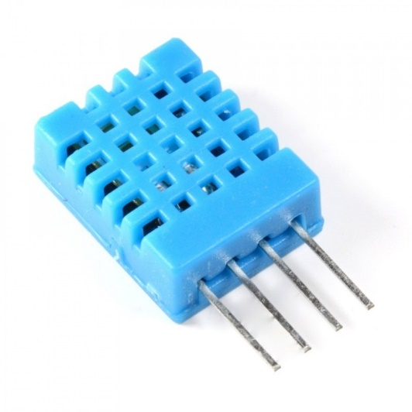DHT11 Temperature & Humidity Sensor features a temperature & humidity sensor complex with a calibrated digital signal output. By using the exclusive digital-signal-acquisition technique and temperature & humidity sensing technology, it ensures high reliability and excellent long-term stability. This sensor includes a resistive-type humidity measurement component and an NTC temperature measurement component, and connects to a high performance 8-bit microcontroller, offering excellent quality, fast response, anti-interference ability and cost-effectiveness.

Each DHT11 element is strictly calibrated in the laboratory that is extremely accurate on humidity calibration. The calibration coefficients are stored as programmes in the OTP memory, which are used by the sensor’s internal signal detecting process. The single-wire serial interface makes system integration quick and easy. Its small size, low power consumption and up-to-20-meter signal transmission making it the best choice for various applications, including those most demanding ones. The component is 4-pin single row pin package. It is convenient to connect and special packages can be provided according to users’ request.

Features:

* Low cost
* 3 to 5V power and I/O
* 2.5mA max current use during conversion (while requesting data)
* Good for 20-80% humidity readings with 5% accuracy
* Good for 0-50°C temperature readings ±2°C accuracy
* No more than 1 Hz sampling rate (once every second)
* Body size 15.5mm x 12mm x 5.5mm
* 4 pins with 0.1" spacing

**Circuit Diagram**

**Project flow**

The overall work is a two-step process. In the first step, fan speed is being controlled based on the temperature at current location. In the second step, temperature is displayed through cloud. Cloud based accessing is used most frequently by the officials in the industries. Initially the fan rotates with 100% speed. After sensing the temperature of the room, the fan rotates accordingly. We use a software called Arduino IDE through which we can easily write code and upload this code on to the Arduino board.

The output of this part is variation of the fan speed with respect to the change in temperature and display it on the LCD screen. The part of the project is displaying the temperature of a particular place from somewhere else. In this module a sensor called DHT11 has been placed. Then

we create a account in ThingSpeak.com. These details are

given in the algorithm which displays the output in

ThingSpeak website in the form of graphs.

Algorithm1:

Input:

i)power supply:- 9v battery

ii)temperature:- sensed value

Desired output:

LCD will display the temperature along with the speed of the

fan.

Method:

Pwm<- 9

startSetup()

analogWrite(0,255)

end Setup()

startloop()

temp<-DHT.temperature

if(temp<=20)

analogWrite(9,0)

speed=20%

else if(temp<=25)

analogWrite(pwm,51)

speed=40%

else if(temp<=30)

analogWrite(pwm,102)

speed=60%

else if(temp<=35)

analogWrite(pwm,153)

speed=80%

else

analogWrite(pwm,255)

speed=100%

end loop()

Algorithm2:

Input:

i) SSID, password.

ii)temperature:- sensed value

Desired output:

The sensed temperature is displayed on the website called

ThingSpeak

Method:

loop()

humidity <- DHT.humidity;

temperature <- DHT.temperature;

cmd = "AT+CIPSTART=\"TCP\",\"";

cmd <- cmd + "184.106.153.149";

cmd <- cmd+ "\",80";

end loop()

Description of algorithm1:

Read the room temperature by using a sensor called DHT11. If

temperature is less than 20 then set pin to 9 and value to 0 in

analogWrite, display fan off, else if temperature is less than or

equal to 25 then set pin to PWM and value to 51 in

analogWrite, display fan speed=25%, else if temperature is

less than or equal to 30 then set pin to PWM and value to 102

in analogWrite, display fan speed=40%, else if temperature is

less than or equal to 35 then set to pin to PWM and value to

153 analogWrite, display fan speed=60% else if temperature is

less than or equal to 40 then set pin to PWM and value to 204

in analogWrite and display fan speed=80%, else if set pin to

PWM and value to 255 in analogWrite and display fan

speed=100%.

Description for algorithm2:

The SSID and password of the Wi-Fi are given as input. The

humidity and temperature are sensed using DHT11 sensor.

The sensed data will be send to cloud by using the IP address

of the ThingSpeak Website.

IV. EXPERIMENTAL EVALUATION

The microcontroller used in this system has a PWM

module which is used to control fan speed by the change of duty

cycle. According to the values that are sensed by the sensor duty

cycle will be changed automatically thus controlling fan speed.

The Table 1 contains the duty cycles varying with the sensed

temperature.

Table 1: Duty c

**Test Case**

The microcontroller used in this system has a PWM module which is used to control fan speed by the change of duty cycle. According to the values that are sensed by the sensor duty cycle will be changed automatically thus controlling fan speed. The Table 1 contains the duty cycles varying with the sensed temperature.

|  |  |  |  |
| --- | --- | --- | --- |
| **S. No** | **Temperature in** | **Duty** | **Speed** |
|  | **Celsius** | **cycle%** |  |
|  |  |  |  |
| 1 | <=20 | 0 | 0 |
| 2 | <=25 | 20 | 20 |
| 3 | <=30 | 40 | 40 |
| 4 | <=35 | 60 | 60 |
| 5 | <=40 | 80 | 80 |
| 6 | <=45 | 100 | 100 |

***Table 1: Duty cycle and Temperature***

The variation of the duty cycle with temperature is shown in Fig. The fan rotates with full speed when duty cycle is 100% and varies accordingly due to temperature changes.

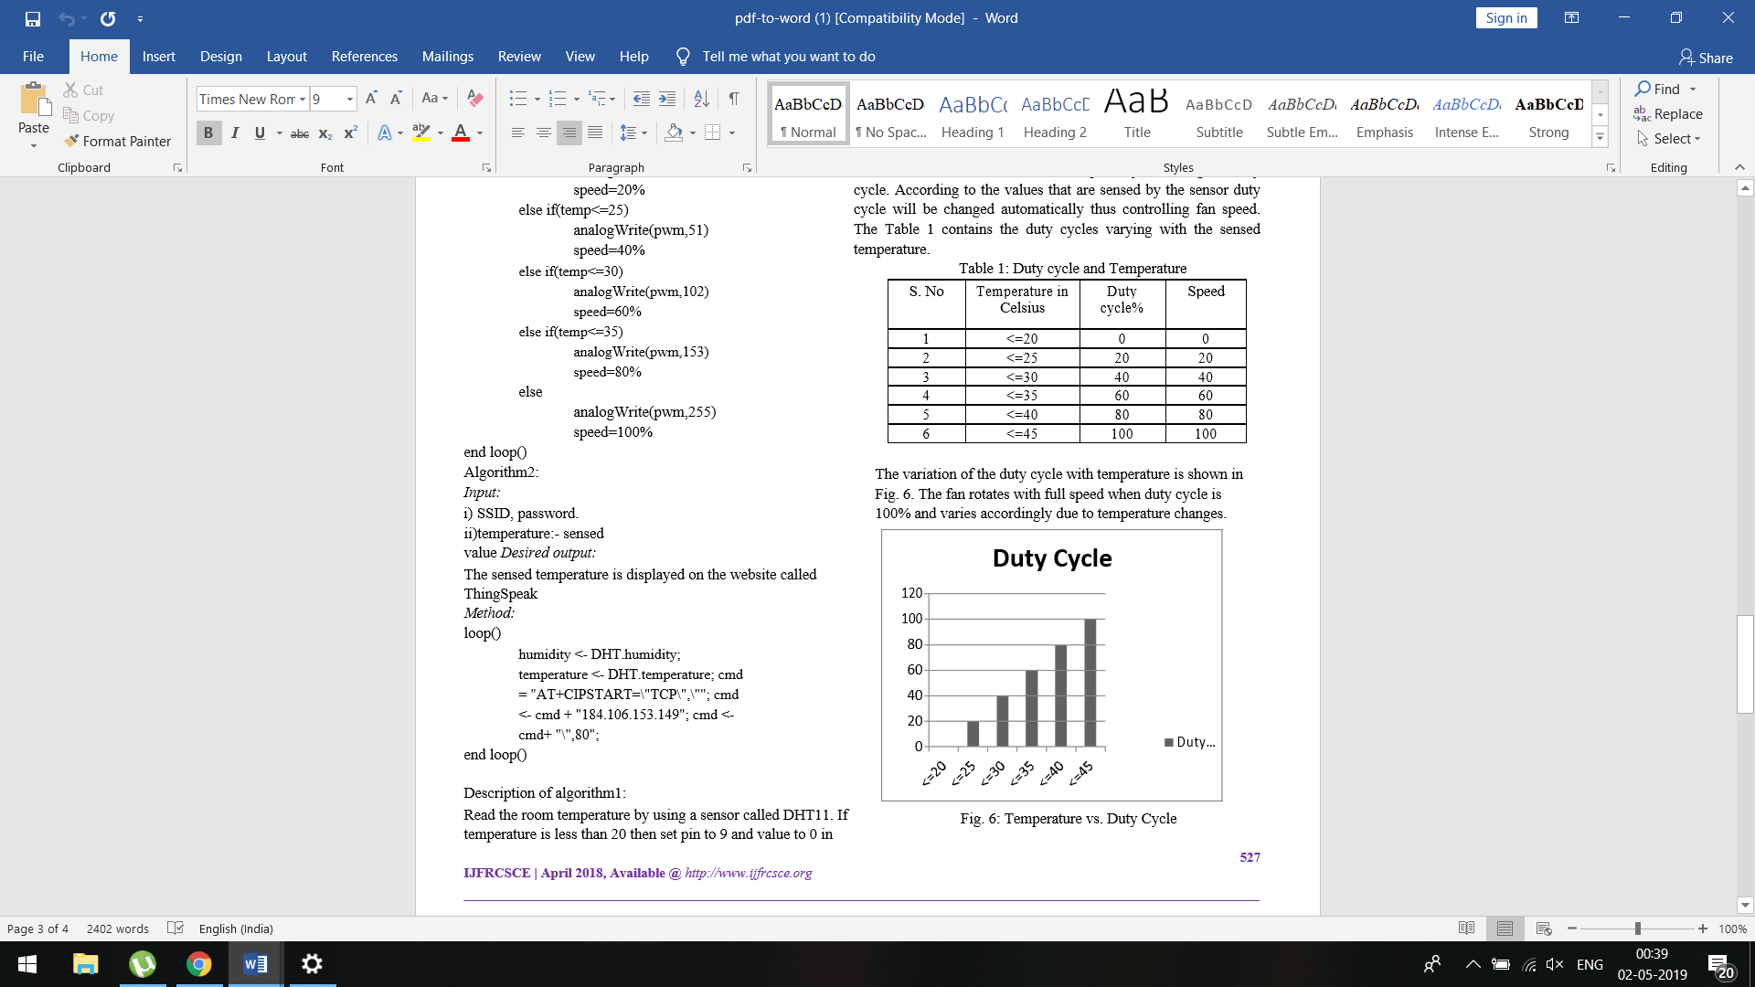

***Fig: Temperature vs. Duty Cycle***

This project requires two inputs such as power supply and temperature.

1. Power supply: Power supply is the basic need for any electric circuit. Here this work uses 5v dc battery to give power to Arduino and sometimes we can give power directly from the system.
2. Temperature: As this project mainly focuses on temperature, the input is taken from a sensor called DHT11. Output: According to this paper, after building the circuit we test it. The output of the project is the temperature that is sensed and the speed of the fan which will vary according to the room temperature.

In Table 2, the proposed work has been tested and the values are recorded accordingly. The sensed temperature represents the value that is sensed by the sensor and the fan speed represents the speed of the fan that changes with respect to the sensed temperature.

|  |  |  |
| --- | --- | --- |
| **S. No** | **Sensed temperature** | **Fan Speed** |
|  |  |  |
| 1 | 23 | 10% |
| 2 | 22 | 10% |
| 3 | 26 | 20% |
| 4 | 27 | 20% |
| 5 | 21 | 10% |
| 6 | 20 | 10% |

***Table 2: Sensed temperature and fan speed***

**Conclusion**

An efficient fan controller based on room temperature by using Arduino board has been developed. Output was checked by setting the temperature at different levels and it was found that the fan speed changes accordingly. It is very useful to the people who are disabled. There is much future scope for this work. The designed circuit can be used in many practical applications, where the circuit can be connected to a device whose temperature has to be controlled at a particular value. For example, a water tank with heater whose temperature can set to a desired value. In future the designed circuit can be connected to a GSM module so that it can be used in industrial areas when a machine crosses its desired temperature. We can send a message to the control room so that the damage of the machine can be avoided.

**References**

* Vaibhav Bhatia, Gavish Bhatia, “Room Temperature based Fan speed control system using Pulse Width Modulation Technique”, International Journal of Computer Applications, Volume 811-No5, November 2013.
* Gokul Ashok Nanmaran ,Neha Shivhare, Aparna A, Kayalvizhi Jayavel, “An Automatic Fan Speed Controller Leveraging Internet Of Things”, IJREAT, Volume 3, Issue 4, Aug-Sept,2015 ISSN:2320-8791.
* Subhankar Chattoraj, ”Smart home Automation based on different sensors and arduino as the master controller”, International Journal Of Scientific and Research Publications,Volume 5, Issue 10, Oct.2015 ISSN 2250-3153.
* Daniel Popescu, Calin Ciufudean, “Automatic Temperature Control of Thermal Agent in Heating Installations of Buildings”, 2017 International Conference on Optimization of Electrical and Electronic Equipment (OPTIM) & 2017 Intl Aegean Conference on Electrical Machines and Power Electronics (ACEMP),25-27 May 2017.
* Ananya Roy, Prodipto Das, Rajib Days”, Temperature and humidity monitoring system for storage rooms of industries”,2017 International Conference on Computing and Communication Technologies for Smart Nation (IC3TSN), 12 -14 Oct. 2017.
* Jingyi Du, Jinbao Guo, Dandan Xu, Qiong Haung,” A remote monitoring system of temperature and humidity based on OneNet cloud service platform,” 2017 IEEE Electrical Design of Advanced Packaging and Systems Symposium (EDAPS), 14 -16 Dec. 2017.