Project Report 1
SG90 Servo Motor Interfacing with STM32
Course: Microprocessor & Embedded System,Section:08
Name: Mobussira Tasnim Pushpita
ID:2311032042
Note: SG90 is an actuator/peripheral device converts a PWM control signal into controlled angular motion.

1. Description and Working Principle
The SG90 is a small 9 g micro servo motor widely used in robotics, automation, camera positioning, and embedded control systems. Unlike a normal DC motor, it does not rotate continuously. Instead, it moves to a commanded angular position and can hold that position.
Internally, the SG90 contains a DC motor, reduction gears, a control circuit, and a feedback potentiometer. The potentiometer reports the shaft position to the internal controller. The controller compares the desired position with the actual position and drives the motor until both match.
The servo is controlled by PWM. A control pulse is repeated about every 20 ms, which means 50 Hz. In common operation, a pulse near 1.0 ms moves the shaft close to 0°, 1.5 ms moves it near 90°, and 2.0 ms moves it near 180°. The exact end positions may vary slightly from one servo to another.
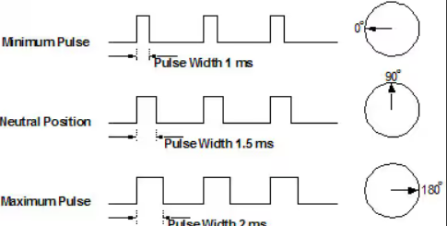

2. Pin Diagram and Pin Description
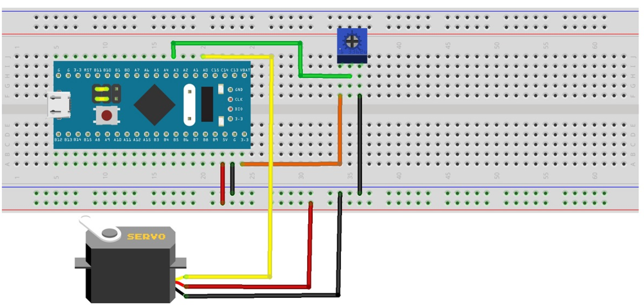
The SG90 has three wires for power and control.

Wire Color | Pin Name | Description
Brown / Black | GND | Connects to common ground
Red | VCC (+5V) | Supplies power to the servo motor
Orange / Yellow | Signal (PWM) | Receives the PWM control pulse from STM32

3. Connection with STM32
A timer PWM output pin of the STM32 is used to control the servo. A common lab setup is STM32F103C8T6 (Blue Pill) using PA0, which works as TIM2_CH1. The microcontroller generates the PWM signal and the SG90 interprets the pulse width to set its angle.
The servo should be powered from a stable 5 V source. The servo ground and STM32 ground must be connected together so that the signal has a proper reference.
SG90 Pin | STM32 Pin | Purpose
GND | GND | Common reference ground
VCC | 5V | Servo power supply
Signal | PA0 (TIM2_CH1) | PWM control output
Working idea: configure the timer for 50 Hz PWM and change the compare value (CCR) to vary pulse width and therefore servo angle.

4. Sample STM32 C Code (HAL)
#include "main.h"
extern TIM_HandleTypeDef htim2;
void Servo_SetAngle(uint8_t angle)
{
uint16_t pulse = 25 + ((100 * angle) / 180);
__HAL_TIM_SET_COMPARE(&htim2, TIM_CHANNEL_1, pulse);
}
int main(void)
{
HAL_Init();
SystemClock_Config();
MX_GPIO_Init();
MX_TIM2_Init();
HAL_TIM_PWM_Start(&htim2, TIM_CHANNEL_1);
while (1)
{
Servo_SetAngle(0);
HAL_Delay(1000);
Servo_SetAngle(90);
HAL_Delay(1000);
Servo_SetAngle(180);
HAL_Delay(1000);
}
}

5. Applications, Advantages and Limitation
- Applications: robotic arm, camera pan-tilt system, smart door system, and small automation projects.
- Advantages: simple 3-wire interface, accurate angle control, lightweight structure, and easy PWM-based operation.
- Limitation: standard SG90 has a limited rotation range and should not be used for heavy mechanical loads.

6. Conclusion
The SG90 servo motor is a low-cost and practical actuator for position control in embedded systems. By using an STM32 timer in PWM mode, the motor can be controlled accurately and repeatedly. Its simple interfacing and useful motion control make it an excellent choice for academic projects and beginner robotics systems.

7. References
- ControllersTech, “How to Control a Servo Motor with STM32 using PWM”- https://www.bing.com/ck/a?!&&p=d7f099f32c582ef7325da1d966c201ee3ac07a7ac2647119aa0fbe4706a33b79JmltdHM9MTc3NTAwMTYwMA&ptn=3&ver=2&hsh=4&fclid=0de28dc5-df1f-691f-07c4-9f02de1e68cc&psq=Controlling+a+Servo+Motor+with+STM32+Using+PWM+(Step-by-Step+Guide)&u=a1aHR0cHM6Ly9jb250cm9sbGVyc3RlY2guY29tL3NlcnZvLW1vdG9yLXdpdGgtc3RtMzIv
- YouTube video: https://youtu.be/WMS0t9WGqVw?si=ZXtakJOJucYzfCGY

