What Is the DHT11 Temperature and Humidity Sensor?
The DHT11 temperature and humidity sensor is a low-cost digital sensor used to measure ambient temperature and relative humidity in basic electronic projects. It is commonly used in beginner and educational applications because it combines two environmental measurements into one simple device.
The DHT11 sensor outputs digital data and is available as either a bare sensor or a small module for easy connection. It is best suited for basic environmental monitoring where simplicity and affordability are more important than high accuracy.

DHT11 Working Principle
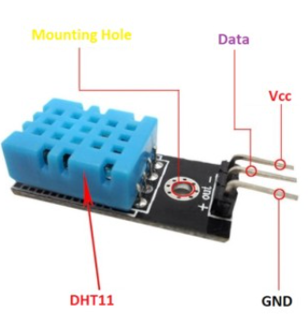
Figure 2: DHT11 Working Principle
The DHT11 sensor works by detecting changes in temperature and humidity using internal sensing elements. These signals are processed by an internal chip and converted into digital data. The sensor then sends the temperature and humidity readings to a microcontroller through a single-wire digital interface.

No | Pin Name | Use
1 | Vcc | Power supply 3.5V to 5.5V
2 | Data | Outputs both Temperature and Humidity through serial Data
3 | Ground | Connected to the ground of the circuit

DHT11 Specifications
• Sensor Type: Digital temperature and humidity sensor
• Operating Voltage: 3.3 V to 5 V DC
• Temperature Measurement Range: 0 °C to 50 °C
• Temperature Accuracy: ±2 °C
• Humidity Measurement Range: 20% to 90% RH
• Humidity Accuracy: ±5% RH
• Sampling Rate: One reading per second
• Application Scope: Suitable for basic, educational, and entry-level environmental monitoring applications

Installing the DHT11 Library
1. Open the Arduino IDE on your computer.
2. Go to Sketch → Include Library → Manage Libraries.
3. In the search bar, type DHT sensor library.
4. elect DHT sensor library by Adafruit and click Install.
5. Search for Adafruit Unified Sensor and install it as well.

Applications of DHT11 Sensor
• Basic temperature and humidity monitoring in indoor environments
• Educational and beginner electronics projects for learning sensor interfacing
• Simple weather monitoring systems to display room temperature and humidity
• Home automation projects such as fan or humidifier control based on environmental conditions
• Greenhouse and plant monitoring in small DIY setups
• Entry-level IoT applications using Arduino or ESP-based microcontrollers

Advantages and Limitations of DHT11

Advantages
• Low-cost temperature and humidity sensor suitable for beginner projects
• Digital output allows easy interfacing with Arduino and ESP-based boards
• Simple wiring and available in ready-to-use module form
• Widely supported with extensive documentation and tutorials

Limitations
• Limited accuracy compared to more advanced sensors
• Narrow temperature and humidity measurement range
• Slow sampling rate, not ideal for fast-changing environments
• Not suitable for professional or industrial applications
https://www.ic-components.com/blog/DHT11-Temperature-and-Humidity-Sensor-Pinout,Specifications,Wiring,andApplications.jsp#:~:text=What%20Is%20the%20DHT11%20Temperature%20and%20Humidity%20Sensor?,GND

Interfacing DHT11 Temperature & Humidity Sensor with STM32F103C8

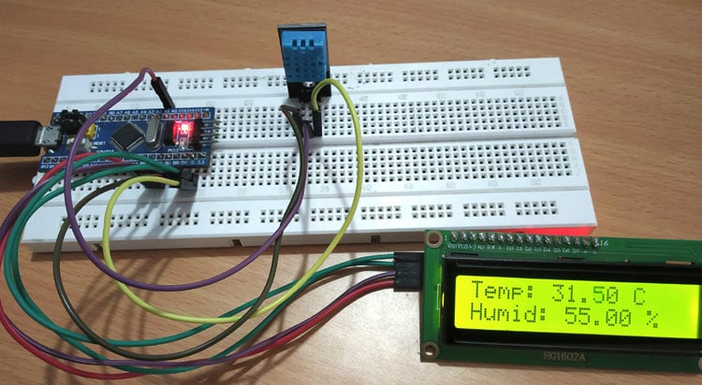

Components Required
- STM32F103C8
- DHT11 Temperature & Humidity Sensor
- 16x2 LCD Display
- IIC/I2C Serial Interface Adapter Module
- Breadboard
- Connecting Wires
As you can see, we have used an I2C interface module to connect the LCD module to STM32. This makes the connections simple and further reduces the number of pins used on the controller side. However if you do not have this module you can also interface LCD directly STM32 by following the link.
the circuit Connections between I2C Serial Interface Module (Fixed with 16X2 LCD Display) & STM32F103C8 is tabulated below:
the circuit Connections between STM32F103C8 and DHT11 Sensor is tabulated below.
DHT11 | STM32F103C8
VCC | 5V
GND | GND
Data | PA1

The entire set-up is powered by the USB port of STM32 from my laptop. Now that our hardware is ready, lets get into the coding part
- Sample C code for that sensors
#include <Wire.h> //Library for using I2C
#include <LiquidCrystal_I2C.h> //Library for using I2C type LCD display
#include <DHT.h> //Library for using DHT sensor
#define DHTPIN PA1
#define DHTTYPE DHT11
LiquidCrystal_I2C lcd(0x27, 16, 2); //initilize object lcd for class LiquidCrystal_I2C with I2C address of 0x27 and 16x2 type LCD display
DHT dht(DHTPIN, DHTTYPE); //initilize object dht for class DHT with DHT pin with STM32 and DHT type as DHT11
void setup()
{
// initialize the LCD
lcd.begin();
dht.begin(); //Begins to receive Temperature and humidity values.
lcd.backlight(); // Turn on the blacklight and print a welcome message.
lcd.setCursor(0,0);
lcd.print("CIRCUIT DIGEST");
lcd.setCursor(0,1);
lcd.print("DHT11 with STM32");
delay(3000);
lcd.clear();
}
void loop()
{
float h = dht.readHumidity(); //Gets Humidity value
float t = dht.readTemperature(); //Gets Temperature value
lcd.setCursor(0,0);
lcd.print("Temp: ");
lcd.print(t);
lcd.print(" C");
lcd.setCursor(0,1);
lcd.print("Humid: ");
lcd.print(h);
lcd.print(" %");
}

https://circuitdigest.com/microcontroller-projects/interfacing-dht11-sensor-with-stm32f103c8

