Manuscript submitted as a Research Article to Nature Plants

Domestication drove the divergent evolution of plant architecture beyond target traits
Emily Townley^{1,5}, Justin D. Stewart^{4,5,}, Gustavo Burin^{1,5}, Yves Caraglio^{2,5}, E. Toby Kiers⁴, Guillaume Chomicki¹
Affiliations: ¹Department of Bioscience, Durham University, South Rd., Durham DH1 3LE, UK. ²AMAP, University of Montpellier, CIRAD, CNRS, INRAE, IRD, F-34398 Montpellier, France. ³Natural History Museum, London, UK. ⁴Department of Ecological Science, Vrije Universiteit Amsterdam, 1081 HV Amsterdam, Netherlands.
⁵These authors contributed equally to the study.
 Email: guillaume.chomicki@durham.ac.uk

Abstract [151 words // 150 max]
Domestication has played a significant role in driving rapid plant morphological evolution, leading to so-called ‘domestication syndromes’. While it is widely assumed that domestication has led to changes in plant architecture, the extent and patterns of architectural changes are unknown beyond the spectrum of the domestication syndrome. Here we generated a dataset for 2395 species and 8 architectural traits and developed a new phylogenetically-informed statistical model to ask how domestication impacted crop architecture at a global scale. We show that domestication drove changes across many architectural traits such as in branching and growth direction for both herbaceous and woody plants. These changes are often outside of what has been characterized as part of ‘domestication syndromes’ and typically are not directly those of traits that are under direct selection. These results suggest that domestication impose major changes in plant architecture via indirect selective pressures.

Main text [MAX 3500 words, excluding Methods]
Crop domestication has led to some of the most rapid and radical changes in plant morphology (Meyer et al., 2012), involving shifts in resource allocation to the economically important part of the plant. So-called domestication syndromes (Harlan, 1971, 1992; Hammer, 1984) characterise crops, in particular major crops. Such syndrome involves traits of agronomic interest such as larger seeds or fruits, reduction in seed dispersal traits such as the loss of seed shattering in grain crops, changes in chemistry, for instance with loss of genes affecting palatability and increase in compounds of interest such as sugar content. Other traits affect plant architecture. The architecture of a plant reflects the spatial and temporal expression of its meristems, determined by a balance between internal growth processes and external environmental constraints (Barthélémy & Caraglio, 2007). Architectural analysis can identify these internal processes by focusing on key traits such as axis growth direction, phyllotaxis, and axis determinacy (Hallé & Oldeman, 1970; Hallé et al., 1978; Barthélémy & Caraglio, 2007; Chomicki et al., 2017).

A crucial architectural trait in cereals is the extent to which they produce basal lateral branches (tillers). In maize, sorghum, and millets (e.g., Setaria italica, Pennisetum glaucum), domesticated varieties suppress lateral branches or tillers, while in wheat, barley, and rice, lateral branching is reduced, and even-maturing tillers are favoured (Doust, 2007; Fuller et al., 2010). Despite not always being a direct target of domestication, it is commonly assumed that domestication has driven major evolutionary changes in plant architecture (Teichmann and Muhr, 2015), yet this remains poorly understood.

Such changes can be driven by a wide range of direct and indirect pressures related to agricultural practices (Turcotte et al., 2017). An archetypal example is maize, where the single-branched domesticated forms evolved from bushy teosinte (Wilkes, 1967; Doebley, 2004). The genetic basis of key domestication-related such as the extent of vegetative shoot and inflorescence branching, branching angle, and internode elongation has been investigated in major cereal crops including maize, rice and wheat (Teichmann and Muhr, 2015; Chomicki et al., 2017; Gómez-Ariza et al., 2018; Wang et al., 2018; 2022). Yet, the extent to which domestication has led to architectural changes beyond these classical examples is unclear.

Evolutionary changes in plant architecture during domestication could have been driven by a wide range of direct and indirect pressures related to agricultural practices (Turcotte et al., 2017). This could have occurred when the trait was a direct target of domestication, as in many cereal crops (Wilkes, 1967; Doebley, 2004; Doust, 2007; Fuller et al., 2010). It could also have occurred through indirect effects, for example when change in one trait, such as seed or fruit size shift the scaling relationship (allometry) between other plant parts (Niklas and Marler, 2007; Quin et al., 2012; Milla, and Matesanz, 2017; Pedrosa et al., 2018; Lauri et al., 2018). This suggest that distinct domestication pathways (Fuller et al., 2023) might have impacted architecture in distinct ways.

Here, we test the extent to which domestication has driven the evolution of plant architecture. Specifically, we ask: (i) did domestication shape crop architecture globally? (ii) did domestication led to homogenizing or divergent shifts in architecture? (iii) are all architectural traits affected in the same way? (iv) are there convergent selective pressure for crops from the same domestication pathway, such as grain crops, root/tuber crops or fruit crops?
To address these questions, we generated a database for 8 architectural traits for 852 crop species. To test whether domestication has increased the likelihood of architectural changes in these traits, we also scored the architectural traits for the closest, and next-closest relatives, leading to a 8-trait dataset for a total of 2,395 plant species. We designed a novel method to test for the impact of domestication on plant traits, relying on a multilevel multinominal mixed effect model that compares trait-transition probabilities between crops. We then used the same model to estimate the probability this would occur without domestication, by comparing each crop’s second closest relative versus the crop’s sister taxa and the second closest relative, while at the same time controlling for phylogenetic autocorrelation. Our analyses reveal that domestication has driven convergent changes in plant architecture, both across herbaceous and woody crops. However, these changes affect architectural traits distinctly and vary drastically across domestication pathways.

Results
Generating a database of architectural traits and their two closest relatives
We generated a database for 852 crops and their two closest relatives, leading to a total of 2395 species (Methods). We used eight morphological descriptors, namely (1) growth direction, (2) phyllotaxis, (3) meristem functioning, (4) flowering position, (5) branching type, (6) branching mechanism, (7) branching position, and (8) presence or absence of short shoots. These architectural descriptors followed the architectural analysis approach (Hallé et al., 1978; Barthélémy and Caraglio, 2007; Chomicki et al., 2017) and can be used as architectural traits (Laurans et al., 2024).
Comparing the rate of architectural change between crops and their closest relatives
To compare the likelihood of trait changes associated with domestication, we developed a novel approach wherein we compared the rates trait change between the second closest wild relative (WR2) and the closest wild relative (WR1) of each crop (Fig. 1a). Assuming that the crop and WR1 are sister taxa, and that WR2 is sister to both WR1 and the crop, this comparison using triplets minimizes phylogenetic distance. Because the position of these triplets in the phylogeny is not evenly distributed, we controlled for phylogenetic autocorrelation using a phylogenetic multilevel multinominal mixed effect models (Methods). This allowed a direct comparison of the effect of domestication on crop architecture.
Plant habit –herbaceous or woody– has profound consequences on the type of plant architectures (Hallé et al., 1978; Barthélémy and Caraglio, 2007), as well as on the rate of morphological (Beaulieu et al., 2013), and molecular (Smith and Donoghue, 2008) evolution. Thus, we fitted our models for each trait, separated into herbaceous and woody crops. Our models estimate the probability of a trait change (Fig. 1b). We then used post-hoc geospatial modelling of climate and crop antiquity (time cultivated) to estimate if our models have biases based on the climate of a crop’s centre of origin or antiquity (Fig. 1c). To associate trait transitions in crops with the domestication process, we used the WR2 to WR1 probability of trait change as a null model for comparing WR1 to Crop transitions. This approach aids in estimating whether trait changes can be attributed to other factors outside of domestication. We used non-linear hypothesis testing to identify the probability that a WR1 to Crop transition represents a significant difference from the probability it could have occurred in a WR1 to WR2 contrast.
The majority of plants in this dataset did not undergo changes in studied architectural traits. However, in the species that did experience a transition in a trait, the probability of change [P] varied greatly between both woody and herbaceous crops, and per trait ranging from 0-25% (Fig. 2). For all species that have undergone a trait transition, there was always a higher probability it was driven by domestication compared to our wild relative null model.
Crops exhibited significantly higher rates of trait transitions compared to WR2 (P = 55-99% across all traits). Branching position, phyllotaxis, and branching type had the highest probabilities that domestication drove architectural changes (all > 95% for both woody and herbaceous crops). Contrary to our expectation, both woody and herbaceous crops largely displayed similar rates of trait transitions. Herbaceous crops had a ~7% higher probability of transition compared to woody crops, averaged across all traits. An exception was meristem functioning, where we found strong evidence that domestication impacted only herbaceous, not woody, crops (Fig. 2, P = 97%). Our branching model would not converge, likely due to low transition rates (< 2%), 18 WR1 to Crop and 10 WR2 to WR1 trait transitions were identified.
Controlling for climatic conditions and age of domestication
The domestication of crops occurred over large time differences, starting as early as 12,000 years to the 20th century (Milla and Osborne, 2021). Thus, differences in architecture could also be due to the time spent under cultivation. Climate is also known to play a role in the evolution of plant architecture, with some climatic conditions restricting or favouring particular architectural traits (Chomicki et al., 2017; Millan et al., 2019; Anest et al., 2021; 2024; Chomicki, 2021). Moreover, crop domestication has occurred over a wide range of climate, largely associated with 11 main centres of origins (Vavilov, 1926, Harlan, 1971, Vavilov and Dorofeev, 1992; Larson et al., 2014). To ensure that our results are not biased by climate and crop antiquity, we employed post-hoc climate and crop antiquity modelling of a subset of our domesticated plants where geospatial data was available. The goal was to identify if our estimates that a transition from WR1 to Crop are biased by the local climate of where a plant was cultivated or for how long it has been cultivated.
To do so, we geo-located 170 of our crops to their centre of origin and antiquity (time since first domestication) using the database form Milla et al. (2020) (Fig. 3a). We then extracted mean annual temperature (MAT) and precipitation (MAP) for each crop. These crops were found on all continents and covered a wide climatic range of temperature (-4-28° C) and precipitation (274-303 kg m⁻²). These crops were also domesticated across a large timeframe, from ~ 18K (Dioscorea cayennensis) to ~30 years ago (Hodgsonia macrocarpa, Fig. 3b). We then fitted logistic regression models, estimating if there were significant correlations between trait change probabilities, climate, and crop antiquity for WR1 to Crop and WR2 to WR1 comparisons. We found that effects of both climate and antiquity were weak and nearly zero – all coefficient estimates covered zero within the 95% confidence interval (Fig. 3). The probability that WR1 to Crop comparisons were significantly different (e.g. > 90%) from WR1 to WR2 was low (P_{MAT}: 5.5-58.0%, P_{MAP}:12.8-85.8%, P_{antiquity}: 41.1-80.2%). This provides evidence our trait transition models are not biased by where crops were originally cultivated or how long they have been cultivated (Fig. 3).
Are there convergence in architectural change across plant domestication pathways?
To ask whether changes in crop architecture evolved convergently across domestication pathways, we used a recent classification that identified seven domestication pathways (Fuller et al., 2023). The seven pathways proposed for plant domestication are the following: (1) The ecosystem engineering pathway, in which long-lived crops are domesticated within their landscape, involving practices such as suppression of non-useful species such as lianas, protection of useful plants, the attraction of non-human disperser of useful plants, human transportation, trait selection and more (Levis et al., 2018) which focuses on domestication within the crop’s ecosystem, for instance promoting useful species across a forest landscape as for the domestication of many Amazonian trees (Levis et al., 2017; 2018) and many minor crops or orphan crops (Tadele, 2019) fit in this pathway; (2) The grain pathway, in which plants have been domesticated for their seeds (e.g., wheat, rice, corn, lentils) (Fuller and Allaby, 2009); (3) The tuber pathway, in which plants have been domesticated for their starchy root or underground stem organs (e.g, potatoes, taro); (4) The ruderal pathway, in which plant adapted to disturbed anthropogenic environments without direct intervention by humans were subsequently domesticated (e.g., squash, chili peppers); (5) The segetal or weed pathway, in which plants that originally grew intermixed with crops were subsequently domesticated as a by-product of that crop’s domestication (e.g., rye, several fodder crops) (Barrett, 1987; Sun et al., 2022); (6) The fruit pathway, in which plants have been domesticated for their fruits (e.g., peach, apples, mangoes); (7) The fibre pathway, in which former food crops or weeds have been domesticated for fibre (e.g., hemp, cotton, flax).
We classified 476 of our crop species in the seven domestication pathways identified by Fuller et al. (2023). Herbaceous crops were found in more domestication pathways than woody crops, which were primarily falling within the fruit pathway (GIVE NUMBER).
Domestication pathways were significantly different for plants that underwent domestication driven changes in branching position, growth direction, and branching type. We then asked if trait transition rates are related to domestication pathways by identifying the target use for 476 crops in our database using a database of crop use. We found that woody and herbaceous crops significantly differed in their target use (p <0.001, Figure_Target). As expected, that woody crops that underwent trait transitions were largely cultivated for fruit and ecosystem engineering. In contrast herbaceous crops felled in more diverse domestication pathways, the most common being tubers, grains, and segetal use. This suggests that domestication pathways led to divergent rather than convergent changes in architecture.
We next identified how plant architecture changed per trait by coding plants based on literature and observation, largely on photographs (Methods). Next, we compared the proportion of each trait’s architectural variant in WR2 to Crop and WR2 to WR1 comparisons, calculating ratios of specific architectural variant frequency increased due to domestication. We found that of the crops with strong evidence for trait changes, this resulted in distinct plant architectures (Table 1). For branching position, crop domestication led to marked increases in basitonic and mesotonic (1.5-fold increase) compared to wild relatives. This change in architecture lead to a proportional decrease in acrotonic (0.62-fold decrease) or mesotonic traits (0.92-fold decrease). Spiral phyllotaxis were favoured under domestication (1.4-fold increase). For branching type, the loss of sympodial architectural variants (0.76-fold decrease) was marked by an increase of (1.3-fold increase) in monopodial architectures. We also found that not all architectural variants were “stable”, e.g. variants were the same in both wild and crop comparisons. These stable variants were identified this for basitonic, acrotonic and basitonic, or absent variants with branching position. For branching type, the absence of branching was also stable, and did not emerge under domestication or with wild relatives, Still for branching type we also identified the loss of a variant, wild plants with monopodial and sympodial architectures were lost compared to their crops. For other crops with weaker evidence of domestication driven trait changes, we found that domestication drove diverging changes in architectural traits. For example, with crop growth direction, axis 1 - orthotropic axis 2 – plagiotropic architectures increased (1.17-fold increase) as well as orthotropic architectures (1.61-fold).

Discussion // GC will work on it when the bigger picture is clearer.
This study aimed to further our understanding of the plant architecture of crops and how this has been driven by domestication globally. Eight architectural traits were examined across 856 crops and their closest and second closest wild relatives. While we found most crops did not experience architectural changes compared to wild relatives, those that did likely occurred due to domestication. We found significant changes for branching related traits, and phyllotaxis, by comparing crop architecture to a null model of how evolution can influence plant architecture outside of human domestication. We also identified that changes in plant traits depended largely on the growth form and target use of a crop and their domestication pathway (Fullman et al., 2023). This led to significant changes in plant architectures where, per trait, a single architectural form was favoured by domestication.
In this study, we found that domestication drove crops to alter their architecture in convergent for traits with evidence for the strongest selection by domestication. Specifically we found domestication has driven the evolution of basitonic and mesotonic branching positions, monopodial branching, and spiral phyllotaxis. These domestication-driven changes mirror modern crop breeding where more simple and compact architectures are selected for higher yield (Fukino et al., 2012; Kaggwa-Asiimwe et al., 2013; Wang et al., 2022). Within the same domestication pathway (Fuller et al., 2023), we found that distinct crop species underwent divergent changes in their architectures. This was the case for instance in the seed/grain pathway. For instance, branching traits have been selected differently in larger crops such as maize and millets, and smaller ones such as rice and wheat (Doust, 2007). This resonates with the protracted, and weak, diffuse selection during domestication (Fuller, 2007; Allaby et al., 2015; Fuller et al., 2023). Still, divergence was found for other traits, such as with crop growth direction, which may be explained by domestication of a single species for different uses. For example, it is sometimes observed within the same crop species when multiple domestication events occurred for distinct uses, for instance in Brassica oleracea, which has been domesticated for diverse forms of cabbage involving the apical meristem (cabbage), lateral meristems (Brussel sprouts), inflorescences (broccoli and cauliflower), stem (kohlrabi), leaves only (kale), but also roots (some forms of turnips) and seeds.
These results contrast with the view that domestication has completely changed the architecture of crops, often give with the example of teosinte and maize (Doebley et al., 2006; Tan et al., 2008; Purugganan and Fuller, 2009; Hu et al., 2018). Our findings challenge the prevailing assumption that domestication converges crop trait values towards a uniform form. Instead, we observe diverse trajectories in architectural evolution among different crop species, underscoring the intricate interplay between domestication and the underlying genetic diversity (Meyer et al., 2012).
In our analyses we found that domestication associated changes in architecture were similarly common for both woody and herbaceous crops. This challenges the idea that woody crops are expected to be less likely to undergo domestication-associated changes in architecture because both their often-clonal propagation and longer generation time with long juvenile phases leads to slower rates of evolution than herbaceous crops (Zohary & Spiegel-Roy, 1975; Zeder et al., 2006; Meyer et al., 2012). However, this did vary by trait, meristem function was 42% less probable to change in woody crops due to domestication in comparison to herbaceous plants. This also was subject to the domestication pathway of a crop. For example, woody crops were more likely to undergo changes in phyllotaxis for fruits domestication pathways.
Although plant architecture was not always a direct target of domestication, it may have been indirectly targeted through selection for these traits. This includes through shifts in scaling relationships (allometry) through redistribution of resources to other traits. In particular, leaf/stem allometry, so-called Corner’s rule, is highly conserved in seed plants (White, 1983a, b; Ackerly and Donoghue, 1997; Lauri, 2019; Chomicki and Renner, 2019), could have played an important indirect role. Another potential mechanism driving these indirect effects is pleiotropy, where some domestication loci would affect both the trait of interest in a given crop as well as architectural traits. Some evidence suggest that this played a role in maize (Bomblies and Doebley, 2006). Likewise, functional and developmental constraints, as well as trade-offs, have the capacity to constrain the scope of evolutionary trait modifications by placing inherent boundaries on their adaptability, thereby shaping the dynamics of trait evolution.
This research also highlights important gaps in understanding the impact of domestication on crop architecture. A major limitation that belowground traits are poorly recorded for most plant species. This is unfortunate as many plants are almost exclusively cultivated for belowground traits (e.g. cassava, ginger, potato). A better understanding of belowground traits under domestication is needed to help answer recent calls to “rewild” crops to create more sustainable agricultural systems. Steps required to investigate belowground traits is already in place with standardized belowground trait measurement protocols, standardized trait-reporting databases (e.g. GRooT, and recent innovations in root phenotyping (e.g. open-source Rhizovision, AMFinder). Specific root length, mycorrhizal dependency, and root tissue density are common and simple to measure, making these ideal traits for populating databases.
Our work provides evidence that domestication has driven the evolution crop aboveground plant architecture. In particular, domestication has led plant architectures to evolve simpler forms, particularly for branching positions and types. Our database for 856 crop species across 124 families and their two closest relatives includes ~25,000 data points. In addition, our new phylogenetic model allowing to test for the association of architectural traits with domestication by using the rate of trait change between wild relatives as null model will lend itself to many applications. Lastly our research highlights that belowground traits are poorly quantified across both crops and wild relatives. Future research would benefit from investigating how belowground traits change under domestication.

Methods
Generating a database of crop and wild relatives with architectural traits
First, we generated a list of cultivated crop species. The definition of domestication used for this study was any plant that is known in human domestication for human food use. While this definition is extremely broad, it is intended to capture all species that may have had their evolutionary trajectories impacted to any degree by the involvement of humans. Due to livestock contributing significantly to the human diet and a significant proportion of agricultural land being dedicated to their rearing, crops cultivated for livestock fodder (forage crops) were also included.
To ensure comprehensive coverage of all cultivated agricultural species, the World Checklist of Useful Plant Species produced by Kew Royal Botanical Gardens (2020) was initially used. This document provided a list of all useful plant species (such as for food, fuel and medicine), totalling 40,292 species from 433 families. This list was then filtered to contain only plants coded for human food use (7039 species) and animal food use (4433 species). From here, each family was researched in detail to extract all species that came under this broad definition of domestication to any extent and added to the database.
This database was then cross-checked with a previously compiled list of cultivated angiosperms (Milla et al. 2018) to ensure that this list was as comprehensive and up-to-date as possible. Species names were standardised using The World Checklist of Vascular Plants to ensure that the most up-to-date taxonomic species name was being used and that any synonyms were removed from the database (WCVP, 2021). Where species were taxonomically unresolved, their provisional binomials were used. In total, 816 cultivated species from 124 families were included in the database.
2.1.2 Wild relatives
Then, the wild progenitors or, where this was unknown, wild close relatives of cultivated species were researched and added to the database. Two wild relatives were selected for each species. Wild relative 1 (WR1) was listed as the closest wild relative and wild relative 2 (WR2) was listed as the second closest wild relative. This use of the crop-WR1-WR2 triplet sets allowed comparisons to be made between the crop and the wild relatives to determine whether more changes have occurred in the crop than would be expected by chance. These sets also allowed comparisons to be made amongst the wild relatives to provide a control of how many changes could be expected in a trait without human intervention.
Wild relatives were researched and added to the database using phylogenetic studies in the literature that identified closely related wild species of cultivated species of interest. These studies were identified via the Crop Trust (2021) and extensive literature searches, and a total of 505 phylogenetic studies were utilised in the creation of this database (see Supplementary Material 1 for full list). Wild relative data could be retrieved for 852 of the cultivated species, resulting in the addition of 1704 wild relatives from the phylogenetic literature. In total 2556 species were analyzed in this database.

Characterizing architectural traits
Eleven architectural traits were selected for this study based on their universality for all species in the dataset and their ability to be identified clearly from photographs. The selection of these traits follows the architectural analysis approach (Hallé and Oldeman, 1970; Hallé et al., 1978; Barthélémy and Caraglio, 2007; Chomicki et al., 2017).
Unless otherwise stated, the traits characterised the first axis order of the plant, and in a large majority of cases, there is only one type of axis [CHECK THIS AND IF WE SCORED THIS]. The 9 architectural traits scored in this study where the following ones: (1) Growth direction, which could be orthotropic when the axis is growing upright and typically shows a radial symmetry; plagiotropic, when there is a physiological determination for horizontal growth, typically associated with bilateral symmetry of the axis, or ageotropic, when there is no particular orientation of the growth direction CHECK CATEGORY OTHERS; (2) phyllotaxis, coded as alternate spiral, alternate distichous when the leaves are arranged in the same plane, giving typically a bilateral symmetry to the shoot or opposite and decussate when there are two leaves per node, each alternating at a 90 degree angle; (3) Branching or absence of branching of the first axis; (4) Type of branching of the first axis: monopodial when branching derives from the same meristem, or sympodial when it occurs through a relay meristem, or absent; (5) branching position, which can be acrotonic if branching occurs predominantly towards the apical part of the axis, mesotonic if it occurs in the middle of the axis, or basitonic when it occurs towards the base of the axis; (6) flowering position, which can be lateral or terminal CHECK OTHER; (7) meristem functioning, which can be indeterminate when the it grows continuously without transitioning to a reproductive structure or determinate if it transition to an inflorescence meristem (or another determinate structure) CHECK OTHER; (8) branching mechanism, which can be continuous when there are no periods of endogenous or seasonally-induced growth interruption or rhythmic, when branching is rhythmed by periods of interruptions CHECK OTHERS and (9) presence or absence of short shoots, defined by specialized shoots that have very narrow internodes, and have typically a specialized photosynthetic or/and reproductive function.
These traits were: growth direction (n=792, orthotropy/plagiotropy/ageotropy), phyllotaxis (n=812, spiral/opposite/distichous), branching (n=793,branched/unbranched), branching type (n=791, monopodial/sympodial), branching position (n=775, acrotonic/mesotonic/basitonic), flowering position (n=803, terminal/lateral), meristem functioning (n-=800,determinate/indeterminate), branching mechanism (n=788,continuous/rhythmic), short shoots (n=788, present/absent), see S_Figure_FormDiagram. Branching data were left out of analyses as these traits had the least amount of available data where trait changes occurred and models would not converge (see below).
The architectural traits listed were then coded via visual observation from photographs and confirmed using literature where possible. A total of 64 architectural studies were used to obtain information on architectural traits (see Supplementary Material 1 for full list). If photographs and literature were not available for a species, or any particular trait could not be clearly identified, the trait(s) were left blank and were not included in the analyses. Using these methods, this project is limited to the aboveground architecture of plants, as obtaining sufficient large-scale information on belowground architecture is poorly quantified for many plant species.
For each crop, the patterns of architectural change may be expected to differ based on whether the crop is herbaceous or woody, as well as the target organ of domestication. Therefore, each crop was firstly coded as either “herbaceous” or “woody”. This information was obtained via Milla et al. (2018) and species photographs.
Then, the target organ of domestication was classified as “fruit”, “flower”, “seed”, “leaf”, “stem”, “underground root-derived organ”, “underground stem”, or any combination of these categories if a crop was found to have been cultivated for multiple purposes. This information was obtained from Plants For a Future (Fern, 2021), Useful Tropical Plants (Fern et al., 2014) and Useful Temperate Plants (Fern et al., 2016). Where the target organ of domestication was unlisted or unclear, this factor was left blank and the species not included in any of the analyses relying on this.
These factors were used to subset the dataset accordingly to allow thorough investigation and identification of the general patterns involved.
Analysing impacts of domestication
Once the full dataset was completed, analysis was conducted to determine whether more architectural changes occurred in crops than were expected by chance. To indicate levels of change in crops, comparisons were made between WR2 and the crop. To indicate levels of change between wild relatives, comparisons were made between WR2 and WR1. These pairs were chosen to control for phylogenetic distance by ensuring that they were equal (Figure_S_PhyloDistance). Due to the categorical nature of the data obtained during this study, no models are currently available that make use of the phylogenetic data, so these methods were designed to ensure that relatedness had been considered and controlled for rather than treating the data as independent (Felsenstein, 1985).
For each trait, a new dataset for use in analysis was created. This included a list of all cultivated species, whether it is herbaceous or woody, its target organ of domestication, whether there was a change in the trait between WR2 and the crop, and whether there was a change in the trait between WR2 and WR1. This was coded as either “0”, indicating no change, or “1”, indicating a change. If both traits changed or did not for either comparison, this was also recorded. Where a change had occurred, the direction of change was also recorded (see Supplementary Material 2).
We also tested if the target use of a cultivated crop differed between herbaceous and woody crops. Plants that underwent a trait change from WR2 to Crop were then compared with their target uses using chi-square contingency tables of counts per target use separated by plant growth form.

Testing for the effects of domestication on specific targets.
Models were constructed to test if changes in crop architecture driven by domestication or through could have occurred by chance for both herbaceous and woody crops. First the probability that a trait changed (e.g. terminal to lateral flowering) was estimated for parameters (A) WR2 to WR1, (B) WR2 to Crop, (C) Both WR2 to WR1 and WR2 to Crop and (D) No change occurred for either comparison.
Probabilities were estimated using a multilevel multinominal mixed effect model using brms in R. A model was constructed for each trait with four chains with 500 warmup sampling for 3000, retaining every 5th draw for a total of 2000 samples of the posterior distribution for each parameter estimated using a uniform prior distribution. The posterior distribution is the Monte-Carlo sampling of the prior distribution to identify probabilities for the four parameters described above.
To account for the non-independence between observations (and consequently in the residuals of the model), in that plants closer in evolutionary history may have more similar traits than by chance, we used the plant supertree inferred by Smith & Brown (2018). We used the most comprehensive tree, including all species with either molecular information and/or information from the Open Tree of Life (for more information, see Smith & Brown 2018), and worked initially at the genus level, since the purpose of the analysis is to compare sister lineages (wild and domesticated). Only two genera were missing from the tree (Fimbribambusa horsfieldii and Pseudocydonia sinensis) due to taxonomic changes, which were replaced by their respective synonyms that were present in the tree (Bambusa horsfieldii and Chaenomeles sinensis - both retrieved from “Plants of the World” database - POWO, 2023). After pruning the tree down to containing only one terminal per genus present in our dataset, our genus-level phylogeny contained 438 genera. Due to the time scale in which domestication processes take place, the branch lengths for the crops would be very short compared to the branches separating the two wild sister species. Additionally, molecular phylogenies almost always only include extant species, meaning that even between pairs of species there might have been one or more species that went extinct (and hence are not included in the tree) but were more closely related to the focal species than its sister species in the phylogeny. Moreover, given the natural incompleteness of a supertree of this magnitude, we must also consider that not all species from a genus are included, meaning that a pair of sister species in the phylogeny does not necessarily represent the most recent divergence event. This way, we opted for a conservative approach in which we treated each triplet (WR1, WR2 and Crop) as polytomies, meaning that our analysis account for the phylogenetic non-independence in two ways: between triplets, we consider the amount of shared evolutionary history by accounting for the branch lengths separating each set of triplets; conversely, within triplets we do not assume any evolutionary scenario (for the reasons above) by treating each triplet as having zero branch length separating each lineage.
The phylogenetic tree was decomposed into a matrix and included in the model to account for autocorrelation of traits, in that plants closer in evolutionary history may have more similar traits than by chance. Model fit was assessed using that metrics (all > 1), and appropriate effective sample sizes (> 1000). Models were also checked visually for complete chain mixing. The posterior distributions for trait changes (A) WR2 to WR1 and (B) WR2 to Crop were then compared using non-linear hypothesis testing to estimate the probability using the “hypothesis” function that the coefficient estimate for (A) WR2 to WR1 was greater than (B) WR2 to Crop. This function works by comparing the estimated posterior probabilities per coefficient. For branching, models were unable to converge likely due to low rates of transitions (less than 2%) and these traits were dropped from analyses.

Post host analysis of climate and domestication antiquity
Crops were cultivated at different points in history and in centres of origin with different climatic conditions. We performed a post hoc analysis by fitting climatic-temporal models to determine if our initial models are biased. To do this we accessed the Crop Origins and Phylo Food database and subset all cultivated crops that are present in our database for antiquity estimates and climate. We included median annual temperature (MAT) and mean annual precipitation (MAP) as our climatic parameters collected from the CHELSA database. We then used these data to fit Bayesian logistic regression models with the same model parameters as our initial models for WR2 to Crop comparisons. Each model ran for 2000 iterations across four chains with 500 discarded warmup draws and fit assessed as previously described above. Each model converged without error; however, the coefficients for the impact of climate and crop antiquity all were estimated at zero, suggesting that these factors are not likely driving changes in architecture. It is worth noting that the sample size for these post-hoc models is relatively small, and further investigations are needed to determine if domestication is driven by climate of origin and crop antiquity for diverse species of plants.

References:
Levis, C., Costa, F.R., Bongers, F., Peña-Claros, M., Clement, C.R., Junqueira, A.B., Neves, E.G., Tamanaha, E.K., Figueiredo, F.O., Salomão, R.P. and Castilho, C.V., 2017. Persistent effects of pre-Columbian plant domestication on Amazonian forest composition. Science, 355(6328), pp.925-931.
Barrett, S.C., 1987. Mimicry in plants. Scientific American, 257(3), pp.76-85.
Levis, C., Flores, B.M., Moreira, P.A., Luize, B.G., Alves, R.P., Franco-Moraes, J., Lins, J., Konings, E., Peña-Claros, M., Bongers, F. and Costa, F.R., 2018. How people domesticated Amazonian forests. Frontiers in Ecology and Evolution, 5, p.171.
Tadele, Z., 2019. Orphan crops: their importance and the urgency of improvement. Planta, 250, pp.677-694.
Fuller, D.Q. and Allaby, R., 2009. Seed dispersal and crop domestication: shattering, germination and seasonality in evolution under cultivation. Annual plant reviews volume 38: fruit development and seed dispersal, 38, pp.238-295.
Sun, Y., Shen, E., Hu, Y., Wu, D., Feng, Y., Lao, S., Dong, C., Du, T., Hua, W., Ye, C.Y. and Zhu, J., 2022. Population genomic analysis reveals domestication of cultivated rye from weedy rye. Molecular Plant, 15(3), pp.552-561.
Wang, B., Smith, S.M. and Li, J., 2018. Genetic regulation of shoot architecture. Annual review of plant biology, 69(1), pp.437-468.
Turcotte, M.M., Araki, H., Karp, D.S., Poveda, K. and Whitehead, S.R., 2017. The eco-evolutionary impacts of domestication and agricultural practices on wild species. Philosophical Transactions of the Royal Society B: Biological Sciences, 372(1712), p.20160033.
Wang, W., Gao, H., Liang, Y., Li, J. and Wang, Y., 2022. Molecular basis underlying rice tiller angle: Current progress and future perspectives. Molecular Plant, 15(1), pp.125-137.

Gómez-Ariza, J., Brambilla, V., Vicentini, G., Landini, M., Cerise, M., Carrera, E., Shrestha, R., Chiozzotto, R., Galbiati, F., Caporali, E. and López Díaz, I., 2019. A transcription factor coordinating internode elongation and photoperiodic signals in rice. Nature plants, 5(4), pp.358-362.
Qin, X., Niklas, K.J., Qi, L., Xiong, Y. and Li, F., 2012. The effects of domestication on the scaling of below‐vs. aboveground biomass in four selected wheat (Triticum; Poaceae) genotypes. American Journal of Botany, 99(6), pp.1112-1117.

Niklas, K.J. and Marler, T.E., 2007. Carica papaya (Caricaceae): a case study into the effects of domestication on plant vegetative growth and reproduction. American Journal of Botany, 94(6), pp.999-1002.

Lauri, P.E., 2019. Corner’s rules as a framework for plant morphology, architecture and functioning–issues and steps forward. The New Phytologist, 221(4), pp.1679-1684.

Milla, R. and Matesanz, S., 2017. Growing larger with domestication: a matter of physiology, morphology or allocation?. Plant Biology, 19(3), pp.475-483.

Pedrosa, H.C., Clement, C.R. and Schietti, J., 2018. The domestication of the Amazon tree grape (Pourouma cecropiifolia) under an ecological lens. Frontiers in Plant Science, 9, p.203.

Laurans, M., Munoz, F., Charles-Dominique, T., Heuret, P., Fortunel, C., Isnard, S., Sabatier, S.A., Caraglio, Y. and Violle, C., 2024. Why incorporate plant architecture into trait-based ecology?. Trends in Ecology & Evolution.

Ackerly, D.D. and Donoghue, M.J., 1998. Leaf size, sapling allometry, and Corner's rules: phylogeny and correlated evolution in maples (Acer). The American Naturalist, 152(6), pp.767-791.
Moulia, B., Loup, C., Chartier, M., Allirand, J. M. & Edelin, C. (1999) Dynamics of Architectural Development of Isolated Plants of Maize (Zea mays L.), in a Non-limiting Environment: The Branching Potential of Modern Maize. Annals of Botany 84, 645-656.
Hammer, K. (1984) Das Domestikationssyndrom. Kulturpflanze 32, 11–34.
Harlan JR. 1971. Agricultural origins: centers and noncenters. Science 174: 468–474.
Harlan JR. 1992. Crops and man. Madison, WI, USA: Crop Science Society of America.
Fuller, D.Q., Allaby, R.G. and Stevens, C., 2010. Domestication as innovation: the entanglement of techniques, technology and chance in the domestication of cereal crops. World archaeology, 42(1), pp.13-28.

Doust, A., 2007. Architectural evolution and its implications for domestication in grasses. Annals of Botany, 100(5), pp.941-950.

Wilkes HG. 1967. Teosinte: The Closest Relative of Maize. Cambridge, MA: Bussey Inst., Harvard Univ.

Doebley, J., 2004. The genetics of maize evolution. Annu. Rev. Genet., 38, pp.37-59.

Doust, A.N., Devos, K.M., Gadberry, M.D., Gale, M.D. and Kellogg, E.A., 2005. The genetic basis for inflorescence variation between foxtail and green millet (Poaceae). Genetics, 169(3), pp.1659-1672.

Hallé, F., Oldeman, R.A. and Tomlinson, P.B., 2012. Tropical trees and forests: an architectural analysis. Springer Science & Business Media.
Barthélémy, D. and Caraglio, Y., 2007. Plant architecture: a dynamic, multilevel and comprehensive approach to plant form, structure and ontogeny. Annals of botany, 99(3), pp.375-407.
Chomicki, G., Coiro, M. and Renner, S.S., 2017. Evolution and ecology of plant architecture: integrating insights from the fossil record, extant morphology, developmental genetics and phylogenies. Annals of Botany, 120(6), pp.855-891.

Beaulieu, J.M., O'Meara, B.C. and Donoghue, M.J., 2013. Identifying hidden rate changes in the evolution of a binary morphological character: the evolution of plant habit in campanulid angiosperms. Systematic biology, 62(5), pp.725-737.
Smith, S.A. and Donoghue, M.J., 2008. Rates of molecular evolution are linked to life history in flowering plants. science, 322(5898), pp.86-89.

Larson, G. et al. Current perspectives and the future of domestication studies. PNAS 111, 6139–6146 (2014).

Lauri, P.E., 2019. Corner’s rules as a framework for plant morphology, architecture and functioning–issues and steps forward. The New Phytologist, 221(4), pp.1679-1684.
Purugganan, M.D. and Fuller, D.Q., 2009. The nature of selection during plant domestication. Nature, 457(7231), pp.843-848.
Doebley, J.F., Gaut, B.S. and Smith, B.D., 2006. The molecular genetics of crop domestication. Cell, 127(7), pp.1309-1321.
Tan, L., Li, X., Liu, F., Sun, X., Li, C., Zhu, Z., Fu, Y., Cai, H., Wang, X., Xie, D. and Sun, C., 2008. Control of a key transition from prostrate to erect growth in rice domestication. Nature genetics, 40(11), pp.1360-1364.
Hu, M., Lv, S., Wu, W., Fu, Y., Liu, F., Wang, B., Li, W., Gu, P., Cai, H., Sun, C. and Zhu, Z., 2018. The domestication of plant architecture in African rice. The Plant Journal, 94(4), pp.661-669.
Fuller, D.Q., Denham, T. and Allaby, R., 2023. Plant domestication and agricultural ecologies. Current Biology, 33(11), pp.R636-R649.
Allaby, R.G., Kitchen, J.L. and Fuller, D.Q., 2015. Surprisingly low limits of selection in plant domestication. Evolutionary Bioinformatics, 11, pp.EBO-S33495.
Fuller, D.Q., 2007. Contrasting patterns in crop domestication and domestication rates: recent archaeobotanical insights from the Old World. Annals of Botany, 100(5), pp.903-924.

Wang, S., Wang, K., Li, Z., Li, Y., He, J., Li, H., Wang, B., Xin, T., Tian, H., Tian, J. and Zhang, G., 2022. Architecture design of cucurbit crops for enhanced productivity by a natural allele. Nature Plants, 8(12), pp.1394-1407.
Kaggwa-Asiimwe, R., Andrade-Sanchez, P. and Wang, G., 2013. Plant architecture influences growth and yield response of upland cotton to population density. Field Crops Research, 145, pp.52-59.
Bomblies, K. and Doebley, J.F., 2006. Pleiotropic effects of the duplicate maize FLORICAULA/LEAFY genes zfl1 and zfl2 on traits under selection during maize domestication. Genetics, 172(1), pp.519-531.

Millan, M., Rowe, N.P. and Edelin, C., 2019. Deciphering the growth form variation of the Mediterranean chamaephyte Thymus vulgaris L. using architectural traits and their relations with different habitats. Flora, 251, pp.1-10.

Vavilov, N.I. and Dorofeev, V.F., 1992. Origin and geography of cultivated plants. Cambridge University Press.
Vavilov, N.I., 1926. Studies on the Origin of Cultivated Plants... Institut de Botanique Appliquée et d'Amélioration des Plantes.
Harlan, J.R., 1971. Agricultural Origins: Centers and Noncenters: Agriculture may originate in discrete centers or evolve over vast areas without definable centers. Science, 174(4008), pp.468-474.

Figures:
Table 1. Table with proportions of final architectures for crops with WR2 to WR1 and WR2 to Crop comparisons, including the fold-change ratio of crops to wild relatives. This table shows the summarized information on architectural traits identified through a literature review and photographic screening. Ratios that are equal to 1 are named “Stable” and if a trait was lost under domestication it is marked “Loss”. If a trait is gained under domestication it is marked “Gain”.
Architecture | WR2 to WR1 (%) | WR2 to Crop (%) | Crop-Wild ratio
Branching mechanism
absent | 8.82 | 5.88 | 0.67
continuous | 41.18 | 47.06 | 1.14
diffuse | 8.82 | 5.88 | 0.67
rhythmic | 41.18 | 41.18 | Stable
Branching position
absent | 5.10 | 5.10 | Stable
acrotonic | 8.16 | 13.27 | 0.62
acrotonic and basitonic | 3.06 | 3.06 | Stable
acrotonic and mesotonic | 1.02 |  | Loss
basitonic | 26.53 | 26.53 | Stable
basitonic and mesotonic | 21.43 | 14.29 | 1.50
mesotonic | 34.69 | 37.76 | 0.92
Branching type
absent | 6.67 | 6.67 | Stable
monopodial | 44.44 | 57.78 | 1.30
monopodial and sympodial | 2.22 | NA | Loss
sympodial | 46.67 | 35.56 | 0.76
Flowering axis
lateral | 23.26 | 51.16 | 2.20
lateral and terminal | 18.60 | 18.60 | Stable
lateral or terminal | 4.65 | NA | Loss
terminal | 53.49 | 30.23 | 0.57
Growth direction
ageotropic | 26.53 | 10.20 | 0.38
axis 1 - orthotropic axis 2 - plagiotropic | 12.24 | 14.29 | 1.17
axis 1 - orthotropic axis 2 - plagiotropic and orthotropic | NA | 2.04 | Gain
orthotropic | 36.73 | 59.18 | 1.61
plagiotropic | 24.49 | 16.33 | 0.67
Meristem function
determinate | 64.10 | 35.90 | 0.56
indeterminate | 35.90 | 64.10 | 1.79
Phyllotaxis
axis 1 - spiral axis 2 - distichous | 9.52 | 4.76 | 0.50
distichous | 25.40 | 17.46 | 0.69
opposite | 22.22 | 15.87 | 0.71
opposite/spiral | 25.40 | 6.35 | 0.25
spiral | 39.68 | 55.56 | 1.40

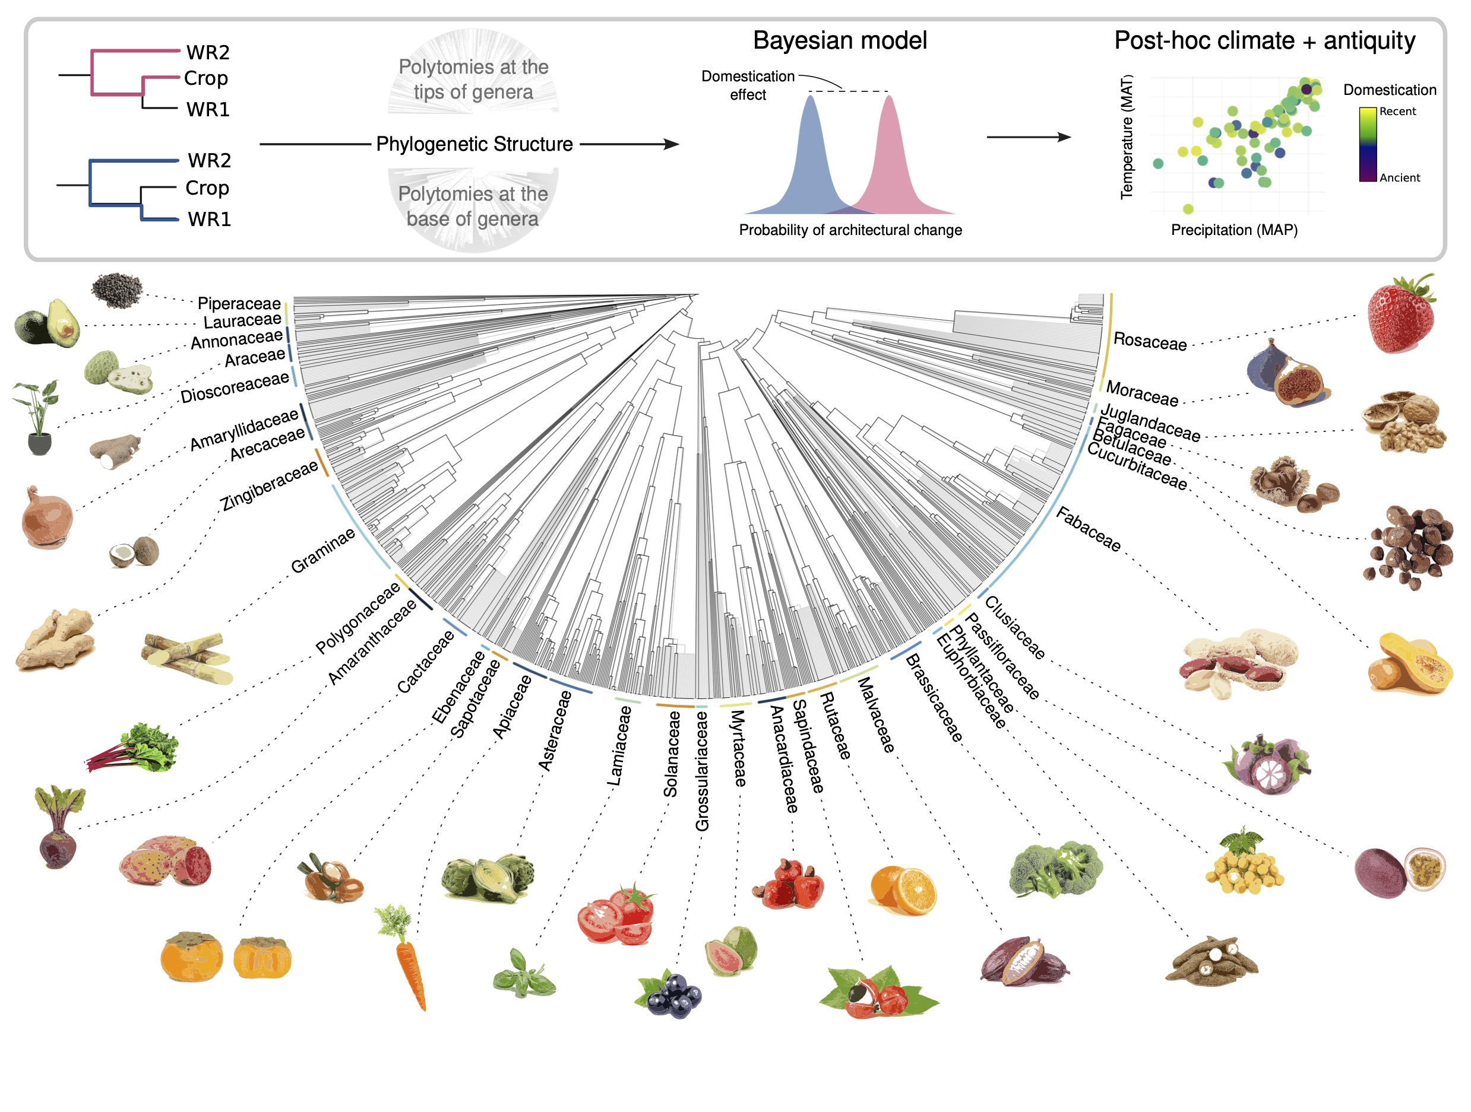
Figure 1: Graphic describing our pipeline testing if domestication was correlated with changes in plant architectural traits. a) Phylogenetic relationship for our comparisons between crops and wild progenitors. The red lines on the left tree show the relationship between a focal crop and the closest wild relative (WR1). The blue lines on the right tree show the phylogenetic relationship between the closest wild crop (WR1) with the second closest wild relative (WR2). b) Example of probability distributions from our phylogenetic models. Here each distribution shows the probability of a trait changing (red = WR1 to Crop, blue = WR2 to WR1). The dashed line represents the effect of domestication, here defined as the diffence in mean distributions of probabilities that a trait changed. Hypothesis testing was done to identify the probability that the mean of each distribution was significantly different from each other, by comparing posterior probabilities.

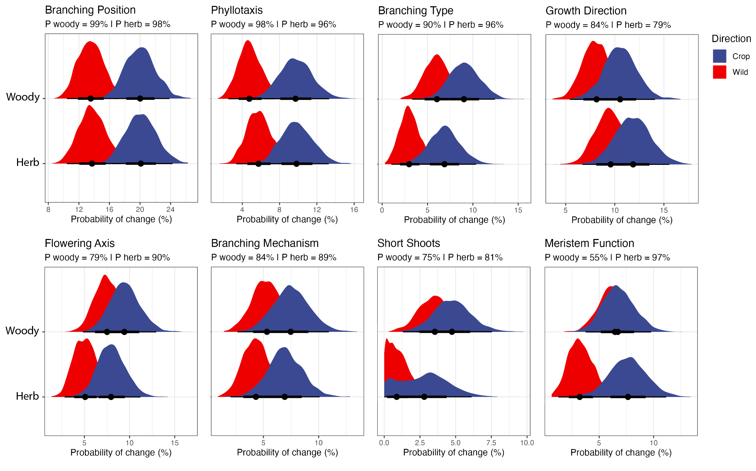
Figure 2: Posterior distributions for herbaceous and woody models. Phylogenetic multilevel multinominal regression models were fit for each trait. Red distributions are the posterior draws representing probability of a trait change from WR2 to WR1 comparisons while blue indicate WR2 to Crop trait change probabilities. The shape of the distribution informs how varied probabilities of change is per trait and herbaceous or woody plant groups.

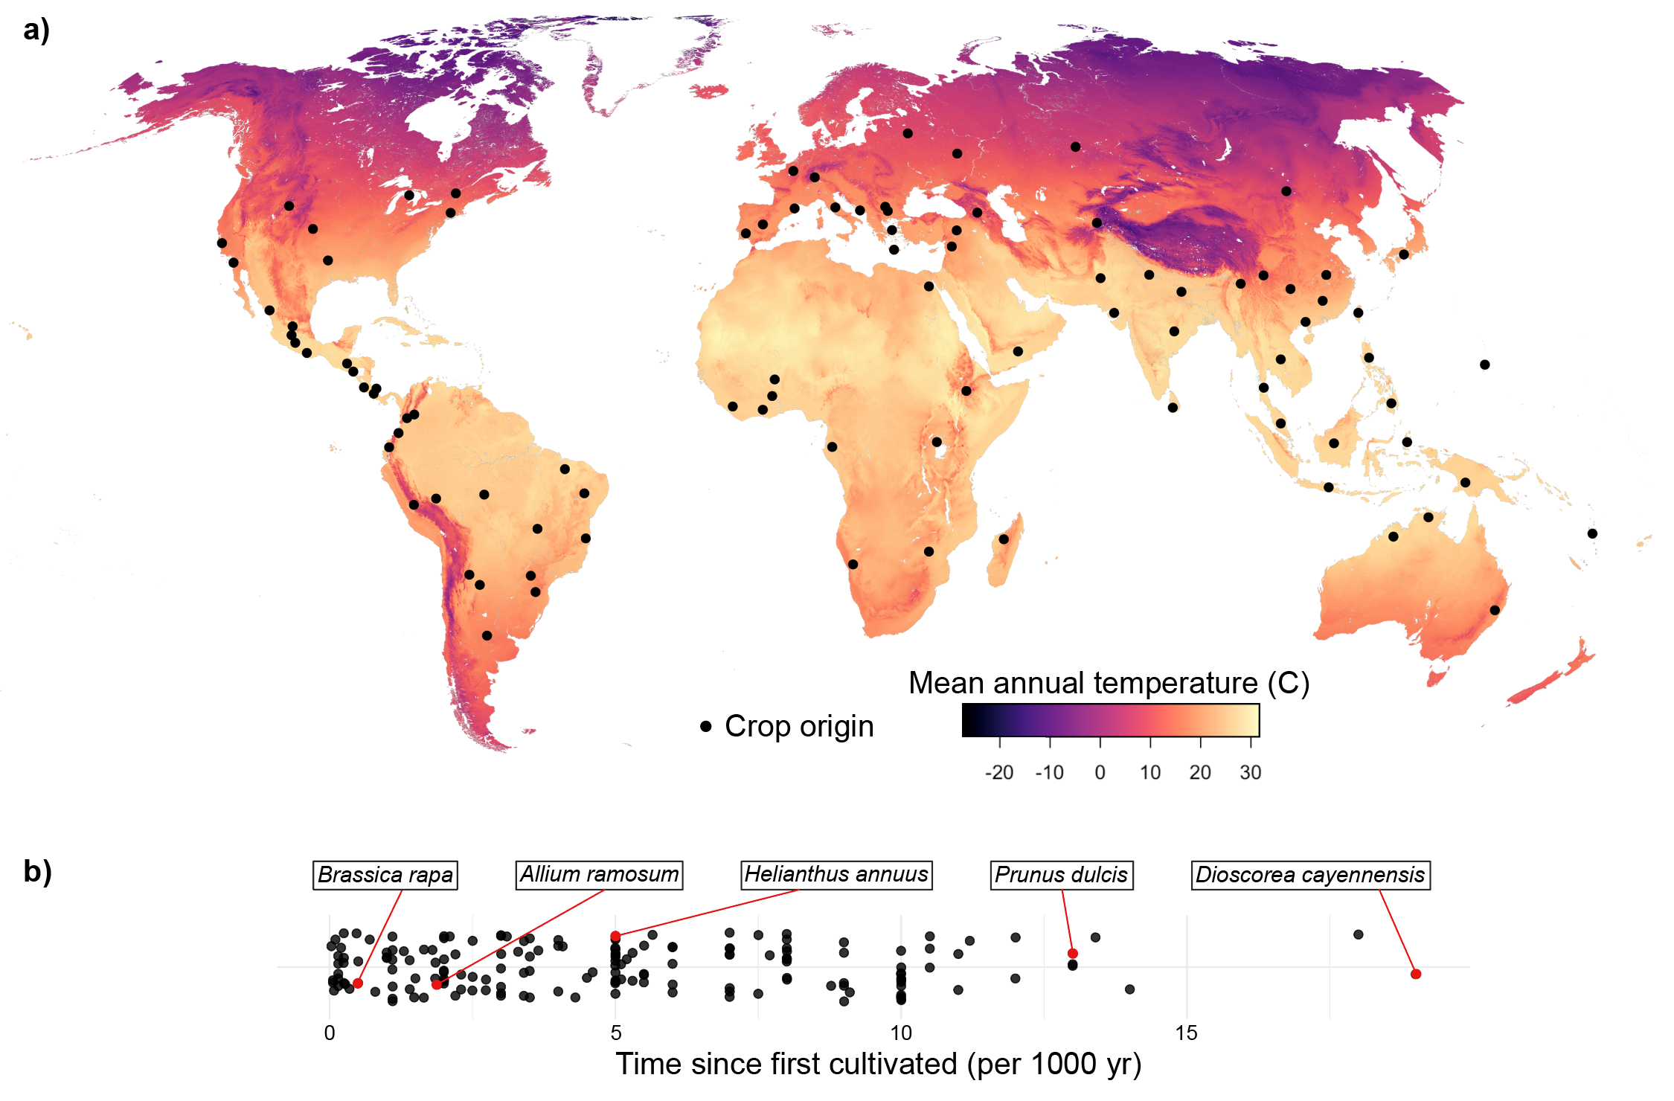
Figure 3. The geographic distribution of crop centres of origin and antiquity for crops in this database that could be geo-located. a) Map showing the geographic distribution of crop centers of origin (black). The map is coloured by mean annual temperature (MAP_ values for visualization. These data were then used with mean annual precipitation data (MAP) and crop antiquity (time since domestication) in Bayesian logistic regression models to estimate if trait transitions (WR2 to Crop and WR1 to Crop) were significantly impacted by climate or antiquity. b) Spread of crop antiquity measured in time since first domestication per 1000 years. Five crops have been randomly selected for visualization, indicated by the red dot and line.

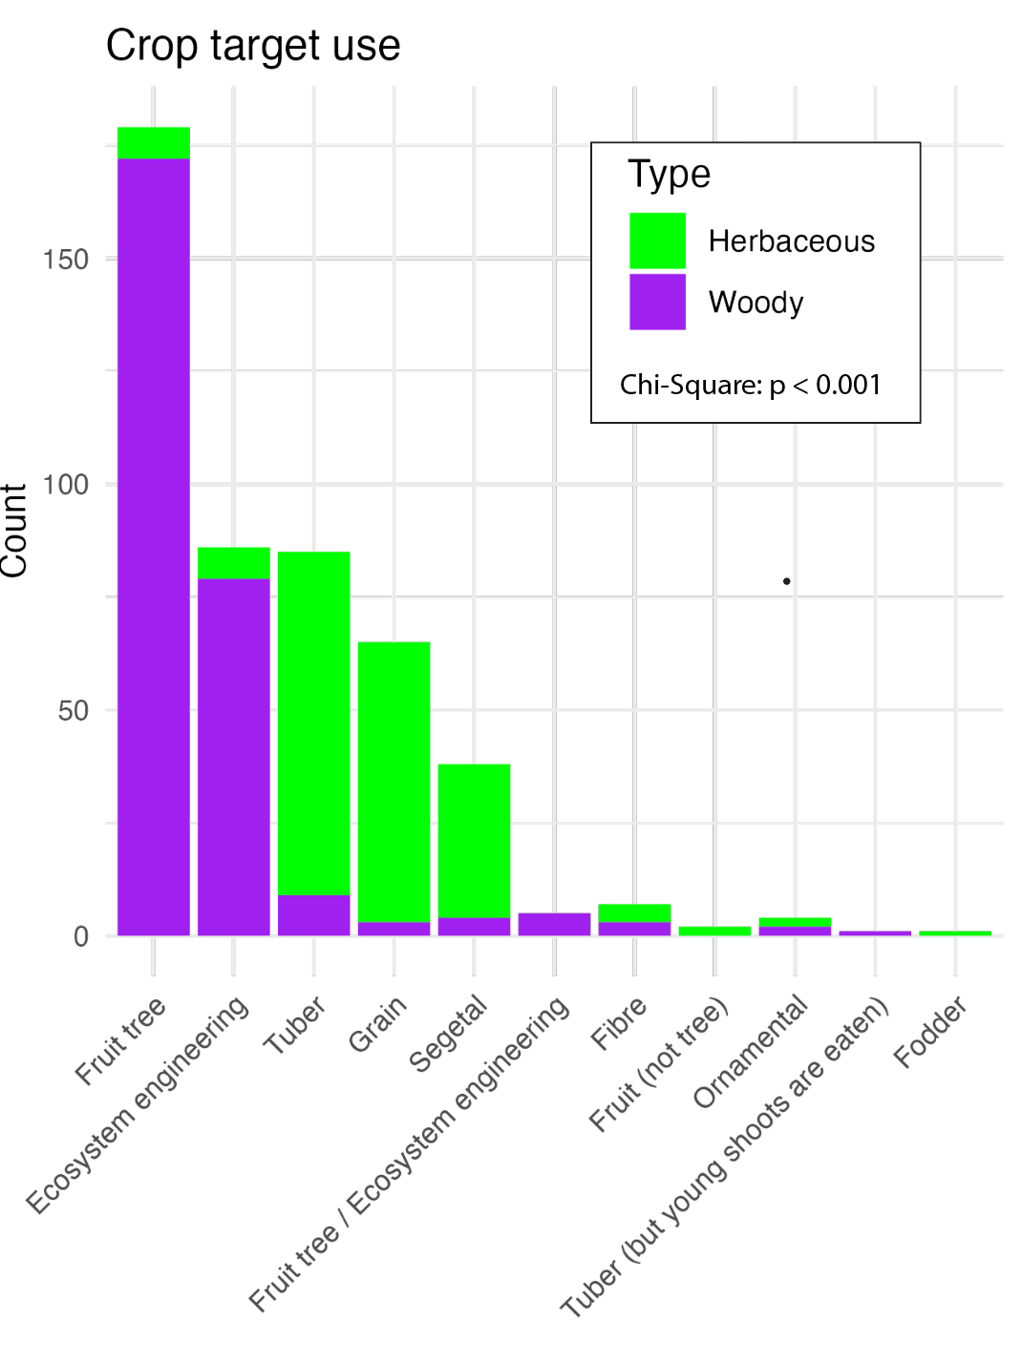
Figure 4. : Multipanel plot showing the number of crops that were cultivated for different purposes (e.g. target use) significantly vary between herbaceous and woody crops. Here the target uses on the x-axis are plotted in order of most frequent to least frequent. Colors indicate if a crop is herbaceous (green) or woody (purple). Significance was tested using a Chi-Squared test (p < 0.001).

Supplementary Material:
Table S1: csv database of crop architectural traits used in this study.

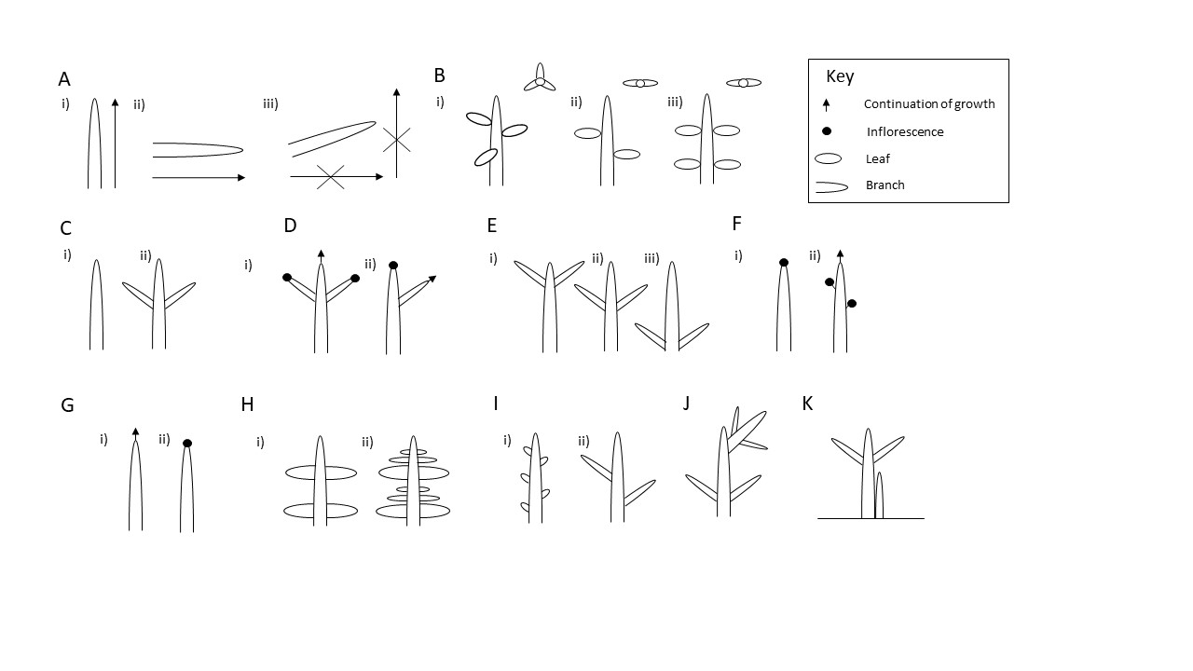
S_Figure_FormDiagram: Visual representation of the architectural traits being studied. A) Growth direction may be i) orthotropic (vertical), ii) plagiotropic (horizontal) or iii) ageotropic (no growth direction). B) Phyllotaxis may be i) spiral (leaves alternately arranged spirally around the axis), ii) distichous (leaves alternately arranged in a single plane) or iii) opposite (leaves arranged opposite one another). C) Branching may be i) unbranched and ii) branched. D) Branching type may be i) monopodial (main axis remains dominant) or ii) sympodial (main axis terminates and lateral axis continues growth). E) Branching position may be i) acrotonic (upper axis), ii) mesotonic (middle of axis) or iii) basitonic (base of axis). F) Flowering position may be i) terminal (end of axis) or ii) lateral (side of axis). G) Meristem functioning may be i) indeterminate (continues growing) or ii) determinate (terminates in reproductive structure or abortion). H) Branching mechanism may be i) continuous (no cessation of growth) or ii) rhythmic (periods of growth and cessation). I) i) Presence or ii) absence of short shoots. J) Presence (as shown) or absence of reiteration. K) Presence (as shown) or absence of basal shoots.

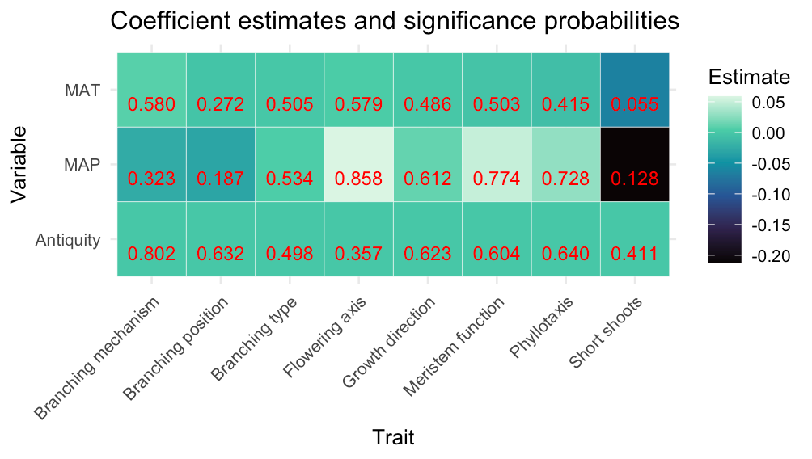
S_Figure_ClimateAntiquity: Heatmap of post-hoc testing if our model probabilities are biased by antiquity or climate. Antiquity was identified using a database (Milla 2020) of how long crops have been cultivated. This database also was used to geo-locate the crops in our database and extract mean annual precipitation (MAP) and mean annual temperature (MAT). The heatmap shows the results of each coefficient from logistic regression models showing the mean effect of each estimate. Coefficients largely are centered at zero, and included zero in their 95% confidence interval. In red within each pixel is the probability that the WR1 to Crop comparison is significantly different from the WR2 to WR1 comparison. All probabilities were less than 95%. These results suggest our models are not biased by crop antiquity or climate.

