**Họ tên: Nguyễn Thế Cường**

**MSSV: 1770155**

**Báo cáo bài tập 8 QUEEN trên B-Prolog**

**1/ Chương trình 1:**

* Source:

% 8Queens_Problem1

% solution( boardposition)

solution([ ]).

solution([p(X,Y)|Others]) :- solution(Others),

member(Y, [1,2,3,4,5,6,7,8]),

noattack(p(X,Y), Others).

noattack( _ , [ ]).

noattack(p(X,Y),[p(X1,Y1)| Others]) :- Y =\= Y1,

Y1-Y =\= X1- X,

Y1-Y =\= X-X1,

noattack(p(X , Y), Others).

* Question:

| ?- solution([p(1,Y1), p(2,Y2), p(3,Y3), p(4,Y4), p(5,Y5), p(6,Y6), p(7,Y7), p(8,Y8)]).

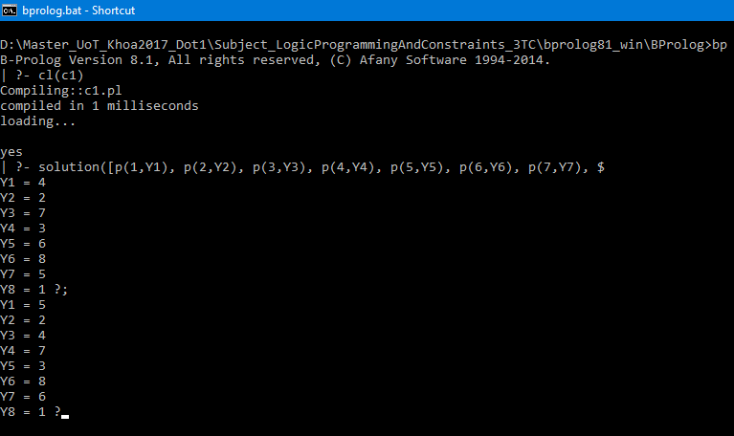

**2/ Chương trình 2:**

* Source:

% 8Queens_Problem2

solution(Queens) :- permutation([1,2,3,4,5,6,7,8],Queens),

safe(Queens).

safe([ ]).

safe([Queen|Others]) :- safe(Others),

noattack(Queen, Others, 1).

noattack( _ , [ ], _ ).

noattack(Y, [Y1| Ylist], Xdist) :- Y1-Y=\= Xdist,

Y-Y1 =\= Xdist,

Dist1 is Xdist +1,

noattack(Y, Ylist, Dist1).

* Question:

| ?- solution(Queens).

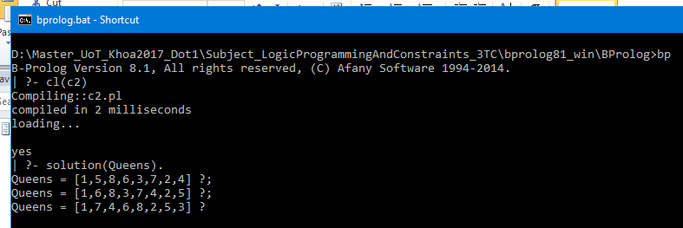

**3/ Chương trình 3:**

* Source:

% 8Queens_Problem3

solution(Ylist) :- sol(Ylist, [1, 2, 3, 4, 5, 6, 7, 8],

[1, 2, 3, 4, 5, 6, 7, 8],

[-7, -6, -5, -4, -3, -2, -1, 0, 1, 2, 3, 4, 5, 6, 7],

[2, 3, 4, 5, 6, 7, 8, 9, 10, 11, 12, 13, 14, 15, 16]).

sol([],[],_,_,_).

sol( [Y|Ylist], [X|Dx1], Dy, Du, Dv) :- del(Y, Dy, Dy1),

U is X-Y,

del(U, Du, Du1),

V is X+Y,del(V, Dv, Dv1),

sol(Ylist, Dx1, Dy1, Du1, Dv1).

del(Item, [Item| List], List).

del(Item, [First| List], [First| List1]) :- del(Item, List, List1).

* Question:

| ?- solution(YList).

