

Mountains are majestic landforms that can inspire awe and wonder in people. They are characterized by their towering peaks, rugged terrain, and breathtaking vistas. From the snow-capped peaks of the Himalayas to the rocky cliffs of Yosemite, mountains are some of the most iconic and recognizable features of the natural world.

Mountains form as a result of tectonic activity, which occurs when plates in the Earth's crust collide and push up against each other. Over time, this pressure causes the land to rise and form mountain ranges. The tallest mountain in the world, Mount Everest, is located in the Himalayas and stands at an elevation of 29,029 feet. The Andes in South America, the Rocky Mountains in North America, and the Alps in Europe are just a few examples of other mountain ranges around the world.

Mountains play an important role in shaping the Earth's climate and weather patterns. They affect the amount of precipitation that falls in an area, as well as the temperature and wind patterns. This is because mountains can create a "rain shadow" effect, where moisture-laden air is forced to rise over the

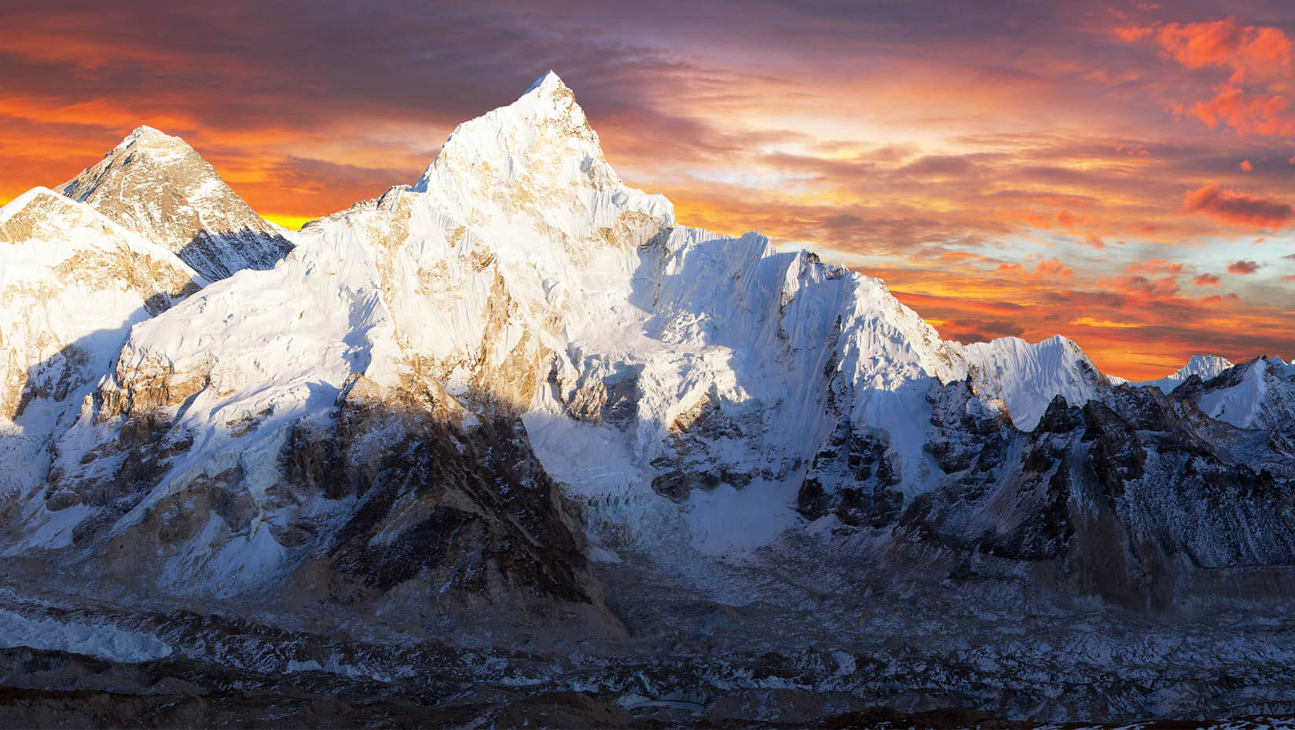mountains and cool, causing it to release its moisture as precipitation. As a result, areas on the leeward side of the mountain may be much drier than those on the windward side.

Mountains are also important ecosystems that support a wide range of plant and animal life. From the alpine tundra at high elevations to the dense forests at lower elevations, mountains are home to a diverse array of species. Some of the world's most iconic animals, such as the mountain gorilla and the snow leopard, make their homes in the mountains.

In addition to their ecological importance, mountains also have cultural significance for many people around the world. They have been the sites of religious and spiritual practices for centuries, and many cultures have myths and legends that center around mountains. Mount Fuji in Japan, Uluru in Australia, and Mount Olympus in Greece are just a few examples of mountains that hold cultural significance for their respective peoples.

However, mountains are also vulnerable to human activities such as mining, logging, and development. These activities can cause irreparable damage to the mountain ecosystem and threaten the species that depend on it. Climate



change is also affecting mountain ecosystems, as rising temperatures and changing precipitation patterns can alter the habitat of many mountain species.

In conclusion, mountains are remarkable landforms that are important for ecological, cultural, and aesthetic reasons. They shape the Earth's climate and weather patterns, support a wide range of plant and animal life, and hold cultural significance for many people around the world. However, they are also vulnerable to human activities and climate change, making it important for us to protect and preserve these majestic features of our natural world.